# **Charles Kovess - Editorial on Democracy - Business and Community Round - Up 18 Dec 2024**

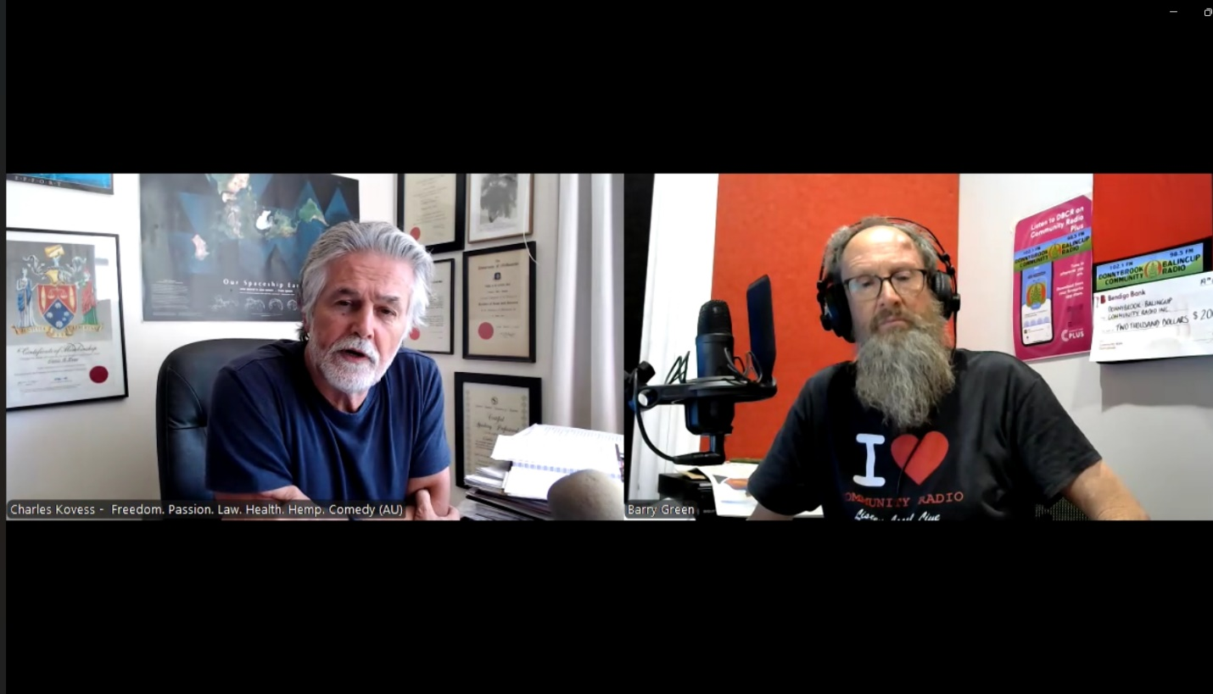

Audio version: <https://soundcloud.com/dbcommunityradio/charles-kovess-editorial-on>

Video version: <https://rumble.com/v60n1u5-charles-kovess-editorial-on-democracy.html>

**Barry Green:** The group. Bagheera, if I've read that right. And is it ever going to make sense? Which is a jolly good question. At this time in history, a lot of things aren't making sense. But anyway, we can talk about these things on community radio, and you're listening to Donnybrook- Balingup Community Radio Business and Community Roundup. My next guest, the bloke I met earlier this year, one of many people that I've met that I probably wouldn't have met if it hadn't been for the things that have happened around Covid. Charles Kovess has been a broadcaster on TNT radio. He's been a lawyer. He's involved in all sorts of things. And he's the Australasian passion provocateur. G'day. Charles Kovess.

**Charles Kovess:** Hello, Barry. Lovely to be with you. Thank you for the opportunity to have a conversation on community radio with you.

**Barry Green:** It's it all starts with a conversation, Charles. And so I met you earlier in the year that was actually through a hoodies men's group. But you're involved with the aligned Council of Australia. Last week I spoke to Katie Ashby Koppens about that group. Do you want to talk a bit about the Aligned Council of Australia?

**Charles Kovess:** Yes. Not only am I associated with it, but I'm on the board now. I became a director of the Aligned Council with Katie on Monday of this week. And there are many, many groups in Australia fighting for very similar things. I consider myself a freedom warrior in the work that I do as a lawyer, as you noted for 20 years, and one of the keys to preserving freedom is the law. And I wanted to become a lawyer from a very young age. And there are people who understand why freedom is important. The problem in Australia is that most people, and in America and in Canada and in the UK, most people would give away their freedom. Barry for Security and the Allied Council of Australia has brought some 40 groups together, united around one thing that Australia doesn't want to give away its sovereignty, um, in relation to health matters. That particularly refers to the World Health Organisation that wants to claim sovereignty over Australia's health decisions. These 40 groups came together under the banner of the Allied Council of Australia, inspired by Professor Ian Brighthope and Katie Ashby - Koppens was one of the founding directors of ACA United in the fight against the efforts of the World Health Organisation to bring in a pandemic treaty, a pandemic agreement. But in fact it's a treaty and new international health regulations IHR which give incredibly increased powers, incredibly, unbelievably Believably increased powers to the World Health Organization to make all sorts of declarations that then requires Australian politicians to limit our freedom Barry they? And so the politicians have to do what the World Health Organization says.

**Charles Kovess:** We get locked in our homes and your freedom is gone. And I want to point out that without freedom, we're not human. Why this is such an important matter from an early age is that freedom is what makes you human. So the Aligned Council came together in April of March, April of this year. All these 40 groups said, no, we don't want someone telling Australian politicians what to do because the World Health Organization is unaccountable. That's what the ACA does. And there are different sized organizations I'm involved in a number of organizations have been now for quite some years in the health space. And that's why I was asked to be a member of the ACA, which I do. And our group called FOAM. FOAM is part of the Alliance Council of Australia and I support those moves. So that's what he does. And the goal the difficult goal is from 40 organizations. We probably agree on 85% of matters. And the difficult goal is when the last 15% there are disagreements and people say, no, no, I disagree with that. I'm out. And it's in these smaller groups. It's like herding cats. And I suppose we see that in the Labor Party and the Liberal Party between the real liberals and what I call the real liberals and the teal liberals, and in the labor on the labor side, between the right faction, the left faction, the socialist faction. So there are all sorts of factions. So it seems that this is a natural human problem. Barry so that's the aligned Council

**Barry Green:** And Democracy, the key to democracy is the ability to debate and track a middle path. So this is has been a problem in the Alliance. Council of Australia was involved in the challenge to the misinformation bill. Um, and, you know, we've got to be able to have these conversations. Um, you made reference to Ian Brighthope, and I think the work he's done warrants further comment. Um, and his presentation at the great debate, Port Hedland versus the premier in Perth that's gone viral around the world, spread on on the independent media doctor John Campbell. Um, and we are in such an interesting time in history with the incoming president and the and particularly the exactly what position he's going to hold. It's Robert Kennedy Jr. Um, he has an understanding of he's a lawyer, but he's an understanding of ecology. And as somebody involved in regenerative agriculture, the fact that he's appointed Joel Salatin as an agricultural advisor, this has huge implications for the for the future of mankind, and the simple act that he can possibly implement is remove the vaccine, indemnity the pharmaceutical, the vaccine indemnity for the pharmaceutical industry, then this whole sort of house of cards probably going to fall over. Charles.

**Charles Kovess:** Yes, it's an interesting question. This this vaccine question. I, I describe myself as a now passionate anti-vaxxer. I became a questioner of vaccines 14 years ago. And Bobby Kennedy, well, the explosion of children's vaccines happened in 1986 with that indemnity to which you refer, that was brought in under the presidency of Ronald Reagan. Some say that he was fooled into signing the authorization to make that piece of legislation valid, giving indemnity to pharmaceutical companies for any damage caused by their vaccines when given to children Be clear about that. And, um, you know the it set up the vaccine injury compensation fund. Now it's said that children's vaccines are the safest and most wonderful medical intervention ever developed. That's a lie. The godfather, the godfather of medicines in America, Doctor Stanley Plotkin, under nine hours of cross-examination by famous trial lawyer Aaron Siri, admitted that no vaccine ever given to humanity has ever been properly tested for safety or efficacy. And so that's the situation in which we are now, where injecting children with these alleged chemicals, putting them into their body, which literally says that God is incompetent.

**Charles Kovess:** Barry you see, God is not competent. He can't produce Babies and you look at the how this fraud on humanity has been undertaken. Bear in mind that when you were a kid, your pets did not get shots today. Today this is oh, have your pets got their shots? We are being sucked into this whole idea by vets who also provided chemicals by the same big pharmaceutical companies that do it for children, that we become used to it. Has your pet got their shots? And this I heard I heard a quote this morning in one of the meetings I was attending that stray dogs live a long time. Pedigreed dogs die young and that's because they've had their shots. So the other, the number that I want to bring to everyone's attention and yours. And this is an important number. When you and I were kids, we got 3 or 4, maybe five vaccines in the first five years of life. Are you aware that Barry how many a child has to get under the Australian Government vaccine schedule in the first four years of life in Australia?

**Barry Green:** It's a lot.

**Charles Kovess:** 43.

**Barry Green:** Yep.

**Charles Kovess:** And I've got the schedule. I can show it to you on the screen. 43. Now that's 43 antigens as double, triple and quadruple pumped into it. And so this is the impact this is having on our health. And then Bobby Kennedy talks about soil health. And so not only are you having these chemicals pumped into us, but then we're getting chemicals on our food. And the food has less nutrition and the food has chemicals. And so it's remarkable, Barry, that you and I are even alive.

**Barry Green:** Well, I guess, you know, I was taken to a measles party when I was a kid to get measles. And that's how humans have evolved with that. And what's really I think what Covid has done is it has exposed the complete overreach of the corporations over our government and the complete failure of the commercial media. And. And I can understand that from a commercial point of view, the failure of the ABC to report on this is as an indictment. But that's, again, the Billy Bay doctor William Bay case is so significant. Can you want to speak on that? As a lawyer, the significance of William Bays case?

**Charles Kovess:** Yes, I do. William Bay, Queensland, doctor, was warning his patients that these Covid jabs, they're not vaccines. These Covid jabs were dangerous. And he was warning his patients that they couldn't give informed consent because there were insufficient or insufficient trials done on these jabs. And no one knew what the implications would be. And he was speaking out. Don't give this to people. So AHPRA, the Australian Health Practitioners Regulatory agency suspended him as a danger to humanity, and the Queensland Supreme Court held that his suspension was invalid. Now it's more than just it was. It was one of the grounds was because the no procedural fairness was given to him. That's one. On the other hand, it held that it is wrong of AHPRA to criticise doctors for speaking out in the political environment. Doctors are allowed to express their views and what they have, what they can be suspended by AHPRA for is for putting their patients lives safety at risk. Well, the court held that William Bay speaking out against these vaccines, was not putting his patients at risk because he was speaking very sensibly. It was political commentary, and he was entitled to do so. And it is a big win, not just because procedural fairness wasn't followed. So Barry it is. It is a very important decision. And we want now all doctors to understand that, that it is proper for them to speak of the lack of safety of what's being provided to patients.

**Barry Green:** And as a lawyer, you'd understand the basics. And I think it's a matter of putting this thing in simple terms. You'd never buy a new car without a warranty. Why would you inject a trial injection without the company supplying it, providing a warranty? It's a fairly basic concept, I'd have thought.

**Charles Kovess:** Yes, the answer to that is that the politicians allowed this to happen, and the politicians allowed this to happen because they have been bought. Politicians have been bought by the medical industry, by the pharmaceutical industry, by the industrial military complex and the money in those fields is such that the they the influence on politicians in Australia, America, Canada, UK is profound, profoundly heavy influence. It is evil, it is corrupt. And politicians are not making decisions based on the best interests of the people whom they claim to represent, but on the interests of pharmaceutical companies, of chemical companies, of military companies. That's what's happening. And so you talk to a politician, they're not interested in questioning this, and they're not interested in having free speech about it. And that's why the ABC needs to hang its head in shame, because it has been bought as well. And you say, how can that happen? And the answer is because our politicians have been bought, our left wing politicians and I say the ABC is hugely left wing. There's not one conservative journalist who works for the ABC, who is on air. The probably the only conservative workers in the ABC are those who never speak up about their true conservatism. And when I say conservatism, I'm talking about a commitment to free enterprise, a commitment to personal responsibility, a commitment to smaller government and less regulation, and a commitment to free speech. Being able to speak freely, as you and I are now doing. And I honour community radio for being able to speak freely rather than being censored by the owners of community radio, which happens to be us.

**Barry Green:** Well, in Donnybrook Community Radio, we are an incorporated body. We have local businesses sponsoring us. In terms of the ABC, doctor Maryanne Demasi spoke at the great debate. She was ABC. She became she became ex ABC after talking about statins. So there's another can of worms there. But we do have to pay our bills. So we'll run the sponsor message, Charles, and come back and continue the conversation.

**Sponsor Message:** DBCR would like to thank the following sponsors for their generous support. The Veteran Car Club of Donnybrook, move with Life Wellness, Donnybrook Glass and Red Tail Plumbing DBCR your community station.

**Sponsor Message:** You travel a lot and you need your mobile phone. Maybe your signal at home is poor and when you're on the phone it's suddenly drop like that. Let sound Wave car stereo show you how to boost your mobile phone coverage with selfie go. Selfie go will work at home, in the car or your caravan. You'll even get phone and internet coverage in areas with a very poor signal. Sound wave Car Stereo 185 Blair Street. Call 9791581.

**Barry Green:** My guest this morning is Charles Kovess, who's many things but involved in the Allied Council of Australia now 2025. Charles, how do you see things unfolding.

**Charles Kovess:** Well, my view is that the solution to corrupted politicians, to enforcing the requirement, the demands of people is unity of us human beings. And I, I'm of the view that the Trump re-election is as Rowan Dean in The Outsiders says, we have passed the point of peak wokeness, and wokeness is one of the ways in which speech is muzzled. If you can't say anything that's not aligned with woke principles, you can't properly say that there are only men and women. That's hate speech. And you have to be politically correct. So Trump being reelected is evidence Barry that the that that people in America voted in favor of free speech, not wokeness. And that syndrome is also going to happen in Australia. I predict I've I predict that Peter Dutton will win the next federal election. I predict that Albanese, Anthony Albanese will be tossed out. And I'm but I'm not relying on I'm not relying on politicians entirely. But it's a wake up call to people. And conversations like this are in 2025 that as human beings, we have to learn to work together, even though we might disagree on certain matters. And it concerns me that on the 85:15 rule that I talked about with the Aligned Council that you and I can agree to, an 85% agree on most things. And then people say, oh, Barry Green believes in regenerative agriculture.

**Charles Kovess:** They say the word. He lost me and they ceased to have conversation anymore. And that's where democracy suffers. You talked about that at the start of our conversation. Democracy requires us to be mates, you know, to go whatever. You know, you got to laugh. Doesn't matter what happens. And literally we should be having a sense of humour. We need to bring back a sense of humour into our conversations and go, wow, do you reckon that you must be an absolute idiot and say, yeah, I'm an idiot, but that's what I believe. And to that end, I am the chairman of the Australian Institute of Comedy. And why comedy number one? Because I'm a professional speaker. I have been for 31 years since I left my legal profession. I give, you know, legal strategy advice to lawyers to help with their clients, but I stop I stop being a lawyer, to be a motivational speaker, to be a speaker on, to be a speaker, on passion and comedy is one of the ways that we get messages across. But interestingly, Barry comedy, in my view, is the tip of the spear of free speech. And when we and it's the comedians thinking back in the 15th century who were the only people in the royal courts who were able to speak some truth.

**Barry Green:** I guess it would be the court jester.

**Charles Kovess:** Very Good, And it was the anyone who spoke against the King, other than the court jester, would have their heads chopped off for treason. And, you know, even then the royal what you say, why did the royal court have a court jester. Because they understood the psychology that you need to have some truth spoken at court. So comedy you see comedians being attacked all the time. What we have to do is to stand up for the rights of comedians, to make fun of literally everything.

**Barry Green:** Well, that's where you start.

**Charles Kovess:** You start limiting it. We're in trouble. And then you don't get fooled. You don't get proper democracy because we're not debating the real issues.

**Barry Green:** As I discussed with Russell Broadbent last time I spoke to him on this programme, I've stopped watching the ABC news, which I used to watch religiously at 7:00. I've stopped watching it, but I've been watching back issues of Yes, Minister, which was far more informative. And it's really what's happened is the, the, you know, the Sir Humphrey, Appleby's that were the Westminster. We've now got the Sir Humphrey Appleby's of United Nations and the World Health Organisation's running the show, and our politicians need to take that back. We've got a handful of really good ones, like Russell Broadbent, Malcolm Roberts, Senator. Senator Rennick and Senator Babett. Alex.

**Charles Kovess:** Alex Antich.

**Barry Green:** Yeah. And so there's absolute hope. And while we can have these conversations, things are looking good for 2025. Charles.

**Charles Kovess:** I think you know. I do think so. And this, this movement, the Trump movement and the lack of support for Keir Starmer and his Labour government in the UK, which is an interesting first past the post voting process. He got something like 22% of the of the vote, and he's got a massive 400 to 200 seat majority in the UK Parliament. And as we're sitting here talking, we're also seeing the demise of the Canadian government of Justin Trudeau and the Canadians. What has been imposed by that Trudeau character on Canadians is simply outrageous. So when we see that, we say, no, we don't. We don't want that. Now that's coming back to this question of freedom versus security politicians. Here's the problem with democracy. Politicians say, vote for me, Barry because I will give you all this stuff. I'll give you free money, essentially. Well, who wouldn't vote for free money? There's only one problem. Politicians only get their money from us. And on the issue of democracy, I had an interesting thought put to me. I've been a supporter of democracy, but really to democracy is the domination of the minority by the majority. And you know, if 51% vote Labour, 41, 49% vote Liberal, while Labour makes all of the decisions, it's not as if 51% of the decisions are for Labour and 49.

**Charles Kovess:** No, it's 100% Labour decisions. And that's where the tyranny of the or the words are tyranny of the majority. And I don't know what the answer to it is, but being aware of it helps us to see, hey, get off this left, right, tram left, right and greens. You know, life is much more complicated. So the thought I'd put to you, or the question I put to you is, would our Parliament be better in the 151 seats in the lower house, 76 senators in the upper house. If in fact there were ten, if there were ten political parties represented by 15, by 15. In the lower house, 15 members each a bit like the EU Parliament. Would that be better rather than just one or the other? I'm of the view that it would, and what it means is that then we'd have a true debate amongst those 15 parties. Well, what are we going to do? There'd be a coalition of eight of the parties and they would have to haggle. And then parties would drop out and move in. Yes, I like that idea. I don't like that

**Barry Green:** stability through diversity. The basic concept of permaculture. Anyway, Charles, thanks for taking the time to talk to us today. No doubt we'll talk more in the new year.

**Charles Kovess:** Lots more to talk about. Barry. Delighted to be with you and thank you for the opportunity.

**Barry Green:** It all starts with a conversation. Thanks, Charles. I've been talking to Charles Kovess, who's involved in many things, including the Aligned Council of Australia.