Charles Kovess - Chair ACA - BCC - 19 Nov 2025
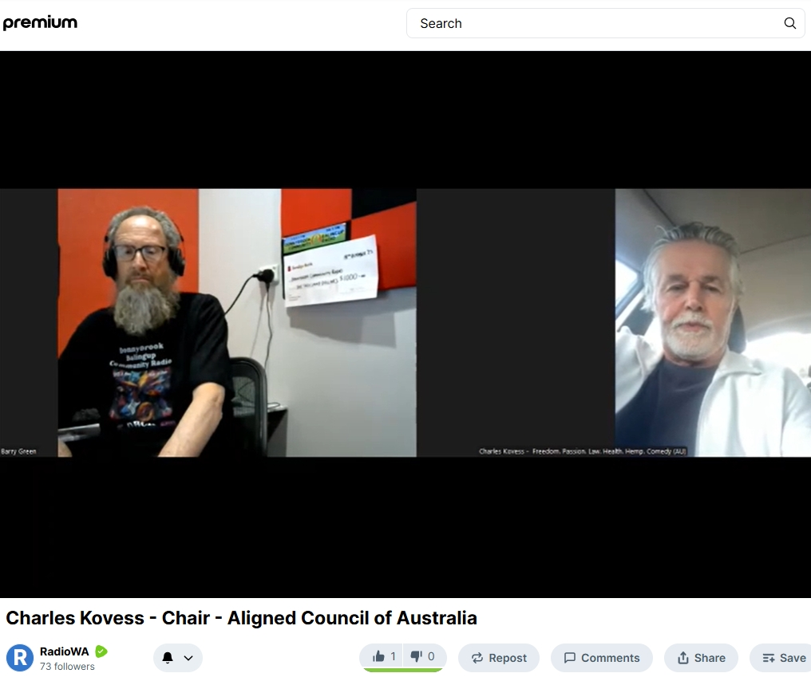

Listen online: https://creators.spotify.com/pod/profile/radio-wa/episodes/Charles-Kovess---Chair---Aligned-Council-of-Australia-e3b600t

Rumble: https://rumble.com/v71xovo-charles-kovess-chair-aligned-council-of-australia.html?e9s=src_v1_upp_a

Barry Green: One More Night on Donnybrook-Balingup Community Radio Business and community conversations sponsored by Harvest Highway.Com.au. It's 1107 and my next guest is the chair of the Aligned Council of Australia. Charles Kovess is the former lawyer and held many positions in business and community organisations. G'day Charles

Charles Kovess: Barry wonderful to be with you and well done on your work that you do for community radio.

Barry Green: Thanks, Charles. Now, for our listeners. Can you tell listeners what the Alliance Council of Australia is about its objectives and and who's part who makes it up?

Charles Kovess: I would be delighted. So the Allied Council was formed in March 2025. And essentially it's an umbrella body.

Barry Green: 5 or 4.

Charles Kovess: Sorry, March, thank you. March 2024. How time flies.

Barry Green: When you're having fun.

Charles Kovess: Um, so we'll be we'll be we just the reason why I was thinking current years, because we just had our annual general meeting. Our first annual general meeting on the 12th of November last week. And so from time of incorporation up till then, that was the first AGM from March of 2024. So it was formed as an umbrella body to represent organisations so that we have an aligned voice and the in a very short time, the Aligned Council brought together 38 member groups. And and these member groups are essentially groups of human beings, men and women. And there are only men and there are only men and women. And they some of these member groups are incorporated associations, some of them are unincorporated associations. And the unification factor was agreeing to fight for Australian Health matters or the health of Australians. Now, now, the the trigger that drove this was the activities of the World Health Organisation in attempting to have a global treaty on health. Number one and number two, to amend the international Health Regulations to give extraordinary power to the World Health Organisation. And these powers would enable the World Health Organisation to demand certain rights, certain sovereignty, certain powers over Australia and all of the members of the World Health Organisation, so that if the World Organisation said that everyone in Australia has to fart, then the Australian government would have to implement that direction that all of us need to fart. And the reason why I mentioned farts is because the fraud of climate emergency is that cows farting are causing a climate emergency.

Charles Kovess: Now you'll notice it's very bloody cold in Melbourne where I live, and the weather is certainly not hot in the 70s. I've got time magazine physical time magazine article showing how Earth is going to turn into an ice age. Then it was hot. Now they're talking climate emergency and they're all on an amazing junket in Brazil in a place called Belem. Some many thousands, I think it's about 80,000 people are in this city in Brazil talking about climate emergency. Now cows. Cows farting and belching. It's such a fraud to say that that's driving a climate emergency. But. But the lack of sovereignty of Australia losing its sovereignty over health matters or whatever the World Health Organization decided was the catalyst that caused the creation of the Allied Council and these members to join up. And they are official members. They've signed agreements and we represent approximately 1.8 million Australians. There is a board of three. I'm the chairman and the secretary is Katie Ashby Coppins, a very well known lawyer, freedom fighter. I'm a freedom fighter. And Neil Angus, a former member of the Victorian Parliament and the three of us as a board, we're all unpaid. It's a not for profit. And we have then reporting to us an operations team. And that operations team is a very successful organisation, group of human beings. I won't mention their names on this call Barry.

Barry Green: But I think we could, I think we could mention one name. And Katie Katrina Lane is known to people in Donnybrook-balingup because she ran a business here for many years. The taste of Balingup. So we do have a local connection to this.

Charles Kovess: Wonderful, wonderful, wonderful. Yes, Katrina Lane for sure. And I think Barbara Mavridis, who lives in South Australia, she's been doing a power of work as the deputy CEO. And then when Paul Lassig resigned as CEO in July of this year, July 2025, Barbara has been acting CEO. And so we've got a board, we've got an operations team, and we've got a whole bunch of volunteers, and we have a significant communications ability to warn people about dangers to your freedom. Everybody listening to this. Your freedom is at risk. Australia's sovereignty is at risk because if the world the powers of the World Health organization want is that if it tells Australia to lock down, Australia is expected to comply regardless of what our politicians wish to do. And I am implacably opposed to it. That's why I'm heavily involved with the Allied Council. And the other element I wish to mention here Barry. And we're having a members meeting on this point. Think about this and I'll ask you a question. What impacts on Australians health? Or so we came together fighting the World Health Organization. But the purpose of the Allied Council is to take steps to protect and preserve Australians health. So what are matters that affect our health? Barry, I guess give me your top of the. I didn't warn you with this question, but you know.

Barry Green: Well.

Charles Kovess: What impacts on our health.

Barry Green: The quality of our food, local food, not ultra processed food. The sense of community. Sense of belonging and the ability to make decisions for ourselves. And. And I guess I should at this point, in the interest of transparency, say that my company, Western Tourist Radio, is a member of the Allied Council of Australia and Donnybrook-balingup Community Radio is not a member. Uh, and I guess also, we need to contemplate the fact that our major defence partner, the United States of America, has withdrawn from the World Health Organization, and maybe that should be providing some indications for where Australia should go.

Charles Kovess: Yes. The chief executive of the World Health Organisation. Tedros. Tedros Ghebreyesus. Um, I used to I memorized his name, but I've tried to forget it. Tedros is a wanted criminal in his home country of Uganda. He is a political activist. He is not to be trusted, and I don't trust him. And I urge people to look into Tedros background. It's a horrific background. I've got it. I haven't got those notes with me, Barry, but it's well put. Now, coming back to the health issue of Australians. My definition of health is this. And I urge people to think about it because I say to most people, I say to you, Barry, are you healthy? Are you not bad? How do you know? Well, I don't have any discernible diseases. That's not health. And most people actually don't have a definition of health. I'm going to give you a definition that I have been teaching for many years. In fact, for the last 32 years, when I stopped, when I left my legal career to become a professional speaker. And my other business interests include industrial hemp, which is going to be very relevant for your region. Um, but my definition of health is this health is the unique optimal balance, the unique optimal balance for you, Barry. And each person who's listening to this or the recording of mental, physical and spiritual elements, the unique optimal. So Barry in terms of mental illness. Spiritual elements, physical elements. Food is a physical element, religion is a spiritual element or spiritual beliefs and your mental health.

Charles Kovess: If you are suffering from depression badly, you wouldn't consider yourself to be healthy. And so what? We are going to come back to the members with for the Alliance Council is this is a unique grouping of Australians is to say, oh, by the way, the other element, of course, is education. If you are badly educated, you will not be mentally healthy, right? So, so that the Alliance Council has the ability to really have an impact on all the important elements. Because the next question is how important is health? I say to people, what's more important, wealth or health? Overwhelmingly, people say health is more important than wealth. And I want everyone listening to this Barry to really understand, gosh, would I sacrifice my money to be healthy? And I have in my life. I've always I've always put health ahead of money. It's a bad decision to put money ahead of your health. And that's why the Allied Council of Australia can play a magnificent role in preserving health. And if you genuinely believe that health is more important than wealth, then I would urge you to look at the website and give generously as a donation to this not for profit that is fighting for your health rights, which includes avoiding any medical intervention ordered by the World Health Organisation on Australians. And just imagine that if the World Health Organisation could force you to have a mental a medical intervention. I'm implacably opposed to that. That's why the Allied Council is important.

Barry Green: And two of the members of the Allied Council Australia are the Amps, the Australian Medical Professional Society, which is esteemed doctors, and the world of wellness. Professor Ian Brighthope, who I've spoken to on this program a number of times. But community radio, we have to pay some bills, Charles. So I'll run a few messages in a song and we'll come back and continue our conversation.

Sponsor Message: DBCR would like to thank the following sponsors for their generous support the Veteran Car Club of Donnybrook, Trevor's Carpets and Bunbury, Donnybrook Glass and Redtail Plumbing. Db CR your community station.

Barry Green: It's Sam Cook. Ain't that good news on Donnybrook-balingup community radio business and community conversations? My guest is Charles Covas, the chair of the Aligned Council of Australia, and one of the issues that the council is bringing to people's attention is the issues around the under 16 social media ban. Charles, what do you make of that?

Charles Kovess: I think this is an outrageous, obviously fraudulent attempt by the Australian government to get my details so that anytime I log onto the computer, I will have to prove who I am. In other words, it is not possible for the government. The government hasn't announced how it's going to police this. So on my computer for 16 years, if a 15 year old comes there, how do they know it's not me there? And then? And then if they say, you know, you look at all of the logistical challenges for millions of children under 16 to be able to prove that it's them and not me. Not possible without a digital ID and Barry. I want everyone to understand how fraudulent this is, and particularly in the context. Just this morning I was watching. I was watching US news and the Jeffrey Epstein Files have been released. Okay. The Jeffrey Epstein files. Thousands and thousands. So it was passed 497 to 1, I'm sorry, 427 to 1 in the House, in the House of Representatives. And and so all those documents are being released. Now, what it shows is that the Biden administration couldn't give a couldn't give a rat's about the trafficking of children.

Charles Kovess: And I say the Australian government is in a similar situation. It doesn't care about protecting children. And this fraud about protecting under 16 from social media. No Australian government. Come on. I call on the Australian government to properly protect children and none of this fraudulent stuff. And I urge every single person to not participate on your internet if you have to prove who you are. And what that will do is put enormous financial pressure on our politicians to scrap this ridiculous rule. Here's the situation Barry the fact is, parents should be controlling the activities of their children. This is a total sop to the parents who want to give over the raising and education of children to government. Take responsibility parents, and stop blaming the government or the internet for the bad behavior of your children. Get your children off the internet if you're worried about them being bullied, and do not give a smartphone to a child. Do not give a smartphone to a child. You can give them a basic phone. Do not give a smartphone to a child. It is fraught with stupidity. So that's my current position.

Barry Green: So the people who say, you know, the children need to be protected from stuff online. I guess you've probably answered my question there, but for the people who who do say, well, you know, how do we protect the children? What is your answer to that?

Charles Kovess: Get them away from the computer. Pretty bloody easy. Take the smartphone out of their pockets. Pretty bloody easy. Yep. Do not let your children be on a computer when you are not watching.

Barry Green: Yeah. You wouldn't.

Charles Kovess: Let it. You say to.

Barry Green: Me you wouldn't let them out on the street alone. So why leave them on the internet alone?

Charles Kovess: Far more dangerous on the far more dangerous on the internet. Yep. Now, that ties into another very interesting syndrome, Barry. And it's this the need for both parents to be working full time. It's a serious social problem, and it has been deliberately crafted. I used to be a tax lawyer for 20 years. I've got tax returns of my mentors going back to the 1940s, 1950s, the tax burden on you and I in the 40s and 50s compared to what it is now, was hugely less. And what's happened? Government wants more and more money. And so we've taxed more and more. The price of housing goes up through the roof and both parents have to work. And so the ability to supervise children is very much restricted. And that's why at home you don't have access. You do not give access to your children to a computer unless you are there supervising.

Barry Green: Very good. Okay, Charles. So, uh, I guess, uh, how do people oppose this? What's the best way to oppose? Apart from, of course, ringing up your local federal MP or senator? Because these are the people who are going to make the decisions or perhaps already have.

Charles Kovess: Well, here's what I would here's what I would say. The three word answer do not comply. Do not participate. Now let's let's also tie into this digital ID, because the under 16 social media is a way to get digital ID and the horrors of digital ID, I talked about in my show, I articulated 22 specific reasons why you all must. We all must oppose digital ID what that means is that if you have a digital ID, the government will be able to control how much you spend each month on your petrol Barry it will be able to control how much meat that you have, and they'll say you're only entitled to 250g of meat a week. You will have to flash your digital ID card. This is a bit like the Aboriginal cards. Remember when they got there were only allowed to use these cards for specific purchases. That's what this is designed to do. So that you go to the you go to the supermarket, you put your digital ID in. It says this person is not allowed to buy any more meat because too many cows are farting and burping. So bird example alcohol.

Barry Green: The the this is really fraught. And on the news today there was talk of, uh, major websites going down. This whole idea of basing the system on a fundamentally dodgy internet platform is is a is a worry. And of course, these data centers are huge energy consumers. So you know we talk about being zero carbon. But these data centers that are going to control all this are huge carbon emitters. So anyway, Charles, uh, thanks for your time today. You've got to get back to your other meeting. So I'll let you go at that. Uh, and I guess if we can encourage people to look at the the Aligned Council Australia when I post this online later today. Uh DB. Com.au click on recordings and there'll be and then business community conversations. You'll be able to hear this uh this conversation again. And in the associated texts I'll include a link to the Aligned Council Australia. Thanks, Charles.

Charles Kovess: Thank you Barry. Wonderful, wonderful work you do. Thank you for your support of the Aligned Council. And everybody. Please have a look at it and and take responsibility for the future of Australia as you are Barry. So well done.

Barry Green: Thanks, Charles. I've been talking to Charles Covas, the chair of the Aligned Council of Australia.

