DB & Capel CCI's - BCC - 10 Dec 2025
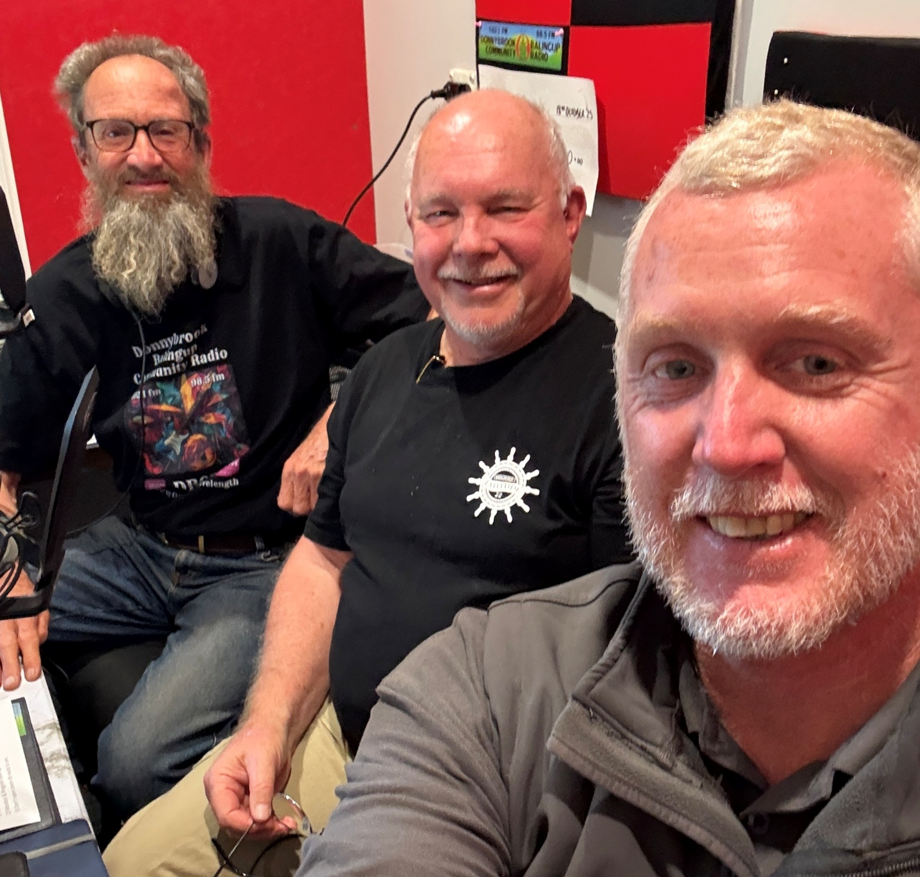
Listen online: https://soundcloud.com/dbcommunityradio/db-capel-ccis-bcc-10-dec-2025

Barry Green: It's 10:05 on Donnybrook-Balingup Community Radio. I'm Barry Green, and this is Business and Community Conversations sponsored by Harvest Highway Commerce.com.au . And this is a live show. And the views of participants may not necessarily be the views of DBCR or Harvest Highway. This morning I'm going to be talking to Brad from what was Donnybrook tyre service now Tyres and More. I'm going to be talking to Tom Overby and Bruce Hearman from the Lions organisation. Tom's a District Governor. We find a bit of time to talk to Anne Wall about the Apple Festival. But first up we're going to be talking about chambers of commerce, both Donnybrook and Capel. And I've at this stage got an Massey chair of or president of the Donnybrook-Balingup Chamber of Commerce in the studio. G'day, Ian.

Iain Massey : G'day Barry G'day all and compliments of the season.

Barry Green: Absolutely. And so I guess there's always a question about what's what's the place of a chamber of commerce. And so and then there's times these things go through ups and downs and there's times you reflect. And why do we exist? What's your thoughts on that?

Iain Massey : Well, I think it begins here for me. Barry the Chamber of Commerce movement actually goes back several hundred years. The first one we know of was was in France. The WA Chamber of Commerce was actually founded in the 1890s to try to address the bottlenecks around trait shipment through Fremantle, which ultimately led to the development of the Port of Fremantle. Right. So it's long standing movement. It's international, it's an informal network, but it's a way in which people who are in business can come together to further the interests, not in a selfish way, but to further the interests of the business community.

Barry Green: And I think DBCR, we very much see ourselves as a business community partnership. And I guess what's tending to happen, especially since in the Covid era, the balance between small business and family, business and community has sort of been tipped in the favor of the corporations and the CCI’s, the bigger CCI’s largely influence those corporations. And what's in their interest isn't necessarily interests in the interests of small business.

Iain Massey : That's right. Barry I think that's particularly right. And it's a particularly sharp contrast to think in the regions, um, where in many cases the large corporations that you can depend on for services and goods in the city simply don't operate here. Um, and so we really do live or die by the health of our small business community.

Barry Green: And that's especially since Covid, there's been a mass sort of a transfer of wealth from government to corporations. And we've seen so many small businesses go by the board, whether it's a relative Covid or Covid policy. Um, and in a dynamic system, you need countervailing forces, and that we don't seem to have had those. The pushback against some of this government and corporate, uh, power grabs.

Iain Massey : I think that's right. Um, obviously large corporations have a great deal of ability and resources to influence governments. They lobby full time. They employ full time lobbyists. Yeah. Um, what we have on the small business side is we are actually the backbone of the economy. And, you know, the majority of employment's, the majority of families who are supported by business are actually from the small and family business sector.

Barry Green: Is that still the case? It certainly has been, but I'm I'm not sure it is quite so much these days because so many, you know, we've had the situation where businesses are encouraged to grow and they get too big for a family and then they get bought by a corporation. And and that is creating an unstable situation. I know in the, in the agriculture space, Joel Salatin, who's a region Ag farmer in America, who I've met, and he's part of the MAHA movement. He's saying in America, the situation is similar here in agriculture where the average age of farmers is 60. So in the next 15 years, there's going to be a mass transfer of agricultural assets from those families to to someone else. And as he says, if that goes to Bill gates, Blackrock and China, we're going to be in a diabolical position. But we've got to find a way in agriculture to get young people into agriculture with a, with a career and to bring enterprise and initiative from an individual. Otherwise, if we get the corporate corporatization of agriculture, I don't think that's going to serve us well.

Iain Massey : I agree. Um, the, the, um, the very large scale corporatized agriculture systems are fragile. Um, they tend to be very broad scale monocultures and susceptible to, to external shocks. Yeah. Um, to return to your first question. As far as I know, it is still the case that the small business sector employs the majority of people who are employed in private enterprise in Australia. So we do still have the numbers.

Barry Green: Yeah, and I read a book in early 2000 or maybe 2010 to Joseph Stiglitz, um, a divided society, a threat to our future. And the basic proposition of the book is that in America and by extension here, government for the people, by the people has become government for the 1%, by the 1%. And the mechanism is the corporations have six lobbyists for every elected representative, and they're very good at presenting their corporations point of view as if it is in the national interest. Uh, and that's really where small chambers are so vital to, to argue from the perspective of small business.

Iain Massey : Yeah. Um, that's that's a fair point. I think the situation is a little less dire in Australia, but certainly the influence of the big corporations can be disproportionate in government policy making as well as in day to day decisions. So a great many of the legislative reforms and bigger policy moves from government are actually crafted with the interests of the big corporations in mind, precisely because those are the people who can afford to sit in on the policy making process.

Barry Green: And I guess that's really why the small chambers are so important. And maybe, you know, you and I can see that maybe we haven't been able to implement the because of our lack of resources. Um, so anyway, maybe we'll we've got, um, Paul Hirschman from the Capel Shire is going to join us. So we'll run the sponsor message and get Paul and Sue in and, uh, take this conversation to the next level. Ian.

Iain Massey : Great.

Sponsor Message: Yeah, that's good to go. Hi, everyone. My name is Sean Nelson from SD Nelson Automotive, your mobile mechanic servicing Donnybrook and surrounding areas at Sandy Nelson Automotive, we offer mobile vehicle servicing and repairs. Taking the stress out of getting your car to us because we come to you for logbook servicing and more. Call me Sean for friendly, honest service with a smile for your next automotive job. You can contact us via Facebook Messenger. Call or text on 0487 769 587. Station sponsor Sandy Nelson Automotive.

Sponsor Message: You're listening to Donnybrook-Balingup Community Radio. This service is made possible by our station sponsors. Please support them. Donnybrook and District Country Music Club, Donnybrook artisans and J A and C Russo Orchard. Stay listening. You'll enjoy it.

Barry Green: It's Divinyls science fiction on Donnybrook-Balingup community radio business and community conversations sponsored by Harvest Highway. Com.au and We've Got a CCI Chamber of Commerce and Industry conversation going this morning. I've been talking to Ian, but we also have in the studio Paul Hashman, who is involved with the Capel Chamber of Commerce. G'day Paul.

Paul Hashman: Good morning everyone. Good morning Barry.

Barry Green: And online we have Stewie Milne from the president of the Capel chamber and Industry G'day. Stewie.

Stewart Milne: Yeah. Hi there. Barry. Nice to be with you.

Barry Green: And, uh, and, uh, Iain, I think you've met Ian. Stewie. So we're talking about the importance of small chambers of commerce, the challenges they face, but the importance of them to represent small business because, uh, the things that are happening in the world, big business seems to be getting the influence. And. But small business is just so vital. How do we make small chambers viable to represent the interests of small business? What's your thoughts on that, Stewie?

Stewart Milne: Um, I think it's very important because we have our own needs and diversity that doesn't doesn't match what Bunbury and Busselton are doing for the larger businesses around there. And I believe that the smaller chambers are representing our local businesses, and I think it's very important that we maintain that.

Barry Green: Yep. And, uh, Donnybrook, uh, one of our major income earners, when I say I, I've been vice president of Donnybrook Balingup chamber. I'm now currently just a committee member. But one of our major earners over the years has been the community directory. And with all the online things, you know, people are starting to wonder if there's a place for hard copy. Um, but it's very interesting period in history, especially today with the, uh, the social media ban coming in on, uh, for, for under sixteens. The, the, the, the impact that can have on the online stuff. And at the end of the day, um, I think there is still absolutely a place for hard copy in the same way as there's a place for old fashioned radio, um, in Donnybrook, we're fortunate to have the Preston press and, uh, in capable. You've got the capable courier. Capable courier that, uh, Paul's involved in. So how how do you think? Uh, I guess, Ian, if I come back to you in terms of, uh, the Donnybrook chamber and the community directory, how do you see that going forward?

Iain Massey : Well, I do hope that we find a way to continue with it in some shape or form. Um, when we put out the invitations this year to advertise in the directory, which, as you say, has been one of our main sources of revenue over the years, um, we got a very limited response. And people we spoke to were telling us that it was, um, not worth their money to advertise that way. Um, very sorry to hear that. We're going ahead with this year's directory. Anyway, it'll roughly break even. It won't make us any money this year, but we feel we owe that to those who had already signed up. Um, and so we'll be looking for ways that we can reconfigure that to make it the kind of short document, small book, whatever that people will want to have on the kitchen table or at their desk, and that people will want to buy advertising in. And we've got a lot to learn from our public about exactly how we do that.

Barry Green: It's interesting you say that because I raised at the meeting last night, and DBCR is going to continue our membership and continue the ad in the directory, and the general consensus around the table was that it would be a great pity if we lose it. So, you know, people do value it. And, you know, with all the stuff that's happening online, you know, we've put a lot of faith in online stuff, but I'm not sure it's necessarily going to be all that secure. But at the end of the day, if you've got a hard copy newspaper, hard copy, whether it's a paper like the Capel Courier or the Preston Press or the community directory, that's tangible.

Iain Massey : That's right. Barry. And if I could just make a couple of points about our directory in particular. One is that it has always had, as you just mentioned, that joint focus on community and business. And we don't see any Berlin Wall in there. So those complimentary things that our community does. The other thing I would say, and without naming any names, we have approached a number of major corporations who have operations in our shire or commercial interests in our shire to take out, for example, an inside cover advertising spot, and we've been turned down flat by all of them.

Barry Green: Right. Okay. I suspect, um, the Bendigo Bank has been such a well, it's been a great supporter of DBCR and maybe there's an opportunity there, but I guess that's something that's evolving. Um, Paul, you're involved, as I've said, with the paper in Capel. Do you want to talk a bit about that?

Paul Hashman: Um, yes, I thank you, Barry. I took on the editorial role of Capel Courier a few months ago. Uh, the previous editor wanted to pass it on and and let it grow in somebody else's hands, which is great. Um, but I took on the the motto. I carried it on, which is connecting community. So there's a huge basis on there in just connecting the community with events that are going on. So there's there's a lot of work that goes on to accumulate all those events and then publish it every month. Um, but what I wanted to grow was and something that was severely lacking within the Shire of Capel was a community business directory. There's a lot of little businesses in town which could thrive if we knew about them. Mm. Um, so I, I took that on as a, as a point to, to grow and it's actually reached, um, it's actually got a lot of attention. It's actually got a lot of, um, well, a lot of businesses have gone. How do I get in there? Yeah. So it was it was quite a good, uh, it was an opportunity. It was a platform. It was something we'd actually discussed in the Capel chamber a couple of times, but we didn't have a medium or a platform to do it. So when this, um, arose, I thought, there's our platform.

Barry Green: Yeah. And the, the online platforms are very good at, you know, selling themselves and they say it's all free and all that. Um, but that's really not the case, because if it takes an awful amount of time and effort on these platforms to to get any traction and people decide, oh, I'm on Facebook so people know, no, you don't, you know, anything I put up, nobody seems to see it because Facebook doesn't seem to like me. But anyway, that aside, um, there's the old story. If you in these social media platforms, if you're not paying for it, you're the product. Yes. And and and people need to understand that. And, and I think, um, what you've done there is, you know, that's local enterprise. That's, that's what we need to get back to. So I guess, uh, you know, the question becomes the Donnybrook chamber and the chamber were in a similar situation. Um, is there ways that we can collaborate? Uh, we do have an executive in the situation. We employ an executive officer. I wonder, thinking out loud because it all starts with a conversation. Is there a way that we can collaborate to move forward? Because, you know, we're not that far apart and, you know, a lot of businesses that, you know, be much better if Donnybrook, if there isn't a business in Donnybrook, would be better if if Donnybrook people supported a capable business and vice versa.

Paul Hashman: Well, there's certainly room for I mean a task shared is a task halved. Yeah. So while we might struggle as an individual set of, you know, pair of, um, chambers to, um, continue to thrive, imagine if we pulled our resources. Yep, yep.

Barry Green: So what's your thought on that, Stewie?

Stewart Milne: Oh, so I think going forward, I mean, this has been a discussion with the regional chambers of commerce over the last 12 months and that the small chambers are really struggling. And there's quite a few around the south West. Um, and I think that the pressure on small chambers to either amalgamate with larger ones or to amalgamate amongst each other is going to be very important going forward. So we're getting a lot of pushback, um, from probably the shires. They're just putting more red tape onto us. Um, they're making us more compliant. They spend all your time with regulations and red tape. Um, so we do need a combined resource to be able to go forward and be able to battle this as one.

Barry Green: I think that's really important because, uh, the function of the chambers is to hold government to account. And when they sort of, they get out of hand, uh, we need, you know, we need to work with the councils. But, you know, when you've got paid officers telling volunteers what to do. Uh, Houston, we have a problem.

Stewart Milne: Absolutely.

Barry Green: So, Ian, how, um, where to from here? Drop you in the deep end?

Iain Massey : Okay. Um, well, uh, it's a very open secret. Now that in the The Donnybrook-balingup chamber not only has the income from our annual business Community directory collapsed to a large degree, um, but we have lost other major sources of funding as well. So we are really facing a question mark over financial viability. Um, the cue that I take in this situation is something that Churchill said, which has never waste a good crisis.

Barry Green: Absolutely.

Iain Massey : So I think this gives us the opportunity to look afresh at what we offer our members and how we can best support our members in the business community locally. And I think one of the options in there is actually a spectrum of ways that we may collaborate with other small chambers in the immediate area, Capel among them. So all the way from sharing some resources, uh, you know, problem shared is a problem halved. Yeah. Um, to potentially, perhaps some sort of federation, which is a very good Australian thing to do. Um, but there's I think there's a spectrum of possibilities, and I'm exploring that with other chambers as I'm able.

Barry Green: Yeah. And you talked about a loss of income. We did used to have some funding from the chamber. But in a way there's a problem there in that if, you know, the function of the chamber is to challenge the council, and if the council funding is coming from the council, it's a bit difficult to do that.

Paul Hashman: Mhm. Yeah. It's a bit of a conflict of interest.

Barry Green: In a way, but we have to pay our bills as well. So we'll run a few sponsor messages and song and come back and continue the conversation.

Station Sponsor: You're listening to DBCR. This station thanks the following sponsors events West John Bailey of Balingup, Donnybrook Panel beaters, Applegate Lane Chalets in Balingup, Solar Fruit and Rita Winkler, jewellery artist.

Song , Slim Dusty : When profit from factory and farming and mine was used to develop a nation so fine. Then I awoke from my dreaming to reality. That the wealth of our nation goes over the sea. Yeah. You say you belong to Australia, my friend and I. May you die for this land to defend. But let us be honest. It's sad but it's true. Australia, my friend, doesn't belong to you.

Barry Green: That Slim Dusty from 1982. He knew a thing or two, I reckon. Slim, but, uh, we can talk about these things. We can start the comeback. Um, the line there, The small businessman is friendlier by far than the big boss with mansions so grand. Um, and, you know, it's really important that we get the the small business promoted. So Stewie, when the song was playing, you were telling us a bit about your plans. Do you want to elaborate on that?

Stewart Milne: Yes. Obviously for the last couple, for the last 18 months or so, um, between Paul and and the Capel Chamber, we're looking at trying to put out something in conjunction with tourism to be able to do, like site maps for towns and put advertising on that so that tourists still like to get a piece of a map.

Barry Green: Absolutely.

Stewart Milne: And, and people that want to go online, you could have a QR code, they can just click on the QR and it'll take them to the website. But I still believe people wanting maps for visiting want to see a map of the town and who's there, and all the businesses can be put on there. Businesses can advertise on there and and that could be an alternative source of income. And the pressure from the Shire is that they don't believe it works and they want to do everything online. Um, what they're doing is whether it will be fully supported. It would be interesting to see how they go, because people still walk into cable businesses and say, do you have a map of the town?

Barry Green: Yeah, yeah, I guess, um, I've had the tourist radio business 25 years, and that time I've seen millions of dollars of government funds spent on, on websites that no longer exist. Um, Harvest Highway Commerce, which is the sponsor of this program, got considerable government funds in the early 2000, uh, from the Dairy Deregulation Fund to promote tourism and producers along South Western Highway and byways that went by the board when the government funds ran out. But, uh, it still exists, and it can become the connection that you're talking about there because, uh, you know, my vision for it has always been, I don't want to create a website with content on it. I want it to be a portal to link to local people's content. And what you're describing there, Stewie, is exactly what I think, uh, needs to happen. And. And that the beauty of the internet, it's, uh, it can provide a mechanism mechanism for us to to promote each other and, uh, get away from the, uh, the control narrative. It's all about sharing information. And, uh, I guess people who've been listening to this program know that I'm very interested in region AG and the key concept of regenerative agriculture. It's about developing diverse, self-organizing ecosystems so we can talk each other up, not each other down.

Stewart Milne: Yeah, absolutely. And also like we do have a bit of funds there to be able to get a kick started. The problem we have is we're all self employed working our asses off and any volunteers and we just don't have the time to be able to to put it together, to make it actually make it happen.

Barry Green: Yeah. And uh, but we've got paid, paid offices of government, uh, putting in all the regulations and expecting us to comply with them. There's a problem there. But, you know, we can have this conversation. And I absolutely agree with you that, you know, the hard copy. And I always get lost trying to trying to read a map off a mobile phone. And, uh, and Google's led me up the garden path on occasions whenever I've listened to it. So, you know, we've we've got to get back to the, you know, people, people, as you say, still want hard copy. Um, and dare I say it, there's still a place for radio, but but with radio on podcast, we can create a product that greater than the sum of the parts. So this program, uh, later in the day will be posted online. And, you know, we share each other's stories. That's how we get around the gatekeepers. So, uh, where to from here, do you think? Uh, Ian?

Iain Massey : Well, Barry, we're we're definitely not done and dusted yet. We're not dead yet.

Barry Green: We're still the Donnybrook chambers. Still got significant funds in the bank. So, you know, we can spend them to get out of this situation.

Iain Massey : We can. And that's that's what I hope we will agree as a committee to do. One thing you touched on just there is, um, there's always been this sort of unspoken separation between tourism and general business, and that doesn't make any sense at all to me. The tourism business is the accommodation operators and so on. They're part of our business community. We're very often talking to the same customers when they're visitors from outside the shower. Yep. And you know, we want people to be able to come here and to capable and to other local places and have not only the accommodation experience here, but taste local wines, local cheeses, local produce mixed with the local people. Find out about the local history and culture. That's my vision for tourism. It's unified with the business community.

Barry Green: And, you know, this is the whole agri tourism thing. And we ran a farm, say, for 20 odd years. And, you know, I enjoyed the fact that, you know, we were getting people from the city on the farm and, you know, explain where their food comes from because there's been such a disconnect. And I think, you know, tourism there's when I was first involved, the chamber chamber actually ran the visitor center, and it was as a subcommittee, which I thought was a much better way to go. Um, and I think, you know, if we can use tourism to, um, to educate people, I know education, but, you know, inform and educate people because once people experience fresh local food, you know, it sells itself. But and if tourism can be used as a mechanism to do that, um, that can be a good thing.

Paul Hashman: Well, isn't that what the basis of tourism is all about? Is going somewhere you haven't been finding out more? Oh, this is where that comes from.

Barry Green: Absolutely.

Paul Hashman: Now we now we see it's creating that connection. Yeah.

Barry Green: And the tourism industry. Tourism is about human relations. And so this whole idea of making it online is the exact opposite of what, you know, the human experience is about.

Iain Massey : Absolutely. You can go on Google Earth and see what a place looks like. Yeah, that doesn't give you the feel of the place.

Barry Green: And if you've if you've got it all, why bother going. But so. Okay, gentlemen, um, I think this has been a really important conversation. As I say, it'll be online and we can share it. Um, any things you want to say before we finish Dewey?

Stewart Milne: Oh, yeah. Absolutely. I think that going forward, we really need to focus on our local businesses and more. There's more regulation, there's more red tape, and the shires are not being accountable for what they what they're not doing. And I think we need to really stand up as a united force to be able to sort of be able to get things, ask questions, rather than being looked on as a chamber that doesn't have many members. Yeah. Um, so going forward, I think it's very important that can maybe combine resources.

Barry Green: And I guess if we get the situation where somebody is having trouble with with the council, they can come to the chamber and and if we've if we're collaborating, we've got the, the, the moral authority to have some influence there.

Stewart Milne: Absolutely.

Barry Green: Okay, Paul. Final message.

Paul Hashman: Um, yeah. Thank you. Barry. Um, but yeah, one thing I've, you know, as as I took over the, um, the Capel Courier earlier this year was I have very much a focused business related on online presence. But coming back to that, you know, I get complaints that there's not enough of the Capel Courier being printed, um, for the locals, which is actually. That's the good complaint. I didn't mind that. So within the community, I've just done some discussions with, uh, community Bank in order to increase the funding that allows me to then print more copies. So your discussion about people wanting to have a hard copy in their hands is just becoming louder and louder.

Barry Green: And it's interesting that people say they want something. But when you when you ask them to pay for it. And this is the great conundrum, I guess. But I guess that's what unites Donnybrook and Capel is is a community bank. Donnybrook. Donnybrook. Capel financial services. So, you know, there's real possibilities here. It's just a matter of working our way through them.

Paul Hashman: Indeed.

Barry Green: Okay. Anything else? Ian?

Iain Massey : Um, yeah, I think what what we just covered there. I agree with that. Um, I think we do have to, while we're at it, kind of reset the working relationship with the shire councils to some extent. Um, and that doesn't necessarily mean making life hard or setting up a conflict with them.

Barry Green: Absolutely. Nobody wins in a conflict.

Iain Massey : Exactly. So there are there are ways to allow the Shire and their planners to follow the rules that they are legally bound to follow, without so greatly disadvantaging the business community.

Barry Green: Very good. That's a good point to end on. And we do. We look forward to being part of this collaboration. And we we, we rely on small business and community to sponsor this program. So we'll run another sponsored message.

Iain Massey : You're listening to DBCR and we're proudly supported by Donnybrook Writers Group, Russell Produce S and Nelson Automotive, Donnybrook Medical Practice, and Donnybrook Recreation Centre. DBCR your community station are.

Sponsor Message: It's pool season, baby. Cowabunga! Ah, ah! What? Is there no water in the pool? Oh.

Sponsor Message: Yeah.

Sponsor Message: Sorry about that. I'll get some out of the water tank.

Station Sponsor: Guess there's nothing there today.

Sponsor Message: Never fear. Blocky is here. Next time you need fresh water to fill your tanks or pool, call blocky from Southwest Water Cartage or go to South West Water Cartage.

Sponsor Message: Comm station. Sponsor Southwest Water cartage.

