Dan Kittredge - Bionutrient Food Association - BCC - 24 September 2025
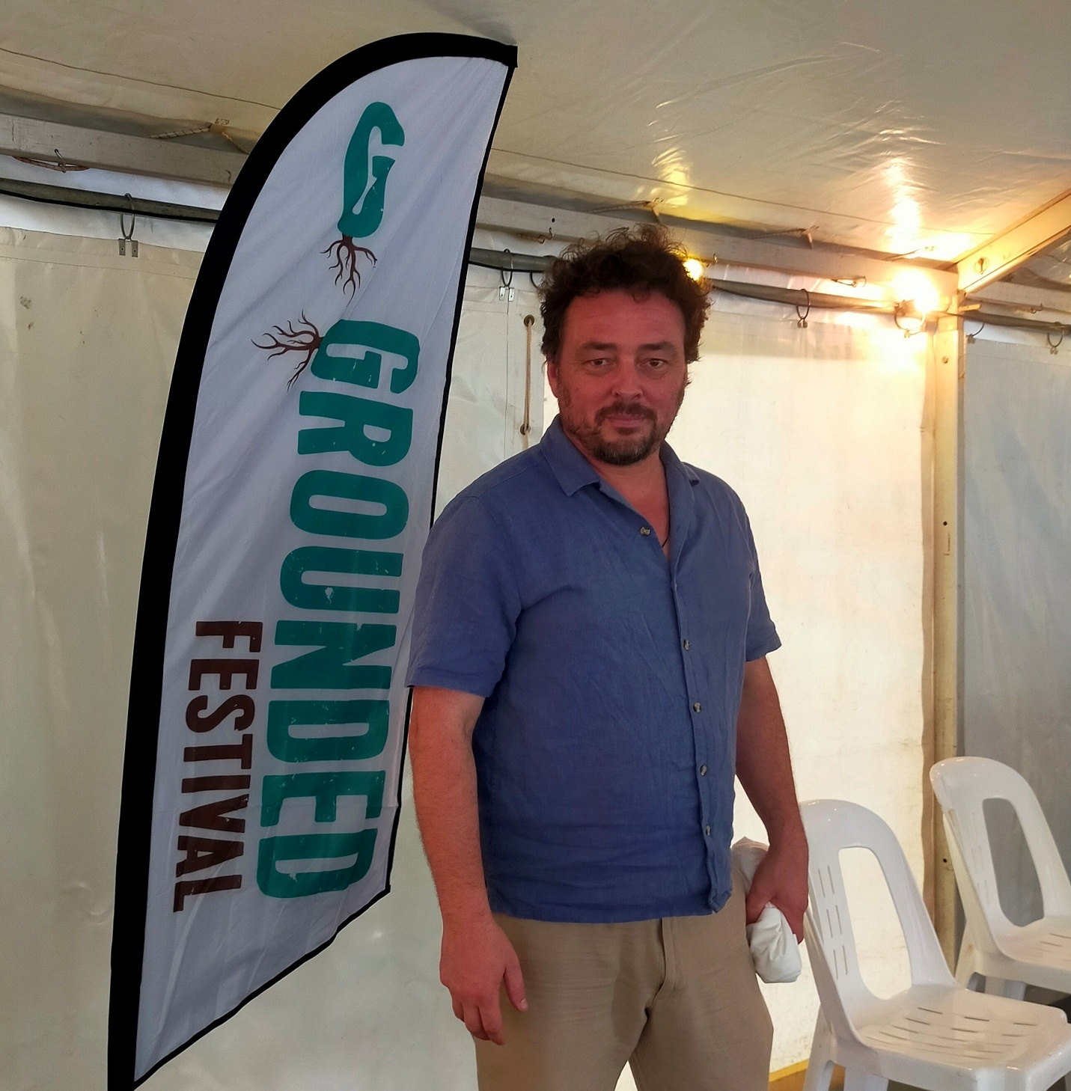
Listen via,
Sound Cloud: https://soundcloud.com/dbcommunityradio/dan-kittredge-bionutrient-food

Spotify: https://creators.spotify.com/pod/profile/radio-wa/episodes/Dan-Kittredge---Bionutrient-Food-Association---BCC---24-September-2025-e38kv11

Barry Green: Grace Potter. Love is love. On Business and Community Conversations sponsored by Harvest Highway.com.au . This week, I'm playing interviews with presenters at the Grounded Festival held in Bridgetown over the weekend. Next one's an interview I recorded with Dan Kettredge. Or. Kittredge is an American who's involved in the Bionutrient Food Association and measurement of micronutrients in food. I'll play that now. The Grounded Festival in Bridgetown in September 2025. One of the key speakers was Dan Kittredge, who's the founder of the BioNutrient Food Association. G'day.

Dan Kittredge: Dan, how are you today?

Barry Green: I'm well. So tell our listeners, what is the Bio Nutrient Food Association all about?

Dan Kittredge: Our mission is increasing quality in the food supply. And by quality we're talking about flavour, aroma, nutritional value which we think connects to soil health, human health, ecosystem function, farm viability, um, all kinds of wonderful things.

Barry Green: And you're developing ways to measure this. That's, I think, the critical thing.

Dan Kittredge: Well, we do many things. We certainly work with growers to help them understand how to work with nature, because effectively, that seems to be the most efficient way to operate. But, uh, yes, we have for the last number of years now been working, um, we coined this term nutrient density to refer to the variation in nutrient levels in food. And we've been working to build empirical frameworks around that. So define it in a 1 to 100 scale. If people maybe have, you know, had a tomato fresh out of the garden that was ripe and, you know, that flavor and had one that was, um, from the grocery store picked, picked raw. Um, you know, that flavor, um, there's a, you know, through your tongue that there's a dramatic nutrient variation in food and, um, that's the that's what we're talking about when we're talking about when we have used this term, nutrient density. So, um, being able to, You, um, measure that variation. Our proposal is we could develop a 1 to 100 scale that could test the that range of nutrient variation in food. Um, and presumably that could be, uh, measured with, um, effectively the camera on your phone. So instead of a certification label that says this is organic or this is not, um, this is regenerative or local or not, what we're saying is it's a continuum of 1 to 100 based on nutrition and through a science called spectroscopy. Um, the camera in your phone could be used literally flash a light at this, you know, bunch of carrots and get a reading 20 out of 100 flash a light at that bunch of carrots to get another reading. 80 out of 100. Um, that anybody, anywhere should be able to know how nutritious the option on the shelf is for them and their family before purchase. Um.

Barry Green: I think that'll be a game changer, because the food systems of the world pretty much have been driven by advertising. And, uh, we live in an analytical Ethical Society. We want to measure things, but we're not actually measuring the thing that matters most, which is the nutrition in the food.

Dan Kittredge: I would argue, yeah, that nutritional how our food affects our health, our children's health, our, you know, not just physical but psychological, emotional, maybe even spiritual, um, certainly ecological. Uh, there's direct connections between flavor of your food and and the health of the ecology. So, yeah, if we're looking at systems change and positive systems change, I think one of the most powerful vectors we have is the money we spend on the food that we eat.

Barry Green: And we live in a free market society, supposedly. And the the where that goes is determined where people choose to spend their money, but they've got to know what what's worth paying for. We've in Australia, we've got two supermarkets and one of them has a byline that's down, down on price. And it always strikes me as strange that we manage food on the basis of down, down on price, but we're subsidizing the Subsidising the sickness industry. So really, there's got to be huge economic benefits to the society as a whole. If we get back to valuing the nutrition in the food so that people's health can return.

Dan Kittredge: Absolutely, categorically. It may be detrimental to, um, vested economic interests that have to do with, what do we say, disease management. Um, and certainly, um, agrochemical. But, um, yeah, if you're talking about human health and soil and ecology health. Um, yeah, absolutely.

Barry Green: So we really we're in a very unstable time in history. But I guess out of chaos comes order. And I think what's happening in America with Robert Kennedy and the work he's doing with the Maha movement that has huge implications for the wider population. And Kennedy saying something like the American young people is only something like 30 or 40% are healthy enough to go in the military. So that's a pretty serious structural problem, isn't it? And if we can address that with change, nutrition, understanding of nutrition, which you are providing the the science to do. That's got to be huge for for civilization.

Dan Kittredge: Dan not that we should want any of our children to be in military, or that we should want war in the first place.

Barry Green: I think that's not the point I was making. I absolutely agree, but but it is a basic problem when people aren't healthy enough to go into services even.

Dan Kittredge: Or let's think about it, healthy enough to have healthy children, um, or healthy enough to have active lives. Um, yeah. No, I think we're, you know, this this thing called epigenetics, which effectively says, um, the environmental conditions have a powerful effect on your physiological function. And if you look at, you know, what our parents ate and what our grandparents ate and what our children are eating and and what our grandchildren might eat, what we're looking at is effectively dying out. Um, there's evolution and there's devolution. You know, if you're in harmony with nature, you you evolve and you flourish and you reproduce and you and you keep going. And if you're out of harmony with nature, you. You degrade and you fall apart. And you and you and you and your line stops. So that's where we're at. Um, yeah. I've been down in Washington, DC a few times in the past few months and, um, have been at meetings with players, you know, active leaders in the movement and, you know, people that are, you know, uh, yeah, very well connected talking to the white House, etc.. Um, and, uh, interestingly, from their analysis, the Maha movement is the most powerful political force in the US as far as grassroots energy of the people, of the populace. People don't care more about anything than the health of their children, because their children are so sick, and it's not because they want them to be in the military. It's because of their children and they're not well. And there's this grassroots, visceral urge drive. If you're a parent, you know what it feels like if your children aren't? Well, there's not much that's more important than that. And that is there's something going on in the hinterlands in America, which is, damn it.

Dan Kittredge: Whatever else, come hell or high water, this needs to get figured out. And I like to say, you know, we're about 5 or 10 years ahead of everybody else in the world and falling apart. Um, you know, we're the belly of the beast. We've been experimented on first. We're a little bit farther in the track of, you know, degradation on these kinds of things. Um, but, yeah, I think this is a this is a movement that is, um, at the heart of the things that are most important and is building and fermenting around the world. Um, and if that's what it takes for us to stand up and to, you know, be the people and find our autonomy and find our, our voice and stand for something that matters if it's the health of our children that can be a thing that we, the people globally, can coalesce around. I don't think that's a bad thing to start standing up and organizing around. So let it be peaceful. Let it be harmonious. Let it be open and collaborative. Let's use science. Let's use the scientific method as a lingua franca. Let's use our power as people that spend money every day to feed the beast, to feed the part of the beast that we want, and not the part that we don't. Every time you spend money on junk, not only are you polluting your children, but you're polluting the ecosystem, right? I mean, electric cars and and, you know, whatever, you know, what do they call them? Led light bulbs are all well and good. But if you think about it, if you you want to use your power well, choosing the best food for yourself and your family has extraordinarily positive implications.

Barry Green: So throughout history, the soil has always been the foundation of our civilizations and to use the term Aboriginal people use in Australia may be misused. It always has been, always will be. Now this is playing will play on tourist radio and community radio. And these I think both of these are part of the new what we might call regenerative media that's evolving. And the grand Festival in Bridgetown, um, is about regenerative agriculture and very much the mood of this event, and it's been fantastic, has been about collaboration from people of all walks of life and all colours. And in Australia we've got so much to learn from Aboriginal people. And the Aboriginal people say that country needs people. And the economic model that we've been operating under is largely depopulated regional Australia. But of course cities can't exist without economically and environmentally sustainable populations. And so are you seeing a move back to that in the US?

Dan Kittredge: Well, my parents did that, they left the city and were part of what was called the back to the land movement in the 1970s and 80s. I think it started in the 60s. Um, uh, you say here the Aborigines say, uh, country needs people. I say occupy the land. I think, um, we are, um, wage slaves in most cases. We're, um, spending our life force to earn money to be able to exist for to pay rent, to pay mortgage, to buy food, to buy electricity. You know, um, we're vulnerable. We're extremely vulnerable. Um, I think the end game here that we need to be looking at is not that food is more nutritious in the shop. The end game is that we have land tenure. We all have access to land where we can feel safe. We've got our homes, um, we there's no debt involved. There's we we have that that resiliency of of tenure, um, where we can raise our children and and let them not be colonized at the birth. At birth. Every beautiful, profound being that incarnates is able to have its indigenous nature supported and trained and and to practice all those muscles of multiple octaves of of perception. Um, we are beautiful, brilliant beings, all of us, of all skin colors and and genetic lineages. Um, it's just what happens to us that that perverts us. And we need to take responsibility for that, because certainly the government is not going to unless we actually engage the democratic process and build a people's movement and actually have the government represent our collective best interest.

Barry Green: Sure. You're right. I recorded a community radio documentary in 2018 with Charles Massey, who's been a doyen of regenerative agriculture in Australia, and he says that the change has got to come from the bottom up. It simply can't come from the top down, um, because the people at top have fought to get there and like it the way it is. But I've been so uplifted by the speakers at this conference and Lynn Abbott talking about the the web of fungi and things in the soil. And I think the internet's created a similar interconnected web among humanity at this time in history. So I share your your view that we need to be optimistic and optimism breeds optimism, while negativity breeds pessimism. So anybody listening to this are interested from the perspective of their love of their children and their grandchildren by nutrient food association. How do people find out more.

Dan Kittredge: Presuming on using the internet bio nutrient.org is the main website. Bio nutrient Institute.org is where we do all the work with the science and the definition products process. We've got a YouTube channel which has hundreds of hours of brilliant presentations from all of our conferences from ever. Forever. Um, certainly. Feel free to look up my name on YouTube. We've got tons of podcasts. Um. You can. I think Spotify is a thing. Um, but yeah, there's podcasts on the internet. Um, social, the Instagram and the and the Facebook and the LinkedIn. I mean, we're, we're we're present in all these sort of electronic platforms. And I go to their website, give us your email if you want to get on our newsletter and and hear about all the fun stuff we're doing. Um, yeah. We engage the electronic interface. Um, but, uh, you know, I think, you know, word of mouth is always amazing as well.

Barry Green: Well, I often use in my conversations, it all starts with the conversation, because everybody has a reason to believe what they believe, and it's only through conversation you can sort of distill that and and track a way forward. And you know, we've in Australia, the media, the commercial media is largely owned by the same corporations that own big food, Big pharma, and that's how they sell their products. So they're not talking about it. So it is happening in the independent media. This is really exciting. Dan, I've sort of those of us in the organic movement. For many years, we've sort of tended to be treated as the loony left and not scientific, but you're actually putting the science into what we've always, I guess, intuitively believed.

Dan Kittredge: Yeah. Well, I think the scientific method is a really, really beautiful thing. Um, and it doesn't belong to people with PhDs. Um, it's been around since long before PhDs were ever invented. Um, and it's a way for us to have a lingua franca. Um, that's beyond our personal opinion. We can find a, you know, a relative truth. And so, um, when it's when it seems to be the case that the Western rational, empirical scientific method correlates with our noses and our tongues and our other deeper modes of perception. You know, we can say it looks like we're on to something here. So, um, if if the way we can be seen in the system is by playing by those rules of doing lab work and looking at microbiome and biochemistry and, and statistics and published papers and journals. Great. But let's, you know, um, have at the center of our intention, uh, humility and, um, a desire to be as much as possible in harmony with nature, love God, call it what you will. That deep and profound thing which seems to be at the center of everything.

Barry Green: And I guess that's the essence of what humanity is about.

Dan Kittredge: Yeah. This quest for enlightenment.

Barry Green: Very good. Dan, thanks for your time.

Dan Kittredge: My absolute pleasure. Thank you.

Barry Green: That was Dan Kittredge, who was a speaker at the Grand Festival in Bridgetown over the weekend, and he is talking to the Maha movement in America that's Make America Healthy Again movement.

Sponsor Message: You're listening to DBCR, and we're proudly supported by Donnybrook Writers Group, Russo Produce, S and D Nelson Automotive, Donnybrook Medical Practice, and Donnybrook Recreation Center. DBCR your community station.

