Dr Brian Walker MLC - Business & Community Round - Up - 27 August 2025
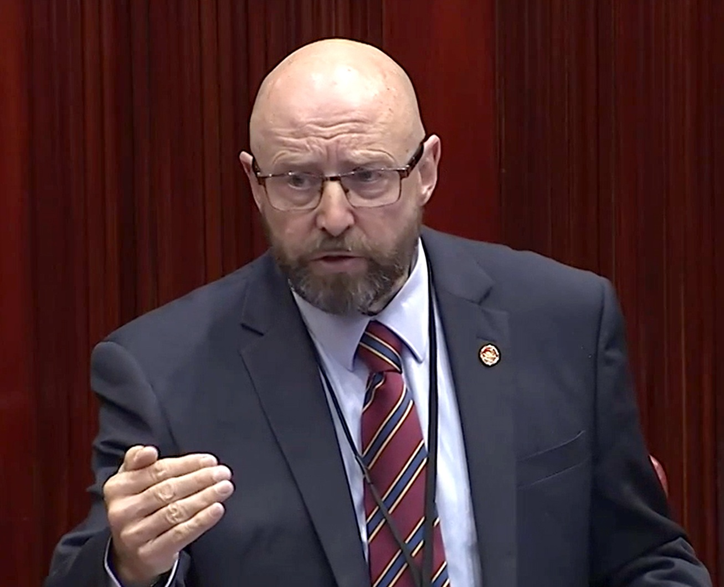

Sound Cloud : https://soundcloud.com/dbcommunityradio/dr-brian-walker-mlc-business

Spotify: https://creators.spotify.com/pod/profile/radio-wa/episodes/Dr-Brian-Walker-MLC---Business--Community-Round---Up---27-August-2025-e37cljt

Barry Green: Dr Hook can better love. Next time it's 11:06 on Donnybrook, Balingup Community Radio on Barry Green and my next guest is Doctor Brian Walker MLC. G'day, Brian.

Dr Brian Walker MLC: Hey, how are you?

Barry Green: I'm well. So in the last Parliament, I spoke to all of the almost all of the southwest MLCs and members of the Legislative Council who have paid the big bucks to represent our interests. And we no longer have regional representation in the MLC. So in the coming weeks and months, I intend to invite all MLCs to come onto this program to tell us a bit about themselves and what they believe, and give an open mic for our elected representatives to talk about what they think are important. So, Doctor Brian Walker, MLC, the mic is open. What would you like to tell your your electorate?

Dr Brian Walker MLC: Oh, there's so many things I could speak about. But you know, I'm a fundamentalist. Well, first of all I'm a doctor, a GP and one of my main issues is that we're dealing with sorts of minor problems with your health. The underlying reasons are not being addressed. And so we get far more bang for our buck. If we dealt with the underlying problems, rather than putting a plaster on the the symptoms we're getting. I'm the same in politics. One of the problems I see in the politics I could give you problem after problem or indeed solution after solution, but the underlying problem we're facing is we're stuck in the past. We've got a status quo system which doesn't allow us to think new ideas. It's like, yes, Minister or yes, Prime Minister. That great show is actually really, really very true. We make no progress because it's safer to stay stuck in the past. We've done it before. We'll keep on doing it. And this is this is killing us. It literally is killing us. And so this is what I want people to realize. If you want more of the old, keep voting the same way. If you want differences. Stop voting for the old parties. They're making it worse.

Barry Green: Very interesting. Brian. My training was as a radio technician. My training very much was that to fix a problem, you've got to address the cause. And on this program last week, I spoke with with Professor Ian Brighthope from the World of Wellness. And, you know, he came in agriculture. He came into medicine from agriculture. And so it's a completely different mindset.

Dr Brian Walker MLC: Oh, well it depends. Actually the innovative agriculture approach is really interesting. But how do we actually regenerate our land rather than doing very good scientific techniques which deplete the land? The farming community is actually one of the most scientific, I think, in the world, the Western Australian farming community. But if we're looking at regenerative agriculture and permaculture, we can do so much more. But I really admire what they're doing. And in medicine we've got to be exactly the same. And in politics too, we need to think outside the box to get a new answer, because thinking inside the box gives us old answers. And when we look the last 30 years. Are we only better off? Are we? Are we? Are we better off financially or be better off socially? I say we're not the legislation. We've got lots of laws to put through Parliament. Has they actually helped you and me? And I think probably on balance, not. So should we make a change? Yeah we should.

Barry Green: It's interesting. We're having this conversation on community radio. And you know, I think we I've said it a few times, I sort of think that maybe the business model of the media is, is a problem too, because if you look at it, the mainstream media, it's largely funded by advertising from big food, big, big ag, big banks, big media, big, big gambling, big pharma. So they sort of lost their capacity to question anything because they don't want to upset their advertisers and community radio. Um, you know, we we have sponsors, local business sponsors, and I like to think we're becoming the, the voice of community and small business.

Dr Brian Walker MLC: You've hit the nail on the head. We've basically got, well, you think we've got the democracy and we have not. Look, our laws basically have been bought for by the vested interests of the multi transnational companies like the Environmental Protection Agency has been systematically defanged. The last time we put that through an amendment to the Environmental Protection Act, it was widely consulted upon, widely consulted upon. And I checked again and again. Who did you widely consult with? Well, it turns out the only people they widely consulted with were the people who are digging the holes in the ground. The industrialists. Not one single advice came from the environmentalists. So you look at why we've lost 70% of our vegetation in Western Australia. I asked the parliamentary secretary why he had no idea. He didn't want to enter that discussion. We're going to actually take further protections away from the people. And I've got no idea why we're losing our flora and fauna. The whole thing is just crazy. The same is true of every aspect of Parliament education. Another case in point. Are we serving our children by doing that? And we've really got to get away from the idea of the 19th century education.

Dr Brian Walker MLC: Teach people how to be mill workers and then the rich people get richer and the poor children are sent to a factory to actually work their fingers to the bone. The same thing is true now, as you can look at the people who are working double jobs and trying harder to own their home. They're not making any progress. Work hard. Do they say you too can become rich? I don't think it's working. And the tax industry, I mean, the amount of money that we give to the tax, not just in our annual returns, but also the government's sales tax that was only there for the Olympic Games, was it not? Why are we paying things like capital gains tax? Why are we paying things like stamp duty when you're buying a home or anything else? Why is the government taking money for us left, right and center? What's it doing with it? And the answer is that actually wasting about 30% of our tax money because they don't care. It's not their money. So we've got a major problem. We've got to fix this. We the people have to fix it, not the politicians.

Barry Green: Yeah. In regen ag, Charlie Massy who Charlie Mathews brought to West Australia in 2018 by Alannah MacTiernan, who was the agriculture minister at the time, and in a talk he did with introduced by Alannah, he said that change has got to come from the bottom up. It simply can't come from the top down. And you talked about region ag. Last week I interviewed Eli Court, who's the CEO of Soils for Life organisation, and I found it a most uplifting conversation because what's happening in the region ag space is that and it's being driven in America by people like Joel Salatin and Gabe Brown and and the whole Make America Healthy Again movement, because, you know, you need healthy food off of healthy soils to create healthy people. And and Eli Court said he's never been so optimistic in his life because what's happening? The internet's providing this mechanism for innovative farmers to work with independent scientists and and get much better outcomes with with less inputs.

Dr Brian Walker MLC: Oh, yes. Well, the internet can be a major problem misleading us. But on the other hand, it's got a source of information that we can make use of. The question is, are we actually being supported by the governmental institutions and we're not. Look. From the bottom up, it's got to happen. Not from the top down. The people at the very top, the ones who are the billionaires, the ones who are multi-millionaires. Do they want a change? They do not, because they're serving them pretty well. Those of us who are actually struggling to put food on the table for our children, we're the ones working hard and wondering, how can I make a buck on this when the system is so stacked against me? So we have to make fundamental changes, and the ones at the top, the ones with the power, are not wanting to help us on that. They just why why would they want to? They're making plenty and they want to make more. So it's like if we get technical, this is actually the neoliberal philosophy which has actually been guiding us not just since 1930s but since 1970s, when the gold standard changed. And then we could actually get big companies buying Politicians and then buying the legislation. That's when things started really to go downhill. Productivity is increasing now. Look at what's happened to our wages is plateauing. So we're working harder at producing more and earning relatively less. We have to fix this. We can't we can't carry on. Agriculture is a case in point. If we're actually going to make significant changes, why don't we do things differently? Um, you know, my my original party is Legalized Cannabis Party, and I'm looking at industrial hemp, which can transform our soils looking you could use industrial hemp and create stuff to send into space. It's stronger than steel. The ADF is using hemp and carbon fibre to make bullet and bomb proof protection for their motor vehicles. Fantastic. And it's like we can make ships out of the stealth planes. It's not just making clothes and pet bedding. It's a whole host of things that you could do with their hemp. But for agriculture, you're turning the topsoil from a few centimeters of topsoil into 90cm of very good microbiome, which you could actually sell, and we could double the yield, for example, of of wheat or whatever you're cropping. And it will be transformative. Not just that, but the water supplies would be enhanced if you planted it near the lakes and the streams, and it also would influence our microclimate with getting better rainfall and more predictable rainfall. If you plant in large numbers, there's a wonderful solution. Look, even the griffin coal. If you transform that by planting hemp to transform the soil, you could restore it within 20 years to something that's reasonably usable.

Barry Green: It's exciting, exciting science that's coming out here. You're talking about Brian. And I think what you're talking about really interesting. And Henry, Henry Ford with a car out of hemp in the 1840s, 1940s. So it's all been done before. We can talk about it on community media, but we do have to pay our bills. So I'll just run a sponsor message of two and we'll come back and continue the conversation.

Dr Brian Walker MLC: Cool.

Sponsor Message : Get yourself into the garden.

Sponsor Message : Mamba organics has put my bee on the map. Did you know my organics is.

Sponsor Message : An agent for CSB? They can help you with all your bulk requirements, bulk.

Speaker1: Bags.

Speaker5: And custom blends, plus firewood to keep you warm this winter to arrange delivery. Email sales at Mumble Up Organics.

Speaker1: Organics. We've got great big bags of it.

Speaker5: Station sponsor Mumble Up organics.

Barry Green: The Donnybrook Men's Shed is located at Egan Park and consists of two sheds fitted with machinery and various types of woodworking equipment. The shed's opening hours are 8 a.m. to 12 p.m. on Tuesdays and Fridays. The daily routine consists of a variety of personal projects, plus some fundraising projects to assist in the day to day running costs of the shed. The men's Shed also received requests from local community to build or repair certain items and assist not for profit organizations. So if you're retired or need some new direction in your life, plus some companionship and a company of like minded people, the Men's Shed is a place for you. Contact the President Jeff Box at the site for further information.

Sponsor Message : You're listening to Donnybrook Bailing up Community Radio. This station thanks the following sponsors. Gj freight, TG and C.H. contracting, the Green Man Cafe and Bulk Foods in bailing up Hasty Waste and DNS, carpentry and maintenance. DBCR your community radio.

Barry Green: Basement birds and skin of the sky on Donnybrook Balingup community radio business and community. Round up. My guest this morning is Doctor Brian Walker MLC, and Brian was one of only two state MPs who have opposed the Covid injection mandate. Uh, Brian did get the Covid injection himself, So he's not an anti-vaxxer. But what was your experience with that, Brian?

Dr Brian Walker MLC: Well, it gave me myocarditis and pericarditis. It took me a couple of years to recover from that.

Barry Green: Right. And you did stand up in Parliament and say that. Did that get reported much in the mainstream media?

Dr Brian Walker MLC: It didn't. Not. Not a single word. I give a lecture about the mRNA vaccine. Now I've got nothing against mRNA. Just I don't like being the guinea pig for it. There's an mRNA vaccine coming out for for a form of lung cancer, I think. And this is a fascinating technology, but you don't experiment with people on that and you don't force people into mandates on an experimental vaccine. It's just it's caused harm. I mean, our colleagues who were opposed to it as good medical practitioners, as indeed I hope I am. And they presented to the New South Wales Select Committee examining the unexplained increase in mortality. And they presented 100 papers thereabouts in printed form to the Committee for the submission. And do you know what happened? They rejected the submission of 100 peer reviewed scientific papers proving that there is an increase in mortality, possibly due to the Covid vaccine. So at the moment, all we have is the news telling us they're not safe. As simple as no, no troubles at all.

Barry Green: Yeah. So the Covid injection was approved under the emergency use. Legislation, if you can call it that. But my understanding that this emergency use classification was only introduced in something like 2018 to the allow the use of trial injections on people in terminal conditions. I don't think it was ever intended to, to be used for, for a mass vaccination.

Dr Brian Walker MLC: Oh, but you know, politicians give them an inch, they take a mile. Look, the GST is an example of that. But still paying GST from something from 25 years ago. Um, look, the 2018, 2016, it was debated actually. The health act still allows a police officer at the command of the police commissioner to have you stripped naked and injected against you with a substance. But even saying what that substance is now, they say we'll never make use of that. But in that case, why is it in the statute book? They've given the permission for it to happen. Look, we've got another one coming up here. The post and post bill, which basically would allow them in its current format to they'll have you thrown into prison for a post you made five years ago. If you put out a video online, on a social media of a protest you attended. So then attack on the freedoms of speech, which is actually people are thinking. Yeah. Let me explain this to the advisers who are giving us the briefing on this. You see, their faces fell as they realised what the implications might be. At the moment it's fairly benign. You know, if you're doing bad things and you push it and say, look how good I am. You know, you ought to be punished for that. Yeah, but if we're no longer allowed to safely stand up for what we think is right, then we have a problem that our free speeches are being curtailed.

Barry Green: So my father fought in the Second World War. He crossed the English Channel on D-Day plus one. He was shot and left for dead in Belgium in, I think, October 1944. He was fighting a regime that controlled the narrative, and if we're not careful, we'll find ourselves in the same situation.

Dr Brian Walker MLC: Well, they already do control their narrative. I mean, look, I've been for years already in Parliament, and I've got a very, very broad range of activity. Look, I'm a I'm a medical practitioner. I've got a real interest in wellness, physical, mental, social and financial wellness. And what does the press report about me, if at all? Or is a weed smoking doctor? I haven't smoked a joint in my life, nor will I ever. I simply support medical cannabis and indeed cannabis. The right to use cannabis whichever way you want, as long as you hurt no one else. You could call me a libertarian, but I'm actually a group of free speech free people in a free country. And all of a sudden now we're finding, actually, we're not free people, we're not in a free country. And no one actually is really aware of this. We ought to stand up and demand that we've become. We're allowed to be free. But what's the point of it? You can't, you know, you have to label the coffee as being hot before you take it, in case you burn yourself. I mean, what are we, animals? Idiots.

Barry Green: Hmm. Well, that's a good question, Brian. But, you know, the whole my understanding of a democracy is based on the ability to debate. And if you can't debate, you don't have a democracy.

Dr Brian Walker MLC: Interesting. There's a lovely book out there, The Mechanics of Change in the World of John MacGregor, a lovely author and correspondent from New South Wales. And what he's putting out there is that democracy isn't really quite democracy. We've never really had democracy. The Athenian democracy, that was just a very short lived one. But there was a democratic approach all those thousands of years ago, 200 years ago, we began to get a different type of democracy, which is what we understand now, but we've outgrown that. The way democracy is practiced. Now, you know, it's been co-opted into vested interests and big money. We don't really have that democracy. We're looking for a third way of a new Democracy to come in, to allow the people to have a voice for the people to be represented, not the vested interests. So this is a very this is what I'm going actually, my my current trajectory in Parliament is to actually promote the idea of a free people choosing a new third wave of democracy, and has any mention come out? Have you heard anything about this in the press? Not a word.

Barry Green: You've heard about it on Donnybrook Balingup community radio.

Dr Brian Walker MLC: And bless you for that.

Barry Green: And but I think, you know, the interesting thing is we're having this conversation live on community radio. We'll post it online later today. Uh, we'll we'll post it online. You can share it. We share it. And I I'm increasingly optimistic because you've got to have optimism. And I'm increasingly optimistic that the internet has democratized the media, because in the previous life I was a tech at GWN and television. And, you know, what's happened, especially in the region, is the media has been bought by the corporations and essentially shut down. But community radio across Australia is providing a local voice and and I think, you know, this is a return to democracy.

Dr Brian Walker MLC: Yes. We need a local voice. I mean, it's a living. I used to live in Kununoppin, which was, you know, a great medical practice at their hospital for clinics, wonderful people and a very different society to the mass of people in the cities where people can, you know, they'll tell you their point of view. No trouble at all. So, well, as a doctor there, if they wanted to make me aware of something, there was no way I was not going to be aware of it. It's very different, I think, when we're controlled and it's increasingly the case that we're not allowed to say what you want. For example, did you know that we doctors are no longer allowed to give you the scientific truth? We've got to tell you what the government says, to tell you not what the science says. And if we don't do that, we're at risk of losing our licences. I've got good colleagues who have lost the licences because they stood up for truth. And this is this is unacceptable. The same is also true if you raise your voice, for example, the whistleblowers, what happens to them? They get put in prison or they get they get sued. In our defence defence industry. When things happen because of law, what happens there? What protections do you have? So people are code into silence, cowed into obedience. And with the Covid vaccine cowed into compliance, we've got to obey. Otherwise, the government will get us. This is intolerable. It's the reason why people are protesting the sovereign citizens. I think they're very wrong, but I can see why they're there. I understand that because they're angry at having their freedoms curtailed. They're angry at being lied to by government. I want to be a free person in a free country. And that's the path of chosen and the police. Two policemen have been killed by someone like that over East. Tragic. But this is what happens when people find themselves cornered. And that be like, like a like a cornered animal with the forces of government arrayed against them. It's not a good place to be.

Barry Green: Very interesting. Brian. Well, thanks for finding the time to talk to us today. Um, as I said, I'm going to invite all MLCs from all parties on this program in coming weeks and months to, you know, tell us about who they are and what they believe in. And you've. I think people know what you believe in now. And and I appreciate that.

Dr Brian Walker MLC: I hope it happens to many people. But on the other hand, do I care? It's the way I feel, the truth I see.

Barry Green: Very good. Brian, thanks for that.

Dr Brian Walker MLC: Pleasure. Take care.

Barry Green: I've been talking to Doctor Brian Walker, MLC on Donnybrook, Balingup community Radio.

Sponsor Message : Donnybrook Balingup Community Radio is now a registered charity, which means that you can make tax deductible donations to your community radio station. Contributions will go towards much needed upgrading of equipment and improvements to programming that will ensure DBCR has an exciting and sustainable future that our community can be proud of. For details on how to donate contact info@DBCR.com.au We are on your wavelength.

Text on post :

A conversation with Hon Dr Brian Walker MLC, Leader of the Legalise Cannabis WA Party.

Brian Follett Walker is an Australian politician and medical practitioner with over 40 years of experience, spanning many continents and cultures. His passion is making this world a better place for our children and grandchildren.

Born in Malaysia to Scottish parents, he received his education at Scotch College in Perth before earning his medical degree at the University of Dundee, Scotland. Brian’s medical career has seen him practice across the globe—from the cutting-edge hospitals of Germany, the Soviet Union, the UK, and Hong Kong, to his eventual return home to Western Australia in 2008, where he established a specialist GP practice in the Perth Hills.

Since being elected in 2021 as leader of the Legalise Cannabis WA Party, Dr Walker has been a strong voice for reform, challenging outdated laws and advocating for modern, science-backed policies. With his deep understanding of medicine and health, he brings a fresh, holistic perspective to the political arena, focusing on improving the medical, mental, social, and economic wellbeing of all Australians.

⁠ www.brianwalkermlc.com.au ⁠
⁠ https://www.youtube.com/@brianwalkermlc ⁠
⁠ https://www.linkedin.com/in/brianwalkermlc ⁠
⁠ https://www.facebook.com/BrianWalkerMLC ⁠
⁠ https://twitter.com/BrianWalkerMLC

