Dr John Campbell - Florida funds ivermectin cancer research - BCC - 19 Nov 2025
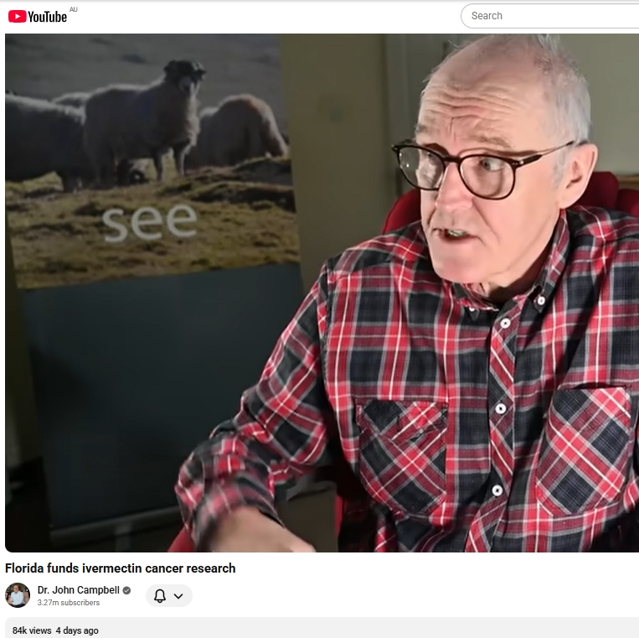
Listen online : https://creators.spotify.com/pod/profile/radio-wa/episodes/Dr-John-Campbell---Florida-funds-ivermectin-cancer-research-e3b63mp

Barry Green: O C Smith and watching Scotty grow on DB's business and community conversations. Living in an interesting time in history and the state of Florida has allocated, I believe, $140 million to investigate the possible use of ivermectin and other out of patent drugs in cancer research. So this has huge implications, I guess, to many people. Doctor John Campbell is a UK nurse by profession, but he's been a medical educator for many years. He has a YouTube channel, which I've been watching for a long time. He's never only once, I think, been pinged by YouTube through the the censorship period. Uh, but he's always been very careful to only play use government data. So I'll play just a few minutes of this piece that he's done on the government in Florida looking at research into treatment of cancer.

Dr John Campbell: Well, well, welcome to this talk. Now, I did mention the last video that Florida is going to be funding research into ivermectin and other repurposed drugs. So I've just put something briefly together on this. It shouldn't take too long. But for example, here's a the Florida Phoenix ivermectin from the capital to state funded cancer research. It's a thing in Florida. And then there's releases from the Ron DeSantis administration. And there's releases from Florida Health as well, and various other references that I've put in that you can peruse at your leisure. Now, at the moment in the United States, as far as I can tell, Tennessee, Arkansas, Louisiana, Idaho and Texas in all of those states. And please, if you live in those states and I'm wrong, do correct me. I believe that you can buy ivermectin over the counter in those states. Now, as far as I'm aware, fenbendazole is not authorized for human use anywhere in the States, but mebendazole and Albendazol are. And Florida looks like it's soon going to be joining Tennessee. Arkansas. Louisiana, Idaho, Texas in buying over the counter ivermectin. So Florida's launched something called the Florida Cancer Innovation Fund. And it's got new priority categories for research.

Dr John Campbell: And, uh, these make a lot of sense. This year introduces dedicated funding categories for nutrition based cancer prevention research and generic drug repurposing. For example, ivermectin, reflecting Florida's leadership in comprehensive cancer prevention and accessible treatment innovation. So this is cancer research in Florida and it's going to be quite well funded. The funding so far I think, is up to $140 million in total talking about novel treatments. And this should be getting done everywhere. Florida, as far as I know, is the only administration in the world that's taking up this challenge of research. Novel treatments. Development and testing of novel cancer treatments. Cost effective generic drugs and supportive holistic therapies that can show measurable patient impact within the grant period, which is one year. And looking at your feedback. Um, that won't be difficult to do at all. Some of you have had amazing benefits with these alternative treatments in a very short period of time. And um, ivermectin, for example, is known to be a remarkably safe drug, as is mebendazole. Uh projects must demonstrate immediate clinical applicability and potential for broader adoption. Now what Florida finds out, of course, the rest of us will be looking at with some interest.

Barry Green: Doctor John Campbell was talking about, um, you know, there's a lot of information on the internet. We do have to be careful what information we take, but I've been following Doctor Campbell from the beginning. He only ever quotes government data. And in this particular, um, piece. There's links in his content. So I and I will, when I post this online, include a link to Doctor John Campbell's channel. Uh, have a look for it yourself and make up your own mind. I guess, uh, if, uh, the government in Florida comes up with this research, maybe if the market fails, free market fails, there is a place for government to get involved in this sort of research. And of course, if they do find satisfactory outcomes, that has huge implications to to everybody. Science is about questioning things and putting up a proposition and exploring it. And if it if it, uh, is sustained, that's good. If it's not, well we'll know. So probably within a year we'll know whether the, uh, the tests in, in Florida have been successful. So that could be a really good news story for many people. That's all I've got for today. Thanks for joining me on business and community conversations sponsored by Harvest Highway Commerce. I'm Barry Green, and I'll be back at 10:00 next Wednesday.

