Dr John Campbell - UK Government data refusal - BCC - 17 Dec 2025
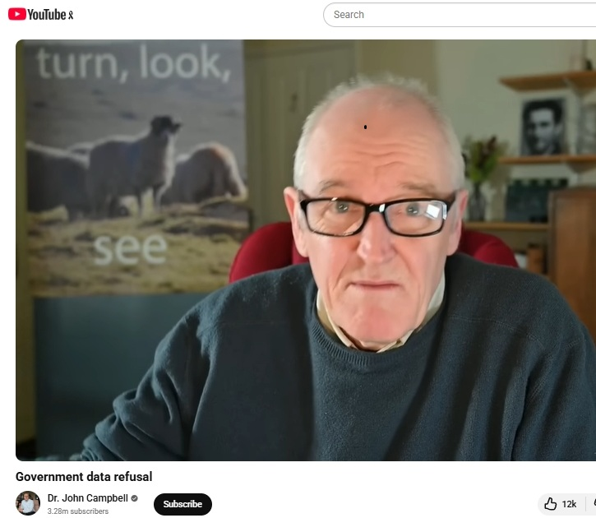

Listen Online:

Sound Cloud: https://soundcloud.com/dbcommunityradio/dr-john-campbell-uk-government

Spotify: https://creators.spotify.com/pod/profile/radio-wa/episodes/Dr-John-Campbell---UK-Government-data-refusal---BCC---17-Dec-2025-e3cflhd

Barry Green: That's James Bay and "Hold Back the River" on Donnybrook-Balingup Community Radio. For the last four years, I've been questioning the narrative around the management of Covid, and there's a lot hasn't been talked about in the mainstream media, but in the UK, it's starting to talk about and questioning some things. Doctor John Campbell is a UK health educator who, is not an anti-vaxxer. He took three of the Covid injections before starting to question it. He's had some high quality interviews, and he's been very careful to only operate and present government data. So he hasn't been shut down. Now, I know some people don't want to hear about this anymore, saying COVID's behind us. But for those of us who've lost loved ones and, and have been injured by the Covid injections, this isn't necessarily over. And I think it's really important that, government release relevant data. John's got a video. He's titled Government Data Refusal. I'll play just two minutes of this. So that you can understand what this is about.

Dr John Campbell: Very warm welcome to this talk. Now, the British government is still withholding data on vaccine deaths, and I'm going to be given the evidence for that now. I have had thousands. I don't want to exaggerate. Yeah, I'm sure it's thousands. Certainly many, many hundreds of emails from viewers, from messages saying that my loved one, my relative, my mother, my father, my son, my daughter got sick after receiving the Covid vaccines and some of them became no longer with us after receiving the Covid vaccine. Sorry about having to jump around YouTube requirements. They became no longer alive after after the vaccine. We need to know the truth on this. We don't want to know the blood scandal that takes 20 or 30 years to come up. Now there is some interesting signs of encouragement. This is from the Daily Telegraph. Government withholds data that may link Covid jabs to excess deaths. That's the link there. Unfortunately, it is paywalled. But that is the article there. Um, this is one of the more reputable newspapers in the United Kingdom. It's the one I tend to read most days. And if this is what they're saying, then we have to listen to it. Public health watchdog has been accused of cover up, refusing to publish data that could link Covid vaccines with excess deaths. And who are they talking about? The public health watchdog. Well, I assume they're talking about the UK Health Security Agency. In fact, I'm pretty sure they are. They argued that release of data would lead to distress of bereaved relatives if the link was discovered. So the reason we're not telling you why your mum died is because it might upset you. That appears to be what they're saying. More information in a minute. Um, risked managing the, uh, wellbeing and mental health of bereaved. So, um. Yeah. We're not. We're not telling you why your loved one died. Because it might affect your mental health. And aren't we a kind state looking after you? So your mental health is preserved.

Barry Green: That’s Dr John Campbell. And when I post this online, I'll include a link in the in the text. I'll include a link to the full interview. Um, I think that might ring a ring, a call with a lot of people. Doctor Campbell's also got another piece. It's called vaccine bias exposed Deaths misclassified, which is, information that's come out of, Italy, researchers have got access to government data and draws a different conclusion to what we might have been led to believe. So let's have a listen to that.

Dr John Campbell: Doctor Panagis Polykretis. Uh, doctor, thank you for for coming on.

Dr. Panagis Polykretis: Thank you. John, it is a great honour for me to be here.

Dr John Campbell: Now, you've got another paper we want to study today. Now, there's a bit of a sly trick going on here. A statistical trick. Technically, it's called the case counting window bias, but this bias is presumably affecting most of the publications around the world that seek to analyse vaccine effectiveness. What is this case? Counting bias and why is it a bit of a sly trick?

Dr. Panagis Polykretis: This effect we have to acknowledge that it has been predicted by Professor Martin Neil and Professor Norman Fenton in late 2021, and they even have a publication in pre-print from January 2022 that I bet that they are trying to to publish in peer reviewed literature. This effect basically creates a misclassification, uh, because, uh, it is based on the, on on the notion that someone has not built up a proper immunity against the virus for a period of time roughly of two weeks, 14 days after vaccination. In some countries, it changed. For example, in England I think it was like 21 days. This this period from 14 to 21 days. In Italy where this study was performed, the period of time was of 14 days. So basically in the in the first 14 days, in this time window, all the vaccinated people were, um, considered unvaccinated. And this created an effect that all the adverse reactions that they had. But even the infections and hospitalizations were moved to the group of unvaccinated. And this created an artificial increase in the death rate and the infection rate, the hospitalization rate of the unvaccinated individuals.

Dr John Campbell: So basically, because they weren't counted, if someone was vaccinated, they were counted as unvaccinated for at least two weeks, sometimes three weeks. That means if they died of the side effect of the vaccine, say, one week after the vaccine, that would be counted as a death in the unvaccinated group.

Dr. Panagis Polykretis: Exactly. Yes.

Dr John Campbell: That makes the unvaccinated look at much higher risk. It makes the death rate in the unvaccinated look higher, and the death rate in the vaccinated group look lower. So it's making the vaccines look effective, and it's making the vaccines look safe, when in actual fact, both of those are incorrect.

Dr. Panagis Polykretis: Exactly, yes.

Barry Green: So that was just a part of Doctor John Campbell interview said I'll include a link to the full interviews in the associated text, and we need to get to the bottom of this. And in a democracy, we need to have free discussion. Otherwise, what's the point?

Sponsor Message: DBCR. Thanks to the generous support of the following sponsors Southwest Electrical and Communications, Chris Cain, Summit Realty, southwest, the Lair of the Phoenix, Balingup, and your community Bank Donnybrook.

