Editorial - Donnybrook Fluoride water and Left - Right Politics - BCC - 26 Nov 2025
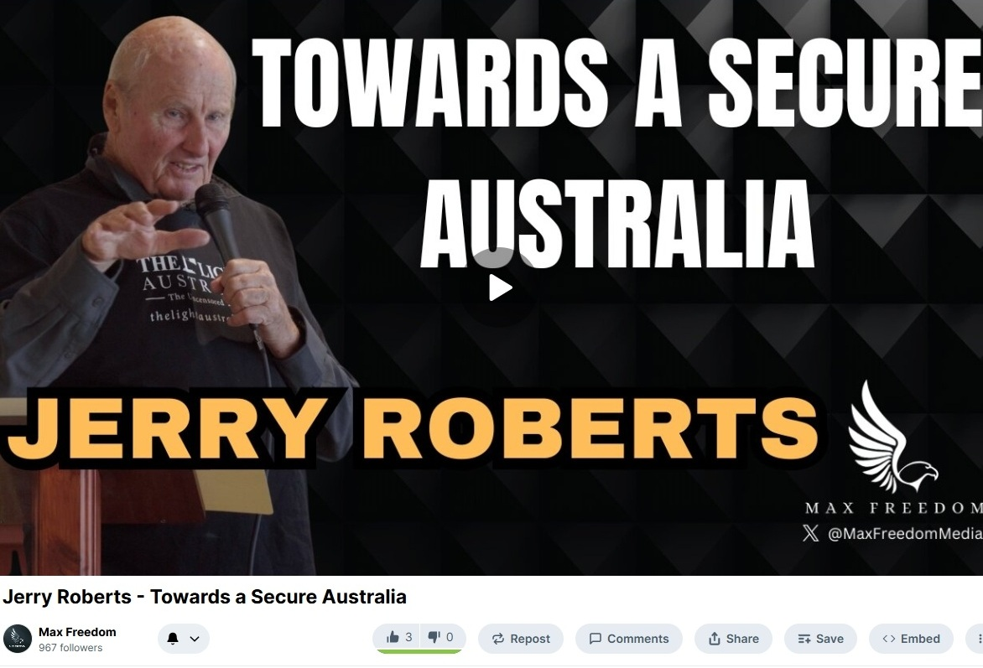

Barry Green: That's Good Neighbours and “Ripple" on Donnybrook-Balingup community radio business and community conversations. The next piece is, I guess you'd say, editorial, something I've been thinking about which might be wrong. Might be right. Well, who say? But last week on the Donnybrook Community page, I shared a post about fluoridation of the Donnybrook Water and how it's being taken out of the water in some cities in the United States generated a bit of conversation online, which is a good thing. Mostly it was positive that, but there was some comments there from a fellow by the name of an entity by the name of Mick Todd. Now, I don't know who he is. I don't think he's local. I think this Mick Todd online might actually be a paid troll if you look at the things, if you have a look at this person or this entity online, I don't think there's any connection to Donnybrook. And the things he's saying, I suspect are being funded by organisations Organizations who are concerned about what Robert Kennedy is doing in America. Um, it's, uh, I'd be interested to know your thoughts on that. Uh, the, uh, when I post this online, I'll include a link to the post and just have a look if you have a look at, uh, the, the the comments of the people who've made comments. But if Mick, Mick, Todd is listening, if he's actually a real person in Donnybrook, I'd be really keen to have him come and explain his his position on things that he talked about.

Barry Green: The general comment was that people feel that they should have the right to choose, uh, whether they drink fluoridated water or not. Um, and it's, uh, mysterious that we don't have that option. We are living in a very interesting time. Uh, Jerry Roberts is a journalist of the old school from the days when journalists used to question things. And Jerry was involved in the formation of the Light Australian newspaper, and he spoke at, uh, At tarpaulins restaurant in Perth recently about the freedom movement, and he talked about the the left wing and the right wing. And we hear lots about left wing and right wing. Uh, and maybe we've sort of lost track of just what that's about. Uh, Jerry's talk was quite colorful. It was an hour. I've just taken seven minutes of it, which I think is thought provoking. And as I discussed with Stuart Halusz history is important and we need to understand where we've come from and just what what this left wing white thing, right wing thing is all about. So I'll just play a segment of, uh, Jerry Roberts talk to at, uh, Topolinis restaurant a few weeks ago, and it's online on the Max Freedom Rumble account.

Jerry Roberts: The first minister I worked for in the state government was Andrew Mensaros, who was a Liberal member for Floreat. Highly educated, highly intelligent Hungarian refugee who escaped from Hungary as the Soviet tanks were rolling into Budapest in 1956 and. And yoga teacher brilliant yoga teacher was 15 and when she escaped same time, they got through the forest, across the river and into Vienna in the clothes they were wearing, and they were glad to get to Australia. I went up one day to speak to the minister. He was our Minister for Industrial Development, Mines and Fuel and Energy in 1976 77, when I first worked for the Department of Industrial Development, and I went up to see him one day, for some reason or other, he was looking at a map of Western Australia on his desk, and he looked up and said, Gerry, he still had that Hungarian accent. You know, the nationals are only a wheat belt party. They've never been outside the wheat belt. And I said, yeah, I suppose you're right. He usually was the member of Parliament who broke that mould for the National Party was Brendon Grylls, who won the seat of Pilbara. I'll come back to Brendon first. I'm going to clarify the meaning of three words that are badly misused and misunderstood in politics today. Those three words are left, right and Commonwealth. Before I do that, I'll just remind you why we're here.

Jerry Roberts: We are the freedom movement, as Tim has reminded us. And we only have one goal, which is freedom, because we can't do anything without freedom. And the best explanation of this I've heard for a while, I've seen for a while was by a professor in Glasgow, and I've quoted him in the penultimate paragraph of the story I wrote for this current issue of The Light Australia as Professor Gordon Stewart. The whole show from Socrates onward, Magna Carta Bill of rights, American Constitution, UN charter depends upon the need no less than the right to give and take criticism. Given that any amount of cheating in politics and public life can be somehow resolved. But if Two boos are placed upon any criticism, without which conflicts with with beliefs and and opinions in official or influential circles. We will descend immediately, go back to a darker age. That's what's happened. We're living in a dark age. The terms left and right are about economics. They are not about anything else. They're about economics. They go their origins go back to the 18th century French Revolution, to the time when Mirabeau was having fun. He gave us a beautiful comment about politics that's timeless. In the Australian translation, Mirabeau said that Robespierre was dangerous because he believed his own bull. At the meeting of the Estates-General in Versailles in 1789, the supporters of the king, the aristocrats, sat on the right of the president.

Jerry Roberts: The commoners sat on the left. Right wing people are rich and powerful, not too fussed about inequalities in society. If the peasants don't have enough bread, they can eat cake. People on the left want everyone to have enough to eat. I'm on the left. I'm not interested in the lifestyles of the rich and famous. I don't want a Learjet for Christmas and a Bentley for my birthday. I was a member of the Labour Party until Mark McGowan ordered shots for employment. There are just as many rich people on the right who are just as interested in the environment as people on the left, and there are just as many probably more transsexuals on the right because they have more time and more money. For the first half of my life and the life of all the baby boomers. If there are any of us left. The immediate post war years, and right up until the 1980s, there was a working compromise between left and right throughout the democratic West. In Britain, it was known as Butskellism, after Rab Butler, the Tory Chancellor of the Exchequer, and Hugh Gaitskell, the leader of the Labour Party. In Australia, I don't think we had any particular name for it, but it was the default setting until Paul Keating came along in the 1980s.

Jerry Roberts: Nobody on either side of parliament dreamed about selling the Commonwealth Bank, and that worked out well, didn't it? I'm lucky I only have to drive 73km to the nearest branch of my bank. Bob Menzies founded the Liberal Party of Australia in 1944. End of the war. And he insisted that it be called the Liberal Party, not the Conservative Party. Menzies may look like a conservative, although he sounded like a conservative, but he was a liberal. Menzies grew up in country Victoria with Australia's most famous Bohemian family. Norman Lindsay's brother Lionel, was Menzies best friend. Long, long term, lifelong friend something the people who are now telling Liberal Party what to do should keep in mind. This consensus of left and right in politics. Was known technically as social democracy or the mixed economy. It had an advantage. It worked better than any system that's ever been tried before or since. These were known as the golden years. You'll read about it in in in modern history, the 50s through to the to the 70s and 80s, periods of full employment, people knew what they were doing in Australia. It was largely held together by the very high quality of the civil service in Canberra during the Menzies years. Nugget Coombs carried the banking through from the days of Chifley and Curtin right through to the end of the Menzies time.

Jerry Roberts: He didn't move until Harold Holt asked him to take on the portfolios of Aboriginal Affairs and, and, uh, and the Arts. And Coombs wrote that Menzies wasn't very interested in economics. It bored him. Understandable. But he liked going to lunch. And in the 1950s, early 1950s, Australia had serious inflation because of the Korean War. So he invited to lunch and he said, Coombs, this inflation is killing me. Can you fix it? And Coombs said, yeah, sure, I can fix it, but it'll be painful. And uh, Wendy says, leave that to me. And they went on with more important stuff like cricket. They both knew a lot about cricket. I mean, several million words have been written, most of which I've read about the decline, the taking over of social democracy. And this is recent history by neoliberalism. So the first 40 years of my life were social democracy. And we look back on that thinking we were lucky and I to be living at that time. And the the next 40 years have been neoliberalism. And now that's falling in a hole. And we're in a vacuum in terms of the political economy. But the last five years we have had a tyranny, the tyranny of the Covid project and a tyranny with a tyranny. It doesn't matter whether it's left, right, military or the church, you have to fight it.

Barry Green: So that was Jerry Roberts speaking at Topolino s restaurant in Perth. And I broadcast that purely as editorial. I'm saying if it's right or wrong, but I think history is important. And Jerry, Jerry Roberts has got a pretty good handle on history. When I post this online, I'll post a link to the full talk. Um, I think it's a conversation that needs to be had and we can have it on community radio. Uh, so we will go out on a lighter note with a Johnny Cash song. The one on the right. Uh, you've been listening to business and community conversations sponsored by Harvest Highway. It all starts with a conversation. I'm Barry Green. Thanks for your company this week. And this is Johnny Cash.

Johnny Cash Song : There once was a musical troupe, a picking singing folk group. They sang the mountain ballads and the folk songs of our land. They were long on musical ability. Folks thought they would go far, but political incompatibility led to their downfall. Well, the one on the right was on the left, and the one in the middle was on the right, and the one on the left was in the middle. And the guy in the rear was a methodist.

