# Eli Court - Soils for Life - Business & Community Round - Up

# 20 August 2025

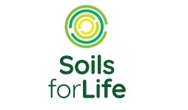

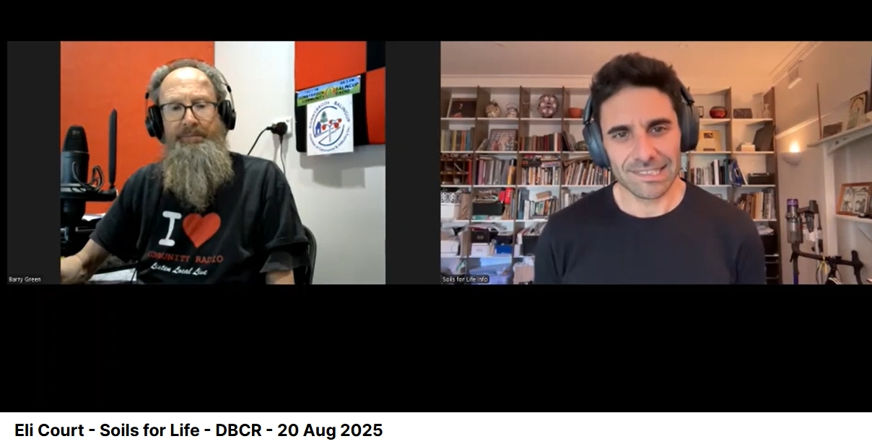

**Rumble :** [**https://rumble.com/v6xttng-eli-court-soils-for-life-dbcr-20-aug-2025.html?e9s=src_v1_upp_a**](https://rumble.com/v6xttng-eli-court-soils-for-life-dbcr-20-aug-2025.html?e9s=src_v1_upp_a)

**Spotify:** [**https://creators.spotify.com/pod/profile/radio-wa/episodes/Eli-Court---Soils-for-Life---Business--Community-Round---Up---20-August-2025-e372tr6**](https://creators.spotify.com/pod/profile/radio-wa/episodes/Eli-Court---Soils-for-Life---Business--Community-Round---Up---20-August-2025-e372tr6)

**Sound Cloud:** [**https://soundcloud.com/dbcommunityradio/eli-court-soils-for-life**](https://soundcloud.com/dbcommunityradio/eli-court-soils-for-life)

**Barry Green:** Donnybrook Balingup Community Radio. It's now 11:07, and Business Community Roundup is sponsored by the Donnybrook Balingup Chamber of Commerce. My next guest is the CEO of the organization Soils for Life [**https://soilsforlife.org.au**](https://soilsforlife.org.au) , Eli Court. G'day, Eli.

**Eli Court:** G'day. How's it going?

**Barry Green:** I'm well. So for people who don't know, can you tell our listeners what Soils for Life is about?

**Eli Court:** Yes. So we are a non-profit organization, and we're established with a mission to support Australian farmers to regenerate soils and with a very specific goal around trying to achieve and support more resilient people, more resilient farming businesses, more resilient rural and regional communities, and also more resilient learning and progress. Um, because I think, um, you know, soils are the foundation of resilience, It's.

**Barry Green:** The foundation of our civilization early, and the soils for life organization was created by former Governor General Michael Jeffery. So he was a military man. How did you see that connecting in? Because really, I actually did an interview with Michael in 2019 and he said, you know, if Australia doubles its food production, it could make a bit of difference. The world, if we can teach the world how to produce food while sequestering carbon, basically we can have a huge impact on the world. And there's all this talk about carbon dioxide. But, you know, regenerative agriculture is about sequestering carbon and producing food. So it's all positive stuff.

**Eli Court:** Yeah. Look, I think that's absolutely part of what regenerative agriculture is all about. I think to your question about why was someone like Michael Jeffrey, um, interested in this space? I mean, I only briefly overlapped with him. I met him once. Our time at soils for life didn't overlap too much, but, um, but I guess, um, he was a person who cared deeply about the security and the security in the broader sense of Australia and of the world. And, um, security relies on, uh, us having food, us having a healthy, um, ecosystem that provides food and water and everything that we need to live, um, and, and security, you know, having those things is also the foundation of actual physical security in the world. A lot of lot of good research around how conflicts are related to the depletion of soil and the failing of the fertility that functional ecosystems provide. And so, as someone who really cared about all of that, he understood that it all comes back to soil health. And in Australia, with more than half of the landscape managed by farmers, he also understood that if we're going to restore our soil health and provide all of those things that improve soil health provides to us as a society, we need to work with farmers, and we need to support farmers because they're the ones making the decisions out in the landscape.

**Barry Green:** Very interesting. And your background is in as a lawyer. So this brings a different perspective to it. And I know Michael Jeffrey is saying that we spend billions of dollars on defense hardware. But at the end of the day, our ability to feed ourselves fundamental to our security. And that's what the people in London found during the Second World War. Um, so, you know, global free trade is all well and good, but, uh, you know, we've got to be able to feed ourselves locally because in the event of some sort of conflict, if we're reliant on imports, we're in a dangerous situation.

**Eli Court:** Well, and I think it's not just about food imports, it's also about inputs. And, uh, a lot of our modern farming methods are very reliant on inputs, and those inputs are vulnerable to changes in pricing, to changes in trade. And I think one of the advantages of taking a more regenerative approach to agriculture, which does aim to work with natural systems rather than against natural systems. One of the advantages of that is that you're replacing some, or ideally, all of the need for those external inputs with the natural fertility that healthy soils and landscapes can provide. And in that sense, it's a security measure as well.

**Barry Green:** So when we were in Victoria recently, we were driving around listening to your your podcasts, and one in particular with Gaye Brand, I found quite uplifting. And Gabe's very much part of the major movement in America. And, you know, Kennedys recognized that the health starts in the soil. So that all goes well for regional communities. But Joel Sullivan also talks about this, and but it's about getting people back into rural communities because, you know, we've industrialized everything, but we need people. And the Aboriginal people say country needs people. And I think, I think they're absolutely right there.

**Eli Court:** Yeah, absolutely. And I think the thing about regenerative farming practices is they are knowledge intensive. So, you know, modern farming systems are often capital intensive. They're technology intensive. They're input intensive. They're resource intensive. But regenerative systems are knowledge intensive. And I guess they're recognizing that every piece of land is different and unique and requires a specific and tailored approach that requires farmers on the ground who are observing that piece of land, um, with some sort of ecological knowledge about what that what's going on in that landscape and then able to design strategies that will build soil health, that will improve water holding capacity, that will increase the ecological function of that landscape, to support the production of healthy, nutritious and productive crops and and products and outputs, you know, fiber products and all sorts of other products. And I think, I think that is important for rebuilding and also revitalizing regional communities that have been experiencing this, you know, get big or get out, um, sort of shrinkage. So, um, certainly a lot of the farmers that we work with have said that since moving in this direction, reducing their input cost and their, their, their operational expenses, they have been able to hire new staff.

**Barry Green:** Yeah. And before you, I was talking to Professor Ian Breithaupt from the world of wellness and the world of wellness has had doctor Mary Cole has spoken that the world of wellness. And you've also got a podcast with Mary. So there's this this, uh, synergy happening. Um, and what Charlie Massey Energy Gen AG talks about. There's this this grassroots change and change coming from the bottom up. Um, and I guess for people who are farming or, you know, we've very much been taught to farm. Now, the research has all been done by companies selling stuff to farmers. So I guess, how do you know people who are interested in this? How do they engage with soils for life and learn more about it?

**Eli Court:** Yeah. So our website is the place to go. It's soils for life. Um, and we have a huge body of work there now providing case studies. It's almost a hundred case studies from around the country of farmers who have found all sorts of different ways to uh, farm with nature, uh, rather than against nature to adopt new practices, whether that be different approaches to grazing management, to use the animals as tools of landscape repair or different cropping practices. Um, you know, use of biological inputs, compost, foliar applications, multi-species crops. You know, we have a huge amount of information from those case studies about what's been successful elsewhere that people can learn from. We're also starting to produce, uh, practice guides that are basically more focused on the practices and how people can actually start to think through which practices might be suitable for their context. And, again, how other farmers have implemented those practices on their farms, and how you might start to get started on your own farm. So there's a heap of resources on the website. Um, and, you know, listen to our podcast. Sign up to our newsletter. We're very close to, um, releasing a new resources page that'll be much more searchable so that people can drill down, drill straight down to, you know, case studies in New South Wales that are livestock businesses who are implementing rotational grazing techniques.

**Eli Court:** You know, so that's coming in the next couple of months. Um, but that's a place to go. I do think people who get curious about regenerative agriculture or however you want a term that building soil health, working ecologically, um, they do sometimes struggle to work out where to go to find information that they feel like they can trust. And so we do try to provide that credible, accessible, easy to understand information on our website. And then we do refer off to like a whole. There is a whole world of information out there now. And so we do try to provide links off to, to other places that that provide more in depth information than US or services. There are also a lot of services starting to crop up now, where people can pay to do a course or some training. Um, but I guess the other thing to look at is your local NRM organization, your local Landcare group. Um, they're all very different around the country, but a lot of those groups are now starting to offer, um, training and education and information and informational events that help people think these things through.

**Barry Green:** Yeah. So I know when tors for life was formed, Michael Jeffery got a couple of million dollars of government funding for the year of the soil. Uh, does the government still funding soils for life? Does it provide support?

**Eli Court:** Uh, we have some government funding, but we, uh, I guess we have a pretty diversified funding, uh, set of funding sources now. Um, we're about half philanthropically funded and about half funded by grants, not just by government grants, but also by a whole range of other grants that are out there, provided by a whole range of different types of organisations and foundations. So yeah, we've diversified a little and I think that's a good thing because, um, you don't want to be too reliant on, uh, on government grants to keep you going.

**Barry Green:** And of course, uh, you know, there's, there's growing evidence of improved, uh, um, nutrition, nutrition, nutrient density in produce off of regenerative agriculture, which is going to have an implication for the health of people eating it. So I guess, uh, I'd sort of thing recently Joel Salatin was talking about, he said, in America, 20, 30 or 40 years ago, people spent about 18% of their income on food and 9% on medication, and now they spend 9% on food and 18% on medication. So it's something that the return on investment for the community is quite huge in terms of better health outcomes and probably, uh, more, more, more satisfying life for the people who eat this food.

**Eli Court:** Yeah, well, what we've got right now is a pretty good deal for the pharmaceutical companies. Not such a great deal for the farmers trying to produce nutrient dense food. I mean, some of that evidence are around the nutritional benefits of food grown in healthy soil is really starting to emerge now. Um, there's Dan Kittredge in the US working with the Bio Nutrient Institute and the one of the, one of the facts from his initial study that really stuck in my head. They did they did a study of hundreds of different products, um, where they sourced hundreds of each of those products. So carrots, capsicum, um, you know, lettuces, all sorts of different food products from around the US, um, from all sorts of different farms, from conventional farms, from regenerative farms, from local farms, from organic biodynamic everything you could think of. And they looked at all of those samples for a whole range of different nutrients, macronutrients, micronutrients and all the, uh, all the sort of, um, polyphenols, antioxidants, all of the micro, um, compounds that might not be the things that we need to keep living, but they are the things that keep us healthy. Um, and I remember the results around carrots. They had, I think, 400 or something carrots in their study from all different farms. And the best carrot had 40 times more antioxidants than the worst carrot. So that would mean you would need to eat 40 of the worst carrots to get the same level of antioxidants as one of the best carrots. And that was just for carrots and antioxidants. The those sorts of results were replicated across all of his results, and it really does just go to show that it's not, uh, It's the conversation we're having about health and nutrition and food is stuck at this level of what types of food should you eat? And where we need to get to is how is that food produced?

**Barry Green:** Yeah. And some people think, you know, technology is going to save this civilization. I think the only way it'll save the civilization, if it comes up with a device which lets you scan a piece of food before you buy it to determine if it's nutrient rich and lacking in toxins, and if it's worth anything. Because a lot of cheap food. You know, we've got a food system based on down, down on price. But I'm old enough to remember when we said if something was cheap, it was cheap and nasty, and I don't think anything's changed. So we do need to get back to, you know, we're in a, in a, in a in a analytical world built on data. So if we have the data on nutrition, that's going to be what leads our health going forward. But I and you mentioned Dan Kittredge. He's going to be in Western Australia in September. He's speaking at the grounded event in in Bridgetown. So looking forward to meeting down there. I guess this is all part of, uh, I like to say what we're doing on community radio is Regenerative Media a play on regenerative agriculture? Anyway, Ellie, you said you've got to leave fairly soon. So thanks for taking the time to talk to us. And do you want to put a final plug in for saws for life? How people should, whether they're farmers or just interested your average eater, how they can learn more about soils for life?

**Eli Court:** Yeah, I guess for farmers, I would just say get on to our website, have a look around. Um, I think, you know, there's heaps there for you. Sign up to our newsletter. Look at look for us on socials, Facebook x, uh, LinkedIn, um, Instagram. And for others we're always looking for partnerships. So, um, we're often working with on ground organisations, NMS, Landcare groups, um, With producer groups. Um, and I think the thing that we can bring to those, um, partnerships is our national network and our international networks of leading farmers. Um, and so, yeah, always looking for good partnerships and obviously always looking for, um, support from those interested in philanthropy as well. So, um, you know, there's, there's information about that on our website as well.

**Barry Green:** So it's all about developing diverse, self-organizing ecosystems. Elli.

**Eli Court:** Exactly, exactly. And you know, we don't have the silver bullet answer. It's all about us being one part of the puzzle and working with others who have their part of the puzzle to play as well.

**Barry Green:** It all starts with the conversation. Thanks, Ellie.

**Eli Court:** No worries. Thanks, Barry.

**Barry Green:** I've been talking with Eli Court, the CEO of Soils for Life.