John Dent - Vaccine Injury - BCC - 22 Oct 2025
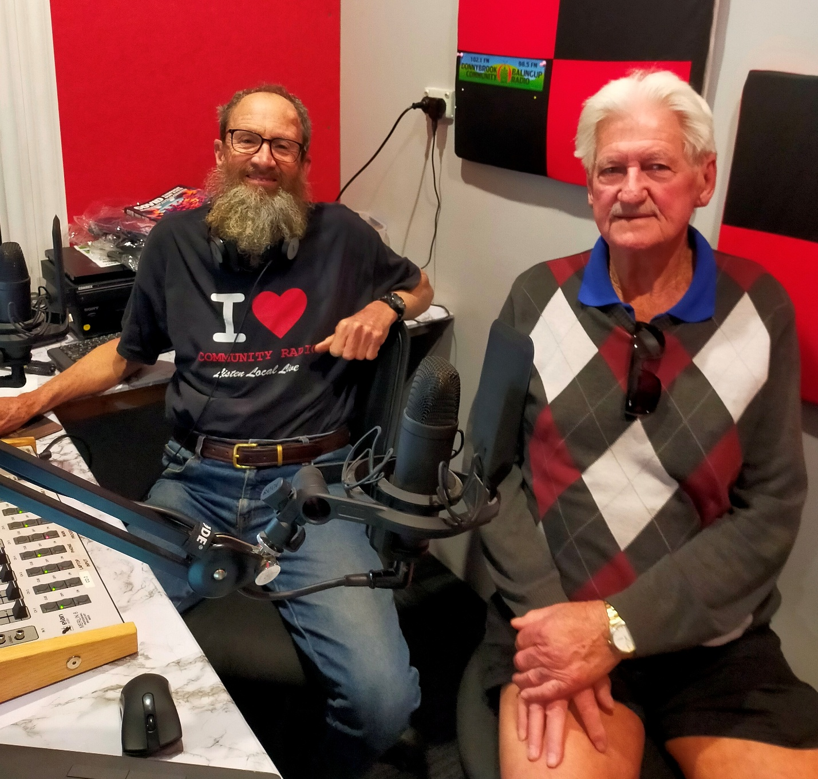
Listen on

DBCR Sound Cloud : https://soundcloud.com/dbcommunityradio/john-dent-vaccine-injury-bcc

Radio WA Spotify : https://creators.spotify.com/pod/profile/radio-wa/episodes/John-Dent---Vaccine-Injury-e39sj95

Barry Green: Good morning, I'm Barry Greene, Donnybrook-Balingup Community Radio for business and community conversations on the 22nd of October, and Business and Community Conversations is sponsored by Harvest Highway. Com.au and this is a live show, and the views of participants may not necessarily be the views of DBCR or Harvest Highway. This morning, I'm going to be talking with Professor Gigi Foster from the School of Economics at the University of New South Wales. I'm going to be talking to Zoe from the Donnybrook Community Bank about the pitch night held on the on Saturday, and the $40,000 being returned to the community from the community bank. I'll be talking to Shire President Viv McCarthy about the election results over the weekend. And but before that, um, two weeks ago, I spoke to Professor Robert Clancy about his book Covid Through Our Eyes and the. And last week I, I played a piece with, uh, Doctor John Campbell, who was, uh, interviewed on Jimmy Dore Show. Uh, Doctor John Campbell had mentioned, uh, Professor Robert Clancy in his interview with uh, Jimmy Dore and, uh, both of Doctor John Campbell and Jimmy Dore both talked about, uh, their vaccine injuries that they suffered from the Covid injection. Um, and then the day after, I got a phone call from John Dent saying that he'd heard the interview and the symptoms that they described described his situation. I've got John in the in the studio with me now. G'day John.

John Dent: Good morning.

Barry Green: So tell me you rang me up. Tell me what prompted you to ring me?

John Dent: Well, it was, uh, I was much of a sceptic up until last Wednesday. But when I heard that, uh, interview or that speech by that chap. He talked about getting, um, blood flow or blood pressure, um, jumping all over the place, which started happening to me nearly two years ago. And I thought, oh, that could happen to anyone. But, uh, then he said, after that, also, I suffered nerve damage to my neck, and all of a sudden I thought, uh oh, this can't be coincidence. This is exactly what happened to me. I happened.

Barry Green: Okay? And there's a lot of coincidences happening. Um, you said to me, why aren't we hearing about this on the mainstream media? Um, what's your thoughts on it?

John Dent: Yeah. Um, it amazes me that there's. I know there's a lot of people that are out there, uh, suffering with different things, and they put it down to, uh, the getting the jab on Covid. I didn't think for for a minute that it was going to happen to me because I thought they were all just scaremongers. But after hearing that speech and knowing exactly what's happened to me in the last two years, I now am more than certain that what's happened to me is because I had those Covid jabs. I had more than three and I think it shows.

Barry Green: And you talked about, uh, lots of in one arm, and that was the arm that you had.

John Dent: Exactly. And, uh, I always made sure that I had the jab done in my left arm because there's more muscle on that arm. Um, and the trouble I had with my left arm and on my left neck is consistent with the fact that that's where I had all the jabs. Um.

Barry Green: And there's so much propaganda around this, you know, they're very clever. The propaganda people, they they they created this division. And the suggestion that even if you questioned this, that you're a nutcase and and that's that's me. People have been frightened to even suggest it. And but what you're saying You've got quite a few friends now who are who have been questioning it. And just by talking to each other about it, we sort of, you know, we can get around that propaganda. I guess the change has got to come from the bottom up.

John Dent: Exactly. And it's the old saying of you throw a pebble in the pond and the ripple turns into a wave. And I didn't believe my best mate who said after he was compulsory and this is what I didn't like, he was compulsory, told he had to have two to keep his job. Otherwise he was out of work. And not long after that he called me and said that because of those jabs he was suffering with vertigo. And I thought, nah, you, you're joking. And fair enough. I started suffering with vertigo too. The only thing that's suppressing these things is these capsules I'm taking which have side effects. So. Yeah.

Barry Green: Yeah. And um, as I said, I two weeks ago, I spoke with Professor Robert Clancy on this program and his book, which I have here is called Covid Through Our Eyes An Australian Story of mistakes, mistreatment and misinformation. And as some eminent Australians have contributed to this book, including Professor Gigi Foster, who I'm going to be talking to later today. Now, as I said, when I was talking to Professor Clancy, um, you know, if, uh, if, uh, somebody alcoholic, that person needs to recognise they have a problem to sort of to own the problem, to sort of address it. My sense is now that the Australian government and the pharmaceutical industry have created this problem, and for the community to progress the powers that be need to acknowledge that they've created this.

John Dent: Of course, because the pharmaceutical companies, although they're to is make billions and billions of dollars, which they did make out of this Covid thing. And of course, you've got to realise that Covid vaccine Seen throughout our time is the only one that has been rushed through and okayed. Now, who okayed it and and who proved that it was right? I'd like to know.

Barry Green: And it's not. You know, there's been vaccines around for years, and they've been made essentially out of dead bugs. Um, but this was a totally new platform. And to to approve that in such a short time, it strikes me as a it's highly irresponsible. And a friend of mine's been talking to former Senator Gerard Rennick, and Gerard said he had a long conversation with then Prime Minister Scott Morrison. Uh, about because early in the piece there were signs that this injection was causing problems. But the government was in denial. And apparently, um, Morrison said to Gerard Rennick that, you know, we can't question it because otherwise people will lose trust in government. Now that's what you get when you get a prime minister who's a marketer. People who deal in perceptions, not facts, but facts are facts are going to win out in the end. Um, and, uh, you know, this needs to be recognized and addressed.

John Dent: Yeah. That's right. I mean, all this thing of, um, governments forcing us to do things, they don't want to admit that they made a mistake. And it's the same with the pharmaceutical. They're not going to admit they made a mistake. It's going to be from people like, well, hopefully myself, who can get the word out. That forces them to look at it. And we can only hope that someone like Robert Kennedy over in America can do his job and make pharmaceutical companies accountable for what they put out.

Barry Green: I think that is happening. But you don't know it in Australia, because the mainstream media in Australia is largely controlled by these same corporations that Kennedy is taking on. And and having read parts of Professor Clancy's book, I'm saying with confidence now that the ivermectin and, uh, the other one that they were talking about, that, you know, I did have some value in treating Covid. That was literally bad math, because if there was a treatment for a treatment available, they would have never got the vaccine approved. So this this was driven by unconscionable commercial interests, and it does need to be held to account I think.

John Dent: Yeah, I think so. I think it's hopefully we can get enough people out there who are listening. And I know there are at least a couple of people out there listening who are thinking right now, gee, he's had this problem. I've had this problem too. I'm going to tell someone about this or I will ask about this. We can only do that.

Barry Green: And this is what Robert Kennedy, who's very smart, says. And people say, oh, he's a heroin addict. And he might have been, but you've got to remember, he saw his dad and his his uncle shot. So that would have had a devastating effect. But you know, he's come through that and he's providing true leadership. Um, and so, uh, think, you know, the facts are getting out in America. We're not hearing about it here yet. But, uh, and the other thing that Kennedy says is that people have to hear to change their view on something. People have to hear something from 4 or 5 different people before they'll start to change their understanding. So by you speaking, John, that could well help people to change their view of what's gone on here.

John Dent: Yeah, I hope so. And if anyone out there is a bit afraid to say things because they're going to be classed as a scaremonger or something like that, uh, don't worry. I'm sure there's a lot more people like me who have now starting to question how come this has happened to me, and what is the long term effect? I don't know what the long term effect is.

Barry Green: Yeah, well, thanks for speaking up, John. I really appreciate you coming in and talking about it. And I think, you know, this is what the it's what can start. Um. It all starts with a conversation. And and, uh, so I appreciate you coming in. Um, we'll run a sponsor message, and then probably after that, uh, if you can stick around, we'll be talking to Professor Gigi Foster.

John Dent: Yes. No worries Barry.

Sponsor Message: You're listening to DBCR, and we're proudly supported by Donnybrook writers Group. Russo produce, S and D Nelson automotive, Donnybrook medical practice and Donnybrook Recreation Centre. DBCR your community station.

