Maryka Groenewald MLC - BCC - 17 Dec 2025
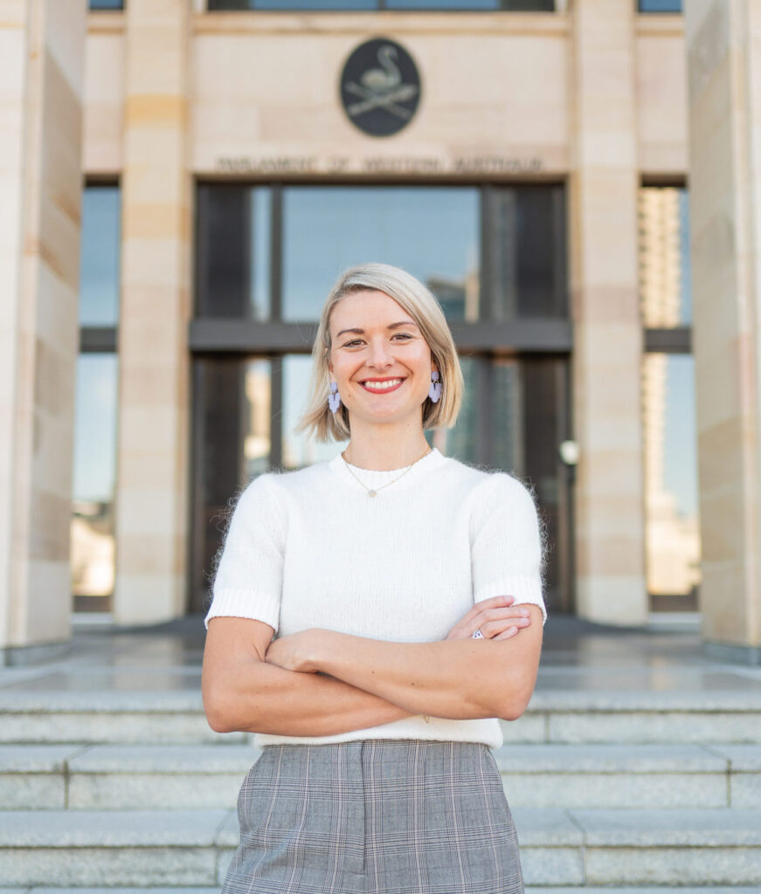
Listen via

Sound Cloud: https://soundcloud.com/dbcommunityradio/maryka-groenewald-mlc-bcc-17
Spotify: https://creators.spotify.com/pod/profile/radio-wa/episodes/Maryka-Groenewald-MLC---BCC---17-Dec-2025-e3cfld2

Rumble: https://rumble.com/v734hp8-maryka-groenewald-mlc-bcc-17-dec-2025.html?e9s=src_v1_upp_a

Barry Green: To 11:36 on Donnybrook-Balingup Community Radio Business and Community Conversations sponsored by Harvest Highway. Com.au. And in the last state Parliament, I interviewed nearly all the South West MLCs. We no longer have specific South West MLCs, but we've got the Member of Legislative Council's represent from all over the state of Western Australia. And a new MLC is, get your name right. You help me out there.

Maryka Groenewald MLC : Such an awkward name, isn't it?

Barry Green: Sorry.

Maryka Groenewald MLC : Maryka Groenewald .

Barry Green: Okay. Sorry about that, Maryka. A dyslexic thing, you know.. Tell us about you and the Australian Christians Party. Tell us a bit about Maryka.

Maryka Groenewald MLC : Yeah. Look, thank you so much. Firstly, Barry, for having this conversation. It's always great to connect with people across our community. And as you mentioned, yes, from a party as random as the Australian Christians elected to the upper house this year. Uh, obviously been a bit of a journey for us to get here. We've been a very active party in, in WA for a number of years now, but, um. Gosh, Marika, who's Marika well, very involved in community development work, obviously, as I mentioned, been involved with Australian Christians over the years. Um, and just for me, it's always just been fascinating to see when you're involved in community development and community work, the difference in policy that you have at a political level, and what people actually tell governments that they need and want. So my motivation, I suppose, I'm this odd anomaly in the system, is identifying and seeing where those gaps exist. And so over the years, over the decades, it's just been fascinating for me to see. Yeah, I guess the lack of not only consultation, but things that actually get put. Uh, the government's take on board when when you are in community. So that's kind of been my motivation. I've been out there, you know, working across WA, Northern Territory. So yeah, a big, big heart to get out and about, I suppose.

Barry Green: So what's your vision for the future of Western Australia?

Maryka Groenewald MLC : Yeah, for me it's always been fairly consistent I suppose, as you can imagine. You know, even though we're a Christian party at the very base, it's this understanding that, you know, you're there to serve people, you're there to identify needs, you're there to meet those needs. So even though, you know, we're not going around telling people about Jesus, we're actually going, hey, how do we show you the values we hold dear, serve people around us? And what does that look like? So, uh, that's been a yeah, a really big, big part of what our hope has been for people, you know, I want to see families do well. I want to see kids do well, as we all do. Of course, that's not a unique thing to Christian, but I think for us there's definitely core issues and values that are a bit of our point of difference. And you might have seen, you know, in our election, uh, things, it's always around life and faith and family and freedom. So they're our four pillars.

Barry Green: Yep. So Khaled's brought up going to Sunday school, but I sort of, I guess I, I learned the Ten Commandments and I think that's something that's a pretty good basis. But I guess like many, like many of my generation, we lost interest in churches and institution. And it's, you know, there's a difference between church, which is in many respects seems to have become another corporate entity and Christianity. And so I guess it gets a matter of, of faith. We must have been put on this planet for something other than to make a profit for shareholders. Marika.

Maryka Groenewald MLC : Absolutely right. And you know what? When you're on polling day and you're talking to people out and about, so many people feed that back what you've just said. They understand that Australia has got these values that sort of underpin everything we do. You might not have everybody go to church, but, you know, there's this guiding principle and the further we move away from those core guiding principles, the trickier things get. I mean, and that is just inevitable. So, you know, I agree with you. I think religion definitely is one thing. You know, we all have to weigh up where we're at with what we believe and who we believe. And it's, you know, been a journey for me as well. You know, I grew up in church, but finding that personal connection beyond the religion, like what does a relationship look like for me has probably been the biggest game changer in my life. But you're right, you know, it's more the values don't have to go to church every Sunday to appreciate them. Um, and of course, they've been a mainstay of Western civilizations, and for good reason.

Barry Green: Yep. And so, you know, like you say, it's about relationships and human beings talking to each other. And we've got challenges at the moment, the internet sort of changing the ground rules on things. Um, but at the same time, you wonder, um, especially with things like digital ID and all these things which sort of dehumanize things. Uh, what's your position on the digital ID? Does your party have a position on that?

Maryka Groenewald MLC : Look, we've certainly written about it, even though it's a federal issue. It's sort of perhaps a bit of my immediate outside of my realm. But, I mean, we've written about, um, digital ID, you know, even during Covid, government overreach, the mandates. I mean, these are all things that we're very mindful of when when government is able to impede so much on people's personal freedom and personal liberties that that should be a worry for anybody. So, you know, uh, and again, it feeds into digital ID, too. We have to be mindful of the pitfalls of these things when we introduce them. And I think, like you said, that's perhaps a gap at the moment. We're not thinking through things as properly and as carefully as we perhaps should be.

Barry Green: And in I guess, a state issue at the moment is the fishing bans. Have you been involved in those discussions? What's your position on that?

Maryka Groenewald MLC : Yeah, look, we tend to be a little bit outside the scope when it comes to these things. But of course I've got fantastic One Nation and national colleagues, uh, in the upper house as well. And I just saw this morning that the Nats are proposing to do something about it. But again, um, this is this is the very issue, right, we were talking about earlier. You've got these decisions that are made, lack of community consultation, lack of thinking through the issue, lack of thinking through the implications. You know, I was listening to one of the spokespeople yesterday on ABC and she's going the the sledgehammer approach that the government, uh, employs when they're talking about these things and implementing these things, it's unbelievable. So, you know, definitely look forward to what that's going to shape up to, to be when we get back into Parliament. But again, a classic example of people going, look, help us to do this reasonably help us to make sure families aren't absolutely put out, as many families now are. No heads up that this was even happening. I mean, imagine like what a what a horrible situation to be in just before Christmas. Just before Christmas. So yeah, look, I don't think this is the end of the conversation on this Barry not not by a long shot.

Barry Green: So the the minister responsible has gone off on holiday. Is there any possibility that other people within government can sort of put a stay on this for the time being and and re-evaluate?

Maryka Groenewald MLC : Look, they will have to wait until Parliament resumes I'm assuming I'm. I don't doubt that there's meetings happening. You know, perhaps between community consultation groups, which there's a few of, of want to go to, um, where we're starting to go. Okay. What is the community feedback on this? And is there a way that you can start filtering this through to some of the ministers? But again, this is this is the issue you've got now this thing done just before Christmas. You've now got this two effectively two month break before decision making and Parliament resumes. So people are almost in this limbo period for two months. So look I hope that there's something they can do. But legally, structurally at this stage I don't think much will happen till next year.

Barry Green: Um, well, it's a bit of a concern. Okay, well, we'll play a sponsor message and and come back and continue the conversation after that.

Sponsor Message: You're listening to db, DBCR. This station thanks the following sponsors events West John Bailey of Balingup. Donnybrook. Panel beaters. Applegate Lane chalets in Balingup. Solar fruit and Rita Winkler, jewellery artist .

Barry Green: Whitney Houston and do you hear what I hear? So very appropriate. My guest this morning is Maryka Groenewald, who's a MLC from the Australian Christians Party. So, uh, what are you. What are you hearing, Marika? So, um, in in your position as a representative of the people? Um, yeah. Uh, a big issue is health. And, uh, and my perspective is health comes from healthy food, which comes from healthy soil. Stony Brook is an agricultural community. And, uh, I think, uh, if in many respects, there's been a breakdown in communications between farmers and eaters because of the supermarkets. And, you know, we have tourism industry in Donnybrook. And so the whole agri tourism thing, if people come to Donnybrook and are able to buy fresh local produce and learn of the benefits of that for their own health, as distinct from the the health issues that are coming out of the processed foods. Do you have a position on all of this?

Maryka Groenewald MLC : Oh, look, I think you're so right. One of the valuable things I find every time I go out into community is like, you've got local communities with local skills that they can pass on, and especially Donnybrook. I mean, the thing I always know when I go down that way is Nana Donnybrook. You always have fresh produce, you're always able to meet the locals. And there's something so special about making that connection. So, you know, I remember even when I was little, um, you know, that connection with local producers, local farmers, supporting local people. There's a guy that used to come around every Saturday in a trailer, and he would sell his food out of this trailer that he's grown. And I just think it makes people appreciate it more. And of course, there was no pesticides on it. You know, back then everything was almost organic as the soil quality was very different. But you had an appreciation and a realization of the importance of that connection and understanding that. So moving towards and I've seen this interestingly, you know, families who are becoming more aware of, uh, what they put into their bodies, the processed foods, things in general, uh, being more self-sufficient, you know, learning about all this incredible stuff that you have in nature and our vegetables and our fruit. So there's a lot of people moving towards that model and trying to cut out these massive, uh, supermarket giants that pretty much monopolize everything around them. And that's been a real shame. You know, obviously the city is a bit of a different ball game, but I really value and love that when you go into the regions that encouragement to support local, that it is truly local and for us not to lose the importance of that either.

Barry Green: Yeah, I think that's important. I think that's why community radio is so important. And there's community radio stations across Australia, and we are providing a voice for community and small business because the mainstream media is pretty much become the voice of the corporations. And and I don't think that's necessarily serving us well. Um, and I guess, um, you know, when you look at, uh, the mainstream media is funded by advertising from big food, big, big, big everything.

Maryka Groenewald MLC : Um, big everything.

Barry Green: Uh, uh, and we've, you know, so while there's lots of bad stuff happening in the world, there's nothing we can do about the focus on community and to, to to recover from what we've been through. Community generally is so important. And, uh, you know, you talk about this is all about self-reliance, creating self-reliant communities.

Maryka Groenewald MLC : 100%. And I think that's even out of Covid. One thing that people probably are more so aware of now is the value and the importance of community. You know what what it means to connect with one another, serve one another, be there for one another. Uh, if as horrible as as those years were, I think people really stopped to think, you know what really is important to me? Um, how do I, uh. Yeah, make myself more self-sufficient? How am I more able to almost separate yourself from this big machine? You know, these these great benefits of it, but more so, I think people are going, hang on. There's something really special about local, smaller being in community with a consistent group of people that are in it for the long haul and a bit like church to, you know, um, it's again finding your community. Uh, and again, making sure that that you're at least connected to one, uh, and not, not not losing sight even of our regions. Like you said earlier, I think so many city people have no idea. No idea what happens in our regions. What happens in our remote areas. Um, you know, I was in Kununurra recently. Big heart for regional, uh, remote Australia as well. And, you know, sometimes I think we're just so out of touch with the needs of people for that very reason that we lose a sense of community and what it means to serve people, because we're just not immersed in it enough.

Barry Green: So mining's very important to Western Australia, but at the end of the day, our health and wellbeing comes from our food. And if it's local food, because, you know, if things if world trade becomes issue, then the ability to feed yourself locally is really important. So I guess, uh, if people it's important in a democracy that our listeners know who our elected representatives are, you paid the big bucks to represent us. So and I'm sure you work very hard for it, but how do people get in touch with you if, uh, if there's issues that they wish to, to to bring to your attention. Because if in a democracy it's, you know, the function of the need of the people is to let our representatives know what their position is on different things. So how do people get in touch with you?

Maryka Groenewald MLC : Yeah, look, for sure. And unfortunately, we're still waiting on our office. But I do have a website people can get in touch with us via that. Um, and also on the parliamentary website, there is an email for me as well. So as people have done over the last seven months, you know, there might be a question they'd like me to ask, an issue that they they'd like to raise. You know, I often say I'm just one person, but I'm a good agitator. So even if it's just putting certain things in the conversation, putting them on people's radar, I think that's also very valuable thing to do.

Barry Green: I think so, because a lot of cases people don't know what they don't know. And, uh, if you're electors don't tell you about something, you won't necessarily know it.

Maryka Groenewald MLC : No, no. And it keeps the connection, like you said earlier, you know, keeping that connection with the people, making sure that people feel like they have the space and the voice to give you that information, because that's literally what you're elected to do. So I think that's a very, very valuable part of the process.

Barry Green: Very good. Marika. So thanks for taking the time to talk to us today, and I wish you and your family all happy Christmas and a prosperous New Year.

Maryka Groenewald MLC : Oh, likewise. Barry, thank you so much for the chat. It was so good.

Barry Green: You're welcome.

Barry Green: I've been talking to Marika Cromwell, the MLC and MLC, one of many and community radio. We do need to be balanced. So I've invited other other people on. I've spoken to for. That's for now. I've spoken to people from the WA Cannabis Party, One Nation, the Liberal Party. I've sent invitations to Labour Party people, but so far they either haven't replied or declined. So. But there's an open invitation to any any MLC who wants to want to come and talk on this program. Um, that's about it for today. In fact, it's about for this year with me. I'm going to take, uh, three weeks off. We'll be back in the New year. Uh, in the event of any, uh, any sort of, um, emergency situation around. But we will arc up at 10:00 and, uh, see if we can prevent a local perspective. Of course, we're not an emergency broadcaster, so if there is an emergency, listen to the official emergency, uh, platforms, but, uh, DVR, we can provide a local voice. So if the need arises, we will. We will man this station and, uh, present local stories. So thanks for your company today. Uh, I'm Barry Green. We'll go out with little River band and “Home on Monday”.

