Melissa Haslam - WA Fishing Industry Council - BCC - 17 Dec 2025
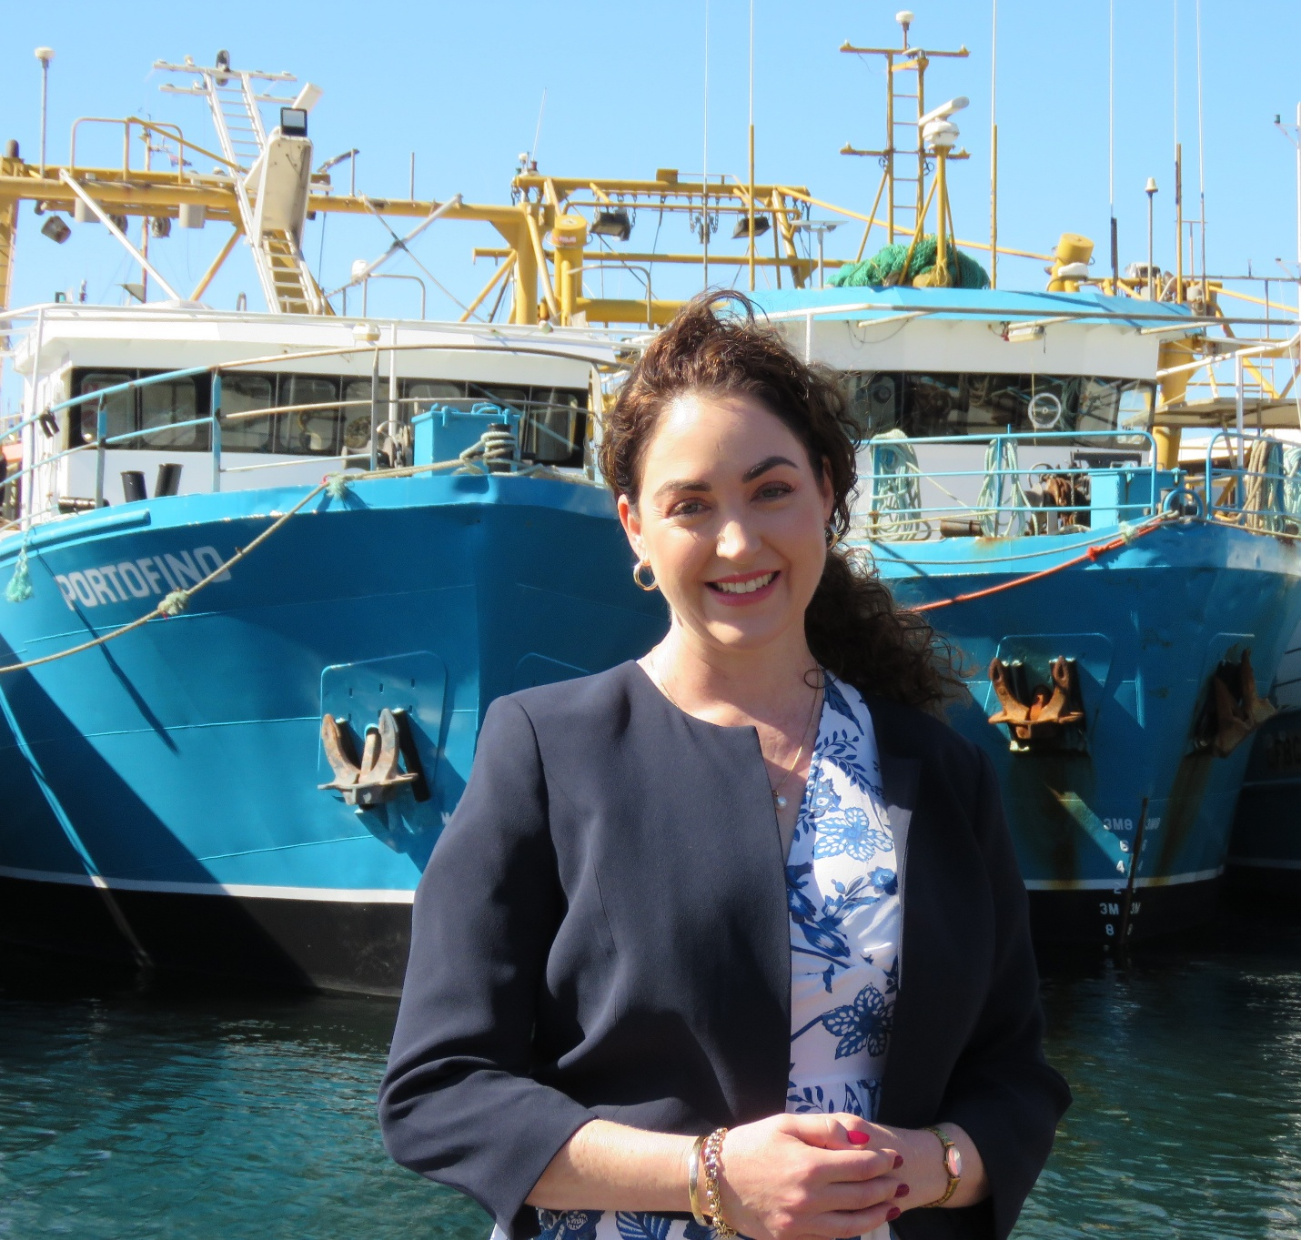

Listen via
Sound Cloud: https://soundcloud.com/dbcommunityradio/melissa-haslam-wa-fishing

Spotify: https://creators.spotify.com/pod/profile/radio-wa/episodes/Melissa-Haslam---WA-Fishing-Industry-Council---BCC---17-Dec-2025-e3cflf4

Barry Green: It's 10:05 on Donnybrook-Balingup Community Radio. I'm Barry Green, and this is Business and Community Conversations sponsored by HarvestHighway.Com.au on the 17th of December and Business and Community Conversations is sponsored by Harvest Highway. And this is a live program. And the views of participants may not necessarily be the views of DBCR or Harvest Highway. Com.au. This morning I'm going to play a piece from Doctor John Campbell, who's starting to report on mainstream media in the UK, starting to question why government isn't releasing various data that one would think should be in the public domain. I'm going to be talking to Neil Simpson, our very own Neil, our music man, the man responsible for the music you listen to about DBCR and our new merchandise that's available at donnyBOOKS. And I've got a live interview with Maryka Groenewald MLC . She's a member of the Australian Christians in the Legislative Council in Western Australia. So we'll have a talk to Maryka, find out who she is and what she's all about. But first up, I've got an interview I recorded yesterday about the issues with the fishing industry. Uh, the audio quality isn't all that flash, unfortunately, but I think you'll get the gist. This is an interview I recorded yesterday with Melissa Haslam, the CEO of the WA Fishing Industry Council. G'day, Melissa.

Melissa Haslam: Hi. How are you going?

Barry Green: I'm well. Thanks. A few technical problems here, but hopefully we'll get around it. So there's real issues happening in the fishing industry. Can you tell our listeners about it, please?

Melissa Haslam: Yeah, sure. I mean, look, a few weeks ago, um, the state government came out and said the stocks of demersal species around the around the coast are looking, um, not particularly great. And um, we were certainly talking about, you know, there would have to be some changes. And next thing we know, big sledgehammer approach entire West Coast, um, shut for two years, which in itself wasn't a huge surprise. But then after just two years ahead of the stocks actually recovering, they're going to reopen it to the wrecks and let them have at it. And we're shutting commercial fishing permanently.

Barry Green: Wow. So West Australians who don't happen to be fishing recreational fish people, um, are no longer going to be able to eat West Australian fish.

Melissa Haslam: Yeah. I mean, it seems terribly unfair. Uh, so if you are privileged enough to have a big boat and all the gear, um, you can carry on enjoying West Australian fish and everybody else, um, frozen, imported stuff for you.

Barry Green: Produced out of polluted waters. So this doesn't sound very good for the, uh, the balance of payments or the health, because fish is good food to keep people healthy.

Melissa Haslam: No Barry it misses the mark on so many levels.

Barry Green: So this is going to have a devastating effect on small business. This government seems to be almost seems to have it in for small business. All the policies they seem to implement seem to impact small business more. More so than big business.

Melissa Haslam: Yeah, it does feel that way. And certainly our fishing community feels very much that way. And for some of them, like I've been saying, it's been generational. You know, it's quite cultural. It's uh, you know, dad fished and great granddad fished. And, you know, for some families it's all they know. It's and it's their kind of, um, their wealth built over generations, their, their boats, their gear, their equipment, their knowledge.

Barry Green: Their knowledge. I think that's the really important thing. If we lose that knowledge.

Melissa Haslam: Yes. Go on.

Barry Green: And but I thought there were sanctuary areas and I thought the theory was that, you know, the numbers build up in sanctuary areas and spill out. And, uh, and that's how it was supposed to work. So for a change of policy so quickly, this this isn't how governments usually operate, usually a sort of a hasten slowly approach. What's happening here?

Melissa Haslam: Yeah. I mean, look, it's been, um, a big sledgehammer approach that, you know, vast areas taken into one sort of, um, you know, one sweeping blow, if you like, where we've been saying, look, break it up into smaller, bite sized pieces. There's other solutions in this, um, hasn't been done. Uh, yeah. So in terms of, um, marine zones, I mean, yeah, certainly. I mean, we have about 24%, um, of our waters in, um, high protected sanctuary zones. Um, and that's no, no fishing zone. Now that works really well generally for commercial fishers. Doesn't work so well for recreational fishers. So commercial fishers have, um, vessel monitoring on board. One of the rules Barry is they're not allowed to they're traversing through a no fishing zone. They're not allowed to travel below. It's about six knots because there could be risks. They might be fishing. So they're monitored. They have to they have to steam through at a particular speed. They have to get to the other side. They have to be able to prove they're not fishing in those, um, sanctuary zones.

Barry Green: Right.

Melissa Haslam: It doesn't work for rec fishers because our commercial fishers, quite often as they steam through our high protection zones, are going in and around wreck session. Yep. Now, unless there is, um, proper monitoring and proper consequences for fishing in sanctuary zones, there's never going to be compliance.

Barry Green: Yep. So I understand the shark make up a fair bit of fish and fish and chip shops. How's that going to be impacted? What's happened there?

Melissa Haslam: Oh, we're losing our shark fishery.

Barry Green: Wow.

Melissa Haslam: Essentially. Essentially, this announcement basically closes it down entirely. So because they catch a very small amount of demersal species as a by product of their operation. So for some of them it's about 2 or 3% I think. Maximum is about 6%. But that sort of 6% of a small catch because they line up catching or whatever the shark. Um, their whole fishery has been shut. But that is a very affordable fish product for a lot of Western Australians, and it's something we all commonly see in our fish and chip shops. So it's a big loss. Very big loss.

Barry Green: Mhm. So I guess we live in a democracy and the way the democracy works, if you disagree with government you contact your local member, the local member for Preston. Preston is Jody Hands. And I guess uh, people who are concerned about this need to give her a ring and let her know, because I understand the minister responsible has gone off on holiday. So presumably there's somebody, uh, somebody there who can overrule this if, uh, if that's the will of the people.

Melissa Haslam: Yeah. Well, it's really listening day to day, and we'll keep our ear out for any questions asked in Parliament today on this. But I mean that I mean, that's just the point. Barry runs off on holiday. Um, our poor fishermen have been given just a few weeks notice that their livelihoods has been taken from them. They are not allowed to fish from the 1st of January. And we have got fishermen calling here in absolute distress saying, what do I do? How am I going to pay my mortgage? You know, I've got business loans and we have reached out to the government and we've said, please, we need some mental health support as a priority. We need boots on the ground. Um, we need some immediate relief. Release of funds for people who are seriously going to be in financial dire straits. Um, come 1st of January. And so far we've heard nothing.

Barry Green: Um, I guess, uh, threatening the food supply is a real is a real problem, isn't it? So I guess, um, we just need to keep talking about it, and, um, let the powers that be know that they're sort of maybe out out of, um, not acting in the best interests of the people of Western Australia on this.

Melissa Haslam: Yeah. Well, I mean, we saw the we saw the timber industry shut down. I mean, we see what's happening with sheep. Um, everyone's worried, where am I going to get my lamb from now? Where are you going to get your fish from? I mean, I don't know what to say, Barry. I mean, as long as there's never any trade hiccups, maybe we'll be fine. I don't know, but, uh, I for one, I'm starting to get a bit nervous about food security.

Barry Green: Yep. And Donnybrook is an agricultural area. Where we've lost a lot of small farmers. And it's a it's the family farmers that are important to a stable food supply. And if the family fishing people as well. So this is a this is a real threat to food security. So, uh, I guess we need to keep talking about it and let the government know. So I guess that's all people can do. Is it? Uh, Melissa.

Melissa Haslam: It is at this moment in time. I mean, like I say, in the very immediate short term, we're just trying to help our fishers who we're very concerned about. But in the longer term. Yeah, absolutely. This is about food security and food supply and West Australians, we should be able to enjoy West Australian products.

Barry Green: Absolutely. Thanks so much for taking the time to talk to us today, Melissa.

Melissa Haslam: No worries. Thanks for having me on. Take care Barry.

Barry Green: You're welcome. That was an interview recorded yesterday with, uh, Melissa Haslam, the CEO of the Fishing Council of Western Australia. Sorry about the audio quality there.

