Prof Gigi Foster - Australians for Science and Freedom - BCC - 22 Oct 2025
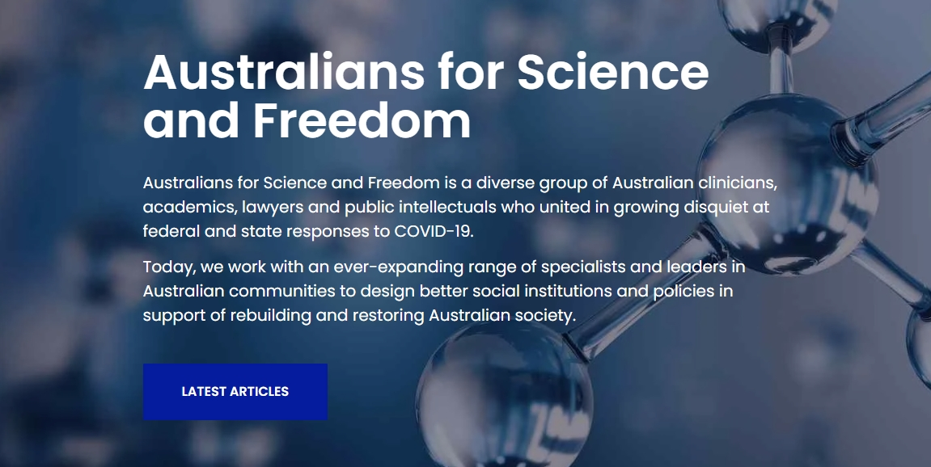
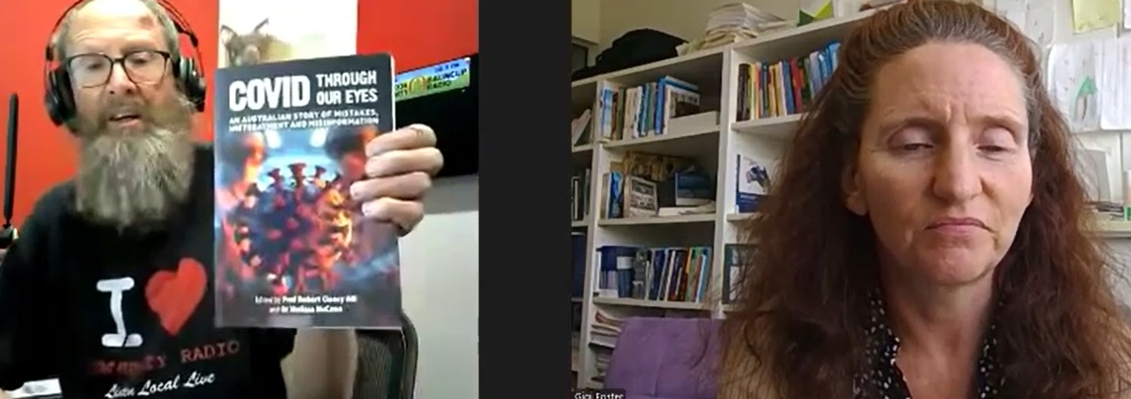
Listen Via:
DBCR Sound Cloud: https://soundcloud.com/dbcommunityradio/prof-gigi-foster-australians
Radio WA Rumble: https://rumble.com/v70mj0u-prof-gigi-foster-australians-for-science-and-freedom.html
Radio WA Spotify: https://creators.spotify.com/pod/profile/radio-wa/episodes/Prof-Gigi-Foster---Australians-for-Science-and-Freedom-e39sj44

Barry Green: John Mayor, Moving on and Getting Over, on Donnybrook-Balingup Community Radio , Business and Community Conversations sponsored by HarvestHighway.com.au. My next guest is Professor Gigi Foster, who's with the School of Economics at the University of New South Wales, having joined UNSW in 2009 after six years at the University of South Australia. Formally educated at Yale University with a BA in ethics, Politics and Economics and the University of Maryland with a PhD in economics. She works in diverse fields including education, social influence, corruption, lab equipment, experiments, time use, behavioural economics, and Australian policy. G'day Gigi Foster.

Professor Gigi Foster: Hi Barry, thanks for having me on. It's a pleasure to be here.

Barry Green: You're welcome. So you, uh, you used to be quite, uh. Uh, how should we put it? You were regularly on the ABC. Uh, what was the ABC program? Q & A and, uh, had a profile there, but I haven't wanted to talk to you so much of recent times. Can you explain that? And the other thing, of course, which I've forgot to mention, is I want to talk to you on the basis of your involvement with Australians for Science and Freedom. Um, I guess maybe that we should start with that. Can you explain what Australians for Science and Freedom is about?

Professor Gigi Foster: Sure. Um, ASF or Australians for Science and Freedom is, uh, a free think tank that I co-founded a couple of years ago with a bunch of colleagues in different disciplines. It's cross-disciplinary, uh, and we founded it out of our shared dismay at the Covid 19 policy response here in Australia. And we have since broadened our focus to, to to sort of generalize to the problems of the West and, uh, multiple different kinds of problems of Australia, not just in the health system, not just the policy response to Covid, but also in our education system, in our system of democracy, uh, so-called, um, and many other problems that we see. And so we are very much a place for people to come and dream and think and write blueprints about the kinds of systems they would like to see in the place of the systems that we have at the moment. Um, many of which are so very, uh, corrupted and sclerotic with many layers of governmental and bureaucratic overreach and, uh, a loss of many of the great values and traditions that we've had in the past, including free speech, for example. Um, that, uh, we feel it's time to think about alternatives to building new systems. And indeed, we try to pilot some of those new systems, including most prominently in our pantheon of initiatives, a new university, which we call Academia Libra, whose campus in Belgium opened uh, at the beginning of last year or middle of last year, uh, and which is very exciting because it's at a castle, uh, it's in a beautiful 18th century property in the Ardennes region of Belgium, and we have programs running there in social science and health science as alternatives to the mainstream. But they can be undertaken as well, uh, by people who are in the mainstream and just want to go for three months or one year hiatus over there to get some intensive education in, in what actually is our best guess of truth and how they how students could potentially use that truth to help their societies to rebuild and restore, uh, the things we've lost and to modernize as well, taking account of new things in the modern era that weren't there when, uh, you know, Western civilization was established, such as smartphones and the internet and AI and whatnot.

Professor Gigi Foster: So, uh, so it's a place ASF is a place to to dream about the future as well as to, um, try to provide community for those who are similarly dismayed, as we are at the some of the decay in their societies. So we run a lot of in-person events. We have members forums every month. There are online that people can join. If they join the organization, they get invited and we platform people across Australia who we feel are doing good work and helping to build community, helping to pursue common sense and sanity in these crazy times. Uh, and we also write submissions to Parliament. I'll actually be going down to Canberra tomorrow to testify on the amendments that you may know of, your listeners may know of. So, uh, very exciting bunch of activities. Uh, and we have a lot of links in the community. I would encourage people to come to our annual conference, which is in about a month here at UNSW in Sydney, has a huge range of speakers, so you can find all the information about us on science and freedom. Org. And you can look under events to find information about our conference.

Barry Green: Very good. Gigi. Now it's a few weeks ago I spoke to Professor Robert Clancy about his book Covid Through Our Eyes. And then, uh, last week I played a part of an interview with, uh, Doctor John Campbell by Jimmy Dore, uh, where they both talked about their vaccine injuries, and that prompted John Dent to call me describing exactly that. Now John's in the studio with me now. And, John, can you explain to me what prompted you to call me?

John Dent: Well, I, I was a much of a skeptic. I thought everyone was scaremongering about this Covid, but when he, uh, said that the first thing was his, uh, blood pressure was fluctuating entirely, I thought, well, that's the same as me, but that could be anything. And when he followed up and said, also suffered nerve damage in my neck, and all of a sudden the bright light went off and I thought, well, more than coincidence, that's me. That was me over the last two years.

Barry Green: So this is what's happening. And, uh, you know, this hasn't been talked about in the mainstream media. Gigi, I'm a volunteer on community radio. I've been able to talk about these things, and all these conversations are online, for the record. So there is this, this grassroots bottom up thing happening. And I think that's what makes community radio across Australia so important. Uh, and having read, uh, the, the book, you know, the, the, the aspects of ivermectin and how that was, was, you know, was useful in treating the disease, but, but got completely sidelined so that pharmaceutical industries could sell their vaccine. Do you want to give a, a professional analysis of what actually went on there?

Professor Gigi Foster: Uh, well, sure. Actually, the best professional analysis I can offer is in my book, The Great Covid Panic, which is Brownstone Institute's first book, came out in about September of 2021. My co-authors, Paul Freitas and Michael Baker and I write our analysis in that book of what we were seeing as a panic around this Covid thing. And we have several chapters, including one on, uh, viruses, one on politics, one on, um, crowd psychology and whatnot. So we try to explain what actually happened, what were all the ingredients that fed into this total panic. And we do talk even then about these vaccines. Who that that at the time we could tell were not that useful and uh, had some serious side effects, sometimes deadly. And that was in, you know, I mean, we finished that in manuscript in August 2021, so quite early in the vaccine era, but it was already clear to us that this was, um, you know, not the best strategy if what you actually are maximizing is health. So what it shows you is that that's not what was being maximized, right? That's not what was being targeted by the decision makers during the Covid era. It was definitely not health of Australians. That's that's simply it's not compatible with their actions that that motivation, that that objective is not compatible with their actions. And so, yes, I mean, now that we've had several years since then to to continue to look at what has happened in the destruction of the policies we've seen, including the Max mandates and the suppression of early treatments, the suppression of dissenting voices about any of the the destructive policies from the lockdowns to the masking to the to the social distancing and everything else.

Professor Gigi Foster: Uh, it is possible to make an assessment of how bad the damage could potentially be. And, um, in fact, a few years ago, I came out with my second Covid book called uh, do lockdowns and Border Closures serve the Greater Good? Connor Court published that that was with my co-author, Sanjeev Sabhlok, and that was the cost benefit analysis of Australia's Covid lockdowns that no government here has ever done. We've never had the lockdowns justified on that standard basis of cost benefit analysis. And so my co-author and I did it and, uh, just based on what we knew at that time and not even including the vaccine damage, we estimate that the lockdowns had a cost to humans in Australia that was at least 68 times as great as the benefits they could possibly have delivered. So that's not a policy that would pass any evaluation of any sane individual in normal times. Uh, and then, of course, on top of that, we have the vaccine damage and uh, on brownstone, which is, as I say, the publisher of my first Covid book, The Great Covid Panic Brownstone.

Professor Gigi Foster: You can see a number of blogs that have been penned by myself and my colleagues on the great Covid panic over the last few years, and one of our more recent ones does finally attempt to make a reckoning of how bad this Covid vaccine story can get for human health. And because the morbidity and mortality effects together are just so eye wateringly enormous, and the morbidity effects are much more difficult to estimate because of difficulties in figuring out how much of current morbidity that is. Ill health is caused by the vaccines versus by other things we can find ourselves just to mortality effects. But even if you do that, even if you just confine yourself to the potential harm of the Covid vaccines worldwide, and this is maximum potential harm. So it's, you know, it is an upper bound, uh, it is possible. And we show that in this blog that's called Into the Abyss. How bad can the vaccine story get Covid vaccine story get? We show that it's possible that the Covid vaccines have, destroyed a quantum of human life that is greater than that ever destroyed by any man made intervention, including the Great Leap Forward and all wars. So it's very, very bad in potential.

Barry Green: So I get a bit of flak for talking about this on community radio, but I think the function of the media in a democracy is to not tell people what they want to hear. To present the facts. And this can be depressing and, you know, but we've got to be positive because if we if, you know, this thing's been driven by fear, this is what's created the problem. I, I think there is there is things to be hopeful for because throughout history, information has been controlled by kings and queens and bishops and dictators. But the internet's changed that, and they're losing control of the narrative. And, uh, and, you know, so the internet has democratized the media. Um, governments at the moment are trying to, you know, put the put the put that back in the can. But I think they've lost control. And the fact that, um, you know, we can have these conversations on government licensed community radio. It'll be posted online. It'll be online for the record. But we're all so even if government does try and control the internet, uh, there's books like, uh, like Professor Clancy's book, uh, Covid Through Our Eyes and the books that you've written. They're out there. They can't be suppressed. And even the light Australian newspapers are hard copy paper. It's out there. So. So we're getting around the gatekeepers. So, um, and, uh, in another life, I'm involved in regenerative agriculture. It's an exciting space to be in, because regenerative agriculture is going from strength to strength, because the internet's allowed innovative farmers to work with independent scientists and get better results with less inputs. So, you know, we we need to acknowledge the problems, but then look to the future and have a positive message. Gigi. So how do we how do you see that? How can we give people hope for the future?

Professor Gigi Foster: Well, I totally agree, of course, and that's one of the main reasons why I founded Australians for Science and Freedom. That is the idea we are. We are wanting to admit that and acknowledge and face the problems that we have, but be a place where we can build the future because, you know, the people in authority aren't going to do that. So it falls to us. It falls to the population. Um, and, and really, we are the source of the power that people in authority have, right? They get power by virtue of being, you know, supposedly elected or appointed by those who are elected. Um, and so it is it is really from us that the power stems. And so once we recognize that and we start acting in accordance with that, which means taking responsibility for the stewardship of our societies, then we start to empower ourselves. We start to back ourselves in the mission that we have got to accept for the sake of our kids and our grandkids, to build a better society, to leave to them than what we see right now. And that's exactly what we're trying to do with Australians for Science and Freedom. Um, as I mentioned, there's this university project in, in, in Belgium that's running and we have plans for a new health system. Our conference. We'll be talking a lot about alternative education systems, not just in university, but also all the way down to primary school. Um, we have thoughts about and I've written about on brownstone how to rejuvenate the concept and the reality of democratic voice in the West.

Professor Gigi Foster: So how can we, uh, do more to elicit the preferences of the population rather than just through voting? Are there other mechanisms that we can use that we can implement? And other countries have started to experiment with this, such as referenda, which are used a lot in Europe, in some European countries, as you may know, but there are different models. And so, you know, we talk about a lot of those. Uh, I have written about, uh, potential revamps of the health system, which are quite radical, really. Um, because I think if we actually had the maximum of total public health and, you know, really trying to maximize that, then we would probably get rid of an awful lot of the health system. At the moment, we don't really need that much of it. We may need some of it for the next 10 or 15 years to help people recover from the vaccine damage and some of their other chronic illnesses that have been brought about by too much medical intervention of the wrong types. Um, but, you know, mostly I think we need to restore people to health and then keep them there with a much smaller health system, uh, and a much more diverse one as well, because of course, people are different in what they need is different. So there's all sorts of really exciting, uh, areas to work on in going into the future. Exciting projects, uh, for the, for the future of Australia.

Barry Green: I'm sure you're right. And, uh, we will play a sponsor message and come back and we can talk about, uh, the world of wellness and the whole positive, uh, future health system.

Sponsor Message: You're listening to DB Community Radio. This station is made possible by our generous sponsors. Please support them. Bridgestone Tyres, Donnybrook, Highland View Farm, Balingup Progress Association and crazy for Fruit and Veg. Stay listening, you'll enjoy.

Sponsor Message: The Harvest Highway is a unique route which meanders through the towns at the heart of Western Australia's famous South West Food Bowl. From Armadale, just south of Perth, to Walpole in the Great Southern region, based on the route of the South West Highway in a number of byways along the way. The Harvest Highway and its website, Harvest Highway, connects you with the produce and tourism attractions of these regions, including fruits, vegetables, wineries and dairy growing areas, as well as must see visitor destinations and events. Incredible places to dine and stay. Harvest. Highway. Com.au. It's about the journey, not just the destination. Station sponsor. HarvestHighway.com.au .

Barry Green: 10:53 on DBCR on Business and Community Conversations, sponsored by Harvest Highway. Com.au. My guest this morning is Professor Gigi Foster from the School of Economics at the University of New South Wales. And before the break we were talking about new health systems. So because we've got to have some positivity out of all this, every cloud, every cloud has a silver lining. So let's talk about the silver lining, Gigi.

Professor Gigi Foster: Sure. Yeah. Well, I mean, I've written about this at length on Brownstone Institute's pages. Again, I think, uh, one of them was called one of the blogs was called is There a cure for the, uh, Western public health catastrophe? And, uh, then one was called the Inherent Perversity of the Medical Profession. Um, so those will be the two that I'd probably refer your audience to. Again, this is with my co-authors, Paul Freitas and Michael Baker on our book, The Great Covid Panic What Happened, why, and What to Do Next? Um, as you mentioned, Ian Brighthope as well, during the break, he's, of course, a professor of, uh, of medicine and the founder of the World of Wellness and the NiMH, the Nutritional Institute of Integrative Medicine, I think is what it's called. Um, and of course, from his perspective, uh, we we and I think this is absolutely right. We to our peril Ignore many nutritional aspects of wellness when we are educating our medical class, and nutrition is fundamental to health. Um, it's not the only thing, but it is certainly absolutely fundamental and doctors don't know nearly enough about it. Uh, and so I think one of the proposals that he is, uh, developing would certainly insert much more nutritional education into the medical educational establishment. And in fact, he'll be talking about that very thing at our conference in November here at UNSW. Uh, on the Sunday the 23rd of November. Um, so that's one thing. Another major problem with our health systems is that, uh, there are there's too much focus on the end of life and expenditure on things that really don't prolong or preserve life particularly effectively.

Professor Gigi Foster: And, uh, and instead we, we sort of kind of coddle people along just to make sure that they're just sick enough to be profitable rather than really, uh, advocating for their health. And one of the problems, uh, one of the reasons why this happens is that, there is the centralization of medical care that older and very, very sick people end up going to. So they end up going to hospitals, aged care facilities, etc. when they're very ill or at the end of life. And then, of course, that's where the, um, the death aspect of the medical system comes into play. Right. The eating, the dead aspect, the medical system pounces on such poor, vulnerable people and extracts as much welfare, as much surplus as it can from these people. And as a consequence, our elderly often experience absolutely dreadful, uh, final days and weeks and months. Um, and so we would very much change, um, when I say we, my co-authors on the great Covid panic and I would very much change the the distribution of dollars spent in the health system. We would spend much more on community health. Um, so nurses, simple people who, you know, not not super, super educated, not very sophisticated, certainly not high, high end specialists to, um, to be, you know, more like GPS, but even even potentially less, uh, formally educated but very experienced in community health provision.

Professor Gigi Foster: They are the people who actually preserve and protect the vast majority of human life when when allowed to do their job basically effectively. And they do it best in communities, not in huge monolithic castles, um, such as the one, for example, that's going up just around the corner here. Um, it's a it's a Stalinist building. It's being built on the edge of the UNSW campus between us and the and the hospital next door. And it says something like the future of health on it, and it really looks like something. It went up in the Communist era. It's quite forbidding. Um, so that's not actually the future of health. The future of health is local, and indeed it is certainly not international. It is not something that the W.H.O. or anybody in Geneva should be prescribing. For Australians, health is produced locally, it should be controlled locally and it should be provided locally. Uh, and there needs to be disseminated decision making for patients, uh, at the coalface with the patient's own free and informed consent. And that's been a pillar of Western medicine for, for generations for a good reason. And, um, and, you know, certainly we think that, uh, that would produce a much healthier population with a lot less need to spend a lot of money on, uh, specialists in the health system. But, of course, many medics today, uh, are not that comfortable with that vision because it means they would be out of a job.

Barry Green: So, um, we've we've got this situation where we manage food on the basis of down, down on price, and we subsidize the sickness industry. And, uh, Joel Salatin, who's a farmer in America region ag farmer, which is a situation in America, people you spend about 18% of their 18% of their income on food and 9% on medical. Now it's the other way around. Uh, and I suspect it's much the same here. Donnybrook is an agricultural community. And, uh, you know, the health comes from healthy, healthy food, comes from healthy soils. Always has, always will. Um, and I think that's what we and you talked about, the change has got to come from the bottom up in region. Um, uh, Charles Massy talks about, uh, change has got to come from the bottom up. It can't come from the top down because people at the top have fought to get there, and they like it the way it is. So we, the people have got to drive this change. Gigi. And, uh, thanks for your leadership. And I guess, um, we can have these conversations on community radio, and it needs to be had in many more places. So for people to find out more about Australians for Science and Freedom, uh, how can they do that?

Professor Gigi Foster: Yep. So please go to our website which is Science and freedom. Org very easy to spell. Just all the words together. No dots. Um, and then you can also, of course visit Brownstone Institute to see, uh, the blogs of myself and my co-authors. And the great Covid panic is on there too. So that's just brownstone.org. Um, so two very easy places. You can also just Google search them or me or, um, you know, any number of, uh, other organizations. I mean, academia is one that I mentioned before, our new university project over in Belgium. Um, that's Libera. L I e r a m e n t s. Meaning Academy of the Free Mind in Latin. So libera. Org. Uh, and, uh, if anybody wants more information, I would definitely encourage them to join ASF and, uh, be part of our monthly members forums, come to our events, get discounted tickets on events, and, uh, be part of the change that needs to happen in your communities.

Barry Green: Very good. Gigi, thanks for taking the time to talk to us today.

Professor Gigi Foster: My pleasure to be on. Thanks for having me, Barry.

Barry Green: I've been talking to Professor Gigi Foster from the University of New South Wales. And, uh, when I post this online today on on the DB SoundCloud account, it'll also be posted to the radio WA Rumble and podcast account. Uh, I'll include links to all the things that Gigi was referring to. And, uh, by using the internet in this way, we can get this information out that isn't getting out via the mainstream media. Let's go to the news.

Sponsor Message : This is the news brought to you by Bendigo Bank Donnybrook .

