Terry McMcCosker OAM- Grounded Festival 2025 - BCC - 24 September 2025
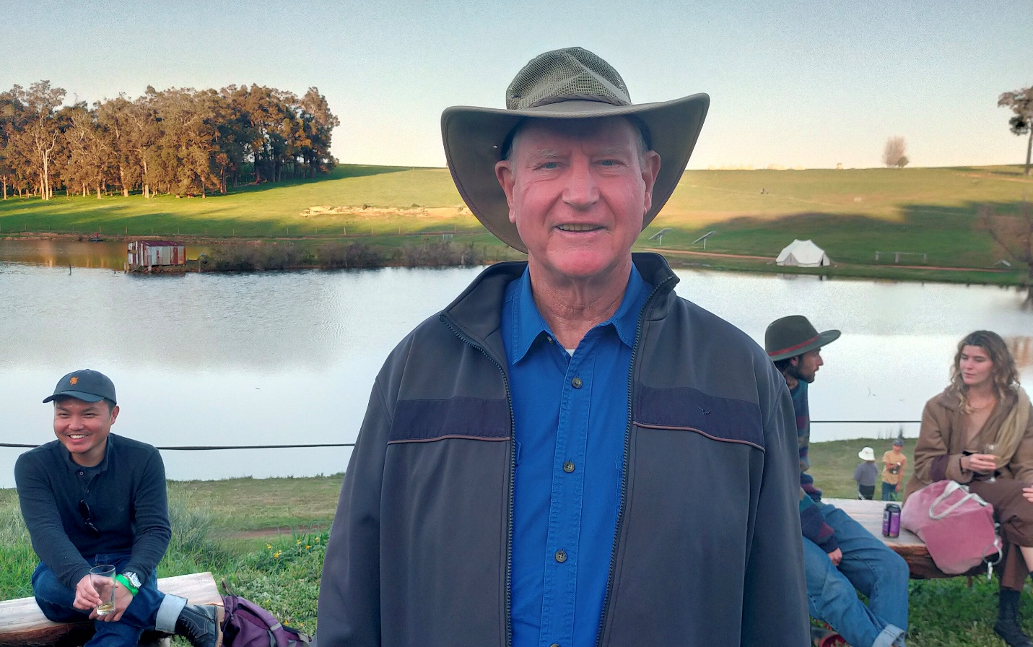
Listen Via,
Sound Cloud: https://soundcloud.com/dbcommunityradio/terry-mccosker-oam-grounded

Spotify: https://creators.spotify.com/pod/profile/radio-wa/episodes/Terry-McMcsker-OAM--Grounded-Festival-2025---BCC---24-September-2025-e38kutu

Barry Green: Head and the Heart and Arrow on Donnybrook- Balingup Community Radio, Business and Community Conversations. It's now 11:38, and the next interview I recorded at the Grounded festival is with Doctor Terry McCosker OAM, who founded the resource consulting service RCS and also Carbon Link. I'll play that now. We're at the Grounded Festival in Bridgetown on when is it? It's Saturday, the 20th of September, 2025. My next guest is Terry McCosker OAM, who is the founder of Arcs and Carbon Link. G'day, Terry.

Terry McCosker: Yeah. G'day, Barry.

Barry Green: So you've been involved in agriculture and carbon and carbon is all about agriculture, isn't it? Um, tell us what carbon link is about now.

Terry McCosker: Well, Carbon Link has been focused now for 20 years, actually, on how do we get carbon into soils in agricultural systems. And then how do we measure that? And in more recently it's been how do we turn that into money for farmers in the form of Australian carbon credit units or acres? And what we've found so far is that on the properties we've done, the income from carbon, uh, the net income, after all expenses is four times the net income from grazing animals. So it's a significant improvement to the profitability of farmers. And the thing that got me on this track is that, as you mentioned, I've been in the agricultural game for a very, very long time, and I feel that farmers have never been paid the full price of producing food. And where that full price is paid is firstly in the environment, because we have to mine the environment frequently to be able to produce food at the cost that people will pay for it. And then secondly, we mind the families and we mind the people. And farmers don't pay themselves enough. A lot of the time, uh, and their families don't get paid. And so they're subsidizing the price of food. So the environment and the farmers themselves are subsidizing the price of food. And so I believe that, um, things like environmental credits and carbon credits are actually a way of society paying farmers that do good by their environment, um, and get them more income back into the farming community. So that's the reason that that I got involved in this carbon space.

Barry Green: Very good. And, uh, in Donnybrook, uh, the council's approved a thousand hectare carbon farm for Woodside. Now, I'm not sure that taking agricultural land out of food production, planting trees and walking away and leaving it is going to serve us well. And the Aboriginal peoples talk of country needs people. And and I think that's really important because if we've got if we take families out to put trees in, there's going to be nobody there to put the fires out when they inevitably happen. So is this something that can work or is it all bells and bells and whistles?

Terry McCosker: Well, it certainly works in the short term. So if you go and plant a thousand hectares of trees for the first five years, it won't really have much impact on the environment. In fact, it can have a negative impact. Um, and then it depends on whether they're putting in a monoculture or a multi-species sort of setup, but often it's a monoculture. So, um, that's in the long term, quite damaging to land. Nature doesn't support monocultures. Um, but in then for the next sort of 10 to 15 years, it will sequester a lot of carbon, and then it'll get to a point where that forest is mature and it no longer sequesters carbon. And often people think that because the forest is there that it's sequestering carbon. It only sequester it while it's growing. Once it's mature, it's cycling carbon. And and I think that's something that, that a lot of people are probably not aware of is that in agriculture and in society, we're actually part of the carbon cycle and we don't talk enough about the cycle. And I think, um, a lot of people have the impression that carbon is something that just comes out of coal and oil and so on, and is a linear thing. It goes straight into the atmosphere. The carbon that we're pulling out of coal and oil and fossil fuels is what I would call the long carbon cycle.

Terry McCosker: So that came out of the atmosphere in the first place. Then it went in and formed these fossil fuels. Now we're pulling it out and it's going back to the atmosphere again. Um, but in the the shorter carbon cycle is what we put back into soils and vegetation. But we've got to do it in a way that's, um, not just short term thinking. So I think some of this stuff is, is quite short term. So a forest like that will have a that'll have about a 10 to 15 year impact, really, on, uh, pulling CO2 out of the atmosphere. But if anything ever happened to that forest, then that'll go back to the atmosphere. So no net gain at the end of the day. Um, but it's. Yeah, there's some there's a lot of issues in all of this stuff, but it's the reason why I work in soil carbon. Because when we're putting carbon into soil, we're improving the productivity of agriculture. We're improving the water holding capacity of those soils. We're we're improving the well-being of the people on the land, and we're keeping people on the land. And we're likely to get more people on the land because we're making it more profitable and more productive. So that, to me, makes more sense than taking it out of production just to put trees on it for a short term hit.

Barry Green: I think you're right. And there's all this talk about zero carbon, which, uh, seems to be coming from people looking at spreadsheets. But, uh, you know, my understanding is that concrete manufacture is one of the biggest emitters of CO2. So while we bring a million people in and building concrete houses. I think the zero carbon is a total impossibility, isn't it?

Terry McCosker: Yeah. It's a it's a pipe dream. It's not physically possible. Um, if you start just thinking about the amount of copper wire it would take to build all the power lines we're supposed to build, and then all the steel to hold them up. And, um, and then a statistic I heard is that we would need another 50 mines that haven't even been discovered yet for copper, for example. Um, and so what is often not spoken about is what are all the resources and what's happening to environments while we're trying to find and use these and use these resources for a very short term hit. Again, um, you know, a solar panels got a lifespan of 15 years, if you're lucky, maybe 20 years. And then we've got to do it all again. Um, and it's the same with the windmills. Um, they've got a lifespan of about 25 years. Um, they've got 60 ton of concrete under them. And I have heard that, um, they take a 44 gallon drum of oil into that gearbox on a very regular basis. So they actually running off fossil fuel. Um, and those windmills are carbon neutral after about 21 years, and they've got a 25 year lifespan. So, you know, there's a lot of, um, sort of short term thinking in this where short term hits and I always think long term, you know, I think, you know, 100 years, 500 years in advance, where are we and what are we actually creating? And I think that on the pathway we're on, I think we're creating poverty for the Australian community down the track.

Terry McCosker: We're certainly going to create, um, uncertainty in the power in the power grid fairly quickly. Um, we've got industries now that cannot, uh, are shutting down because their power supply is too unreliable to keep an industry going so that industry will go overseas and produce the same amount of CO2 to the atmosphere as what it would. Have in Australia. Um, and but some other country will pick that up. We'll pick up the jobs, we'll pick up the wealth from that. And the Australian people are going to suffer as a result of that. So I think we've got to be really careful. There's probably, you know, and should we reduce our emissions? Of course we should. You know, should we reduce our, our use of everything. Of course we should. We're a consumptive society and we've got to reduce consumption. But the thing I think that most people don't talk about is that this whole issue is about the number of people there are it's a people issue. And, um, and we're continuing to grow the population. Well, generally, not so much globally in the Western world now, the Western world is flattened out and is actually in population decline. And most of the population growth over the next 30, 40 years will be in Africa. So and pretty well everywhere else has also stopped.

Terry McCosker: So our population now is actually levelling out. But um, it's the number of people we've got, but it's the consumptive lifestyle that the Western world has created and that is going into the other countries. And, you know, they got every right to want to expect the lifestyles that we've had. Um, but I just think about my grandchildren and my great grandchildren. Um, if we go and try and reach this net zero thing, will they ever have any copper that they can mine again for anything that they need? Will there be, you know, what will be left? What industry will be left for them? What will their power supply look like? Now, I'm not too worried about it, because the first 13 years of my life I had no electricity. I grew up with kerosene lamps, um, no running water in the house. And that was in the 1950s. Now, if we take net zero to its natural conclusion, And we're taking the Australian population back to that. And I don't think the Australian population firstly realises that. And they're certainly not going to vote for it down the track. So once that realization happens that we are headed back in time, um, in terms of our ability to consume and and don't get me wrong, I think reducing consumption is really what we should be focused on, but we don't seem to focus on that at the moment.

Barry Green: I find it most perplexing that, uh, we're shutting down our coal power stations, but we're selling millions of tonnes of China, and it's all right for them to burn coal, but not for us.

Terry McCosker: Yeah, and some of that industry that will leave Australia because we don't have the power supply to to keep those factories and plants operating will actually end up over there potentially using our coal to, uh, to do it. You know, there's, there's, uh, it seems to me that there's a lot of, um, I don't know, hype or Hardball, politicization of stuff and not a lot of common sense, and not a lot of. I don't think if you start talking to the engineers about what's going to happen to become net zero, they just say it's a physical impossibility. It cannot happen. So, you know, yeah.

Barry Green: It's sort of marketing over science I think. And but but of course, in all this, regenerative agriculture is the one industry that can sequester carbon and, and produce food and create employment in regional Australia.

Terry McCosker: Yeah. If, you know, if, if the government, for example, encourage farmers to pull, improve their soils and pull CO2 out of the atmosphere, if we just had 15% of Australia's farmers doing that, we could offset a quarter of Australia's emissions like Australian farmers. And they're not all like if we just took a group that was capable of doing it, that we could draw down 100 million tonnes of CO2 a year and put it in a place where it's useful. And to me, taking it out of the atmosphere and putting it in a place where it's useful should be our highest priority. But our highest priority seems to be, um, let's try and stop emitting, um, or reduce our power. But, you know, there's a tractor just driven past us. What? What fuel will that tractor be able to use in five years? Ten years? 20 years? Still be using something like diesel? You know, so we got a long way to go, and we're just at the moment just focused on the power system.

Barry Green: I was talking to Ian and Di Haggerty, their West Australians or Australians, the years for Western Australia this year. And Ian was saying that, you know, the financial situation they could be offered, you know, multi million dollars from foreign corporations to, to buy the farmland to put in, put in solar panels or wind farms. So it means that Australian productive farmers are competing with those sort of buckets of money to to buy farmland to try and grow food for Australia. So I think this really becomes a national security issue. There's no point in having a 21st century defence force if we're reliant on imported food. So how do we sort of get that, that, that issue onto the agenda? Terry.

Terry McCosker: Uh, I fully agree with you that food security is one of the biggest issues facing Australia. Um, for example, Australia today, we've done so much damage to the dairy industry that Australia has to import butter. Now that, you know, when I was a kid, Australia exported butter. Now we're an importer. And it wouldn't be too long now if the dairy industry continues to collapse at the rate it's collapsing. And that's simply because farmers are not paid enough money to stay doing what they do. Um, that we'll be an importer of milk as well. We already import a lot of fruit and vegetables.

Barry Green: With the diseases that come with them. And in Western Australia, the West Australian apples, one of the most wholesome apples on the planet because we haven't had apple scab, codling moth and fireblight. But we risk bringing those in by bringing those those products in. So the whole sort of global free trade agenda is about free trade, but it seems it's not environmentally very smart.

Terry McCosker: No, it's a free trade is a real issue because, you know, if we want somebody to buy our product and they want us to buy their product. And so that's a tricky situation when it comes to biosecurity.

Barry Green: So it is a it's a wicked system. We're in a system that's always looking for three word slogans to solve all the problems. But even getting back to that and this, you know, the whole Covid thing. Doctor John Campbell in the UK, I've interviewed, uh, Doctor Aseem Malhotra, who's a, who's a doctor who's, you know, questioning the whole process. But what he is saying and I think this is really relevant. He said what deregulation has done really is shifted regulation from government to the corporations. And I think the dairy industry, which you touched on is a classic example. You know, we had a significant dairy industry around the south west of Western Australia, mostly medium sized farmers. They've all gone now. Dairy industry is actually one of the most highly regulated industries in the world still. It's nominally deregulated, but as a farmer, I can't sell you unpasteurized milk. So to say it's deregulated is a complete con. It's simply transferred regulation from the elected governments to essentially foreign corporations.

Terry McCosker: Yeah, I really haven't read in that subject, so I really can't comment on that. But, um, a farmer have not been able to sell whole milk to society. I grew up on whole milk. I lived on whole milk. We never had anything other than whole milk, um, for most of my life. And, um, well, certainly the first quarter of it. And, um, we never got sick. And I'm very thankful today for the microbiome that built in me. And now I'm getting older, but I'm very, very healthy. And it's because of that microbiome I built on that dairy farm. There's no doubt that Australia's a nanny state now, and we're overregulated in everything you do. And and it seems to me that the majority of people's jobs are to stop the minority of people for doing what it's going to take to run the country and feed it.

Barry Green: So that was, uh, Doctor Terry McCosker OAM, talking at the Grand Festival in Bridgetown on the weekend. All these, uh, interviews and conversations I've had on the program today will be on the Dbca on SoundCloud. Go to dbca, click on recordings and you'll be able to listen to them online. I'll also post them to the radio podcast. Um, I'm Barry Green, thanks for your company today. I'll be back. Same time, same station next week. Now we'll go with Texas and in our lifetime.

