Tom & Bruce - Lions Organisation - BCC - 10 Dec 2025
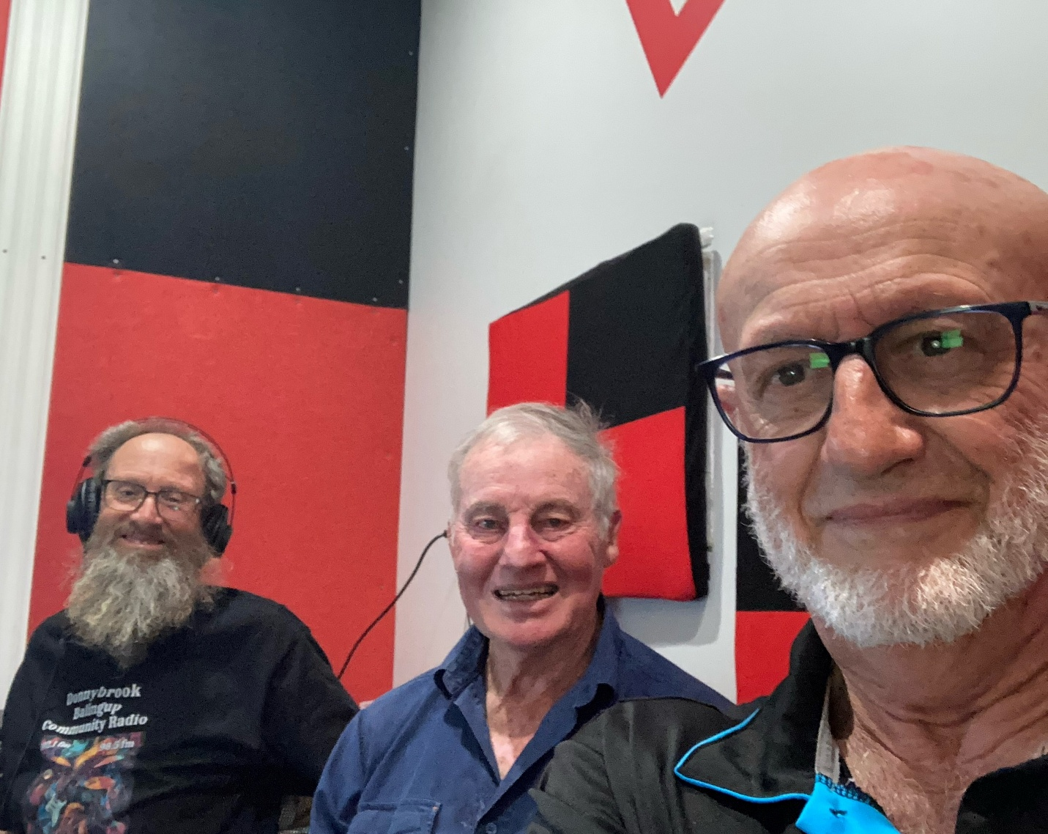

Listen Online

Sound Cloud: https://soundcloud.com/dbcommunityradio/tom-bruce-lions-organisation

Spotify:

Barry Green: That's. Yes. And, uh, "Wondrous Stories" on Donnybrook-Balingup Community Radio Business and Community Conversations sponsored by Harvest Highway.com.au . Our next guests are members of the Lions organizations. Tom Oversby is the district governor in Western Australia. G'day, Tom.

Tom Oversby: Hello.

Barry Green: And Bruce Hammond, the secretary of the Donnybrook Lions. G'day, Bruce.

Bruce Hearman: Good morning, Barry and Tom.

Barry Green: So we're here to talk Lions. And I guess, uh, first of all, the Lions as an organisation was founded in 1917, in Chicago, successful business people wanting to return something to their community. And that's still the ethos of the organisation. Tom, do you want to talk a bit more about it?

Tom Oversby: Yeah. Thanks, Barry. We, uh, our main motto is we serve. And that's the whole idea. And this year is quite significant because it's 100 years since, uh, Helen Keller challenged lions to be knights for the blind in the Crusade Against Darkness. And I'm really pushing for a lot of, uh, donations towards in among Lions Clubs, donations towards our Lions Eye Institute, because I think it's a really significant year.

Barry Green: It is. And I think, you know, there's lots of things about charities these days. But I think what a lot of people don't understand about lions is that it doesn't have the, the hierarchical top and that, uh, the, the, the, the organizations runs two accounts and administration accounts and, and an activities account. So any any time you buy a sausage sizzle off of lions, the proceeds of that becomes public money. It isn't used to employ senior executives and all that sort of thing. I think that's something that people really need to understand.

Tom Oversby: That's right. Barry. Uh, in fact, in Lions Australia, I think there's only three permanent employees. There's a few people work part time, but in the whole operation throughout Australia. There's only three people work full time. All the rest are voluntary.

Barry Green: And they are paid for out of members funds, not funds raised from the public.

Tom Oversby: That's right. Each Lions Club is asked to contribute so much towards Lyons. Lyons, Australia. And that's where it goes.

Barry Green: So that's the big picture. But uh, but down at the grassroots level, we've got Donnybrook Lions Club. Bruce is the secretary. Bruce, uh, there's so many things happen in Donnybrook that wouldn't happen without lions. And they're coming up in the next few weeks. Do you want to talk about what we've got?

Bruce Hearman: Well, um, certainly. Um, this week is probably the one we're concentrating on at the present time. And that is our Twilight markets. And this is the first year the Lions Club at Donnybrook have been involved with organising that. Um, we've stepped in in the middle of the year when, uh, the tourism association finished its time managing the station markets and now the twilight markets. So, um, that's something other where we as volunteers, members of the club can support the community by maintaining, you know, that that event from from running or perhaps fading away into the future because it does add something rather to the to what we are as a community.

Barry Green: Absolutely. And and I guess it's probably going to be good for lions because, uh, you know, any organization needs new members to, to, to grow and new ideas and, uh, you can go through cycles. I know the club wound up, but that's reactivated and got young people in. So I guess with all the things happening in the world at the moment, there's nothing we can do anything about. If Lions provides a mechanism where people who want to contribute to their local community can get involved.

Bruce Hearman: Uh, very decidedly. And, you know, we're quite clear, um, we all join organizations, whatever they are, because, uh, we, our experience of them or our sense of them is that they give us something back in return. Um, you know, the opportunity to make a contribution somehow or other, um, to give back into our community, if that's what's important to us. Well, then there's just the basic friendship issue, too, that, uh, you know, we all appreciate in any organization we're part of. So, you know, in Lions, I think that is the main contribution that it can make to individuals is that it gives us a chance to be involved in our case and what's happening in the town and the community, and that we can support those, you know, the town and those elements of it.

Barry Green: And people do grow through the experience. I know I was I did Lions leadership training in 1998. I think it was the year before I was president of Lions Club at Donnybrook, and I learned so much in that. And and the DCR exists because of lots of people working as volunteers. But the Lions Club was the the provided seed funding to, to get it started. So the Devco wouldn't be here without the Donnybrook Lions. And also, you know, the Lions have allowed us access to this, this building as well. So this very much comes back to this business community partnership sort of thing.

Bruce Hearman: Well, it certainly is. And that's, that's a that's an element if you like, that. We've become involved with, you know, going back before that time, we didn't see necessarily that was a requirement of us or something we'd become involved with. But it became an opportunity where we did and we were able to support it. And, you know, that's the element of being a member of organizations like Lions, where there's fulfillment and reward in knowing that you're actually making a contribution, that other people are getting some value from it.

Barry Green: And you gain experience and contacts, too.

Bruce Hearman: Well, that was the other element you started to talk about, you know, Tom's district governor. Now, I was district governor in 2004, 2005, but I never joined lines to be a district governor. I just joined lines for those other things we've been talking about. But over time, um, you develop skills and abilities and, and you're recognized by other people, possibly to the point that, um, you move up the administration line, if you like, inside of lines. And next thing, your district governor doesn't happen to everyone. Um, but I don't know of any district governors that have regretted ever the opportunity of serving that that 12 months as district governor. And they're their district lines district around Australia, of which there I think are 19 districts now or something, 18, 18 districts. So, um, that year is usually a very special year, but it was not something you anticipated before you joined the organization. Yeah.

Barry Green: So you're the District Governor at the moment, Tom. So you where did you go for the inaugural?

Tom Oversby: Oh, I went to Orlando in Florida.

Barry Green: Right. Okay. And so that was a great experience.

Tom Oversby: Oh, yes. It's a great experience. And I was just listening to what you were saying about the community radio Barry. And I remember when you spoke at our convention, you said that there's no district radio without a Lions Club in the town.

Barry Green: And that's the South West. Yeah.

Tom Oversby: That's right. Oh, that's the south west. Okay. Well, that's quite significant. It is. Yeah, actually.

Barry Green: And you know, we see ourselves as a voice of community and small business and, uh, you know, there's a lot of focus on the online stuff and that sort of, you know, causing a bit of displacement around the place. But at the end of the day, I think community radio, The local voice is so important and you know, AI is creating all sorts of change in the world. But a lot of the time with the, the AI, uh, it's getting very hard to know what's truth and what isn't truth anymore because, you know, you can see something looks like somebody you think, you know, saying things that they never said. Yeah. Um, and I guess that's with all that, a sense of community, uh, whether it community radio or other community organizations aligns is vitally important going forward.

Tom Oversby: Yeah. Well, I think what, uh, the point that Bruce brought up earlier about, uh, fellowship and friendship and I consider lions a family. I think we're a family, a Lions family. And, uh, if you go to any town, if you know lions, they're well, already. You've got an inn, haven't you? And you've got to start. And that's why it's. It'd be great if people like teachers and police and people that transfer a lot. If they joined Lions, they'd find life a lot easier, I reckon. Yep.

Barry Green: Well, when I joined Lions and wrote in 1980, and in the 80s we did a working holiday around Australia, and I made contact with the local Lions Club and got work.

Tom Oversby: Yeah, that's a good example.

Barry Green: Yeah. Okay, well, I often say we do have to pay our bills, so we'll run a sponsor message and come back and talk after that.

Sponsor Message: You're listening to Donnybrook-balingup Community Radio. This service is made possible by our station sponsors. Please support them. Donnybrook butchers, Donnybrook RSL and Skippers Plumbing. Stay listening. You'll enjoy it.

Barry Green: The BeeGee’s “More than a woman” on Business and Community Conversations sponsored by Harvest Highway. Com.au and I'm talking to Tom and Bruce from the Lions organisation. And since about the 1980s, Lions. It used to be just a male organisation, but it's a men and women organisation and that's sort of changed the organisation and been a big part of its continued success. Tom.

Tom Oversby: Ah, yes. Yes. Well, Mao Tse-tung said women hold up half the sky. And I tell you, in Lions Clubs there's a lot of, a lot of the offices are filled by ladies. Yep, that's for sure.

Barry Green: Yep. And, um, Bruce, you were talking about the Twilight markets on this Friday. Lions are also doing the, uh, carols.

Tom Oversby: Christmas carols?

Bruce Hearman: Yes. The carols are on December the 20th, which is the Saturday next Saturday a week away. Yep. So we're busy sort of with the Twilight markets this Friday. And then of course, it doesn't stop. We carry straight on with the organization that's been ongoing for some time for the carols, which is our regular annual night. So with just the Twilight markets at the present time, there are about 50 stallholders going to be attend. So the whole of Aires Gardens is going to be chock a block with stallholders. They're coming from Perth, all around the southwest as well as locally. So it's really I'm quite impressed by the response we've had to, um, for people to come and be on site. Um, bit of food there. Um, we're not overdoing that because we'd like to. And of course, this is being run in combination with the Chamber of Commerce, and the chamber chambers. Of course, keen that the opportunity for food providers down the main street get the opportunity to get something out of all this. So they've been organized to, uh, you know, to have food stocks available for someone. I think in the past, there's been the occasion where people have run out of chips and things like hot chips and so on. So anyway, so have a little bit of food available. Um, it'll run from 5 to 8, but there'll be people there from midday onwards. Basically didn't set up. Um, so it's really quite going to be going to be a great event.

Barry Green: So yeah. So that's something to get along to. And I guess one of the things about the Lions organizations, it does provide a structure. And uh, and with that structure comes insurance. So if, if you've got some project that you'd like to get up, if you become a Lions member, then there's an opportunity to do that under that structure rather than starting from scratch and incorporation and all that sort of nonsense. So I guess that's one of the strengths of the organisations. Tom.

Tom Oversby: Yes. Uh, mate, because if you even if you're a volunteer helping the lions as long as you're, uh, jotted down. They put your name down when you volunteer and the hours you do. Well, you're well and truly covered, so that's a good thing. And when, uh, people take lions on to help them with a project, that's where it's a big advantage to be with lions.

Barry Green: Yep. Okay. So, um, any organization needs new people and young people to to to grow and gets, uh, I guess the lions being at the market should be a good thing for for people to sort of meet up with Lions members and, uh, express an interest. And there's lots of people moving to Donnybrook, and there's nothing like getting involved in a community organization to become part of the town.

Bruce Hearman: Well, and quite often new people to the community are looking for something or other, some mechanism where they can become involved in their community. And the Lions Club is a wonderful opportunity for them to do that. So, um, you know, and we we're not we're completely unlimited as to areas we might become interested in is simply that it's the resolve of members if they want to take on an issue around about to support, well, they can do it or invent something new. You know, there's like no limit at all to what it is we might become involved with. Um, but at the end of the day, we're all in it because we're getting something back from it, whether it's serving others, looking after others or or the friendships that are formed, um, the relationships you create with other people out of your own town, through through lines and other clubs and other communities. It's it's really no end to it. Yeah. So whenever we're travelling, we take what we call our lines directory with us in the car. And we any town we come to throughout Australia, we can always locate a Lions Club and contact people there. And it's like there are just other people's members of the family. That's really a remarkable.

Barry Green: Thing, is it? It really is an important thing. And as I said, that's how I got work when I was travelling, you know, when I was young last century. Um, and. Yeah. And people who are travelling, um, you know, actually we're talking about this with the chamber and tourism and, you know, the online stuff is all well and good. But at the end of the day, tourism is about relationships with fellow human beings. And if it's an introduction to somebody in another town, that's a that's a great part of the human condition.

Tom Oversby: Contact. That's the key.

Barry Green: Yeah. Okay. Gentlemen, anything you want to say before we wind up?

Tom Oversby: I Barry I'd just like to say that next month I'm going to the council of, uh, Council of Governors. Yep. And, uh, we get there, we get ideas. I'm going over to Sydney, actually, for it. There we get ideas from other, uh, clubs, you know, right around Australia. And, uh, we're all facing the same issues so that, you know, we're not alone. We're, um. In fact, it's not only lions. Of course. It's everywhere. Uh, membership is difficult, but I think it's just going through a cycle, and I think things will get better. I think younger people will realize, uh, what's going on, and hopefully they'll jump on board at a later date.

Barry Green: And, you know, being actively involved in your community is taking ownership on any issues that are happening. And as I often say, there's nothing we can do about what's happening on the other side of the planet, but we can influence what's happening in our own backyard. And and the lions structure provides a mechanism for that.

Tom Oversby: Dead right?

Barry Green: Yeah.

Bruce Hearman: Very definitely.

Barry Green: Okay. So thanks both for coming in and I guess look forward to seeing you all down at the Twilight Market on Friday.

Tom Oversby: Yeah, you won't see Tom because I'll be at the Twilight Markets in Vass because I'm a member of the Kerry Park Club. But that's a branch of Vass, right? And I'm assisting Vass on on that Saturday. And they're having their Christmas carols that night.

Barry Green: Okay. So there's lots happening around the South West that wouldn't happen without lions.

Tom Oversby: That's dead right. Thanks very much, Barry.

Barry Green: You're welcome. Thanks, Barry. I've been talking to Tom overby, the district governor of lions in Western Australia, and Bruce Heyman, the secretary of the Donnybrook Lions. Now we'll go to James Smith and dancing with you.

