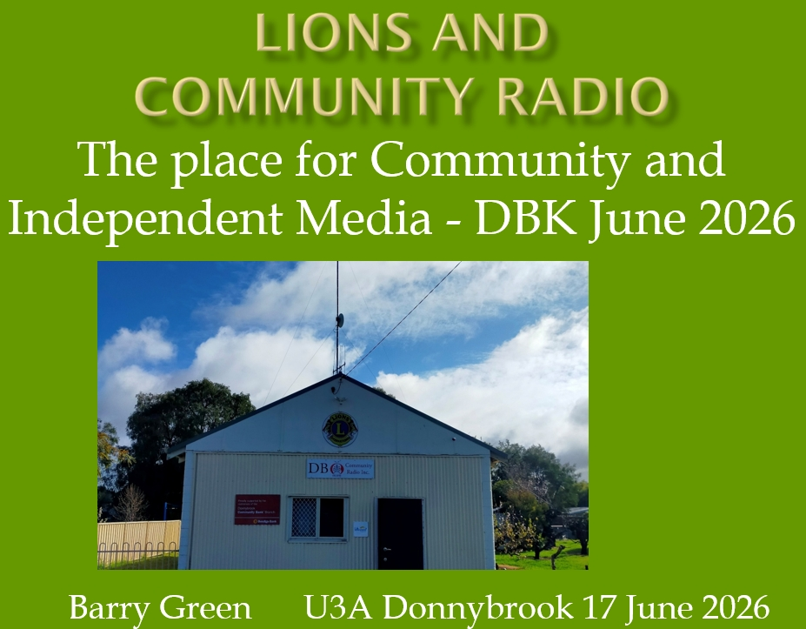
Listen online
Radio WA Podcast : https://creators.spotify.com/pod/profile/radio-wa/episodes/The-Place-for-Community-and-Independent-Media-e3kv33i
Sound Cloud : https://soundcloud.com/westerntouristradio/the-place-for-community-and
I gave a talk at the Lions District Convention in Busselton last year. So the first 15 minutes, I'll repeat that talk. And there's a lot that's happened since September last year so I'll wing it after that with some slides.

Donnybrook Balingup Community Radio Inc, is very much a product of the Lions Club of Donnybrook. DBCR exits because of a lot of work by a number of people who have brought differing skills and dedication to the organisation. I think it would be fair to say that it wouldn’t exist without me, but I wouldn’t have been able to do it without the training and experience gained through Lions.
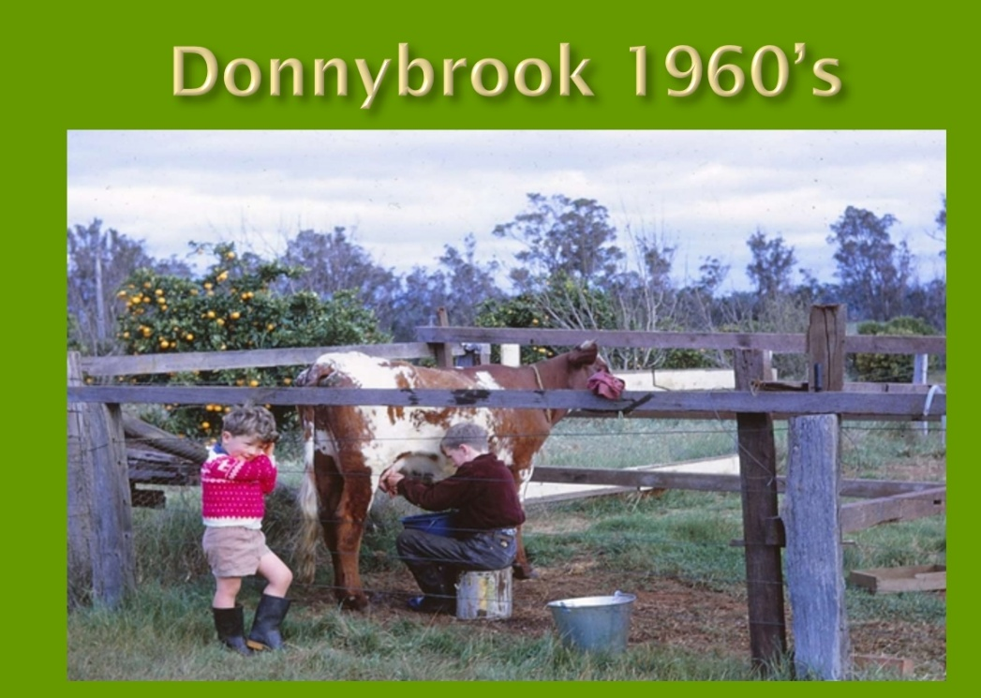
I grew up in Donnybrook in the 60’s. I was a members of scouts and first got interested in radio from a technical perspective because of the scouts Jamboree of the Air, where we visited local Ham radio operator Jack Kitney, who became a mentor to me.
I trained as a radio tech with Dept of Aviation, and in 1980 when working at Wickham, joined the Lions Club of Roebourne.
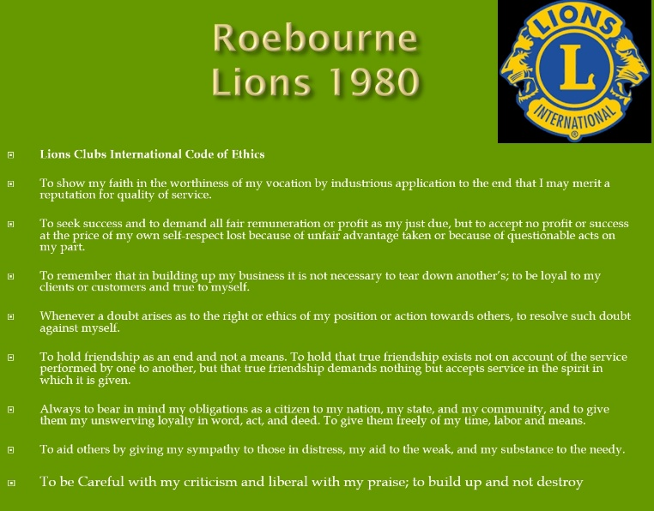
At my induction night, the guest speaker, a pom, said it is great to see so many active community services organisations in Australia. He said in the UK government had filled the function that used to be done by such clubs and numbers had declined. In 1980 Donnybrook had Rotary and Apex Clubs . The Lions Club of Donnybrook was formed in 1982. Sadly, since then Australia has followed the same path as the UK. We seem to have develop the idea that government is for looking after the community and business is for making money just for shareholders. It is becoming increasingly apparent that asking government to look after community is not serving us well!
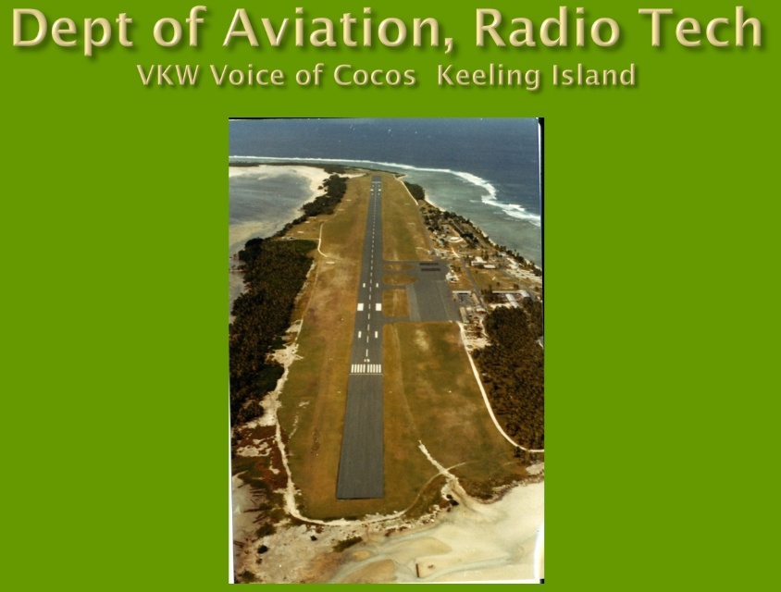
In 1983 we were transferred to Cocos Is and I got involved with the local community radio. I saw what a powerful community building tool it could be.
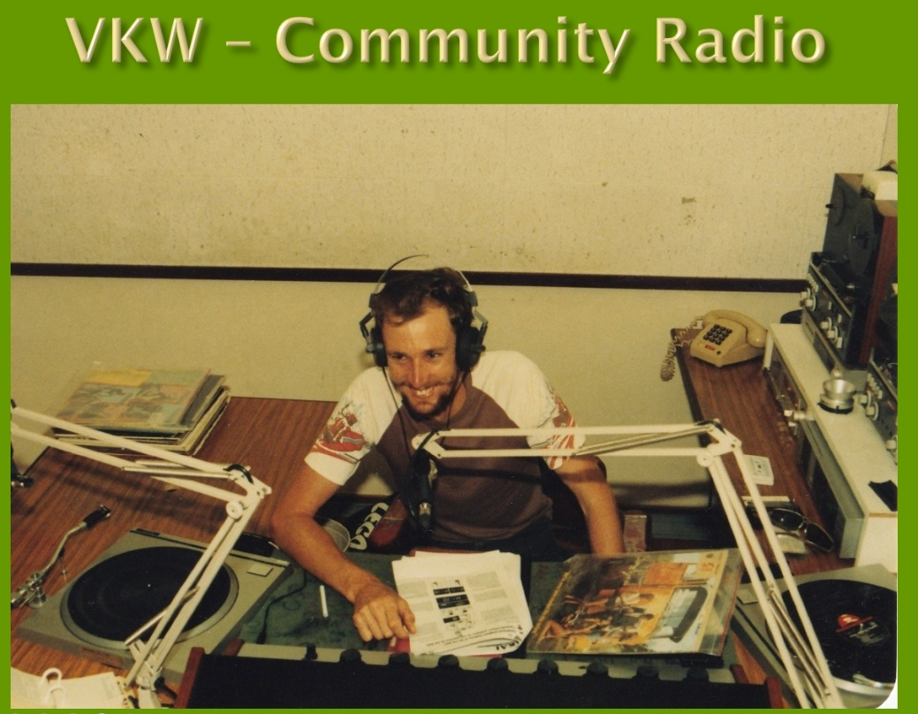
My wife and I grew up on farms in the South West and were keen to bring up our kids in a similar environment.
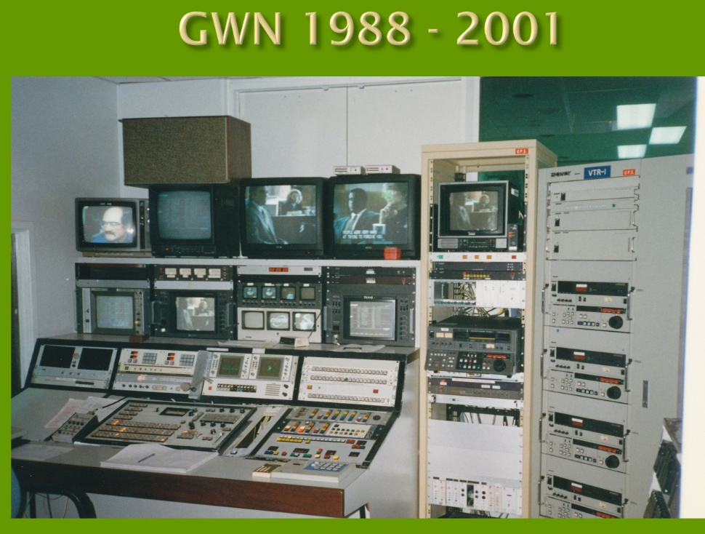
In 1988 I got a job at to GWN TV in Bunbury which gave us an opportunity to buy Boronia Farm at Donnybrook.
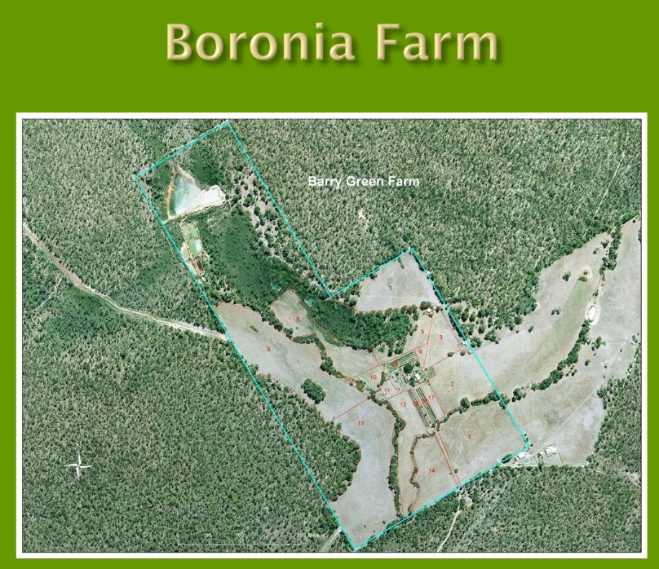
I then transferred into the Lions Club of Donnybrook.
1998, the year before I was President of the Donnybrook Lions Club I attended Lions Leadership training course at the Q station at Albany run by Jeff and Irma Needham. That changed my life.
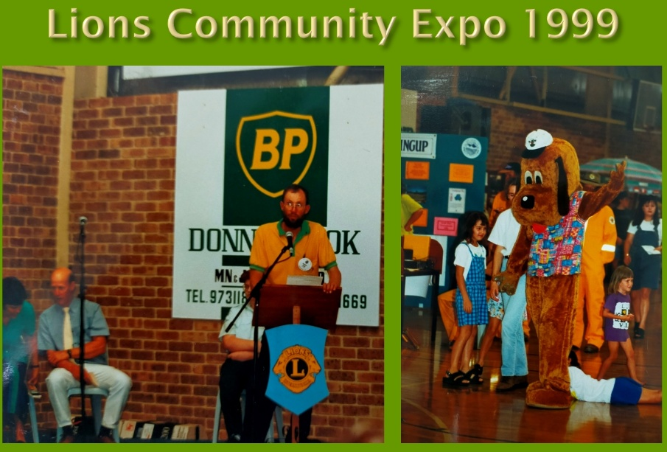
As a result of the training, I formed the idea of the DBK Community Expo as a membership project of community organisations in Donnybrook. I chaired a committee with members of a number of community organisations and the Lions Donnybrook Community Expo’s were held in 1999, 2001. I got a buzz out of the success of the Expos.
In 1999, we renovated an old cottage on the farm for Farm stay accommodation and this got us into tourism in a small way.
By the year 2000 it was becoming obvious to me that the job at GWN was going to end, so I was looking for something else to do. I’d become involved in the tourism assn in Donnybrook and was aware of Tourist Radio. I asked if there was any interest among the Donnybrook tourism assn in establishing a local tourist radio. There wasn’t. So I made enquiries anyway.
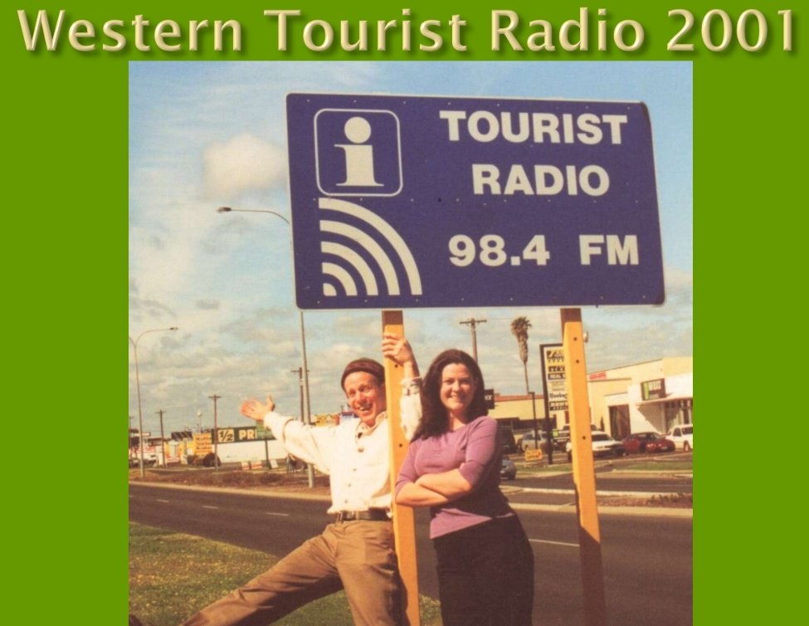
This led in 2001 to us acquiring Western Tourist Radio which at the time had 23 licences and operating stations in Perth, Fremantle, Bunbury, Busselton, Dunsborough , Cowaramup and Karridale. At that stage the program was just playing from a CD player.
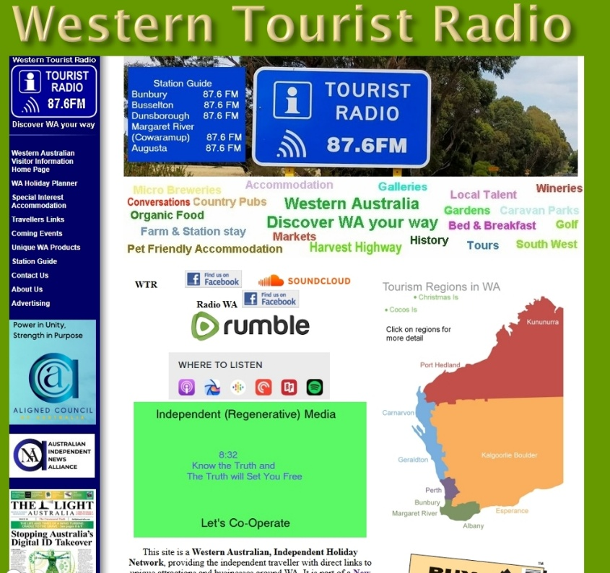
I employed a local company, which operated the “South West Life” E-Magazine, to do Search Engine Optimisation or SEO for us. We invited the owners to our farm for a bbq, and talked about how SEO worked.
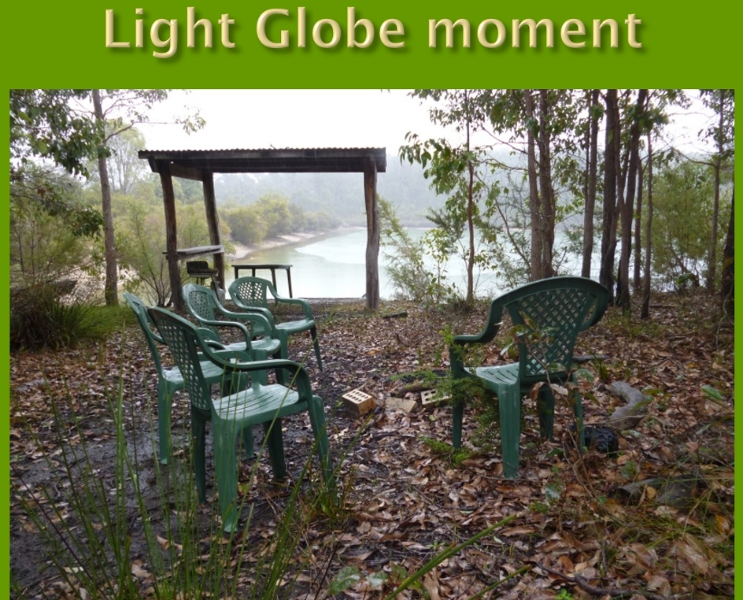
Graham explained that Google had become the most successful search engine because they had figured that the more sites that linked to a particular website, gave that site authority and it would come up in the rankings.
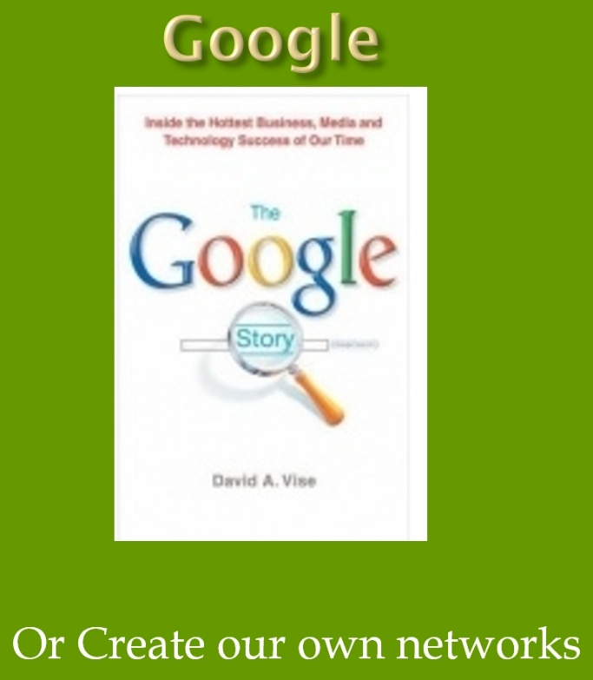
That was a light globe movement to me because I could see that it would allow the best information to come to the fore, not the information promoting products with the most money to spend on advertising, delivered via my old employer, Commercial TV. So I tried to build the website as a WA Visitor Information Portal, on the basis of reciprocal links. It was, and still is a good idea, but was hard to sell to people who had a competition rather than a collaboration mindset.
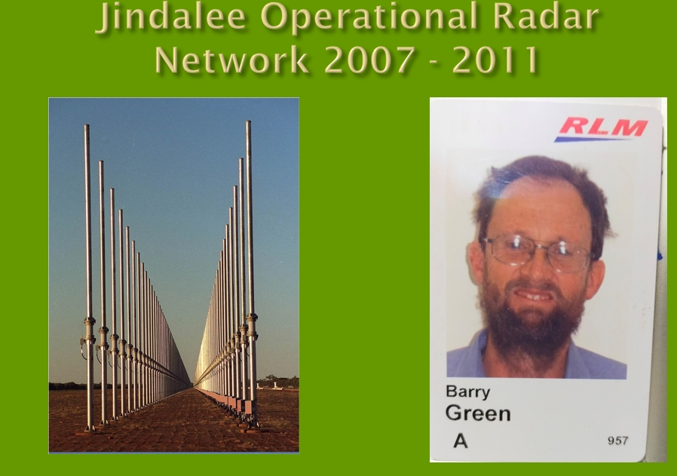
Western Tourist Radio nearly sent us broke. So I was fortunate in 2007 to get a job working FIFO on the Jindalee over-the-horizon radar at Laverton in the WA goldfields. This is a RAAF installation, but Lockheed Martin had the contract to operate the maintenance contract for that job. I had to have a Top Secret Australian government security clearance. I'm not sure our cabinet members have one of them.

In 2011 2 people came to me separately, asking how to establish a community radio in Donnybrook, both knowing about my radio background. The three of us met and we called a public meeting to see if there was community interest in perusing community radio.
There was, so we formed a steering committee, and the Lions Club of Donnybrook provided seed funding.
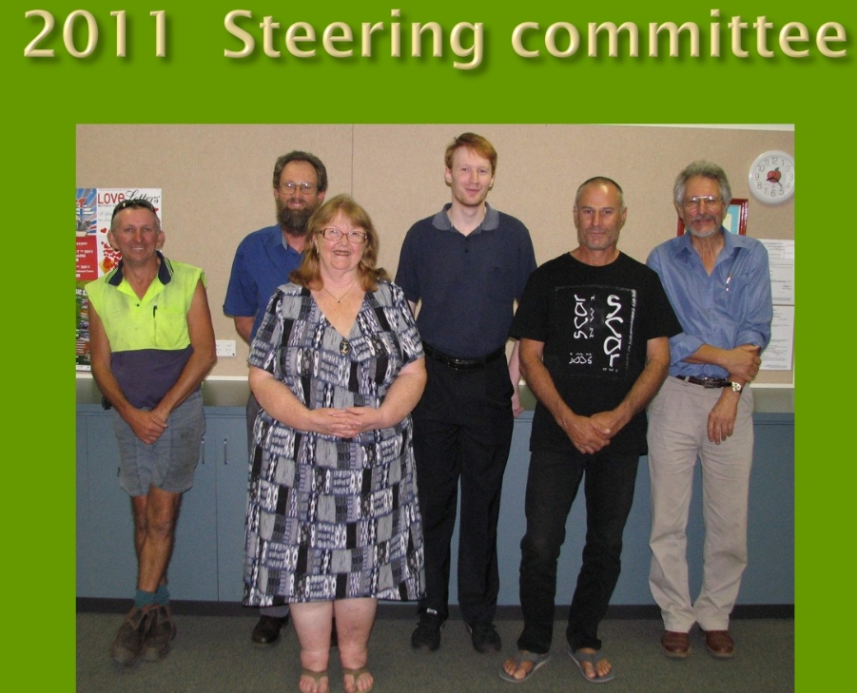
Donnybrook Balingup Community Radio was incorporated later in 2011, but we could not find anywhere to operate from until the Lions Club agreed to allow DBCR to annex part of the Lions Den.
We developed a 3 stage plan to get on air in Donnybrook and Balingup.
Stage 1 was just a 50 Watt Tx with an antenna on the roof the Lions Den / studio.
Stage 2 was a tx on the police mast on the hill overlooking Donnybrook which would reach much further and
Stage 3 was a transmitter in Balingup.

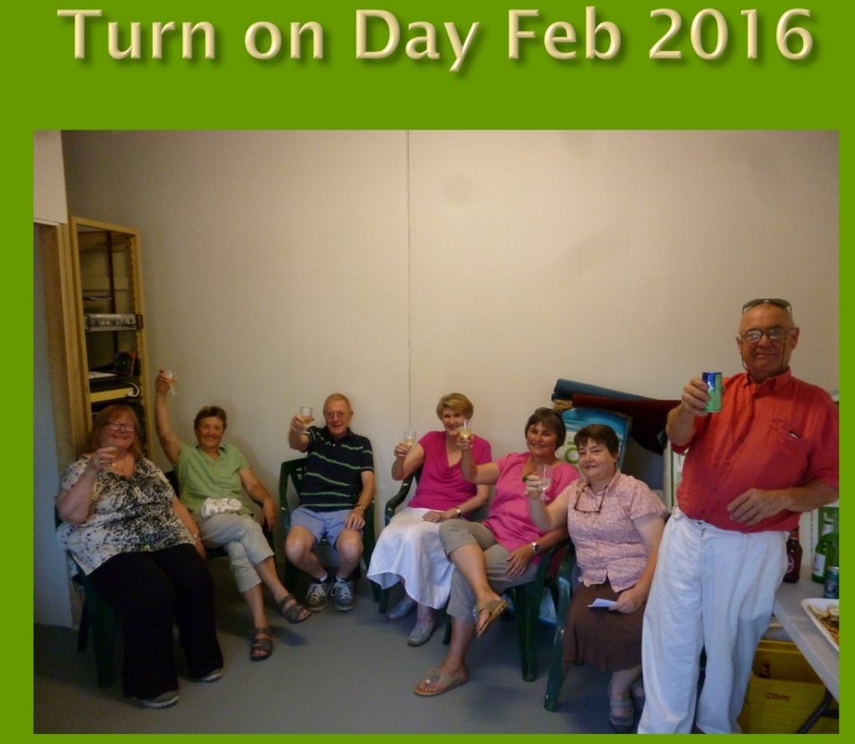
We got to stage 1 in Feb 2016. This didn’t go very far but at least we were on air. We did this with all our own fundraising. Initially we were just running a loop program, but the Lottery West funding allowed us to buy the automation system that allowed us to operate 24 hours a day and to run live programs as well. This proper service started in about June 2016.
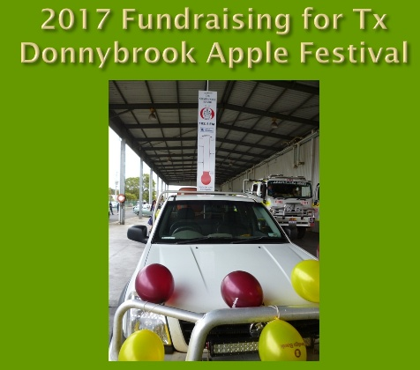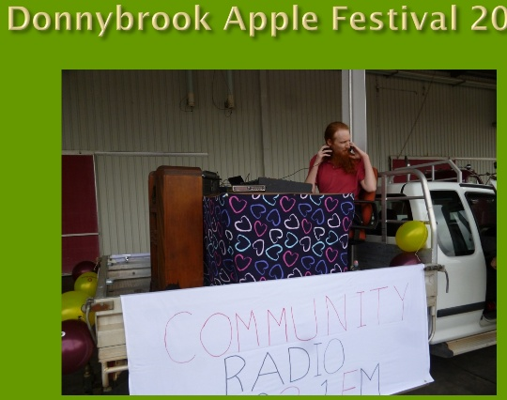
We continued fund raising for the new Donnybrook Transmitter site , and participated in the Donnybrook Apple Festival
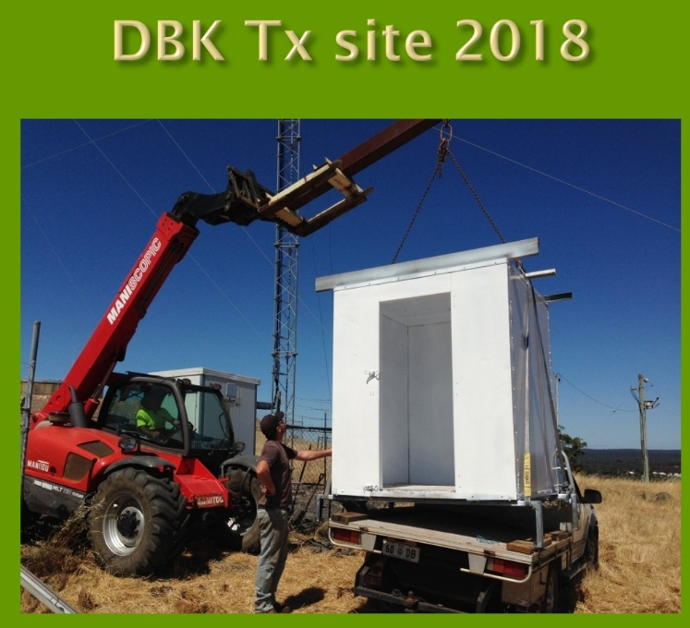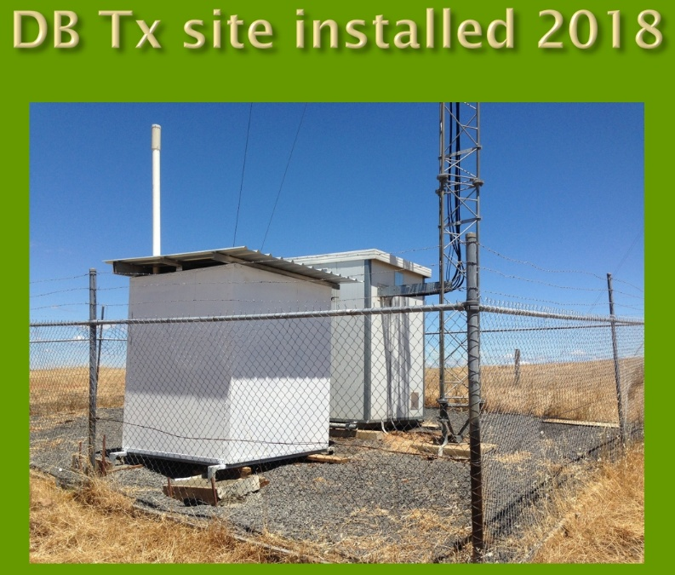
We then received $30,000 state government funding for the Donnybrook transmitter on the hill which we completed the day before Anzac day 2018.
By doing most of the work with volunteers we completed this for $21,000.
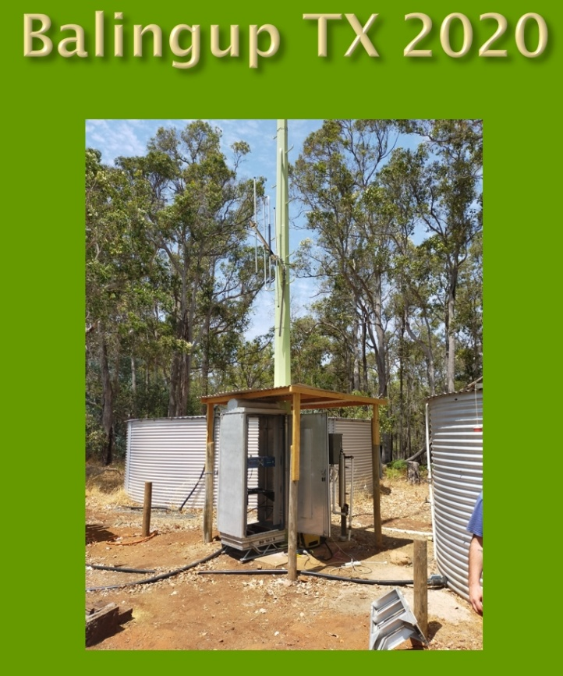
The government allowed us to use the remaining funds for the Balingup Transmitter which we completed in February 2020.

DBCR is a member of the Community Broadcasting Assn Australia, or the CBAA. In 2018 I nominated for their “National Features and Documentary Series” where community radio volunteers are mentored to produce a 30-minute documentary.
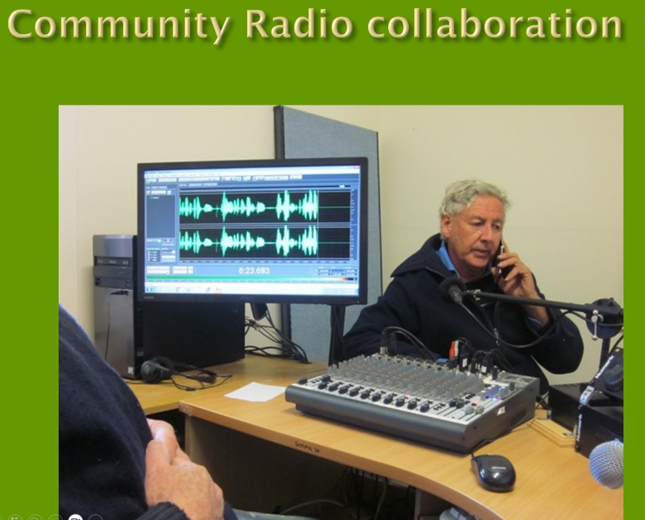
This resulted in me producing a half hour documentary titled “Healthy Soils, Healthy Communities” about Regenerative Agriculture. It was based on interviews with Charle Massy, Author of “Call of the Reed Warble, a New Agriculture, and New Earth”, and others, including Regen Ag farmers Ian and Di Haggerty who are current WA winers in the Australian of the Year awards for their leadership in regen ag.
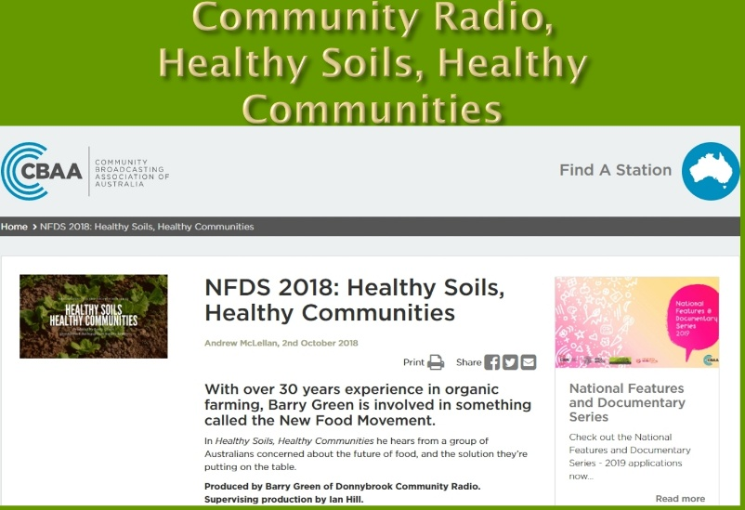
The program was available for community stations all across Australia to broadcast and remains online. This combined my interest in organic / regenerative agriculture and radio.
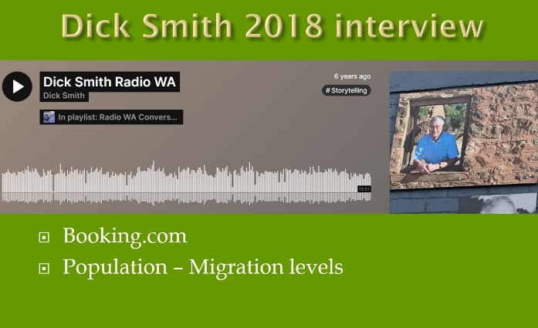
In 2018 I interview Dick Smith on tourist radio. This came about because Dick was encouraging people to book accommodation direct, and not use the big booking engines that are taking big commissions overseas. That is what I have been trying to do with the tourist radio website.
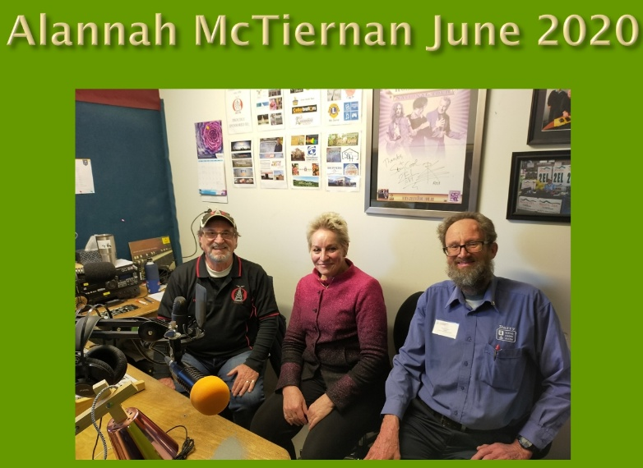
Alannah McTiernan, was the Minister who approved the state government funding for our transmitter, and also brought Charles Massy to WA to talk about Regen Ag, which prompted my CBAA documentary with Charles.
In mid-2021 I started producing a weekly 2 hour talk show initial called “Talk of Our Shire”, which was sponsored by the DBCCI. We talk to local businesses and members, local organisations, artist, musicians politicians and other movers and shakers. Our interest is local and national issues, from a local perspective.
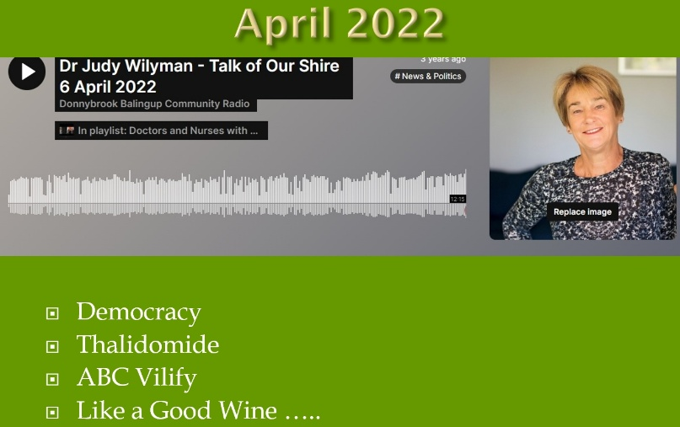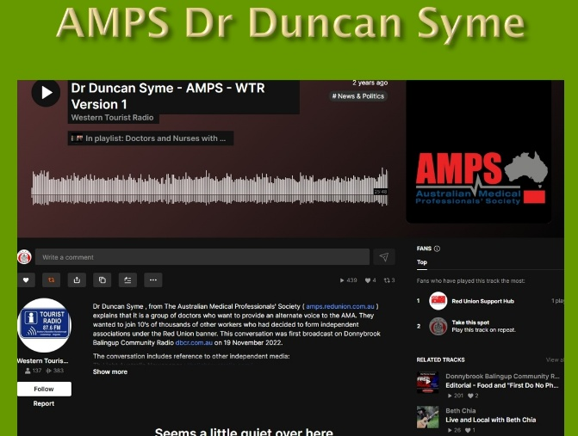
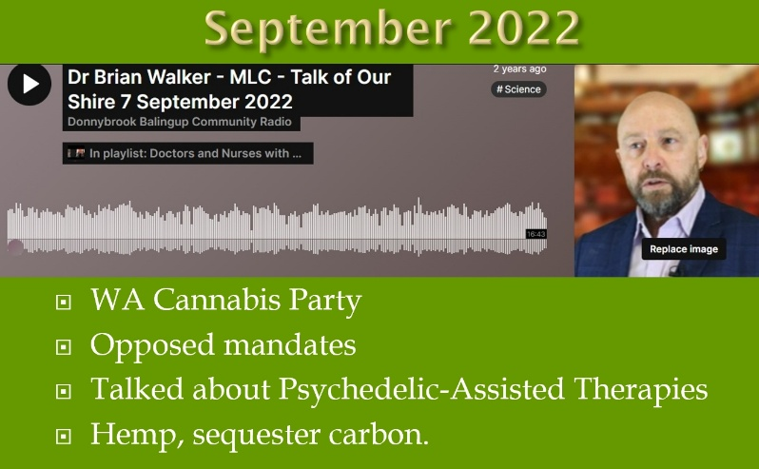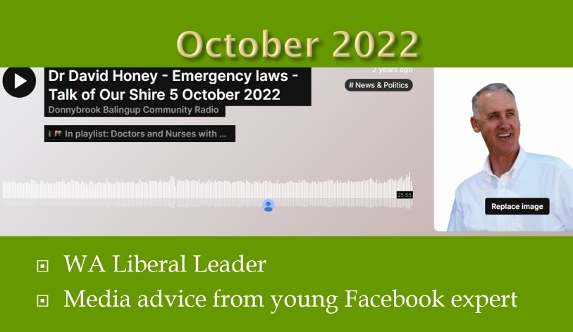

I’d been very concerned about the Covid injection narrative and associated censorship, so used the opportunity to question that narrative. As a volunteer on Community Radio, I have been able to have conversations with all sorts of experts, that professional journalist have not been able to have, for fear of getting the sack.
As a volunteer , it doesn’t matter if I get the sack!
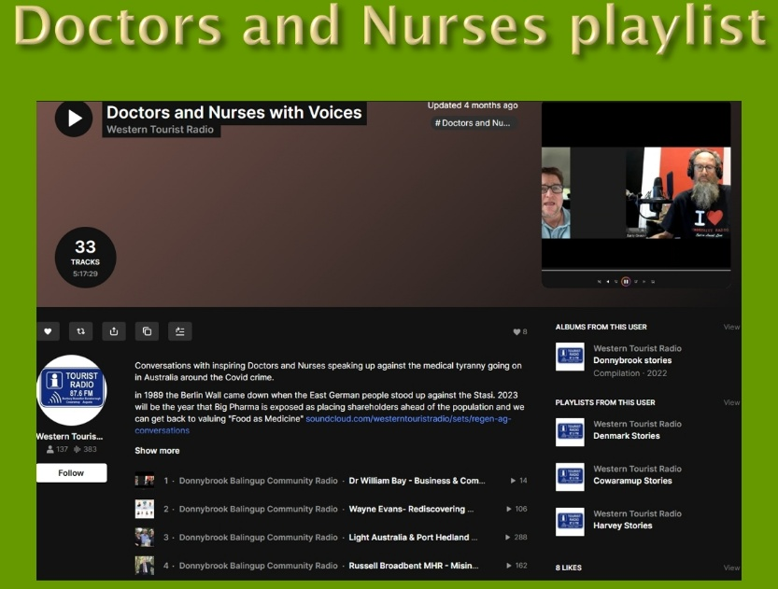
All these conversations are posted online, where they remain as an oral history, recorded at the time.
The conversations are compiled into the Doctors and Nurses with Voices playlist
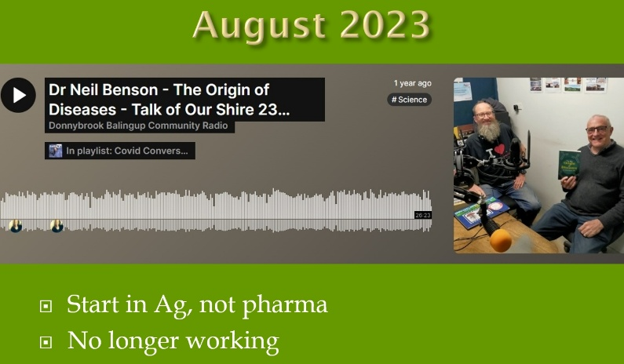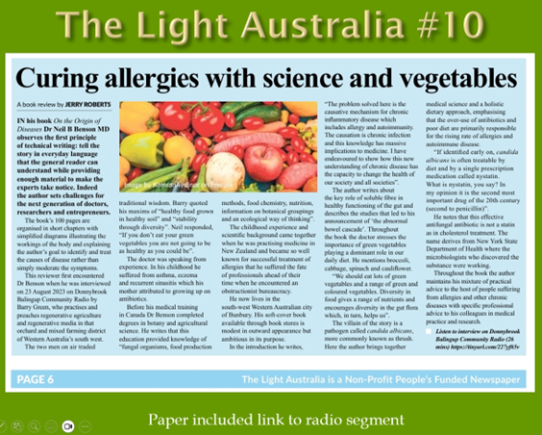
One of the Doctors I interview was with Dr Neil Benson, who wrote the book “On the Origins of Diseases”. Jerry Roberts is an old school journalist who ask questions. He was one of the founders of The Light Australia Newspaper. Jerry heard this interview which prompted him to read the book and write a review he titled “Curing Allergies with science and vegetables”
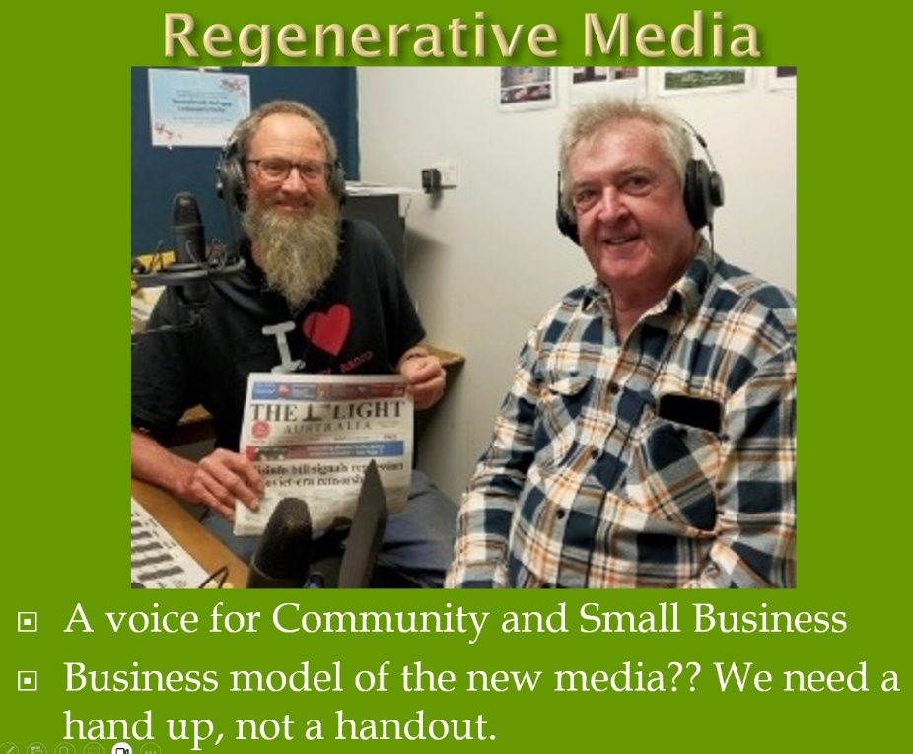
With my interest in Regenerative agriculture, I’ve coined the term “Regenerative Media” for all the new independent media that is currently evolving, including the Light Australia Newspaper. The West Australian Newspaper referees to this paper as a “Conspiracy theory” paper. Corporate media doesn’t like people asking questions
Graham Hood is a former Qantas Pilot, now podcaster, a leader withing the independent media movement.
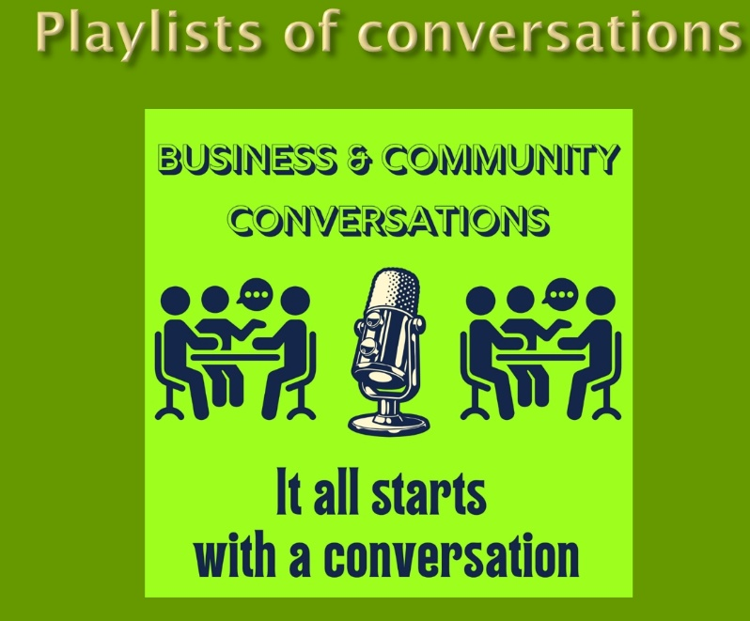
My weekly talk program is still running, now called “Business and Community Conversations” byline, “It all starts with a conversation”. The program is now sponsored by HarvestHighway.com.au . While Radio is old technology, all the conversations I’ve broadcast on DBCR are online for the record. They are an oral history of the times we have lived through. This is important because we need to remember this and not allow corporate online interests to re-wright history.
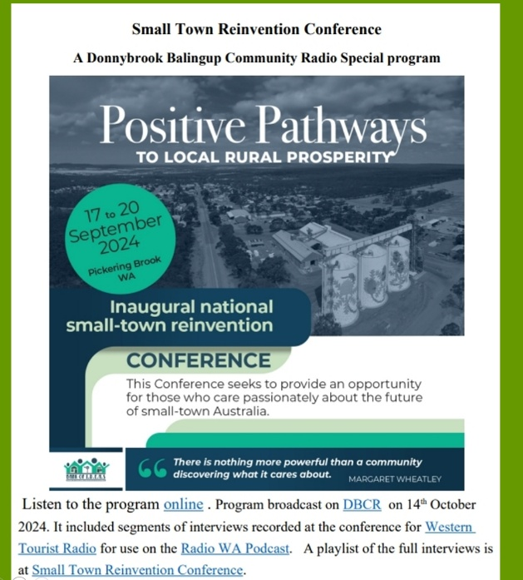
Last year Peter Kenyon from the Bank of Ideas organised the Small Town reinvention conference in Pickering Brook. I attended and recorded a number of interviews which were followed up with a special program on DBCR on the subject, based on those interviews and with Peter Kenyou and Wendy Trow from the Balingup Progress Assn, who was a presenter at the conference.
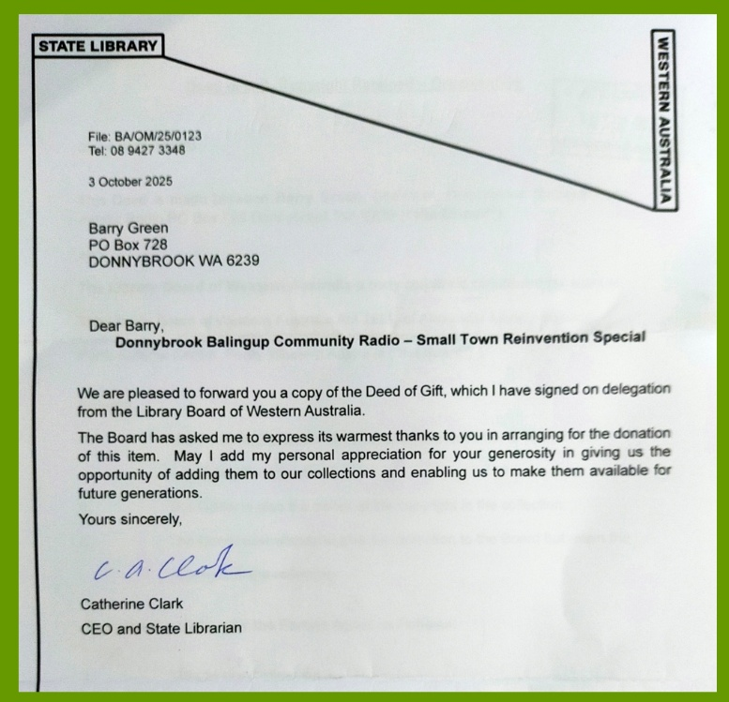
The Audio and transcript of the program has been accepted as an archive by the stare library.
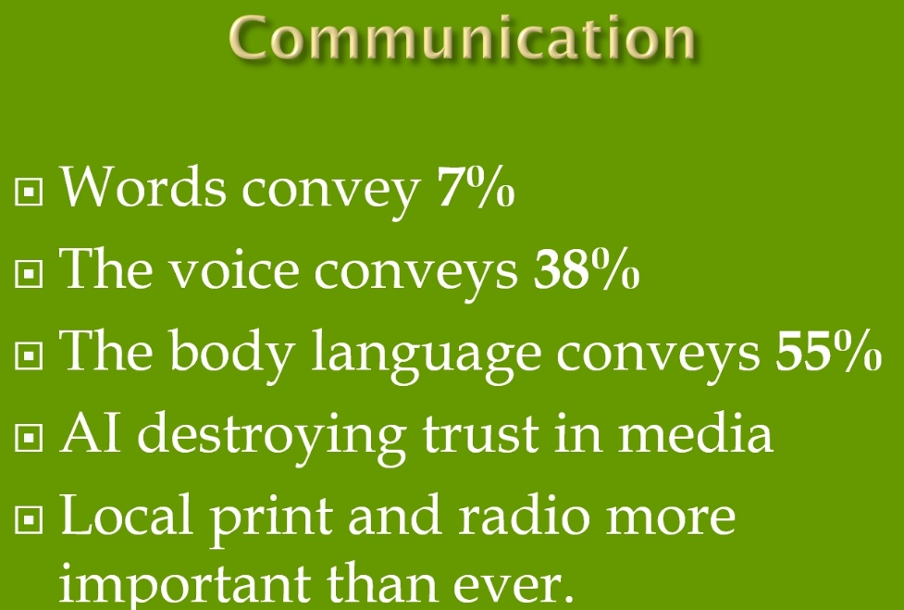
Communications people say that Communications is made of the words, the voice and the body language. The words convey 7% of the message, the voice 38% and the body language 55% . So short of a face to face conversation, radio and podcast is the next best thing!
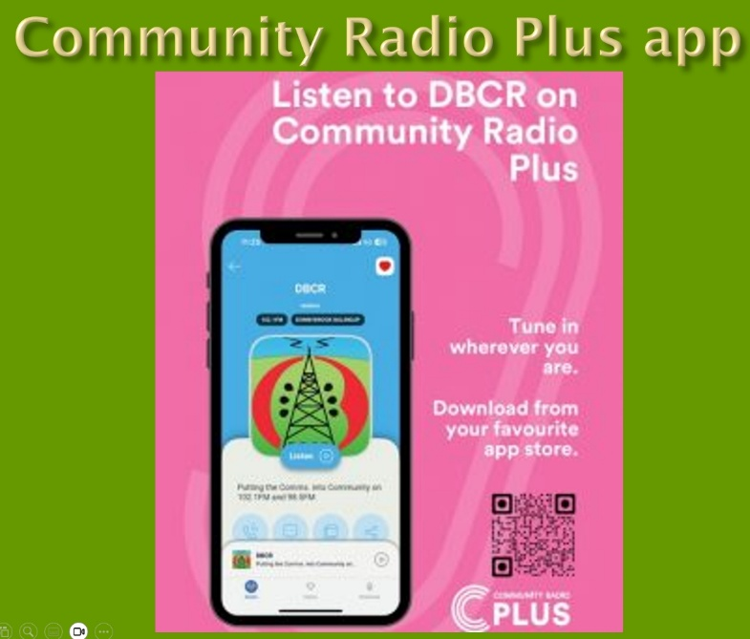
Most Community Radio stations now also live stream their program to multiple platforms, including the “Community Radio Plus” app. This allows people to listen all over the world.

In the South West, there are now Community Radio stations in Harvey, Collie, Bunbury, Donnybrook, Margaret River and Augusta. All these towns also have Lions Clubs. Busselton where is yours?? Perhaps a future Project for the Lions Club of Busselton?
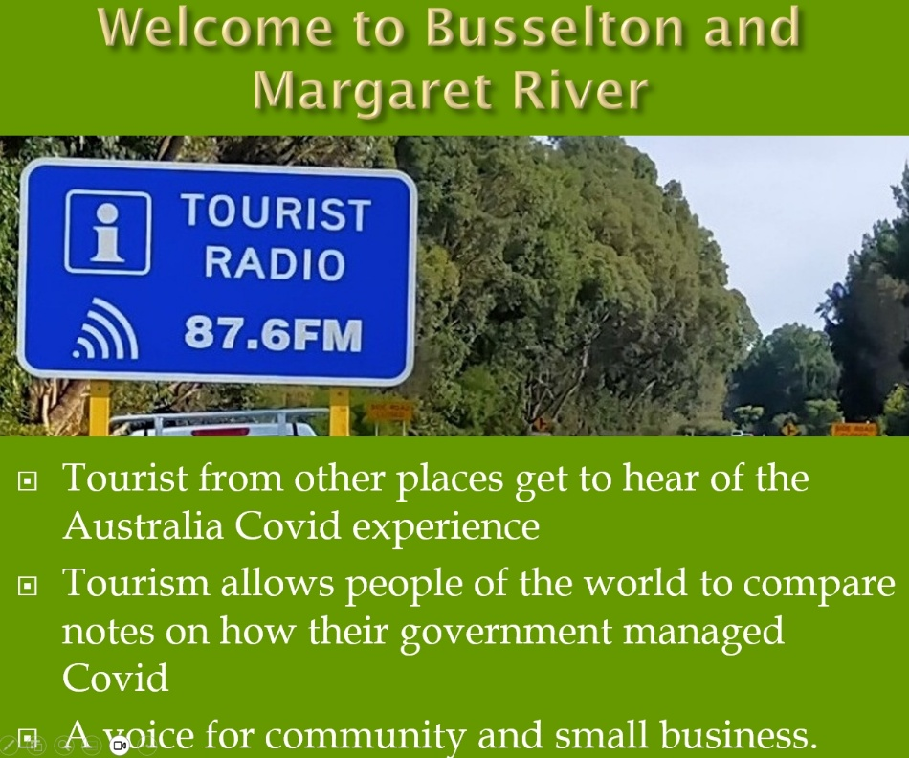
Western Tourist Radio promotes all the community stations, the 2 radio formats are complimentary, not in competition. Tourist radio stations have a limited range and are all a repeating loop program. The program content for each town is also online as a playlist.
While locals might have become shop blind to the tourist radio signs, visitors are likely to see them and tune in to hear local stories. Listening to a local community station is also part of the local experience to visitors, especial now that the commercial stations have been networked and lost their local identity.
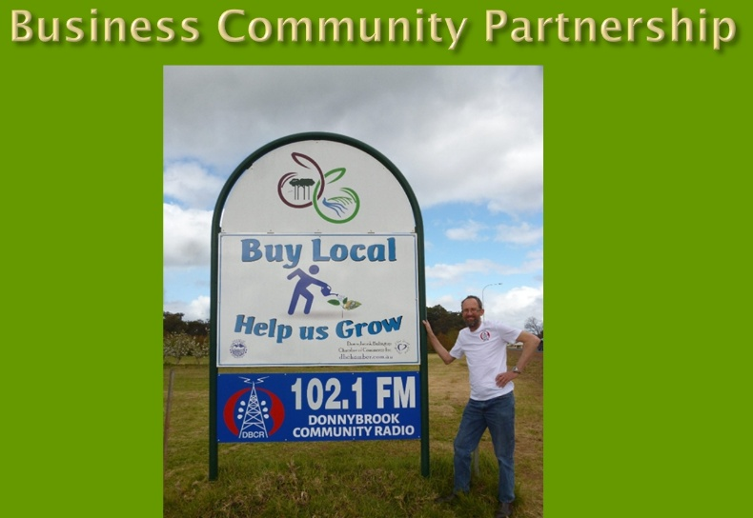
I see Community Radio as a Business / Community partnership, we rely on business and community organisations to sponsor our service and encourage our listeners to support local businesses. I see this as the foundation value of the Lions organisation
In Conclusion, I know Lions do not discuss partisan politics or sectarian religion. But there is growing evidence that the Covid event was made much worse by vested commercial interests and a compliant media. When the Mainstream Media is largely funded by advertising from Big Food, Big ag, Big Pharma, Big Gambling, Big retail, Big Banks, Big Government and all the other Big’s they seem to lose their capacity to question these organisations.
My radio technician training taught me that to fix a fault, you need to identify then address the cause of the problem. We face many problems as a society, I believe that part of the problem is that the government has allowed a concentration of media ownership by corporate interests, which now control the narrative in their interest.
Independent and community media is vital for the democratic process.
We are living through a turbulent time in history, not unlike 1917 when Lions was formed. I’d argue that the Business ethic that led to the formation of Lions is what made America a great nation.
The same can happen again as we rebuild a sense of community from the bottom up, and Lions in partnership with Community radio is again well placed to provide that leadership.
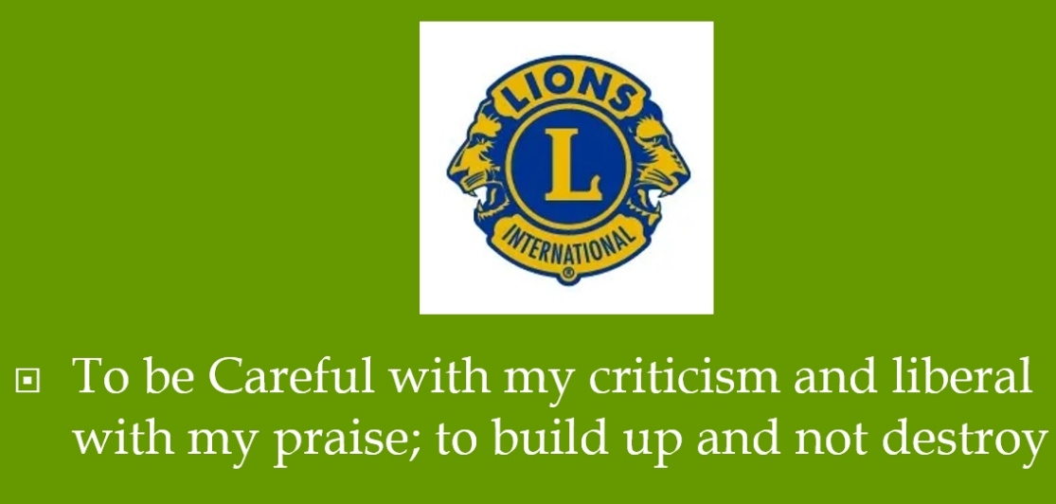
There is so much division within society these days, which I feel this is by design.
This makes the last line of the Lions code of ethics so important to remember.
To be Careful with my criticism and liberal with my praise; to build up and not destroy.

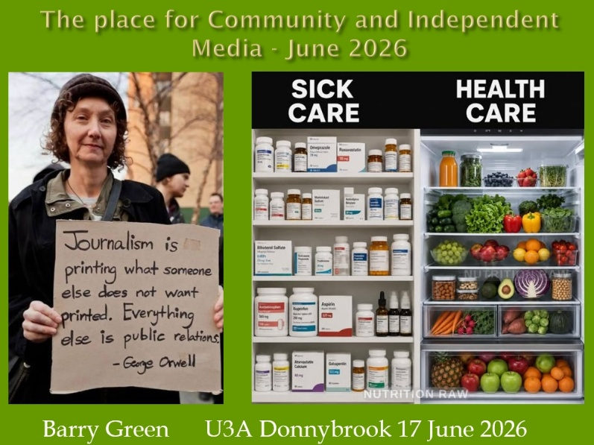
That was the talk I gave to the Lions District Convention last year. I'm going to wing it from here based on these slides. So much has happened since October last year. As I said, my training is a radio technician, I learned to identify and address the cause of a fault. The following is an attempt to try and make sense of what's happened over the last six years.
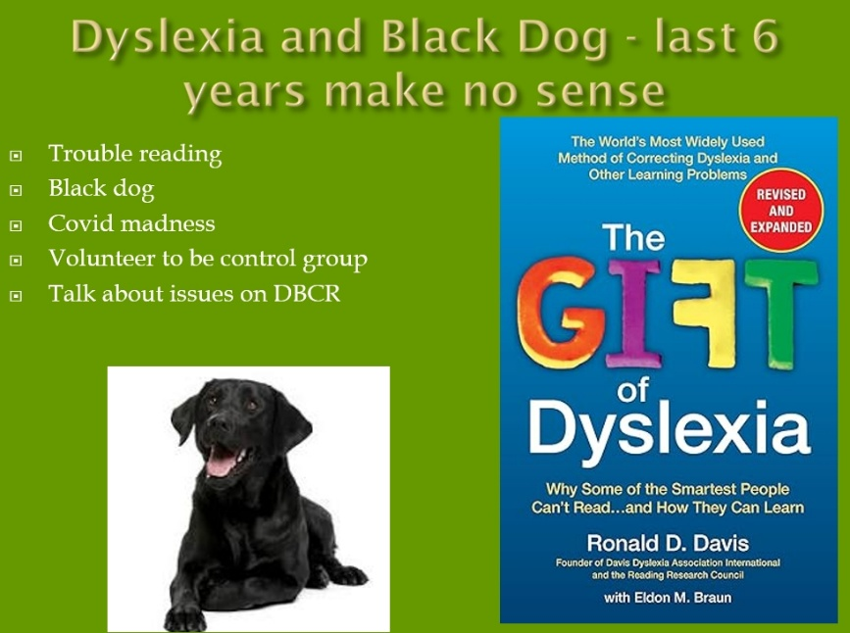
I'm probably dyslexic. I struggle to learn to read, and I'm prone to black dog disease. So the last six years I found pretty difficult. So much of what happened during Covid didn't make any sense to me. And so I guess I've had lots of time to think about it. And so this is the outcome of that thought process.
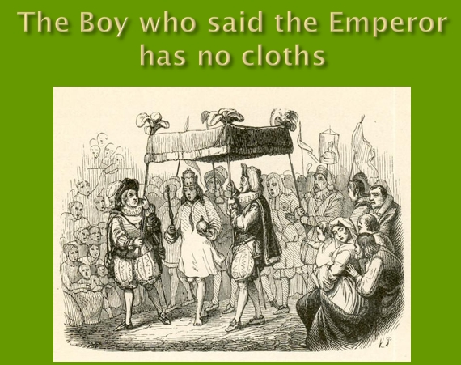
“The boy who cried the emperor has no clothes”. Well, I've spent most of my life feeling like that boy. This is University of the Third Age and Universities are all about new ideas and challenging ideas, but old people know stuff, young people don't know what they don't know. And we're in a society that's driven by young people and that's all well and good, and the future is theirs says. But I think what's happened in the universities, they've almost been corrupted by money. At universities, any research is funded by somebody and they're only going to do research into stuff they can sell. This is what's happened in agriculture.
Research in agriculture has been driven by corporations selling stuff to farmers. And it's allowed a process of a whole body of human knowledge gained over generations to be denied by the corporations as being not scientific, because it can only be scientifically proven if companies have got a patent to profit from the research. Allan Savory from the Savory Institute is, a thought leader within the regenerative agriculture movement. And he's got a very good 90 second video explaining what's happened with peer reviewed science and how peer reviewed science almost doesn't allow any new ideas. He said that new ideas always come from outside the establishment. And this is what's got us to where we are and how big food and big ag, you know, they're selling stuff. Their primary interest is their shareholders. They don't give a toss about us. That's what's happened. But what's exciting is regenerative agriculture is going from strength to strength, because the internet provided a mechanism for independent scientists to work with innovative farmers and get a better outcome without all the inputs. And so I see the science of organic / regenerative agriculture is sort of like open source software. It's a community asset. I mentioned Ian and Di Haggerty in the last segment. Their son Matthew is working with them now and he's using Tik Tok and things to get to the next generation. And I'll be interviewing him on community radio next week.
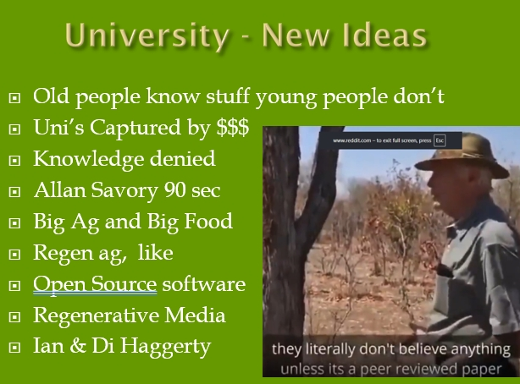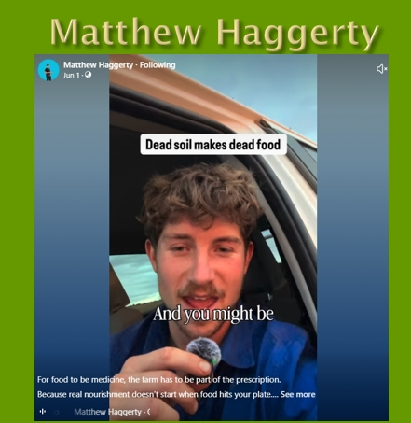
And so this is exciting thing that's happening. As I said my training taught me to fix a problem you have got to identify the cause, and we've got to look at history and learn from history. And some years ago, I became aware of Weston A Price, who was an American dentist in the 1920s, going around indigenous cultures around the world, looking at their teeth and linking it to their health. And what he figured that the health of populations, even of similar genetic makeup, was influenced by the mineralization in the soil. And at that stage, most people were eating food that came from, you know, within cooee of where they'd lived. So the important thing is that mineralization and that depends on the state of the soil. Now, in soils books that I've read, they talk about, there've been 26 civilizations throughout history that have collapsed when they've destroyed their soils locally. And when you destroy your soils, you don't suddenly run out of food. But nutrition declines and you end up with physical and mental problems and the whole system spirals down. That's sort of happening globally, which is a bit depressing. However, I remain optimistic because the Regenerative Agriculture movement, as I said, it's allowing new ideas to come forward. And at the end of the day, your health starts in the soil, not in the laboratory.

Warning : In the next few minutes I'm going to be mentioning Covid, but from the point of view of things that haven't been reported in the mainstream media, and this is the importance I see of independent and community media.
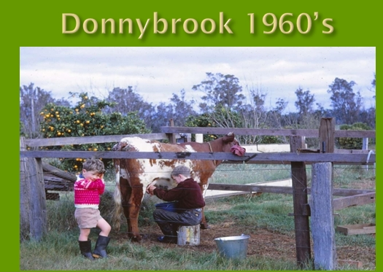
So going back to the 1960s, when I was growing up, we had a house cow and my young brothers there. He's seven years younger than me. I had to milk some mornings because Dad couldn't get out of bed. As a result of his war wounds. But we were drinking unpasteurized milk and around Donnybrook in the 60s, most farms had a small dairy. Some of them were just butterfat and others were whole milk. And in 1970, we were all lined up just over there. I was in second year high school, to get the Mantoux test, which was for TB. And if you tested positive, you didn't get the jab. If you didn't, you got the jab. Now, I tested positive and so I didn't get the jab. Now, whether that's because drinking unpasteurized milk, I don't know. But anyway, at that stage the medical profession recognised natural immunity. Come Covid it was no longer recognised. Novak Djokovic when he came to Australia to play tennis, he'd had Covid already. There was no need for him to get an injection, but he got sent home because he hadn't had the injection, even though he'd had the disease. This is how the pharmaceutical industry have sort of taken control of the government.
But getting back to the dairy. As I said there was lots of small dairies around Donnybrook. And Tom Costello, who built the brick house just across from the library. He was the herd tester. And he'd go around all these dairies and testing. And by the 1960s, 70s, TB had been eradicated from the herd. But at the same time, all of a sudden, it was illegal to sell unpasteurized milk. How many people here drank unpasteurized milk? (lots of people put up their hand) we got this far, but now it's illegal. And it's that process that allowed the corporations to get control of the industry. It's an offence to sell raw milk, but you can buy Coca-Cola. God knows what's in that.
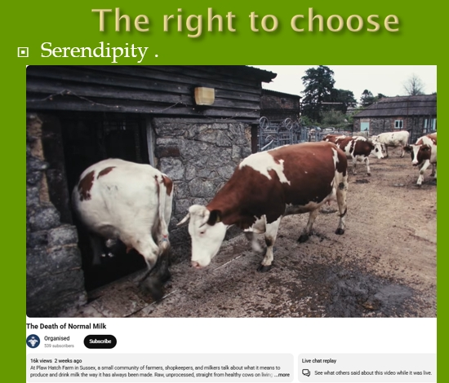
But serendipity. Just today this popped up on my feed and it's called “The Death of Natural Milk”. And it's an excellent little video. I'm not going to play it now, but I'll send you a link. And it really explains the process that's happened here and how, you know, we all grew up with milk. Sure, there are issues with it, and you sure as hell wouldn't want to drink unpasteurized milk if it came through the industrial process. But, you know, humans evolved with milk in the traditional sense.
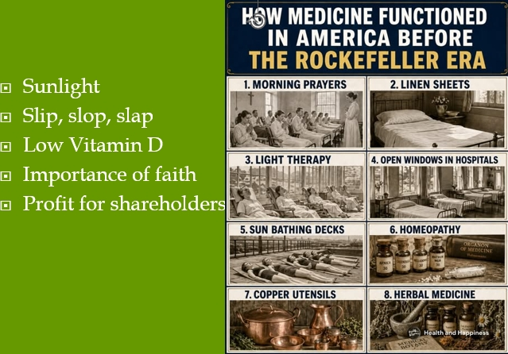
And also getting back to the 1920s before the Rockefellers started to get control of the pharmaceutical - medical industry. And, you know, these are really important points and the importance of sunlight. Now, I've been taking this slip slop slap thing very seriously, and I end up with low vitamin D.
Now what? You need Vitamin D to fend off diseases. And I think the last six years really has pointed to the importance of faith. You know, they talk about morning prayers, I think faith is really important. And I think Christianity has a lot to offer, although I hate to say it and think the last six years, Christianity and church have become perhaps something different. That's just a thought. You know, I think we must have been put on this planet for some reason other than to make a profit for shareholders.
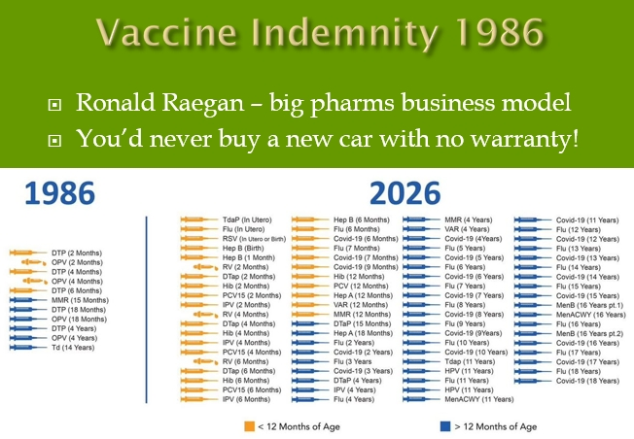
Getting back to 1986, the pharmaceutical industry in America was getting lots of lawsuits. And so they went to Ronald Reagan and said, we can't keep doing this. So he gave them an indemnity for vaccine injury. Now think about that. You know, you'd never buy a new car with no warranty, but you get a vaccine with no warranty. So the business model of the pharmaceutical industry since 1986 has made to make vaccines. Now, all of us here probably got 3 or 4 vaccines of kids by 1986. This is American figures. It was up to what's at 8 or 9. By 2026, it's up to 70 something. Now why is that? You've got to understand this is a process that's driven this.
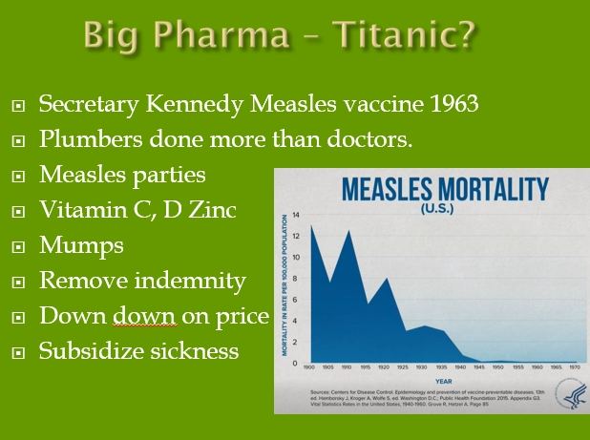
So people are saying, Big pharma's too big to fail. But they said the Titanic was too big to sink, but it sank. And with Health Secretary Kennedy in America, he talks about, the pharmaceutical industry is very good at marketing. They spend more on marketing than they do on research. And they just claim that vaccines have reduced measles. But in actual fact, the deaths from measles, you know, it's high at the beginning of the century, last century. But by the 40s and 50s, it was down to almost nothing. And that's come about due to improve, improve hygiene and this sort of thing. But the measles injection only came about in 1963. And yet they claimed credit for this decline in measles and that the science of the vitamin C, vitamin D and zinc. Now that's been suppressed. When I was 17, my younger brother was Ten. He got the mumps. It was the first year I was in Perth. And I came home the weekend and, went back to Perth and then realised I got the mumps. So as you do, I came home to Mum. But I’d heard about vitamin C and its ability to, you know, help fight disease. So I took big doses of vitamin C and my younger brother was off school for two weeks. I was only off work for one week. And you know, at that stage say, well, you know, you get mumps as an adult there's all sorts of, fertility problems. Well, I've got three kids, so that wasn't a problem.
So now if Kennedy can remove this vaccine indemnity from the pharmaceutical industry, this has huge implications because sure, they make some great products, but it's become the tail that wags the dog. And I sense we've got this problem in a society where we manage the food on the basis of Down Down on price, and we subsidize the sickness industry. Houston, we have a problem.
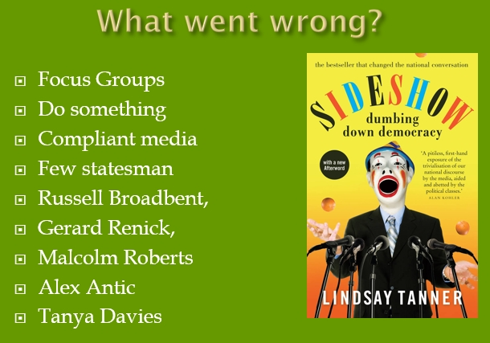
So what went wrong in the bigger scheme of things in Australia? Lindsay Tanner was a Labour Party minister in the Bob Hawke government, and he wrote the book Sideshow The Dumbing Down of Democracy. And he's saying what really happened. Government policy now is driven by focus groups. So government sends people out to the community. They offer the people, a pizza and a beer and ask them what they want. And that's the basis of government policy. And there's this notion if something goes wrong, you've just got to do something, whether it's the right thing or not. And so and then we've got this compliant media on top of it. And we've got so few statesmen left. There's a few like Russell Broadbent, who was a Liberal MP, he got dis-endorsed. I've interviewed him on community radio. Gerard Rennick, Malcolm Roberts, Alex Antic, Tanya Davies we don't have any in Western Australia.
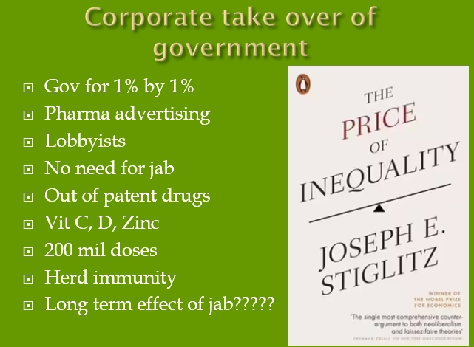
Another book I read in 2010's The Price of Inequality by Joseph Stiglitz, and it talks about this corporate takeover of government. He says government for the people, by the people, has become government for the 1%, by the 1%. And the mechanism is there's six lobbyists for every elected representative, and they're very good at presenting their corporation's point of view as if it was in the national interest. And this is what's got us to where we are now through this whole Covid period. You know, there was plenty of evidence that vitamin C, vitamin D and zinc and, various out of patent drugs could relieve the problem. But the out of patent drugs were bad mouthed because if there was a treatment, the pharmaceutical industry could never have got the vaccine approved. This is a failure of capitalism. What's happened here and this whole idea of herd immunity that comes about by people actually catching the disease, it doesn't come about through the vaccination. And that's become fairly obvious. And we don't know what the long term effects of vaccination are going to be.
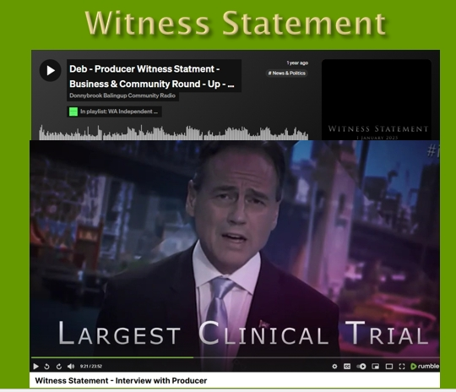
Now, last year a lady by the name of Deb Lee produced a video called Witness Statement, in which she collated, video that was in the public domain and presented it in a video suggesting evidence of crimes that have been committed through the Covid years. I interviewed her on community radio, and this is a slide from within that film with the health minister of the time saying, this is the largest trial in history. Now, if it's a trial, how the hell could people be forced to take it? This just defies any sort of logic.
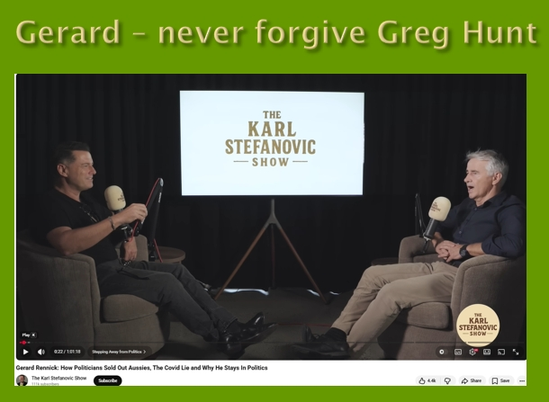
Gerard Rennick, who was a Liberal Party senator, just a backbencher at the time, very smart bloke. I'd been following him. He started calling out the jabs and he said on the Karl Stefanovic podcast, he said he went from having 5000 followers on Facebook to 100,000 followers because he was calling out vaccine injuries and he said he was getting lots of people, hundreds of people contacting his office with vaccine injuries. And he said he talked to Scomo. And Scomo said, well, you know, he was busy. Greg Hunt, who was the Health Minister, paid big bucks by us to protect our interests. Wasn't interested. He's responsible for the TGA, the Therapeutic Drug Administration, which approved this trial injection. So in that interview, Carl actually apologized because Gerard Rennick speaks very eloquently and scientifically. And Carl apologized for his part in the propaganda to push the vaccine. And in that interview, Gerard said he won't forgive Greg Hunt.
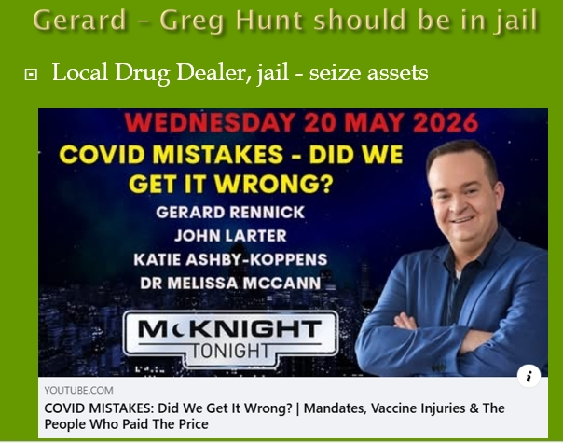
He was subsequently interviewed by Rob McKnight on McKnight Tonight. And this time he didn't say, I won't forgive him, he said. I think he should be in jail, and I'm inclined to think that. So the people on this, this podcast called Covid Mistakes, did we get it wrong? There was Gerard Rennick and I broadcast segments of his talk, John Larter and Katie Ashby-Koppens. I've interviewed both of them, and Doctor Melissa McCann is a GP who's got a class action against the government over the Covid injections on behalf of her patients. And she's written the book Covid Through Our Eyes with Professor Robert Clancy.
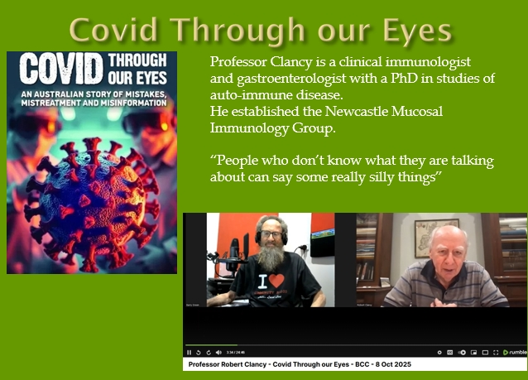
Now, Professor Clancy is a clinical immunologist, and gastroenterologist with a PhD in studies for autoimmune disease. He's based in Newcastle. He's established the Newcastle Mucosal immunology group. His expertise is the immunity that comes through mucosal stuff, the biology of that. This is a bloke who has mooted as a Nobel Prize winner for his work and recognised around the world. Prior to Covid, come Covid, he was persona non grata. The government didn't want to hear from him and this was an airborne disease. You'd think they'd be asking him for advice. In the interview I did with him, he said, “people who don't know what they're talking about can say some really silly things” , and there's been a fair bit of that. Professor Clancy's also written a book called The Long Enlightenment Australian Science from the beginning to the mid 20th century. So this is a bloke who knows a lot of stuff and he's looking at Australian science and how, you know, we started off as a jail. We ended up as a jail for a while there didn't we. and all the problems that we faced, we had to solve within our country. And so there was a lot of science involved at innovation. And since the 50s, the sort of corporatisation of science we, we're losing that innovation. And it's a really interesting read. 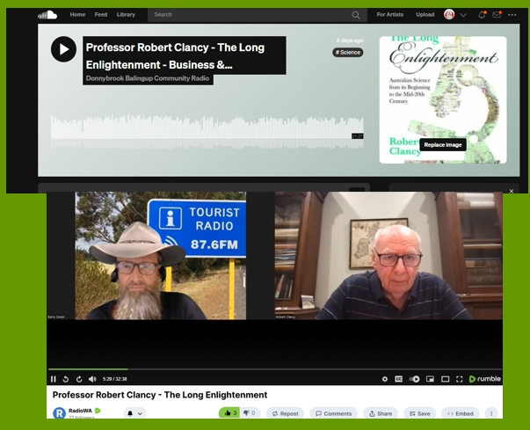
Another professor I've spoken to is Professor Ian Brighthope from the Australian College of Nutritional and Environmental Medicine. And this is a bloke that was talking to the Prime Minister going into Covid and he said, if we make sure the people that are up to reasonable levels of vitamin C, vitamin D and zinc, this thing's over in six weeks. But they didn't want to hear about that. And that's what we took vitamin C, vitamin D and zinc. We did both get Covid, and I was pretty lethargic for a few days, but that was about the limit of it. And as Professor Brighthope said, Australians know this stuff. When Covid struck, sales of vitamin C, vitamin D and zinc tripled. So people know about this. It's just that it hasn't been talked about.
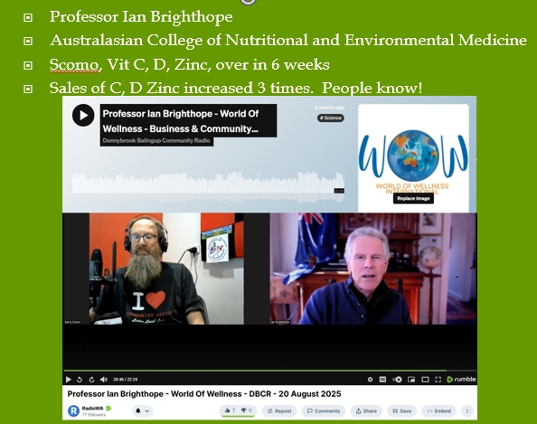
Another professor I spoken to is Professor Gigi Foster from Australians for Science and Freedom,
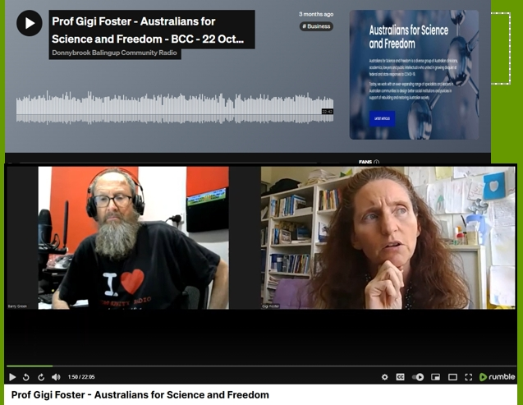
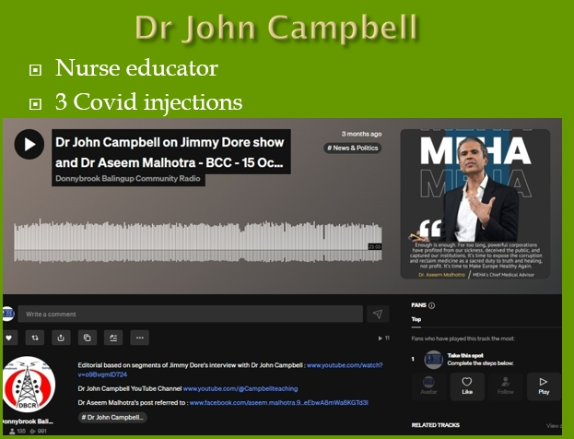
Dr John Campbell. He's actually a nurse and people dismiss him as being “just a nurse” in fact, nurses probably being hands on know this stuff too. But he was a nurse, educator and. initially he took three Covid injections, so he's not an anti-vaxxer. And then he started to realize he was having problems and being a good communicator he started looking around the world and there's so many experts are calling that things have gone wrong here. Anyway, he was interviewed on the Jimmy Dore Show in America, and they were both talking about their Covid injection injuries. And I broadcast that. And, the next day, John Dent, who's here, he called me up and he said, I heard that interview. And it made me realize some of these health problems I've got, I think might be due to the injection.
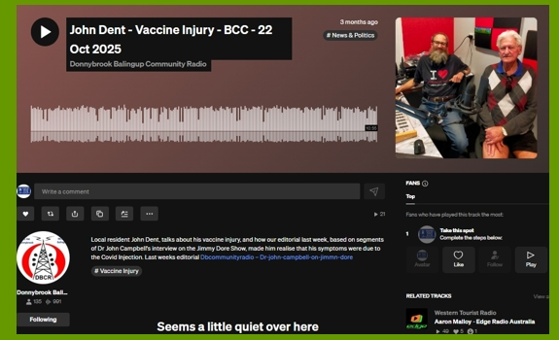
And so I really appreciate that because I sit in that radio studio talking to myself, and I know some people don't want to hear about it, but in a democracy, we've just got to be able to talk about these things. But, you know, we need positive stories as well. And this same Doctor John Campbell, did a thing a bit later in America about three patients who'd been written off with cancer by the system, and they'd self-medicated with out of patent drugs and had recovered. Now, he said, this doesn't prove anything, of course, but the bloke who figured out that vitamin C is the cure for scurvy, his original test of ten people two survived. It didn't prove anything, but it's indicative that maybe something we should be looking at more seriously now. The pharmaceutical industry isn't going to look at this because there's no money in it. But this is a good news story, because the government in Florida has allocated $180 million to research into out of patent drugs to treat cancer. Now, it might go nowhere, but if it proves successful, the implication for the human population is terrific.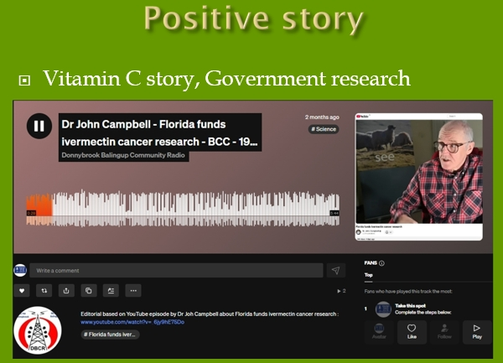
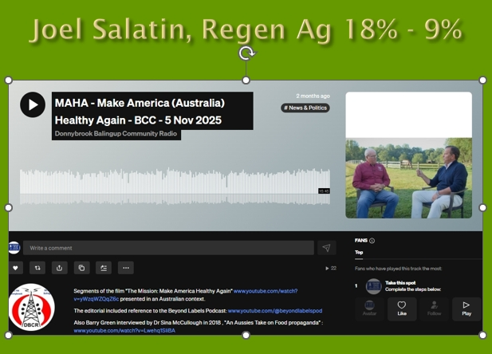
My real passion is regenerative agriculture. Joel Salatin is a regen ag farmer in America who I've met, who has brought to Western Australia. He's been there a few times, and he talks about regenerative agriculture and getting back to small farms and the MAHA movement in America, Make America Healthy Again. A lot of people hear MAHA and think Trump and think bad, but there's a whole lot more to it that we're not hearing about. There's a very good video called The Mission Make America Healthy Again. Joel Salatin speaks on it and in that presentation, he talks about how a couple of generations ago in America and probably similar here. People spent about 18% of their income on food and 9% on medical. Now they're spending 9% on food and 18% on medical. So, you know, when you look at the numbers, there's a problem here. And our food system has been so corrupted that we need to get back to local farmers producing food.
And the other thing that Kennedy has done is turn the food pyramid upside down, you know? So we've got to eat the foods that our grandparents or great grandparents recognized as food. That's whole food, not this ultra processed food like materials that the corporations are making big money on. And Doctor Wietske, who writes a piece in the Preston Press, she's very much from a similar talk in terms of health, coming from a sense of community and, and avoiding toxins and, nutrient dense food. And she came in and talked about that same subject with me, which I really appreciate. And we referred to the realfood.gov website, which is an American government website.
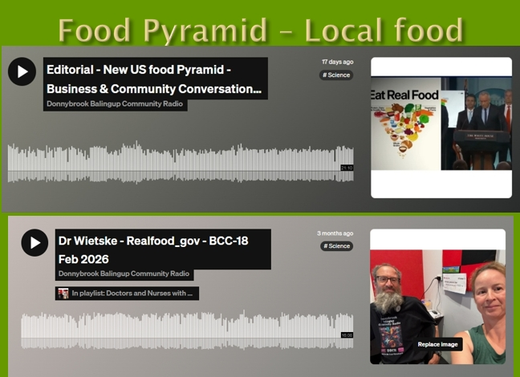

Over the time I've been doing the show, I've spoken to lots of politicians since the current state government's been in. I've spoken to MLCs from all political parties except the Labor Party. We have to be balanced. I've invited Labor Party MPs on but so far they haven't replied or declined the invitation. But I think now these MLCs are paid big dollars to represent our interest. I think it's important that our listeners get to know who these people are and what they believe. 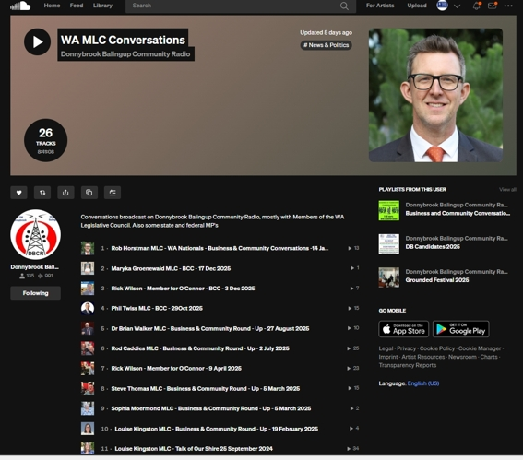
What I try to do when I get them on, I say, the microphone is open, I want to hear about who you are and what you believe in. it's a live show. I'm not going to change what they say, because that's the importance of a live show and also importance of transcripts and hard copy.
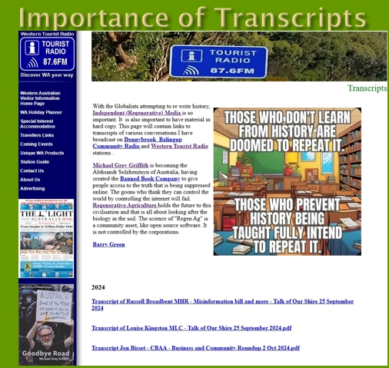
Because there's so much on the internet, it's hard to know what to believe. But at the end of the day, hard copy is really important. And a lot of stuff's been scrubbed from the internet. But this little slide I like, Those who don't learn from history, are doomed to repeat it. And those that prevent history being taught fully intend to repeat it. And so a lot of my programs of recent times, I've been using the software to generate transcripts. Then they can be saved online as PDFs, and you can print them out so that you know they're there for the record.
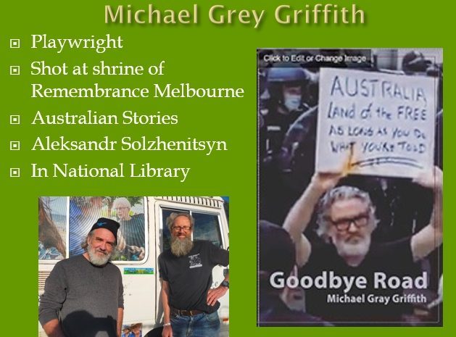
Michael Grey Griffith was a playwright. He was protesting in Victoria when the big protests were going on about the vaccine mandates and the picture on the front of his book, Goodbye Road, said Australia, the land of the free, as long as you do what you're told. So after being shot at the Shrine of Remembrance, Michael's been travelling around Australia ever since recording Australian stories, for the record. And now his book came about because John Stapleton, who's a journalist of the old school, said to him, Michael, these are important stories you're getting. We need to get into a book, Michael said oh no, nobody's interested. But then Michael had a heart attack and John contacted me and said, you know, you could die, it's important that we get these stories into a book. And that's how the book Goodbye Road came about. Michael was in Donnybrook a few weeks ago. He recorded an interview at Donnybrook Men's Shed, while he was in Transit Park in Donnybrook.
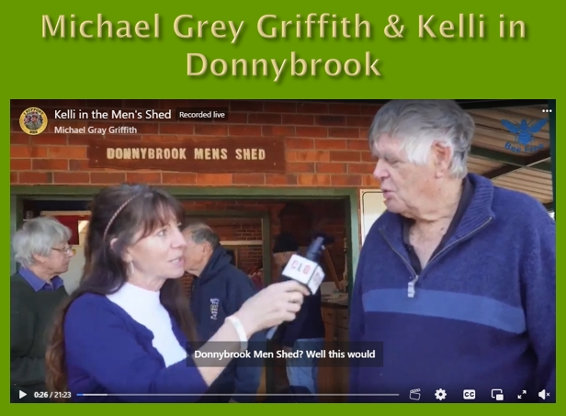
He recorded a 2.5 hour interview with Senator Malcolm Roberts. Now, I knew of Senator Malcolm Roberts, but I think this is really quite profound because whatever you think of One Nation, it's a phenomenon that's happening. Malcolm Roberts has a lot to do with it in some respects. I think he's the brains behind it. And Michael, sitting in his old bus in the transit park in Donnybrook, recorded a 2.5 hour conversation with Senator Malcolm Roberts. He was originally allocated one hour, but he talked for 2.5 hours because Michael just let him talk. Whereas mostly what you hear from politicians is what the journalists decide you're allowed to hear. And this is what's happening. And this is where I’d argue mainstream media has lost its way. And the independent media is sort of filling that void. 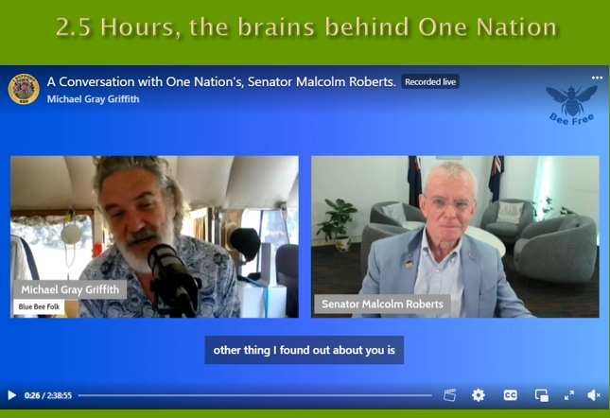
Another interview that Michael recorded when he was in Donnybrook was with five doctors that have been deregistered by the Australian Health Practitioners Regulatory Authority. They weren't deregistered because of patient complaints. They were deregistered for the crime of issuing Covid injection exemptions five years ago. So we're short of doctors in Australia. And this regulator that's supposed to be protecting our interests is deregistering doctors that were issuing exceptions for the Covid injection. Now, people don't know this because it's not reported in the mainstream media. But this is serious because this regulator is really acting in the interest of the pharmaceutical industry. People need to know about this and they're not hearing it in the mainstream media.
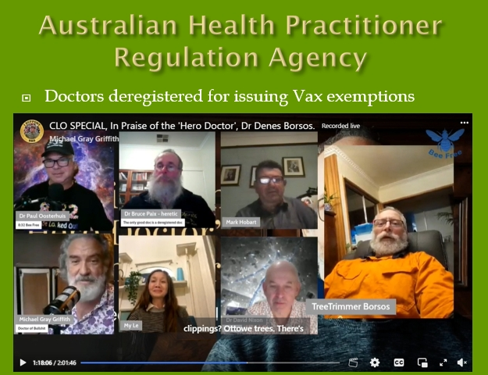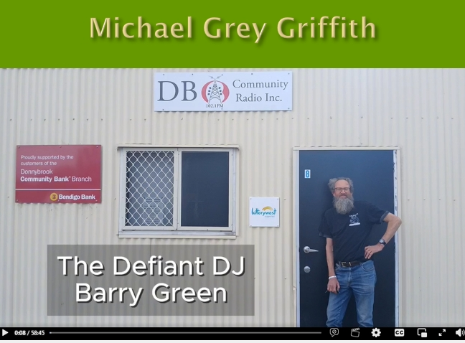
While Michael was in Donnybrook, he also recorded an interview with me, which he called The defiant DJ Barry Green. I've copped a bit of flack for talking about this stuff over the years. People don't want to hear about it, but there's so much information in the alternative online media, which I'm aware of, but people aren't aware of if they rely on the mainstream media, which I found sort of difficult. But as I said, you know, I've been talking about it because I can and I'm probably the only person in Australia that's been questioning the narrative on government licensed radio. It's been questioned online, but it hasn't been questioned much in the mainstream when in licensed government media. DBCR is a member of the CBAA Community Broadcasting Association of Australia, and they have a code of practice which we have to comply with. And the code of practice includes the provision which provide access to perspectives not adequately represented by other broadcast sectors. So by providing a voice to people who've lost their businesses and jobs for not getting the Covid injection and those who've been injured by it. I'm doing exactly what the code of practice calls for, providing a voice for people not represented in other media.
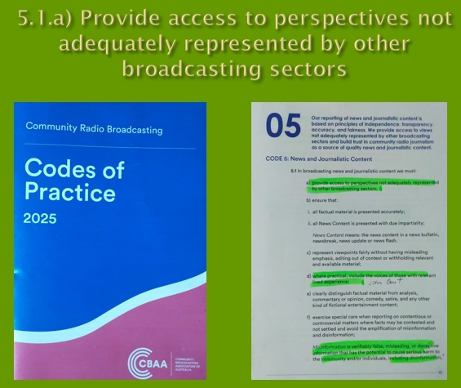
Now, I’m dyslexic are struggled to learn to read and write but I've been writing a piece in the Preston Press ( our local monthly news sheet) for the last 3 or 4 years, which is just a review of the conversations I've had on community radio, which is still all online, and the Preston Press is stored on Trove. So there's a record of all these conversations I've had in the official record,
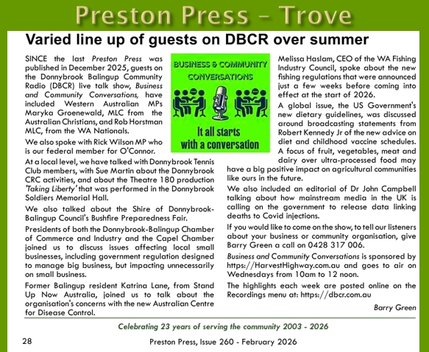
Professor Angus Dalgleish, is a UK oncologist. In June 2024, I broadcast segments of Russell Broadbent's interview with Professor Angus Dalgleish. Now, earlier this month, Professor Dalgleish spoke at a Senate inquiry in America. The subject title of the inquiry was Plausible Mechanisms of Covid 19 Injections Causing Cancer and the Attack on Scientific Publications and Research. I broadcast segments of the interview that Russell Broadbent had recorded with him, and I posted that online on. Facebook decided that this interview didn't meet community standards. Given that Russell Broadbent was an Australian elected representative talking to an eminent UK oncologist. Facebook's a guest in our country. For them to decide that something that these people talk about doesn't meet community standards. Give me a break.
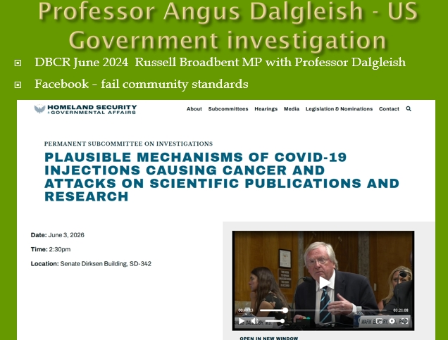
Anyway, it is starting to get into mainstream, the Wall Street Journal just last week came out with The Lockdown Dissidents, and it's talking about all the people, eminent scientific people that were belittled and deplatformed through Covid are now getting a voice. So we are getting to a tipping point. 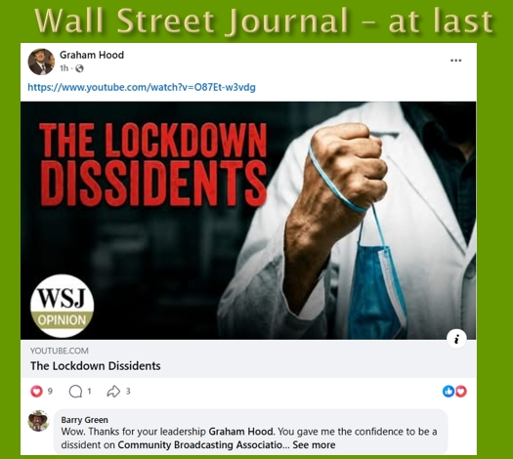
There's lots of talk about. RUOK ? Am I okay? Not really. I was one of 2 million Australians that didn't participate in the vaccine trial, and we got shut out of society. Can you believe that In 2019, if somebody said, if you don't participate in the vaccine trial in Australia, you're going to be shut out? This just never made any sense. And we were we were vilified for even questioning it. I've lost at least four family members, I believe, due to this injection. You know this this has an effect. But science and democracy both require open debate. If we don't have a debate, we don't have a democracy. And there's been no debate in the last 5 or 6 years. And I've lost trust in government and the mainstream media.
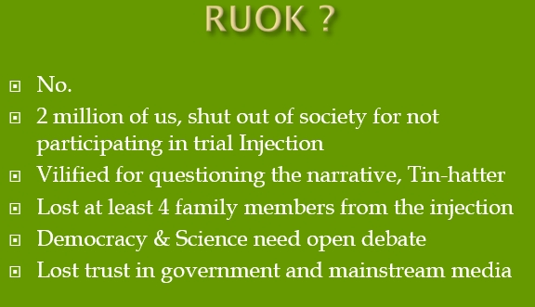
But for the future, we need to keep positive. And there are positives, every cloud has a silver lining. Just a bit hard to find at times. I'm really excited by Make America and Make Australia Healthy Again Movement, this can change the future trajectory. The whole agri-tourism thing to remake the connection between farmers and eaters. That has huge implications for places like Donnybrook where we are. We've got to get back to producing local food that human biome recognises. I think that the frontier of science is understanding the biology in the soil, and biology and the human guts. And if we get those things right, most health problems will go away. So I think we've got to get back to more family farms in agriculture. We've got to get people back into the regions doing agriculture, because the corporations want everybody in the city eating their crap food to keep them sick. That's what their business model that's built on. But the silver lining behind the Covid years is it's exposed this agenda. It's the importance of community. You know, there's nothing we can do about things happening around the world, but we can focus on our own community and the community radio providing a voice for that is important. I think the worst thing we can do is ask the government to fix anything. You know, they're the problem in most cases. The problems have got to be fixed, as Charles Massey says, change has got to come from the bottom up. It simply can't come from the top down because the people at the top have fought to get there and like it the way it is.
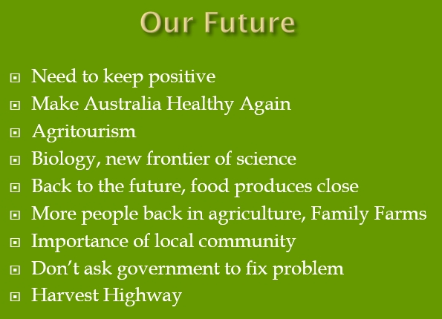
Which leads me to Harvest Highway. Harvest Highway Inc. was formed in early 2000 to promote tourism and producers along the South Western Highway and byways. It got government funding largely from the Dairy Deregulation Fund, of all things. Look what that's done for the dairy industry. But like most things, the government funds, it failed when the funds ran out. I'd been on the Committee of Harvest Highway Inc. Robert St Duke from Harvey Cheese was president all the time it operated. Once Harvest Highway, Inc. was wound up, Western Tourist Radio got in and acquired the business name and the website. And it's been sitting their sort of in hibernation for about ten years. But I think the time is right to reactivate it. Thers some Harvest Highway postcards there ( on the table). And it's developing as a network of community and small business along the South Western highway and byways.
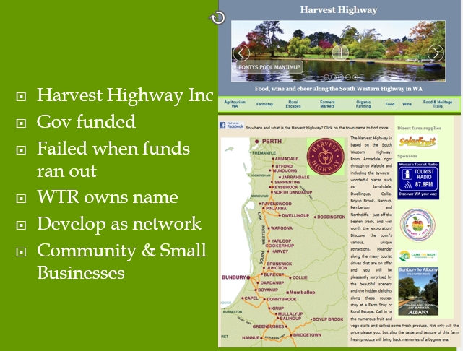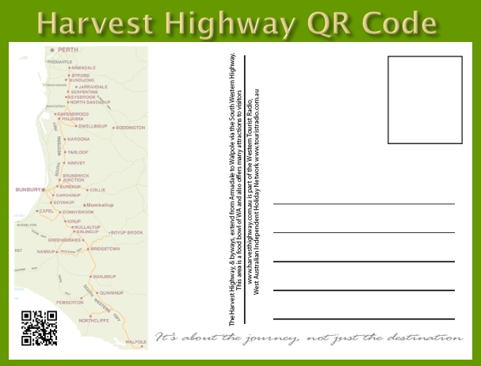
On the on the postcard, if you scan the QR code, it'll take you to the Hardest Highway website. If you click on Donnybrook on the map, it will take you to the Donnybrook page.
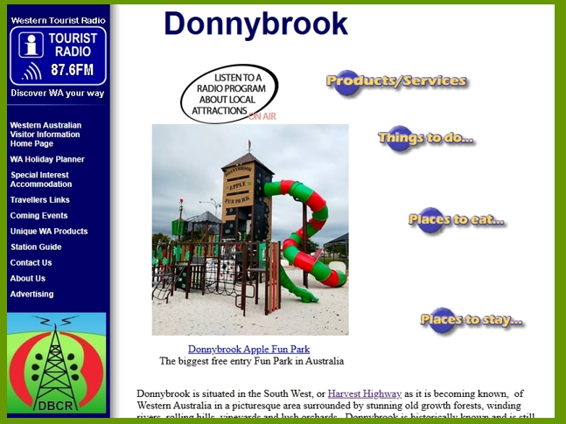
If you click on the Listen Online button at the top, it'll play stories of Donnybrook. And this is how I see the grassroots change, how we're taking the storytelling back into our own communities.
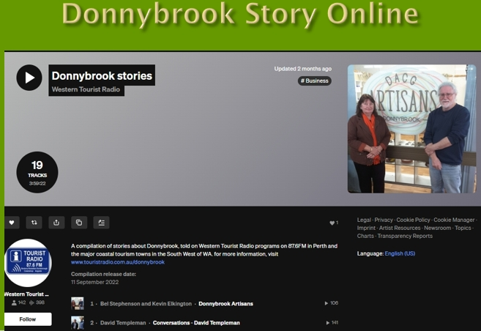
My program, Business and Community Conversations, is providing a local voice. I'm always looking for people to talk to. I sit there talking to myself, but you never know who's listening. But, you know, this is where the byline is, It all starts with a conversation. It's through having conversations that we can start to get people thinking about things. My take very much is that we've got two ears and one mouth for a reason. We need to listen to other points of view. At DBCR we welcome volunteers. , we especially looking for local musicians, Beth Chia does great program on Friday called Live and local. There’s Jackie's Local and the What's On show. We've got some drive time shows. We're always looking for special interest shows. Community radio will be what the community makes it. There's a small committee there, It's a platform that's open to community to get involved in. This is all about the place for community and independent media that hasn't been captured by corporate interests.
So in conclusion, I think, we've been lied to by the government and, the media in relation to diet and Covid. there's more and more information coming out now. There has definitely been criminal activity and that has occurred. And those need to be held to account.
I'm not going to be talking about Covid anymore on DBCR because we've got to look to the future and, focus there on the positive stuff. We've actually been through a bit of a dark age, I think in the last Dark Age they through witches into the village pond for questioning the doctrine of the church.
In this Dark Age, we've thrown families into unemployment and poverty, for questioning the doctrine of Big Pharma. But after the last Dark Age, there was a new renaissance. And I think we're on the verge of a new renaissance because we now have the science to understand and, well, we don't understand. We're starting to understand the importance of biology in the soil, the biology in the human guts. And if we get these things right, a lot of problems go away in.
In 2000 I attended a soil seminar at Manjimup, the presenters said the soil has made of the chemical, the physical and the biological properties. We got pretty good at understanding the chemical and the physical. The biological was too bloody hard, so I ignored it. It's still hard and it's incredibly complex. But we're starting to get a handle on that. And that's the exciting thing for the future. I think the exciting thing is that I think this change is going to return the focus to family farms and getting people back into regions producing healthy food for the community. Our health starts in the soil, not in a laboratory. So that's my presentation. Thank you.
Journalism is about printing what someone else doesn't want. Everything else is PR. I think there's been a fair bit of PR gone on lately, and we've got this conundrum between the sick care and health care.
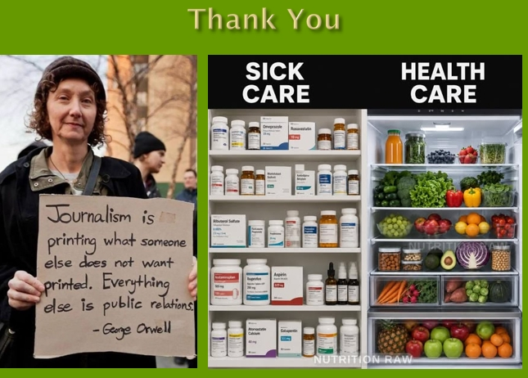
From the floor That's certainly food for thought, isn't it? Any questions?
From the floor This controversial subjects you bring up, shouldn't you make an effort to put the contrary argument?
Barry Green That's a really good question. And this one I struggle with but what I'd argue, the ABC has only presented one side. Now, I'd argue there's, there is data supporting all the things that I've talked about, but the way the media and propaganda works is that, you know, they've been in denial about that data, but it's more and more data comes out. It's getting harder and harder to justify the government policies over the last six years.
From the floor You're just talking about Covid, the vaccine, but what about all these other vaccinations? I mean, look, we've just had a huge influx of, diphtheria up in the Kimberly and that's because of non-vaccination.
Barry Green Well, that's the narrative. From I can make out, I think the Covid injection has done damage to people's immune systems. You know, we have a natural immune system created by God or evolution, whichever you choose to believe. And so you know that immune system fights off disease. It's done that through time. But as soon as you inject something, you're bypassing all the natural immunity. And, so, like the Kennedy says about measles, you know, the incidence of death from measles was down to next to nothing before the vaccine was invented. I guess if you look at the situation, those of us who didn't get the Covid injection, we were all supposed to be dead, but we're not. And so, you know, the natural immunity, the human body has incredible Capacity to develop natural immunity. Now, in a in a proper pandemic, you'd expect the, the death rates to go up, but then following it, they should come down below the five year average because the pandemics, sadly leads to the demise of people perhaps a bit earlier than they would otherwise would have. Through Covid, our excess death rate in government data is still higher than it was before the pandemic. So there's something gone
From the floor what about the soil health stuff? What's happening now? What are we doing in Donnybrook? Is there anything that's happening? Because I've followed, Peter Andrews. And I know there's considerable interest in the reintroduction of worms and stuff into the soil. So what's happening locally?
Barry Green Well, that's a really good question. And that's where Alannah Mactiernan was very influential as the agriculture minister. She brought Charles Massy to WA. Peter Andrews gets a mention in Charles Massy's book. All the research since the Second World War has been done by corporations selling stuff to farmers..
From the floor University's as well done research. Not all corporations.
Barry Green Yeah, but most University research in recent years has been funded by corporations. This is where they've sort of got control of the research there's two soil scientists at Dr Maarten Stapper, and Doctor Christine Jones. I've interviewed Doctor Christine Jones. She's ex CSIRO. Both were drummed out of CSIRO because the organiosation had got so aligned with corporate interests.
Now getting back to the vaccine thing and I understand it's controversial, but this idea of mandating a vaccine. This was a real problem. By all means, take any vaccines you like, but mandating the vaccine, that's a bit. That was criminal, especially when it was recognized as being a trial injection and still is officially.
Getting back to soils, In Western Australia we've got old soil. So they are nutrient deficient. So we do have to bring some nutrients in. but absolutely in terms of the term organic agriculture, which has got a hippy connotation really. But the term organic agriculture is about building the organic matter in the soil. That's the origins of the term. Traditional natural soils varied all around the world, but in Western Australia they originally had organic matter of about 5%. Industrial agriculture with soluble fertilisers and chemicals has reduced that soil organic matter down to less than 1%. Now organic matter (OM) . that's carbon. Carbon is organic matter. So industrial agriculture has liberated carbon from soil and put it in the atmosphere. If we're worried about climate change, if carbon is the issue, I'm not altogether convinced it is. But regenerative agriculture is putting carbon back in the soil. And the effect of that, is if you increase the organic matter in the soil 1%, you increase the water holding capacity of the soil by something like 150,000l per hectare. So, you know, we're getting more floods, but that's in part because we've just destroyed the organic matter in the soil. Now, absolutely. The point about the soil biology, you know, that's the worms, that's all the biology. And that's what Haggerty's are doing on you know, this isn't just backyard stuff. They're doing it on 60,000 acres.
From the Floor Where are they?
Barry Green They're Mollerin in the northern edge of the wheat belt. They're globally recognized but you don't hear much about them in the Australian media. And they're bringing in worm juice and they they've got the sheep as part of the rotation, because the big ruminant animals are an integral part of the soil building process. The deep soils of the plains of Africa and the plains of America were created by big herds of ruminant animals going through an area, pissing and pooping and moving on. And it's that action that created the deep soils. And that's what regenerative agriculture using big ruminant animals I about. We've only got 100 acres of pasture, but we've got 70 little paddocks. So we're moving them every day. And that is the process.
From the Floor Focusing on Western style food instead of food that is actually suited for these things. Is there research in that.
Barry Green Well, what you talk about Western style food, that's just food that's come about, you know, since the Second World War, you know, this is what the process and ultra processed foods, which Michael Pollan The Omnivore's Dilemma refers to as food like materials. I know a bloke who had health problems, mental problems, weight problems. And he said he'd cured himself by not eating anything with a barcode. So, you know, getting back to eating foods that God or evolution has created. Not all this processed stuff.
From the Floor Thank you. Is there anything happening around Donnybrook?
Barry Green It is slowly. Yeah. we did have organic certification on the farm. We've actually dropped the certification. Joel Salatin, who I made reference to, he's, an interesting bloke. He's, he now does a podcast with a doctor. Sina McCullough that's called Beyond Labels. Have a look. An interesting story, in 2018, after I did this community radio documentary, I sent it to the Savory Institute that I referred to Allan Savory, and they introduced me to this American nutritionist called Doctor Sina McCullough. And we had a conversation via Zoom the first time I'd used Zoom, and she recorded an interview with me, which she called an Aussie’s take on Food Propaganda, and in it I talked about having worked in commercial television. Seen how the media works and basically how the way we think has been influenced by advertising in commercial media. And that's what's created the world we live in. And they talk about the mad diet, the Modern American Diet, which is all been driven by advertising. And, and again, the whole advertising thing without wishing to appear a Luddite. But, you know, I've worked in technology all my life.
Technology is not going to save the civilization. To save it we need to be looking after the biology in the soil. Talking about meaningful indigenous cultures. When I was at GWN TV and Gina Williams, Aboriginal girl used to produce a program called Millbindie . And then in 2014 or 15, she produced the first Noongar language CD called Kalyakoorl and I interviewed her. She played in Balingup in 2015, and I interviewed her. And just in that interview, I came to realise how Aboriginal and all indigenous cultures around the world, their cultural, corporate and ecological knowledge is passed from generation to generation through storytelling. In our culture, the storytelling has been taken over by the advertising executives of the major corporations. Delivered through my old employer, Commercial television, to make people think what they want them to think. And that's got us to where we are now. As Charlie says, the change has got to come from the bottom up. Any other questions? Well, thanks. I realize some of it's confronting, but, you know, we do need to have a conversation. That's what democracy is about.

