Bunbury U3A Community Media Presentation
13 Feb 2026
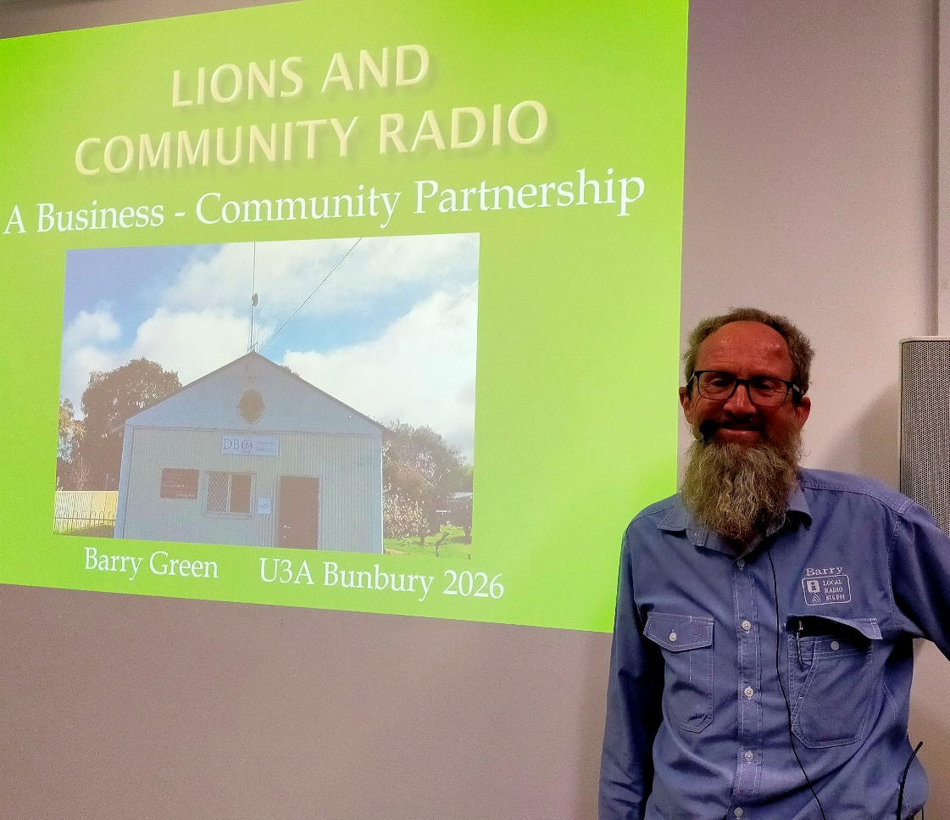
Listen to Part 1 & 2 online : https://creators.spotify.com/pod/profile/radio-wa/episodes/Bunbury-U3A-New-Media-Talk-Feb-2026-e3fb8ai

Lyn Frings: Sit back, enjoy and remember you are allowed to ask questions, I'm sure. Okay. Thank you very much. Barry is a Donnybrook boy and has a couple of times been to U3A Donnybrook, our sister organization. He is going to talk today about his instigation of the Western Tourist Radio and the Community Radio at Donnybrook-Balingup, and a few other things that he's been involved in. So please welcome Barry.
Barry Green: Thanks Lyn. I gave a talk at the Lions District Convention in Busselton last year. So the first 15 minutes, I'll repeat that talk. And there's a lot that's happened since September last year so I'll wing it after that with some slides.

Donnybrook Balingup Community Radio Inc, is very much a product of the Lions Club of Donnybrook. DBCR exits because of a lot of work by a number of people who have brought differing skills and dedication to the organisation. I think it would be fair to say that it wouldn’t exist without me, but I wouldn’t have been able to do it without the training and experience gained through Lions.
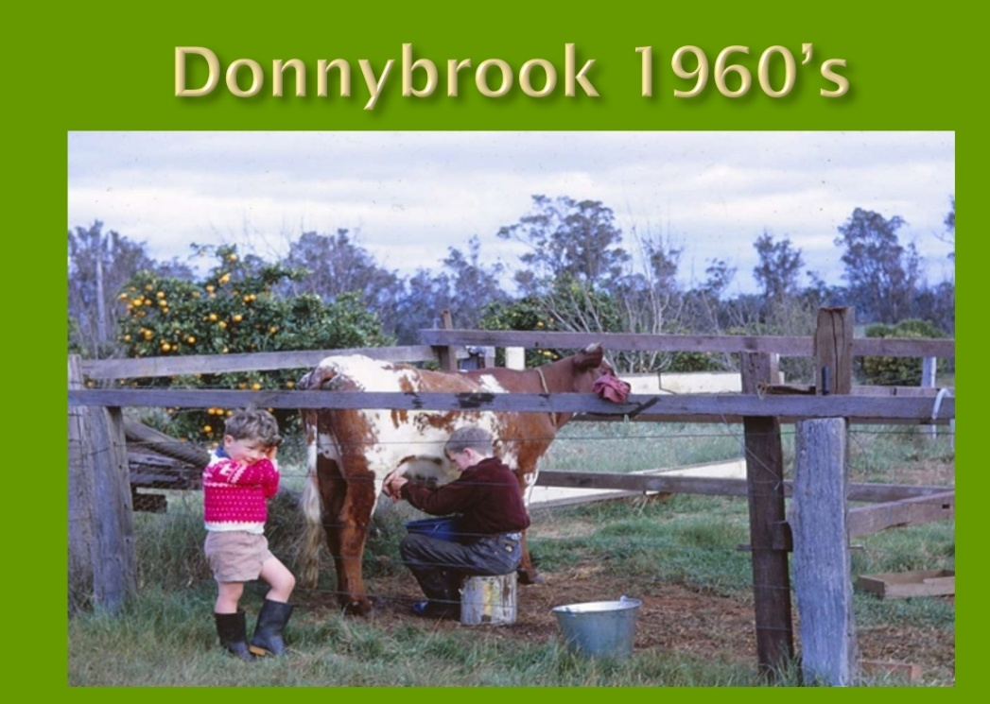
I grew up in Donnybrook in the 60’s. I was a members of scouts and first got interested in radio from a technical perspective because of the scouts Jamboree of the Air, where we visited local Ham radio operator Jack Kitney, who became a mentor to me.
I trained as a radio tech with Dept of Aviation, and in 1980 when working at Wickham, joined the Lions Club of Roebourne.
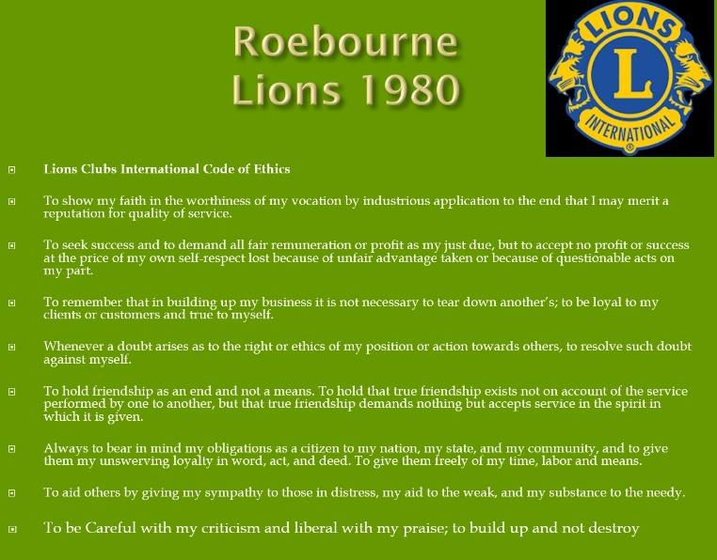
At my induction night, the guest speaker, a pom, said it is great to see so many active community services organisations in Australia. He said in the UK government had filled the function that used to be done by such clubs and numbers had declined. In 1980 Donnybrook had Rotary and Apex Clubs . The Lions Club of Donnybrook was formed in 1982. Sadly, since then Australia has followed the same path as the UK. We seem to have develop the idea that government is for looking after the community and business is for making money just for shareholders. It is becoming increasingly apparent that asking government to look after community is not serving us well!
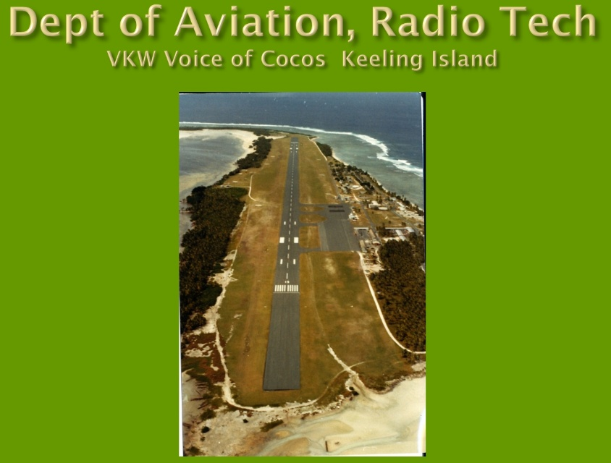
In 1983 we were transferred to Cocos Is and I got involved with the local community radio. I saw what a powerful community building tool it could be.
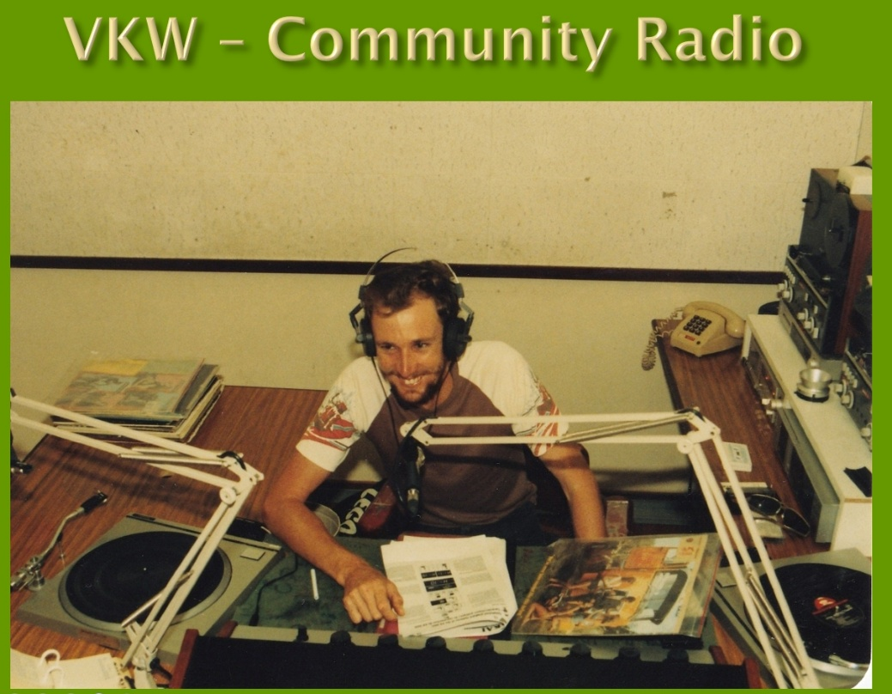
My wife and I grew up on farms in the South West and were keen to bring up our kids in a similar environment.
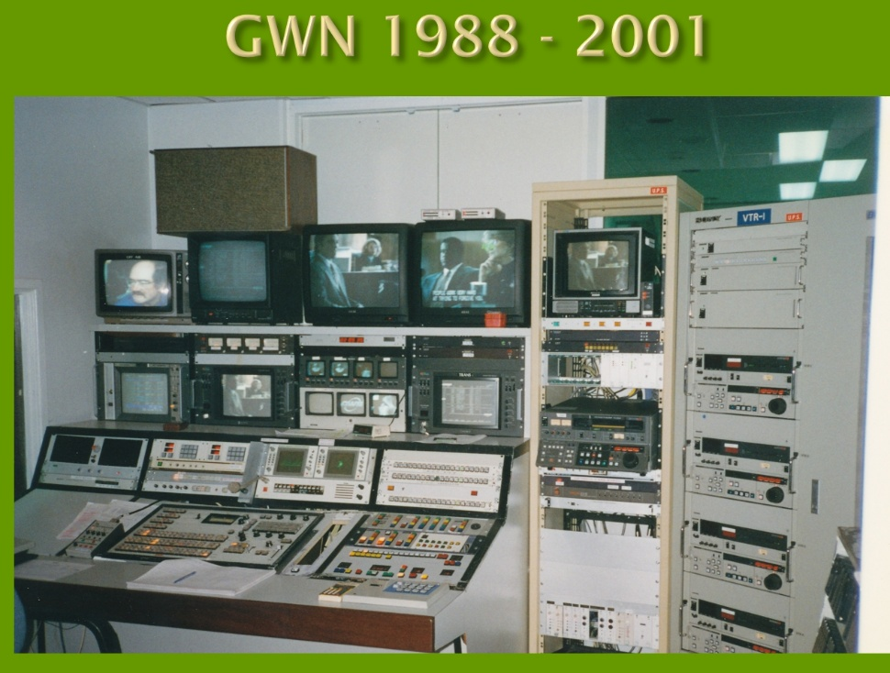
In 1988 I got a job at to GWN TV in Bunbury which gave us an opportunity to buy Boronia Farm at Donnybrook.
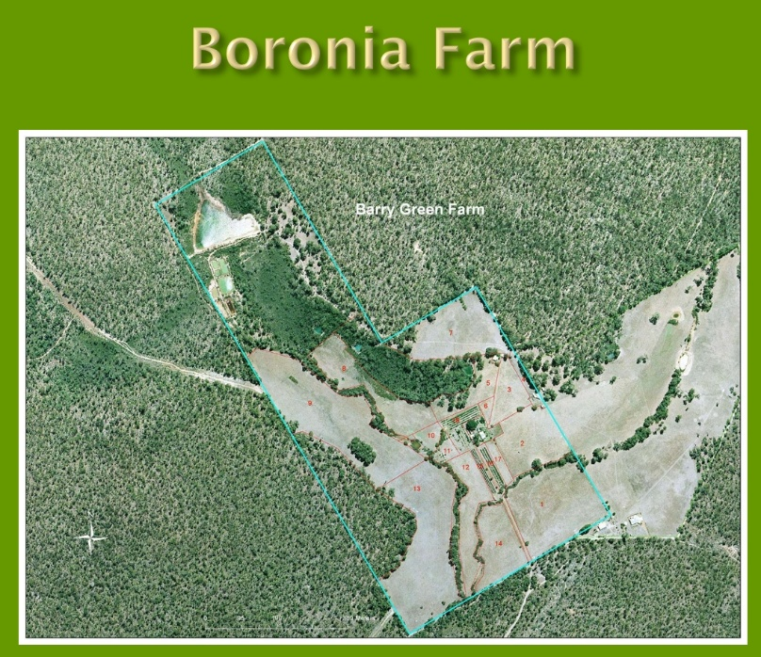
I then transferred into the Lions Club of Donnybrook.
1998, the year before I was President of the Donnybrook Lions Club I attended Lions Leadership training course at the Q station at Albany run by Jeff and Irma Needham. That changed my life.
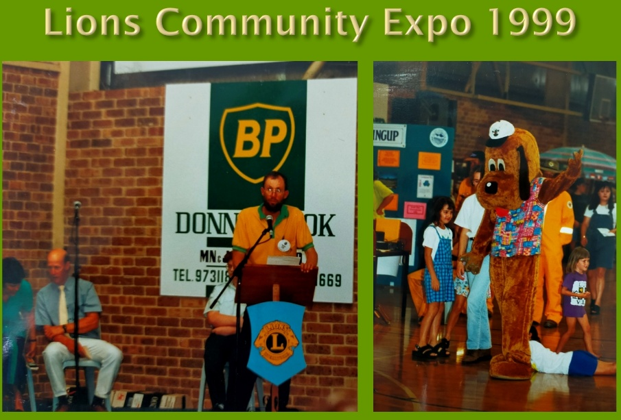
As a result of the training, I formed the idea of the DBK Community Expo as a membership project of community organisations in Donnybrook. I chaired a committee with members of a number of community organisations and the Lions Donnybrook Community Expo’s were held in 1999, 2001. I got a buzz out of the success of the Expos.
In 1999, we renovated an old cottage on the farm for Farm stay accommodation and this got us into tourism in a small way.
By the year 2000 it was becoming obvious to me that the job at GWN was going to end, so I was looking for something else to do. I’d become involved in the tourism assn in Donnybrook and was aware of Tourist Radio. I asked if there was any interest among the Donnybrook tourism assn in establishing a local tourist radio. There wasn’t. So I made enquiries anyway.
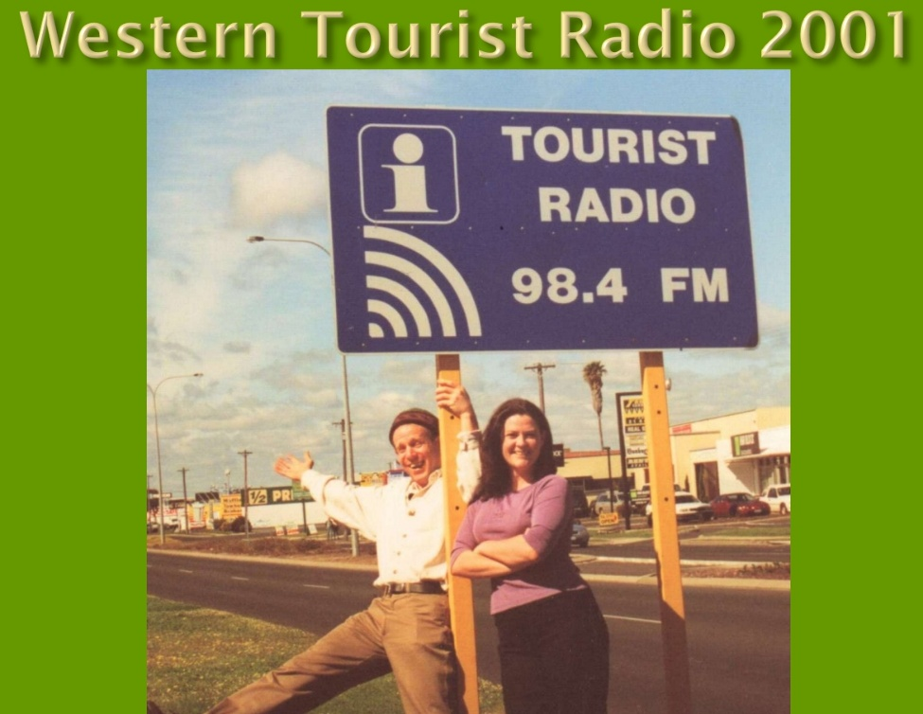
This led in 2001 to us acquiring Western Tourist Radio which at the time had 23 licences and operating stations in Perth, Fremantle, Bunbury, Busselton, Dunsborough , Cowaramup and Karridale. At that stage the program was just playing from a CD player.
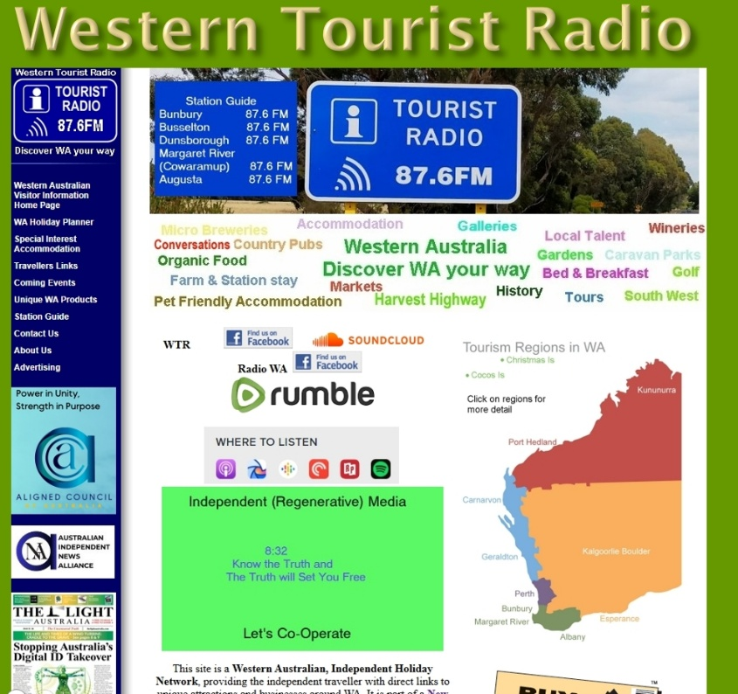
I employed a local company, which operated the “South West Life” E-Magazine, to do Search Engine Optimisation or SEO for us. We invited the owners to our farm for a bbq, and talked about how SEO worked.
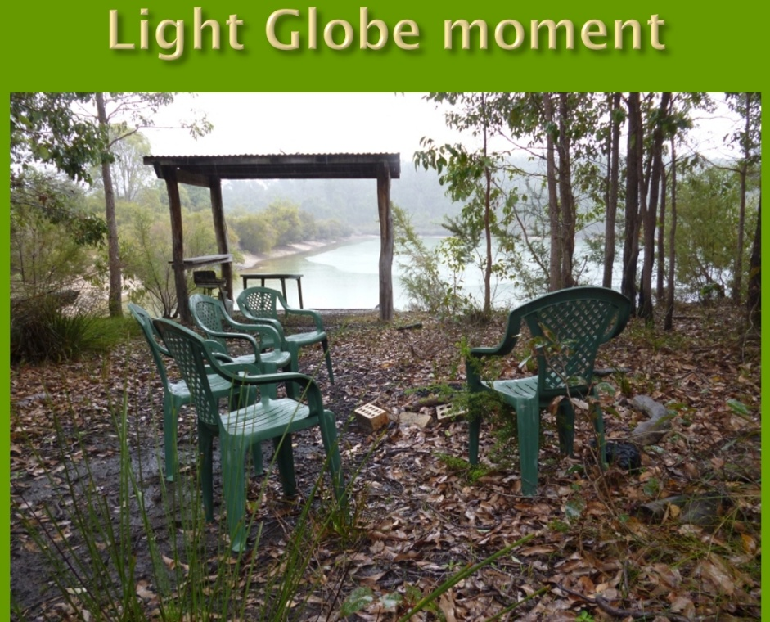
Graham explained that Google had become the most successful search engine because they had figured that the more sites that linked to a particular website, gave that site authority and it would come up in the rankings.
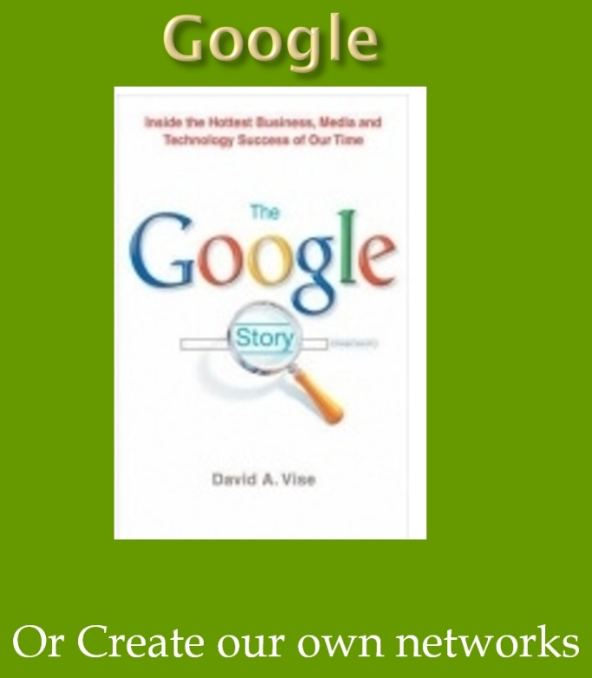
That was a light globe movement to me because I could see that it would allow the best information to come to the fore, not the information promoting products with the most money to spend on advertising, delivered via my old employer, Commercial TV. So I tried to build the website as a WA Visitor Information Portal, on the basis of reciprocal links. It was, and still is a good idea, but was hard to sell to people who had a competition rather than a collaboration mindset.
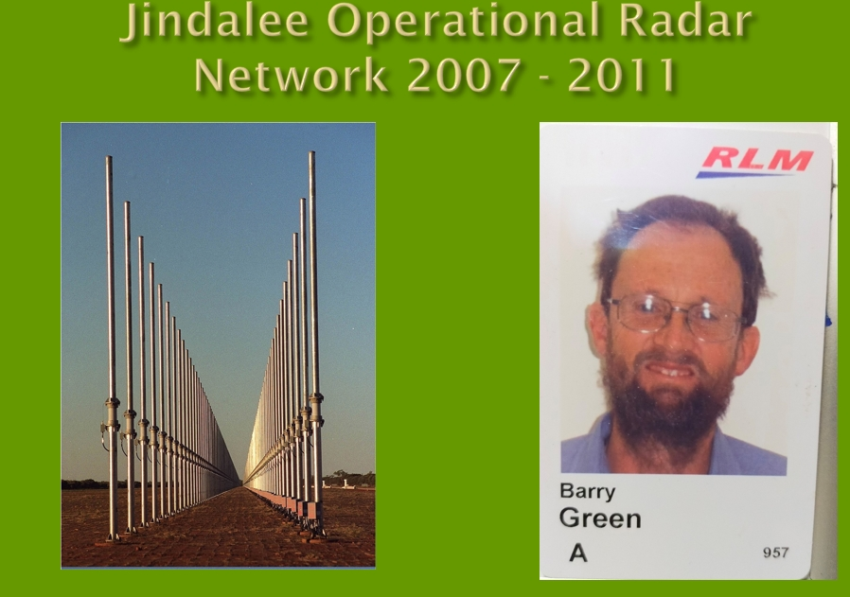
Western Tourist Radio nearly sent us broke. So I was fortunate in 2007 to get a job working FIFO on the Jindalee over-the-horizon radar at Laverton in the WA goldfields. This is a RAAF installation, but Lockheed Martin had the contract to operate the maintenance contract for that job. I had to have a Top Secret Australian government security clearance. I'm not sure our cabinet members have one of them.

In 2011 2 people came to me separately, asking how to establish a community radio in Donnybrook, both knowing about my radio background. The three of us met and we called a public meeting to see if there was community interest in perusing community radio.
There was, so we formed a steering committee, and the Lions Club of Donnybrook provided seed funding.
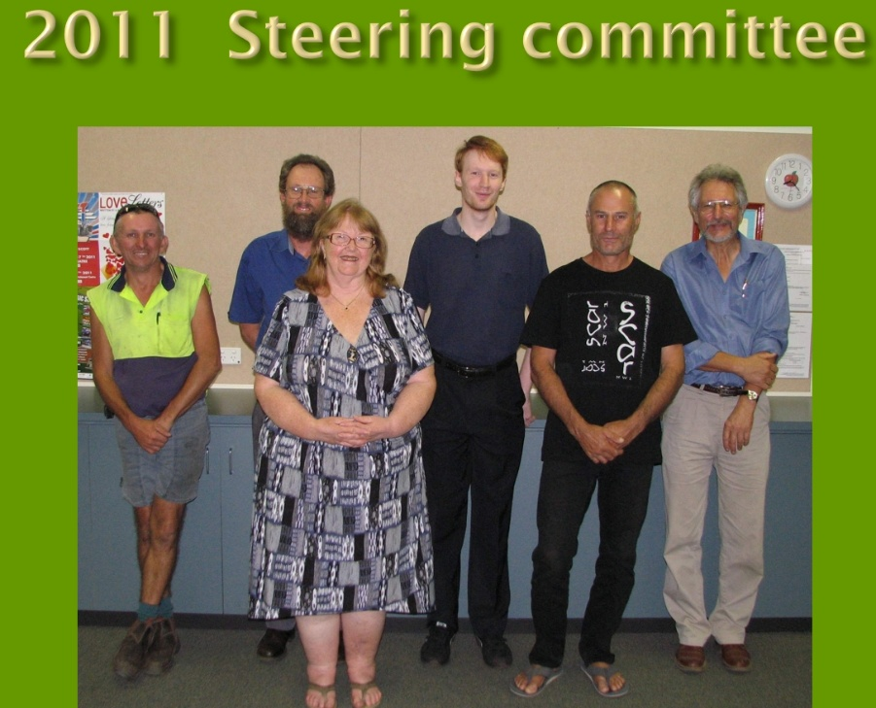
Donnybrook Balingup Community Radio was incorporated later in 2011, but we could not find anywhere to operate from until the Lions Club agreed to allow DBCR to annex part of the Lions Den.
We developed a 3 stage plan to get on air in Donnybrook and Balingup.
Stage 1 was just a 50 Watt Tx with an antenna on the roof the Lions Den / studio.
Stage 2 was a tx on the police mast on the hill overlooking Donnybrook which would reach much further and
Stage 3 was a transmitter in Balingup.

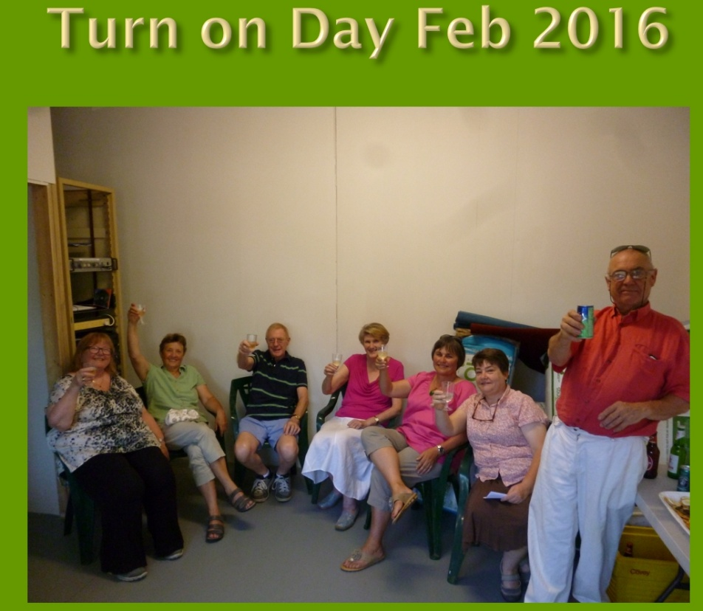
We got to stage 1 in Feb 2016. This didn’t go very far but at least we were on air. We did this with all our own fundraising. Initially we were just running a loop program, but the Lottery West funding allowed us to buy the automation system that allowed us to operate 24 hours a day and to run live programs as well. This proper service started in about June 2016.
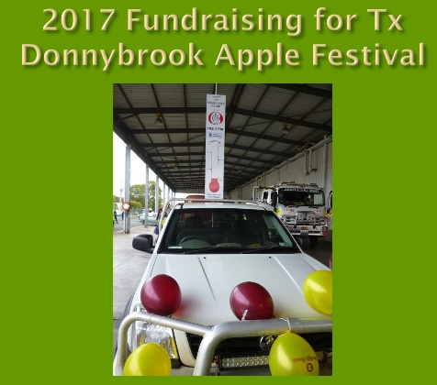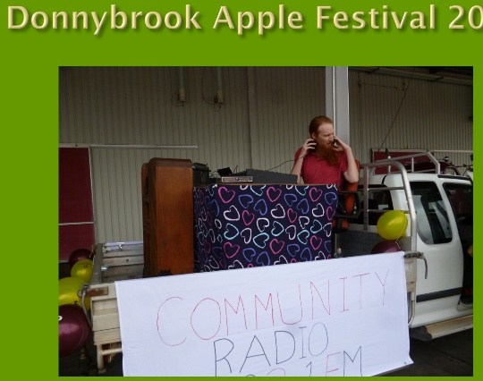
We continued fund raising for the new Donnybrook Transmitter site , and participated in the Donnybrook Apple Festival
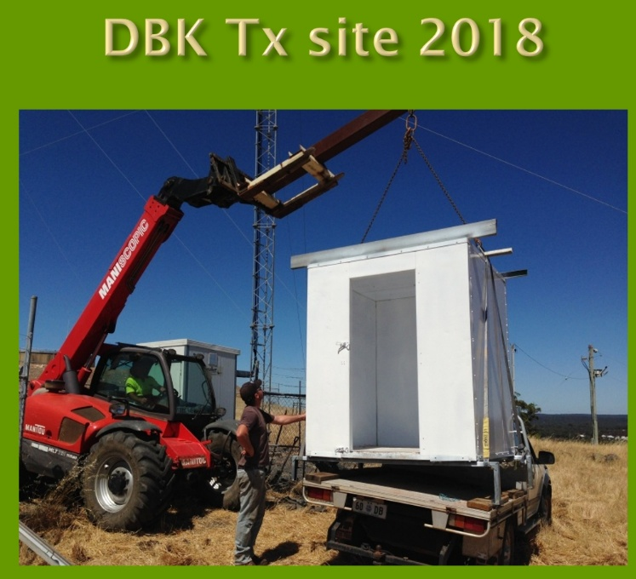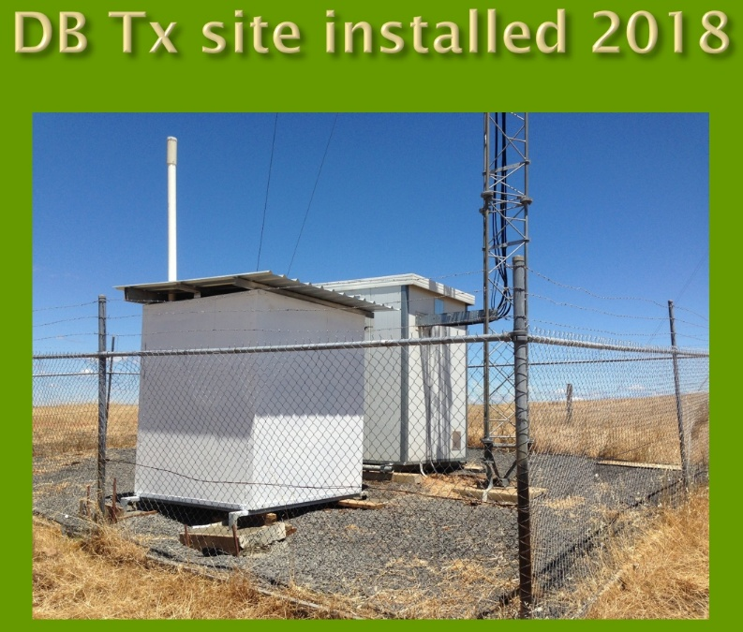
We then received $30,000 state government funding for the Donnybrook transmitter on the hill which we completed the day before Anzac day 2018.
By doing most of the work with volunteers we completed this for $21,000.
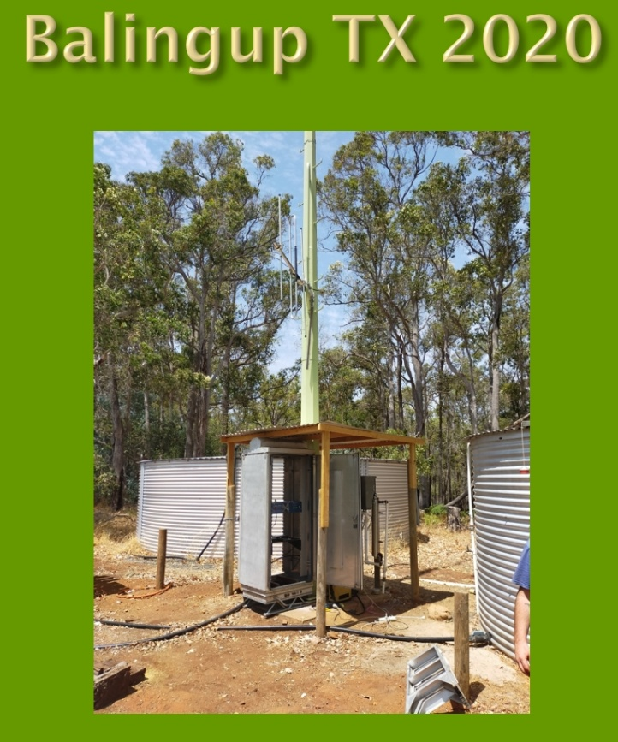
The government allowed us to use the remaining funds for the Balingup Transmitter which we completed in February 2020.

DBCR is a member of the Community Broadcasting Assn Australia, or the CBAA. In 2018 I nominated for their “National Features and Documentary Series” where community radio volunteers are mentored to produce a 30-minute documentary.
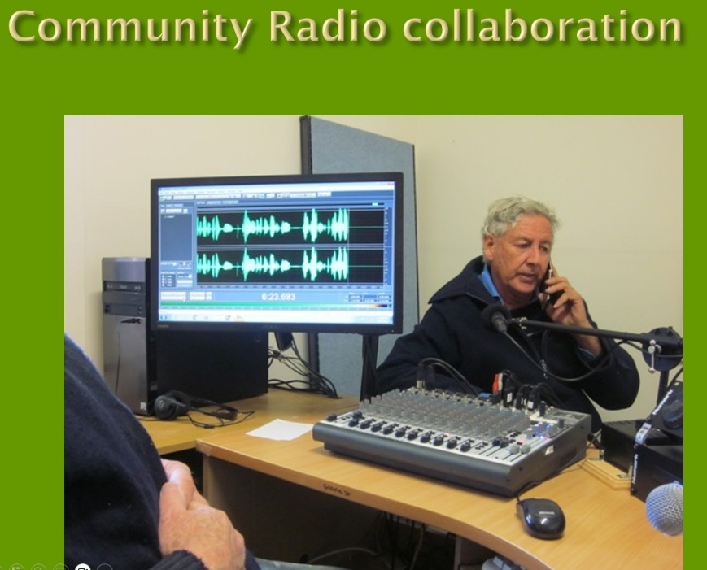
This resulted in me producing a half hour documentary titled “Healthy Soils, Healthy Communities” about Regenerative Agriculture. It was based on interviews with Charle Massy, Author of “Call of the Reed Warble, a New Agriculture, and New Earth”, and others, including Regen Ag farmers Ian and Di Haggerty who are current WA winers in the Australian of the Year awards for their leadership in regen ag.
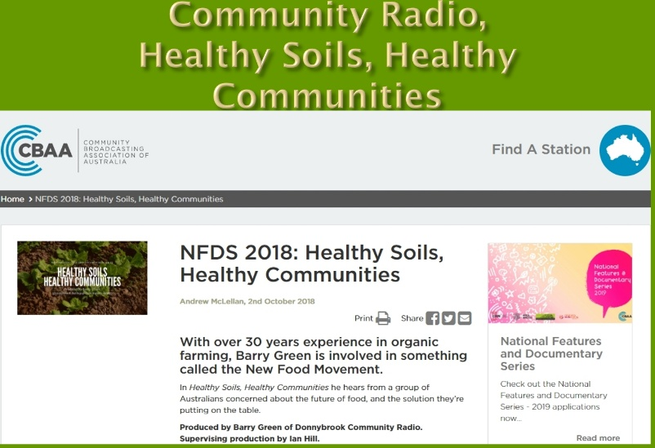
The program was available for community stations all across Australia to broadcast and remains online. This combined my interest in organic / regenerative agriculture and radio.
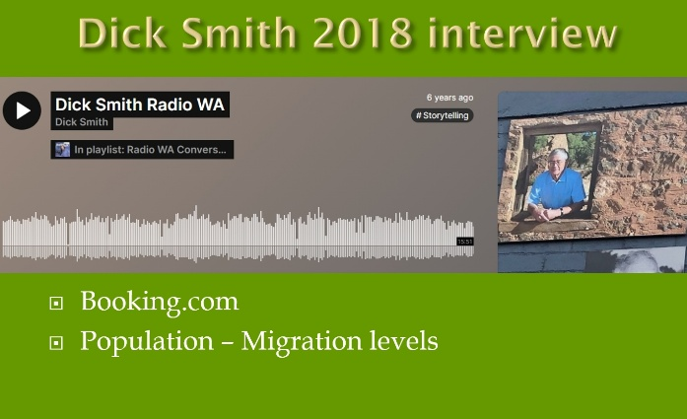
In 2018 I interview Dick Smith on tourist radio. This came about because Dick was encouraging people to book accommodation direct, and not use the big booking engines that are taking big commissions overseas. That is what I have been trying to do with the tourist radio website.
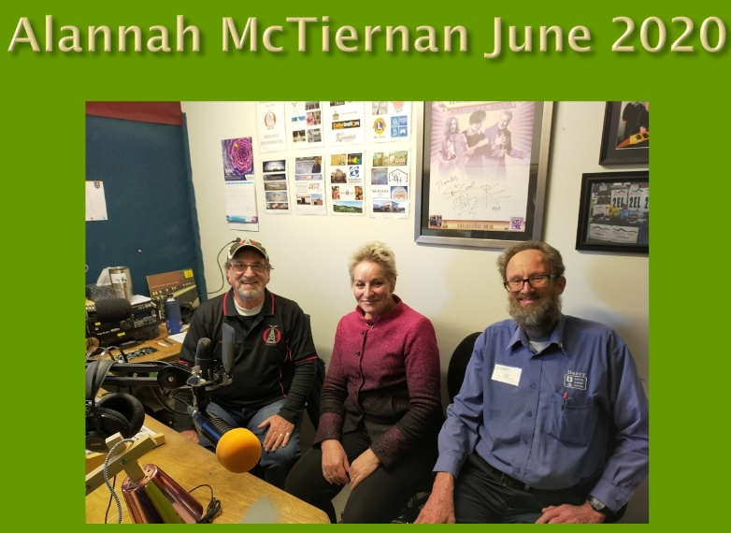
Alannah McTiernan, was the Minister who approved the state government funding for our transmitter, and also brought Charles Massy to WA to talk about Regen Ag, which prompted my CBAA documentary with Charles.
In mid-2021 I started producing a weekly 2 hour talk show initial called “Talk of Our Shire”, which was sponsored by the DBCCI. We talk to local businesses and members, local organisations, artist, musicians politicians and other movers and shakers. Our interest is local and national issues, from a local perspective.
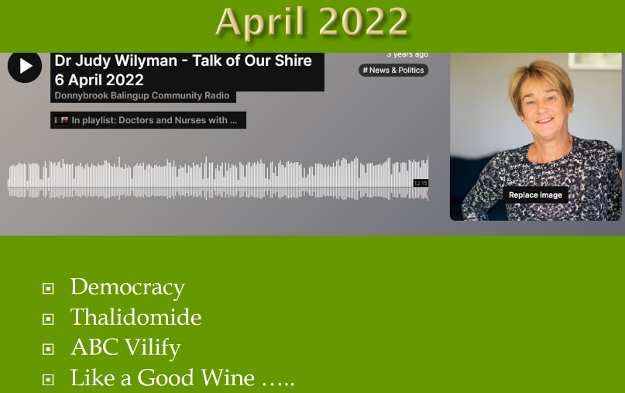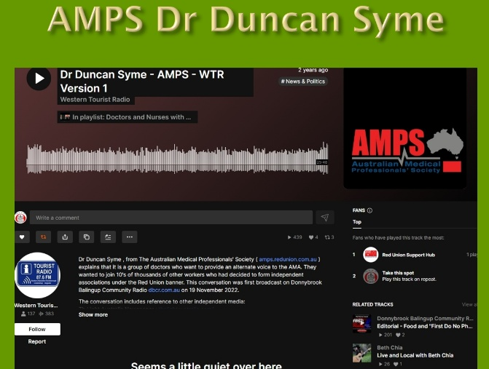
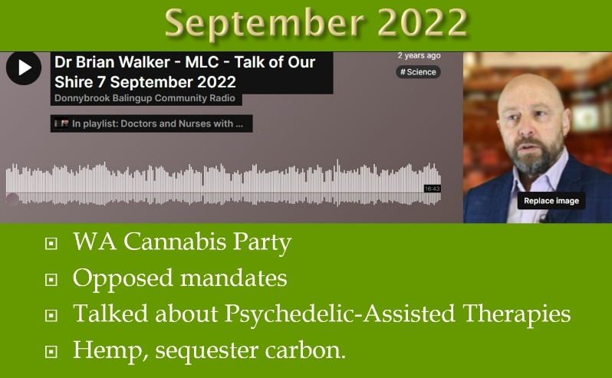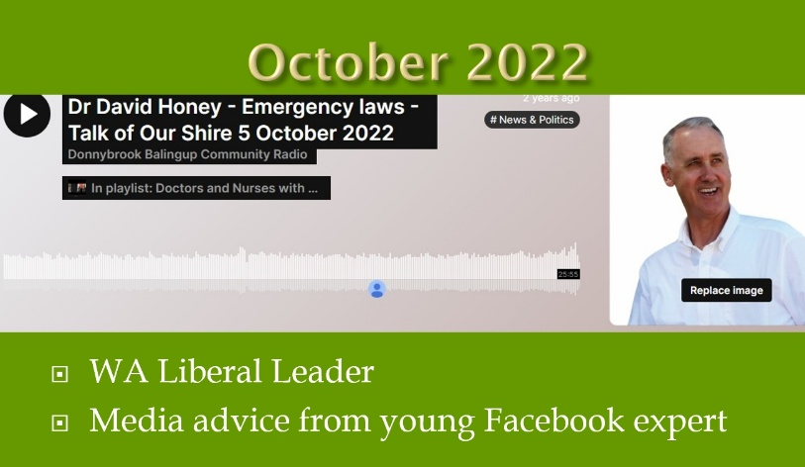

I’d been very concerned about the Covid injection narrative and associated censorship, so used the opportunity to question that narrative. As a volunteer on Community Radio, I have been able to have conversations with all sorts of experts, that professional journalist have not been able to have, for fear of getting the sack.
As a volunteer , it doesn’t matter if I get the sack!
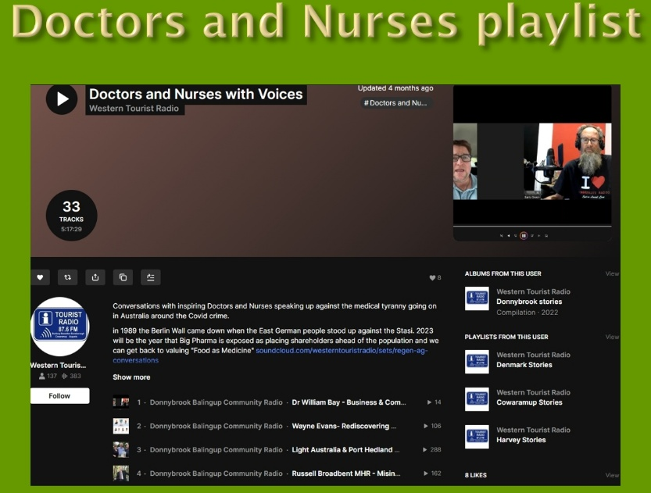
All these conversations are posted online, where they remain as an oral history, recorded at the time.
The conversations are compiled into the Doctors and Nurses with Voices playlist
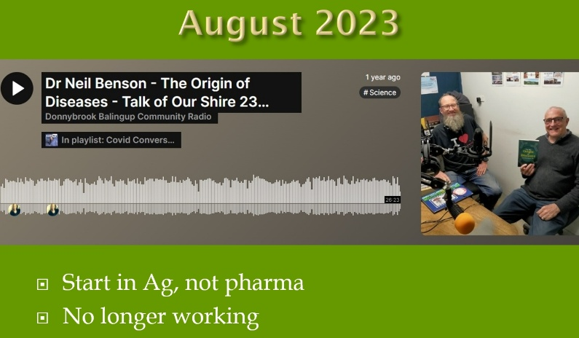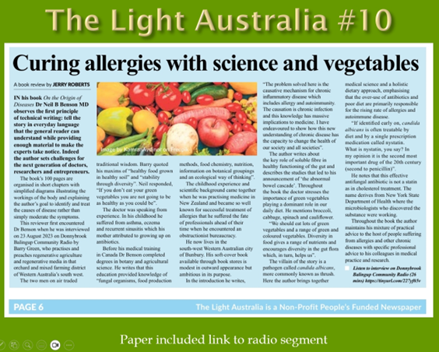
One of the Doctors I interview was with Dr Neil Benson, who wrote the book “On the Origins of Diseases”. Jerry Roberts is an old school journalist who ask questions. He was one of the founders of The Light Australia Newspaper. Jerry heard this interview which prompted him to read the book and write a review he titled “Curing Allergies with science and vegetables”
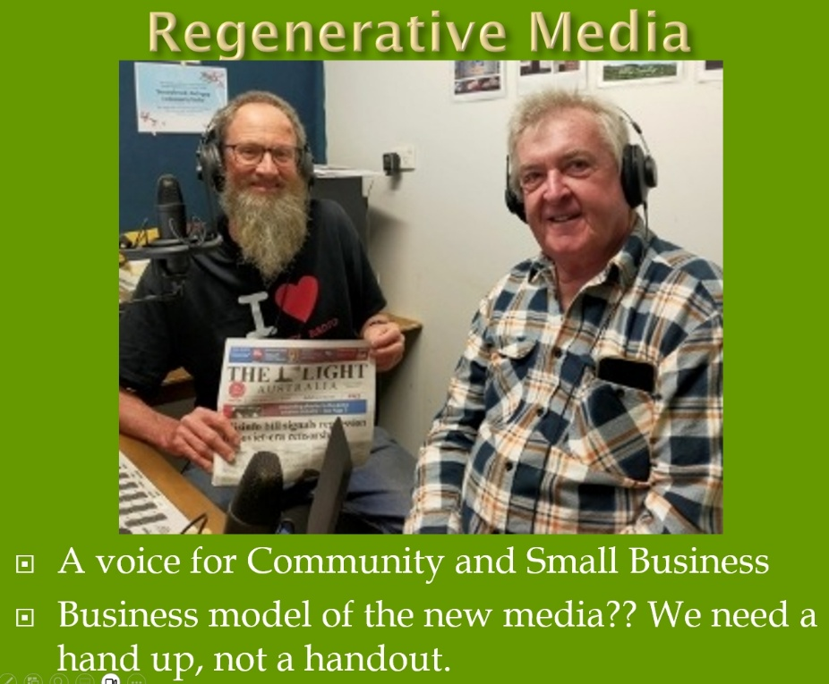
With my interest in Regenerative agriculture, I’ve coined the term “Regenerative Media” for all the new independent media that is currently evolving, including the Light Australia Newspaper. The West Australian Newspaper referees to this paper as a “Conspiracy theory” paper. Corporate media doesn’t like people asking questions
Graham Hood is a former Qantas Pilot, now podcaster, a leader withing the independent media movement.
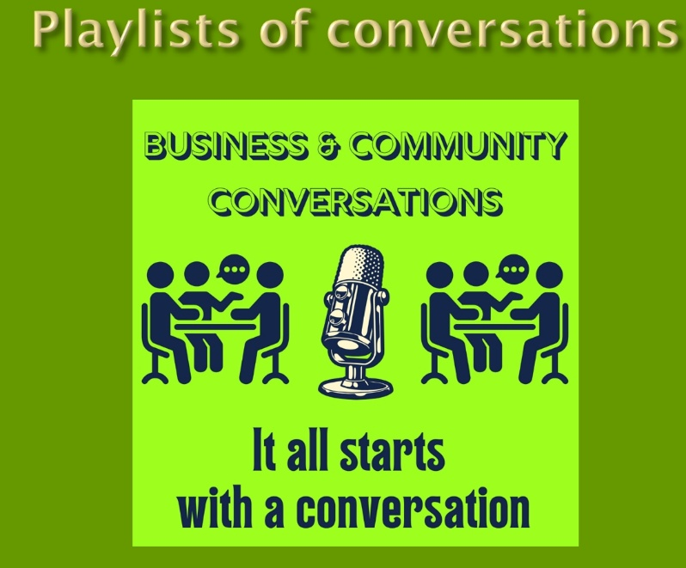
My weekly talk program is still running, now called “Business and Community Conversations” byline, “It all starts with a conversation”. The program is now sponsored by HarvestHighway.com.au . While Radio is old technology, all the conversations I’ve broadcast on DBCR are online for the record. They are an oral history of the times we have lived through. This is important because we need to remember this and not allow corporate online interests to re-wright history.
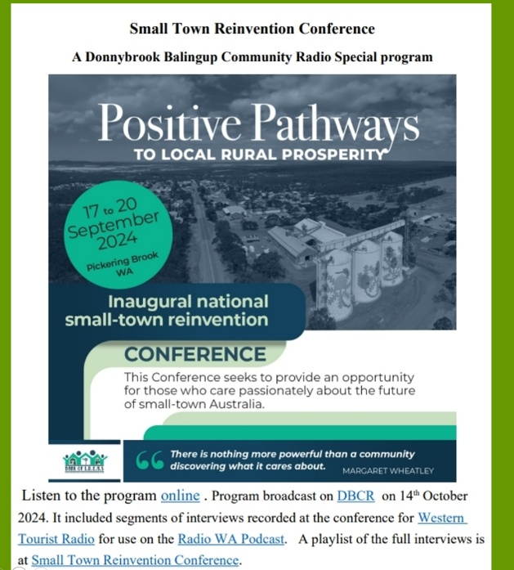
Last year Peter Kenyon from the Bank of Ideas organised the Small Town reinvention conference in Pickering Brook. I attended and recorded a number of interviews which were followed up with a special program on DBCR on the subject, based on those interviews and with Peter Kenyou and Wendy Trow from the Balingup Progress Assn, who was a presenter at the conference.
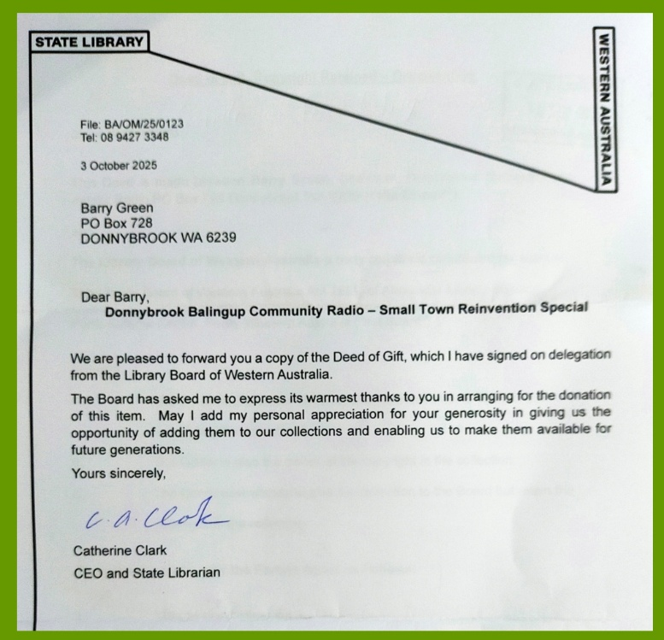
The Audio and transcript of the program has been accepted as an archive by the stare library.
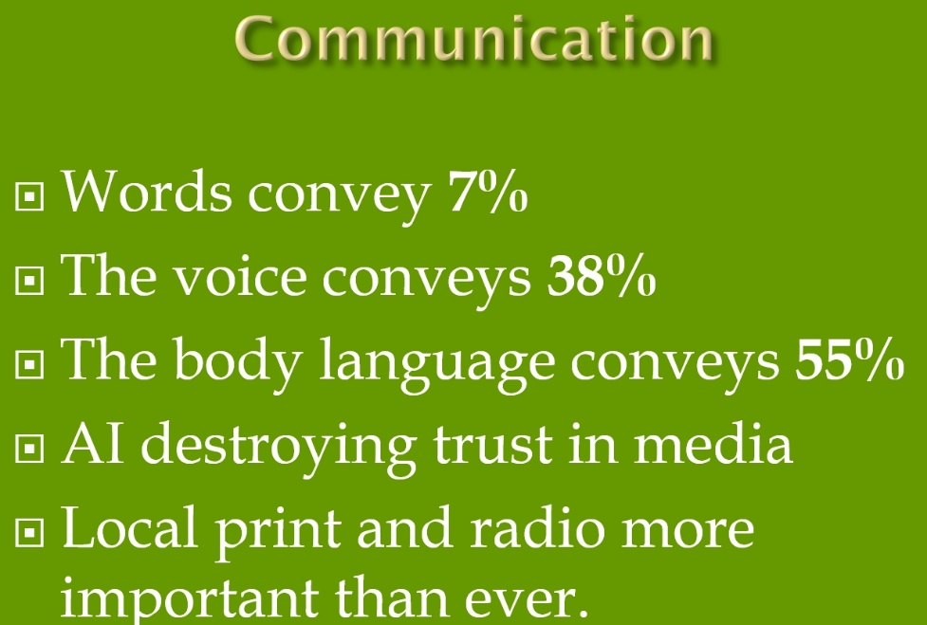
Communications people say that Communications is made of the words, the voice and the body language. The words convey 7% of the message, the voice 38% and the body language 55% . So short of a face to face conversation, radio and podcast is the next best thing!
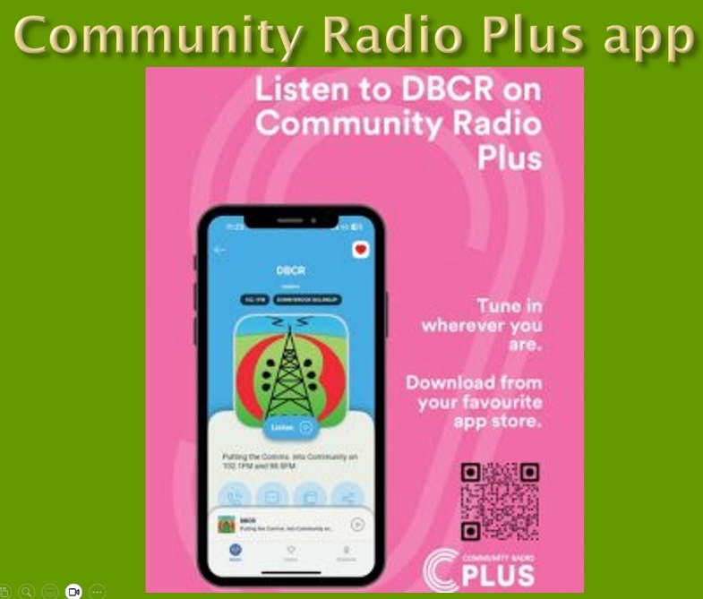
Most Community Radio stations now also live stream their program to multiple platforms, including the “Community Radio Plus” app. This allows people to listen all over the world.

In the South West, there are now Community Radio stations in Harvey, Collie, Bunbury, Donnybrook, Margaret River and Augusta. All these towns also have Lions Clubs. Busselton where is yours?? Perhaps a future Project for the Lions Club of Busselton?
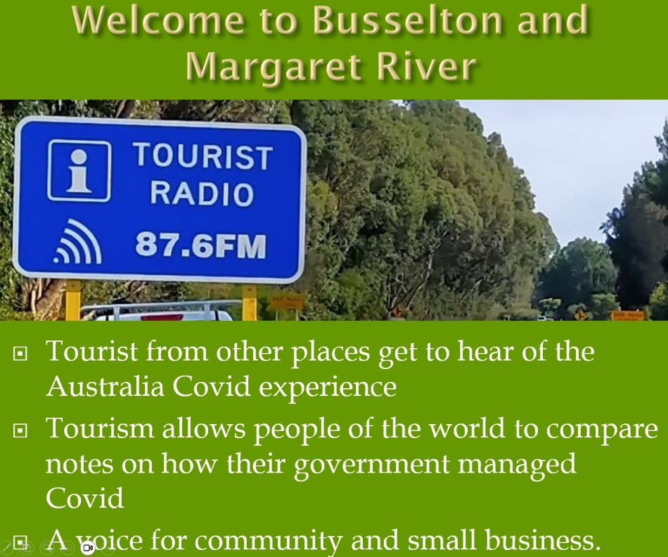
Western Tourist Radio promotes all the community stations, the 2 radio formats are complimentary, not in competition. Tourist radio stations have a limited range and are all a repeating loop program. The program content for each town is also online as a playlist.
While locals might have become shop blind to the tourist radio signs, visitors are likely to see them and tune in to hear local stories. Listening to a local community station is also part of the local experience to visitors, especial now that the commercial stations have been networked and lost their local identity.
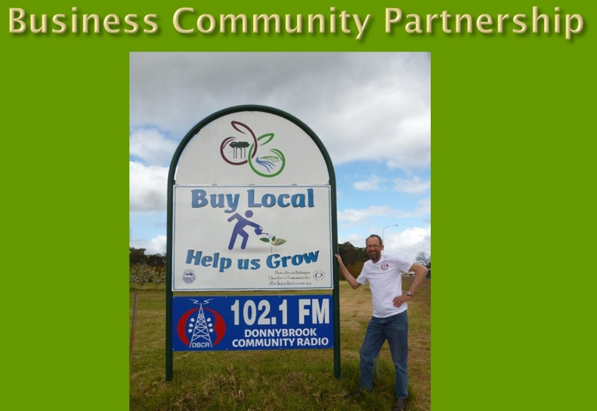
I see Community Radio as a Business / Community partnership, we rely on business and community organisations to sponsor our service and encourage our listeners to support local businesses. I see this as the foundation value of the Lions organisation
In Conclusion, I know Lions do not discuss partisan politics or sectarian religion. But there is growing evidence that the Covid event was made much worse by vested commercial interests and a compliant media. When the Mainstream Media is largely funded by advertising from Big Food, Big ag, Big Pharma, Big Gambling, Big retail, Big Banks, Big Governent and all the other Big’s they seem to lose their capacity to question these organisations.
My radio technician training taught me that to fix a fault, you need to identify then address the cause of the problem. We face many problems as a society, I believe that part of the problem is that the government has allowed a concentration of media ownership by corporate interests, which now control the narrative in their interest.
Independent and community media is vital for the democratic process.
We are living through a turbulent time in history, not unlike 1917 when Lions was formed. I’d argue that the Business ethic that led to the formation of Lions is what made America a great nation.
The same can happen again as we rebuild a sense of community from the bottom up, and Lions in partnership with Community radio is again well placed to provide that leadership.
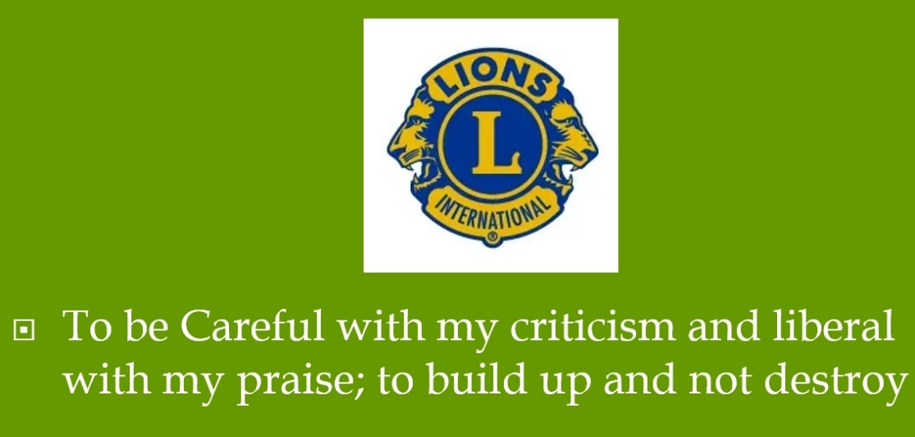
There is so much division within society these days, which I feel this is by design.
This makes the last line of the Lions code of ethics so important to remember.
To be Careful with my criticism and liberal with my praise; to build up and not destroy.
Thank you.

