Bunbury U3A Community Media Presentation Part 2 - 13 Feb 2026
Listen to Part 1 & 2 online : https://creators.spotify.com/pod/profile/radio-wa/episodes/Bunbury-U3A-New-Media-Talk-Feb-2026-e3fb8ai
That was the presentation I gave to Lions. So continue on from there. There's a lot's happened since September last year. 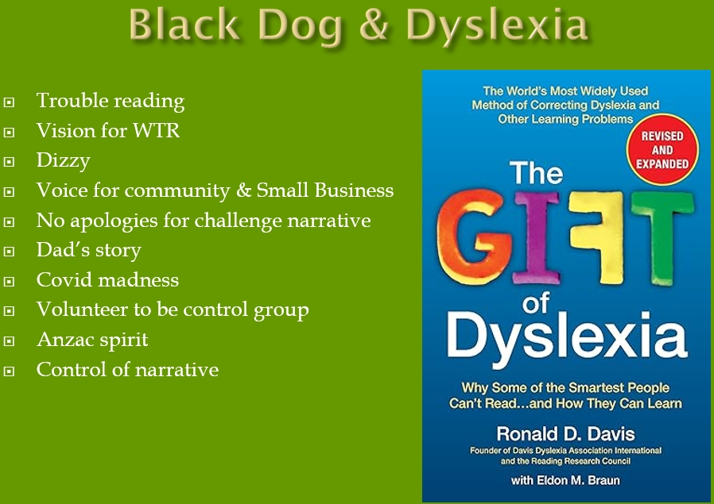
I’m probably dyslexic. I've struggled to learn to read as a kid. And I've been a bit prone to black dog disease. But, the book “The Gift of Dyslexia”, talks about people with dyslexia as seeing things differently and, it talks about when you, when you perceive something in a reality doesn't match. You get this dizziness. And I've had that a fair old dose of that, especially over the last five years. My vision for the tourist radio right from the start was to provide a voice for community and small business in the media environments dominated by big business. And, in challenging the Covid narrative, there's been a bit scary. A friend of mine, Graham Hood, who I alluded to earlier said when he started questioning the Covid injection narrative, you know, we were told you can't question a narrative about the injections and all that. When you started questioning, he said, it felt like, you know, First World War climbing out of the trenches and racing to the other trenches. And he said, we did that. We went over the wall, got to the other trenches, and there's no bugger there. So, you know, we've been told you can't question this, but there's no reason that we can't question it. In fact, you know, in a democracy, the function of the media is to question the government. My Dad fought in the Second World War, and he crossed the English Channel on D-Day plus one. He fought his way up to Belgium, where he shot and left for dead in October 1944. He wasn't dead. Otherwise, wouldn't be here. But he was fighting a regime that controlled the narrative in the way our government is trying to control the narrative, which is a really scary prospect. So anyway, I think we've got to rebuild the Anzac spirit and, challenge government at times.
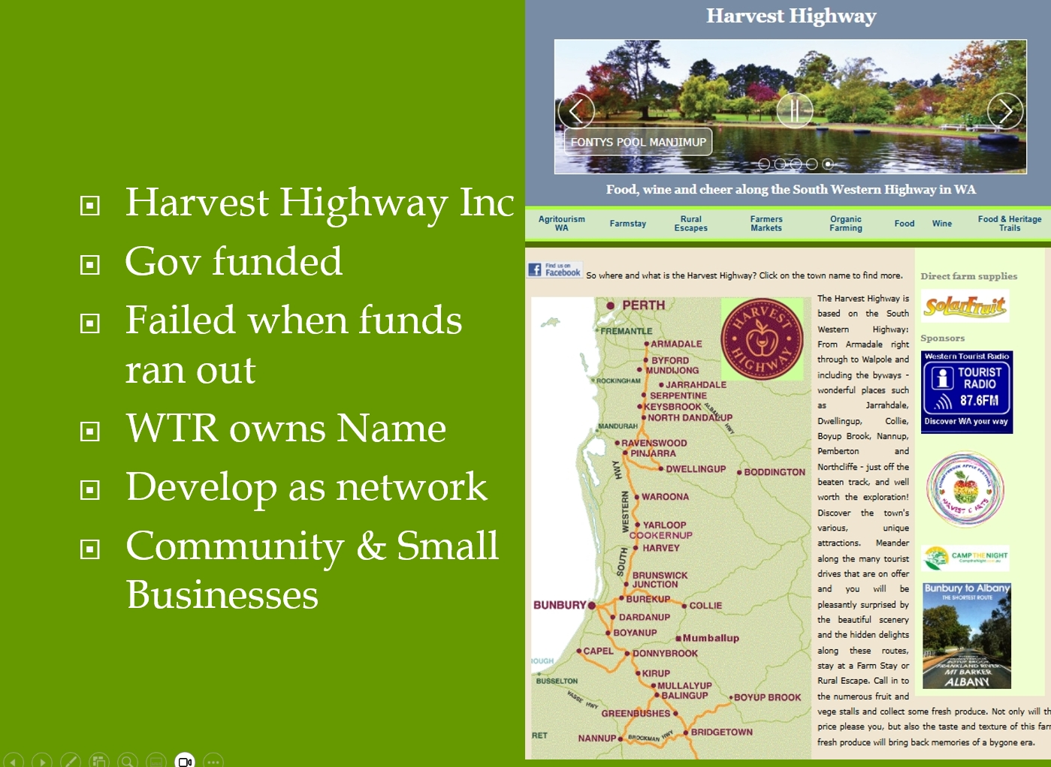
Lyn we, mentioned Harvest Highway, Harvest Highway Inc. got lots of government funding in the early 2000's to promote tourism and producers along the South Western Highway and byways. Like a lot of things, government funds, it failed when the funds ran out. I had been on the committee of it and when Harvest Highway Inc. was wound up. Western Tourist Radio acquired the business name and, the website and it's still there. The black dog sort of held me back a bit over the recent years, but it's still there. And I think the time is right to reinvent it as a network of businesses up and down the highway. So I've produced this postcard. I did this 12 years ago, but I've reprinted it and there's some there. The QR code on it will take you direct to the Harvest Highway website.
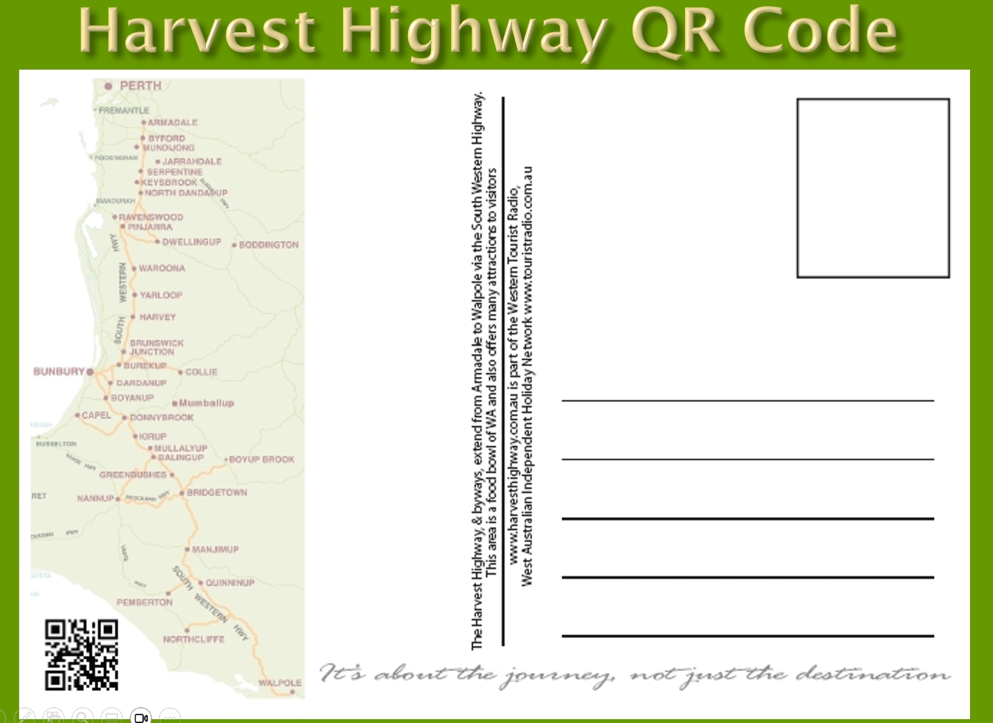
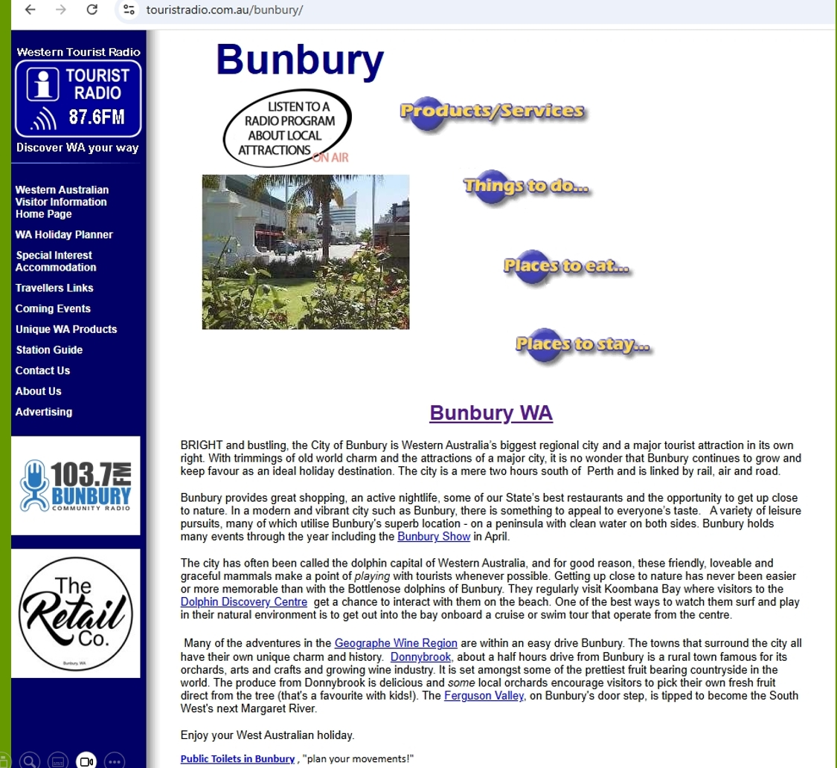

So if you go to the website, if you click on, say, Bunbury on the map, it will take you to a Bunbury page. And if you click on the on air button at the top of that, it'll take you to a playlist of, Bunbury stories that you can listen to on 87.6 in around Bunbury, but also online. And I've got an interview there with the former tourism minister, David Templeman, who was very complimentary about what I was doing, didn't reflect in the departmental support. 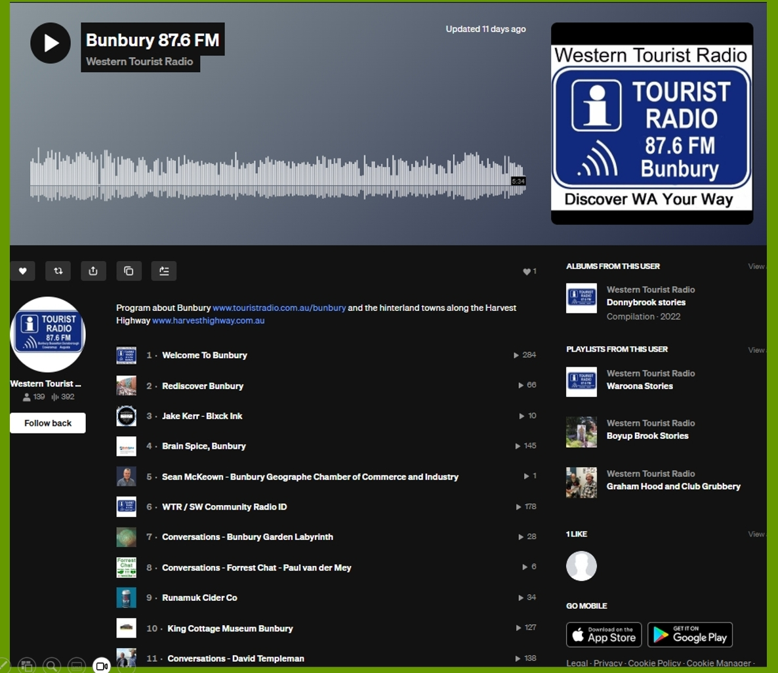

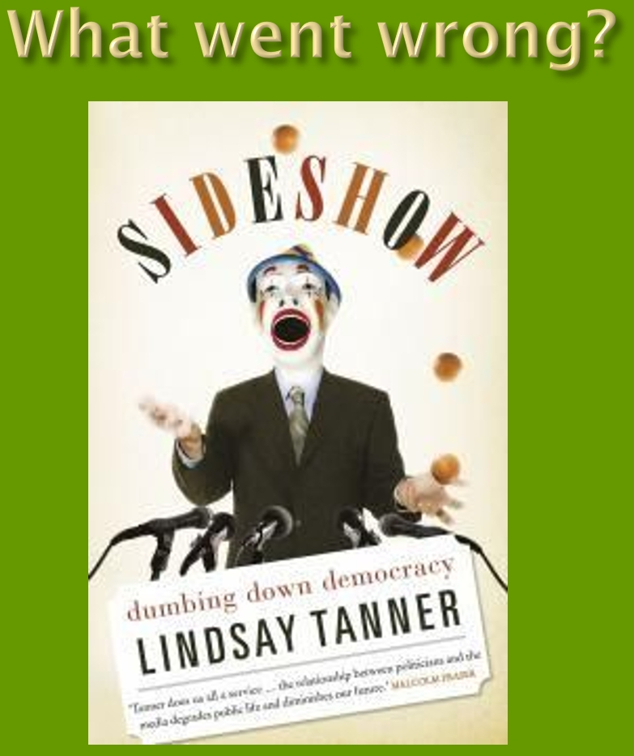
So the great question of our time is what went wrong? Lindsay Tanner was a Labour Minister in the Hawke Keating government. His book, “Sideshow The Dumbing Down of Democracy” from about 2010, I read it and it was really quite enlightening. It's what's happened in the democratic process. Politicians are all sort of driven by focus groups and what people want. There's no real leadership there, and it's all been steered by the media. So, you know, the politicians can't say what they want because everything that we hear in the mainstream media is filtered by what the journalists want to get at. So it's very hard for politicians to say anything. But I've been talking to all sorts of people on my show on community radio. I did an editorial about fluoride being added to the Donnybrook Water, which, nobody demanded that,
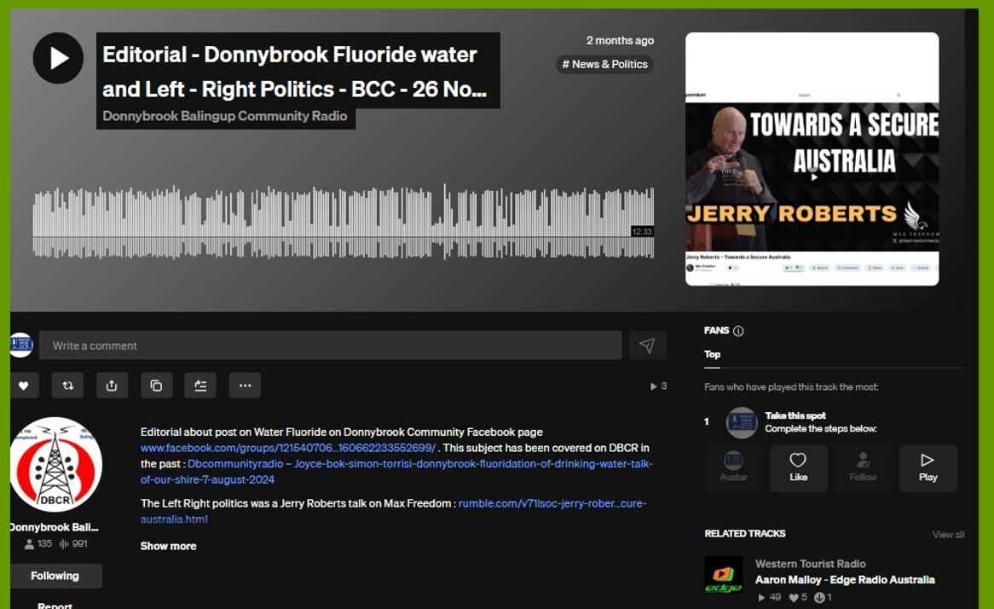

But I also played this thing, Jerry Roberts spoke at a, Truth Media place in Perth that it was very interesting because Jerry's an old school journalist from the days when journalists used to ask questions and he was one of the founders of The Light Australia Newspaper, and he talked about the left and right divide. And, there's a limit to how much I can go into at this time, but it's, it's online, for the record, and it makes good listening.

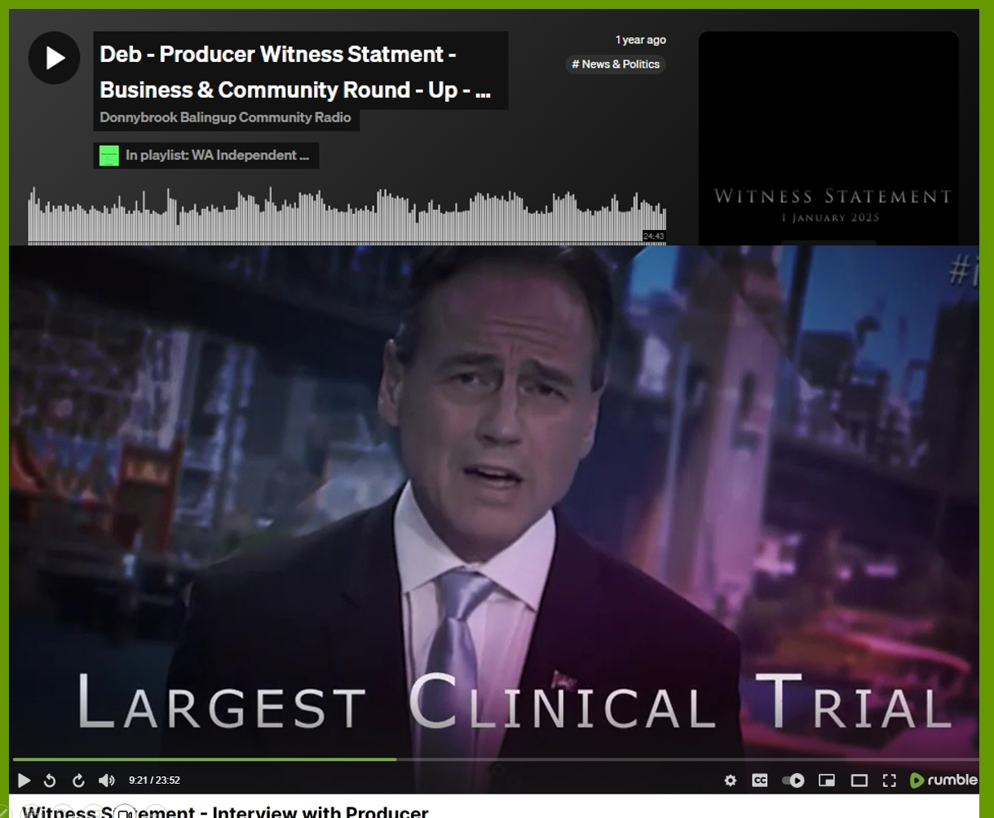
In February last year I spoke with Deb Lim, who produced a video called Witness Statement, where she took public domain information of things that had happened through the Covid period and presented it. As she's saying, when I was a young person, if we saw evidence of a crime, you'd go to the police and their job was to investigate that crime. So it's a video presenting evidence of a crime that's been committed through this period. And things like the health minister saying this is the biggest clinical trial in history. Now, the idea of having a clinical trial and forcing people to participate in a clinical trial made absolutely no sense to me. And, and a lot of other people, including Professor Ian Brighthope. This is at University of the Third Age. Professor Ian Brighthope is a professor of integrative medicine, like Doctor Neil Benson, who I referred to before he started, before he became a doctor, he started in agriculture and in agriculture it's about health and production. And, then he started training as a doctor when he was 23, as he said on the program. All the smart young people come out of high school, went to university to study medicine, and their teaching was all basically driven by the pharmaceutical industry. Whereas Ian, having come from an agricultural side, had a totally different approach to it. He ended up forming, WOW , the World of Wellness. Ian had told the Prime Minister early in the Covid event that, if he'd, given all everybody who is low in vitamin C, vitamin D and zinc, supplements, the pandemic would be over in six weeks. The prime minister wasn't interested. We took the advice of a local naturopath, and that's what we did. My wife and I, we did both get Covid, and I was pretty lethargic for a few days, but that was about the limit of it. So we were frightened into this thing, but it wasn't that bad if you took precautions and boosted your immune system . I've also interviewed Professor Gigi Foster from the University of New South Wales. She's one of the founders of Australians for Science and Freedom because science has been corrupted. This idea that we're told follow the science is the most unscientific statement anybody could make, because science is about questioning everything, and we weren't allowed to question things.
Doctor John Campbell is a UK medical educator. He's actually a nurse by profession, but he's been a UK educator, medical educator for 30 odd years. I've been following him since very early in the Covid event. He wasn't an “anti-vaxxer” , he took three Covid injections before he realised he was having heart troubles. He was interviewed on the Jimmy Dore Show, and Jimmy Dore was talking about heart problems he'd experienced since the injection. And I played the segments of that. Doctor John Campbell's got 3.3 million subscribers on YouTube. Our ABC got about 300,000. So this this independent media is becoming much more powerful than the old, legacy media. Anyway, after I played that, I had a call from John Dent, local bloke, and he said, I heard that, and he said, I've had these problems since for some time. And he said, I thought it was just a coincidence. But I, having heard that I'm sure this injections, what's caused my health problems. He said, I've had all five injections in one arm. This arm doesn't work properly anymore. He was prepared to come in and talk about it because there’s been so much conditioning that even if you question the, injection, you're sort of supposed to be a nut case! Well, John was happy to come in and talk about it.

On the positive side, Doctor John Campbell did a thing about, people with cancer that had been written off by the system. Self medicating themselves with out of patent drugs and getting good results. Now, this case referred to three cases. Well, that doesn't prove anything. But he said the bloke who figured out that scurvy is caused by vitamin C deficiency. He did a test of ten people, two on lemons and limes and the others on other scenarios. And the two that survived were on lemon and lime, so that didn't prove anything, but it was warranted for further scientific research. So on the positive side, what Doctor John Campbell is saying is the government in Florida has allocated $140 million to investigate the use of out of patent drugs, including ivermectin. That was bad mouthed through Covid, for treatment of cancer. Now, from this anecdotal evidence, this could work. Now, I'm a private enterprise person. I believe in free market private enterprise. But when the free market fails, there is a place for government involvement. And the free market, I believe, has clearly failed in relation to the pharmaceutical industry. And so if the government in Florida can fund research that can result in treat cancer without patent drugs, because that's never going to happen with the pharmaceutical industry, because they exist to make profits for their shareholders. So this is a really positive outcome of the rather dark period we've been through and in America.
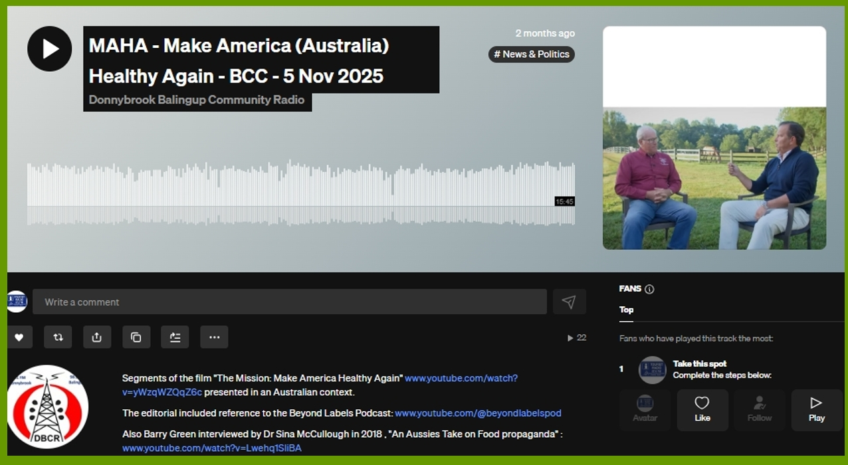

Make America Healthy Again. I like think it can be Make Australia Healthy Again. Joel Salatin on the left. Joel's a regen ag, regenerative ag, farmer in America who I've met. He's been in Western Australia. He's brought here in the 2010’s I think, by the South West Development Commission to talk about regenerative agriculture and food and health. So there's a very good 30 minute video called The Mission : Mission Make America Healthy Again. One of the speakers is Doctor Robert Malone. The other is Joel Salatin. And a lot of people think anything to do with America, think Trump and think bad. But when you understand all that we know about Trump and Kennedy has come through our mainstream media, and what they're doing is they're taking on the big American corporations, the big food and the big pharma and the big AG in America. So this this is a fairly big change. Now the US government has just turned the food pyramid upside down, which means we should be eating fruit, vegetables, meat, dairy and whole grains. The food pyramid that's been driven, which, you know, we're told we need to eat the carbs and all that. If you understand the science of it. There's two versions of it. One is that it was created by the seventh day Adventist Church in the 1850s because of their vegetarian agenda. They wanted people to eat plant based, but also then in the early 1900s, the Kellogg's and the likes of them, their marketing people wanted to sell more grains. And that's what's driven the food pyramid that has existed until a few weeks ago. I sort of see this as like a I've been saying for a while, I think we're approaching a Berlin Wall moment. I see when I saw the Health Secretary in America, Bobby Kennedy stand up and say, with the authority of the president of the leading capitalist country in the world said, you've been lied to by your government and corporations about what you should eat. That's a fairly profound thing. Now Joel Salatin, who I alluded to is a farmer, Talks about the situation in America at the moment. The average age of farmers, 60, in the next 15 years is going to be a mass transfer of agricultural assets. If it goes to Blackrock, Bill Gates and China, we're in trouble. We've got to get young people back in agriculture, young entrepreneurial people getting back to the first principles of agriculture. Let's see where we go here. I'll digress a bit here. My interest and passion in organic or regenerative agriculture. It's about the soil biology. And there's so much new science in terms of the biology of the human gut and its relation to physical and mental health. And all these processed foods aren't recognized by the human gut as being food at all. Back in 2000, I attended a soil seminar in Manjimup, and the presenters were talking about the soil being made to chemical, the physical and the biological properties. We got pretty good at understanding the chemical and physical. The biological is too bloody hard, so we ignored it, which is pretty much what's happened. But the, exciting thing about regenerative agriculture at the moment is that the internet's provided a mechanism for innovative farmers to work with independent scientists and get a much better outcome without all the expensive inputs. And this is what Charles Massy talked about in the Healthy Soils Healthy Communities program. After the Second World War, the big corporations had nitrogen plants to make explosives and they remarketed it as fertiliser, nitrogen fertiliser. And you chuck this stuff on, things fly out the ground. There's no two ways about it. But that was the whole green revolution that that sort of put the, corporations in control of agricultural system. What's exciting in this period of history is the greater understanding of the biology, because it's bloody complicated and the ability of innovators to work together to get a better outcome without all the inputs. So it's really quite an exciting period in history. And Bill Clinton, who people might remember, said that, “it's all about the economy, stupid.” And the economy is important. No two ways about it. But my take on it, it's all about the biology, stupid. And if we get the biology right in the soil and the human guts, so many health problems go away, which doesn't interest the pharmaceutical industry because their business model is based on sickness.
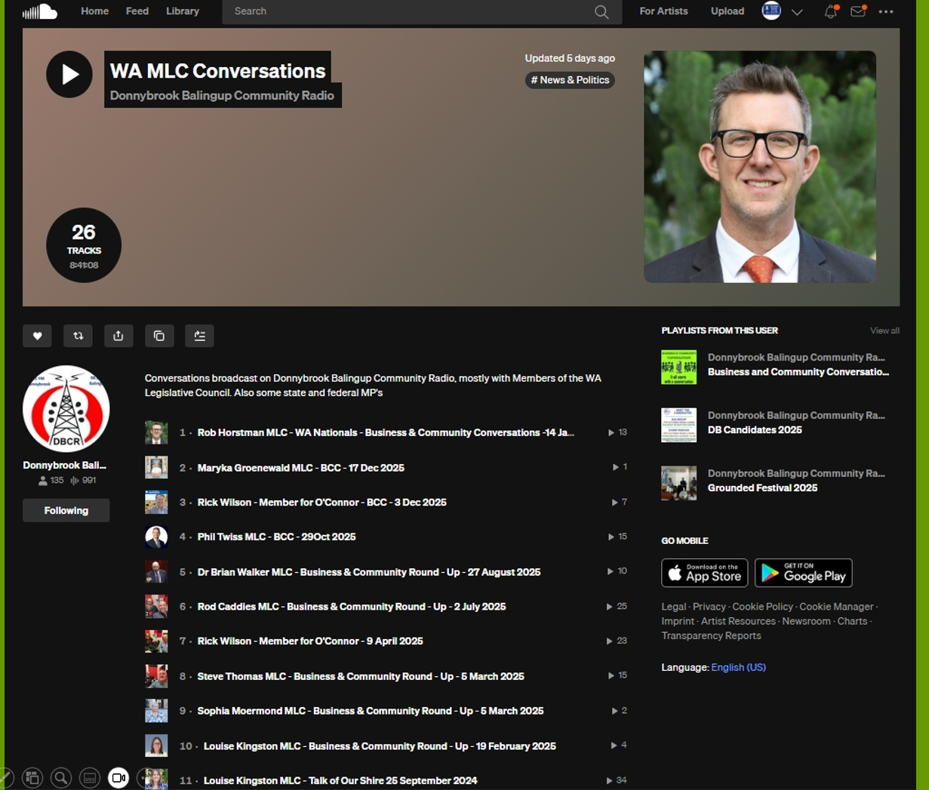
In the state government, we used to have, six MLCs for the southwest. Mr. McGowan decided that he was going to take that away. So we now got the MLCs represent the whole state. Now, when they had southwest MLC’s on my program, I spoke to nearly all of the SW MLCs. Now they represent the whole state. It gives me license to talk to any MLC in Western Australia, because these people get paid the big bucks to represent us. I want to know who they are, what they believe in and what's their vision for Western Australia. So far this year or in this government, I've spoken to Rod Caddies from One Nation, Dr Brian Walker from the Cannabis Party, Phil Twiss from the Liberals, Maryka Groenewald from the Australian Christians and Rob Horstman from WA nationals. I've invited Labor Party MPs on. They either don't reply or decline the invitation, but with community radio we have to be balanced. So, you know, I've given them all an opportunity to say their piece. And when I do, I say, you know, you're paid the big bucks to represent us. What are your issues? What do you want to talk about? So I'm not filtering what they say. I think that's important. And all these conversations are online, for the record. I've also spoken recently to Rick Wilson, who's a member for O'Connor, because Donnybrook used to be in Forrest, but we're now in O'Connor.
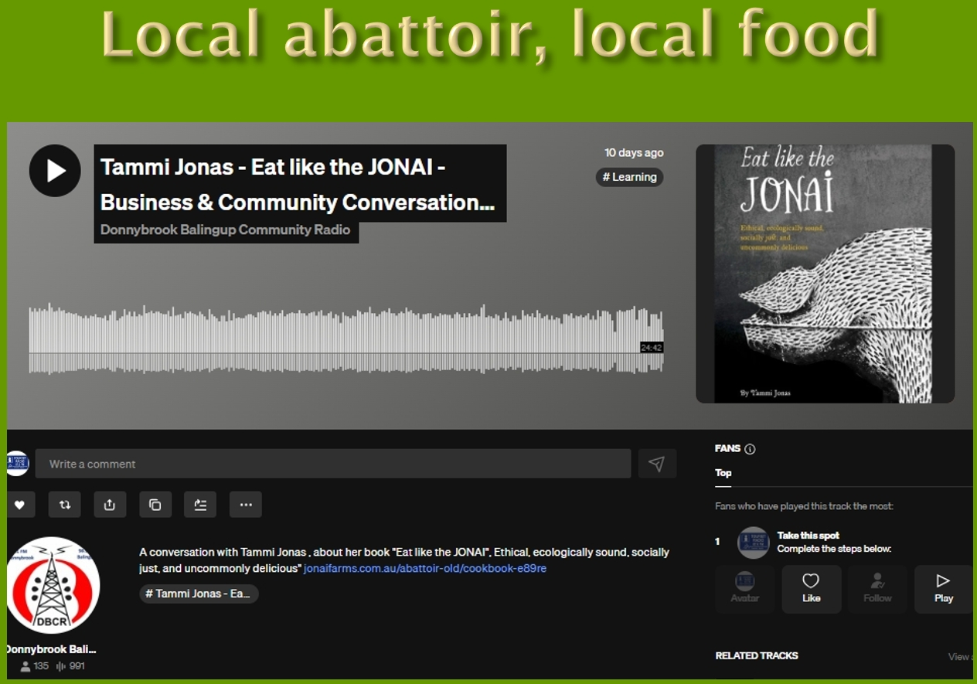
A huge issue for local producers, you know, 30 or 40 years ago, there was something like 30 or 40 private abattoirs around the southwest. They've nearly all gone because not because they were making people sick, but because governments bring in more and more regulations that make them unviable. And the big private abattoirs that we have got, DBC and Walsh's, have been bought by foreign corporations. This isn't this isn't unique to us. This is happening around the world. So this, uh, Tammy Jonas, who's an interesting lady, she's actually American, but she's married an Australian, and they're farming in Victoria, and she was a vegetarian. The reason she was vegetarian, she didn't like the, you know, the system and animals were raised under. And she said she was vegetarian until her third pregnancy, when she suffered an anaemia, lack of iron, and then she started eating meat again anyway, so she was involved in a community agriculture thing in Victoria, and they had the same problem. They couldn't get animals killed. So they've created a community abattoir that meets all the requirements, but is allowing small producers to get back into the market. So I did an interview with her. That's, So I didn't bring a book, but it's, uh. It's an interesting story.
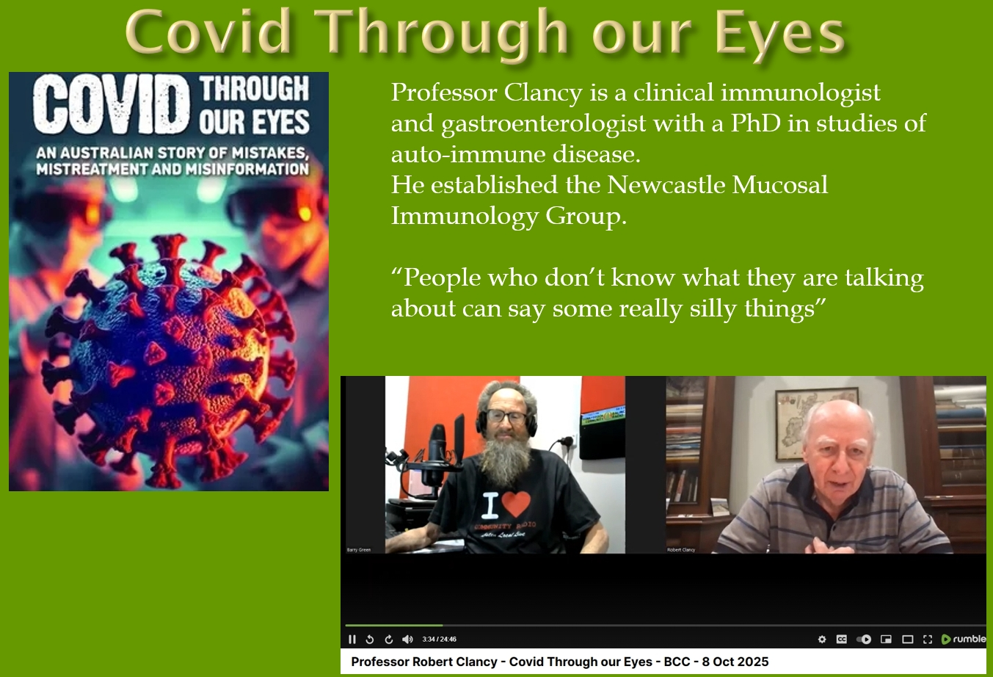
Professor Robert Clancy is a clinical immunologist and gastroenterologist with a PhD in studies of autoimmune disease. He established a Newcastle mucosal immunology group. Pretty smart bloke. And I heard him referred to on the ABC as a possible Nobel Prize winner. And when you've got an airborne disease, you'd think somebody whose expertise within this innate immune system of the airways and the biology of the airways was somebody that government would listen to, but they didn't like so many people of that expertise. He was ignored. And he subsequently written the book with Doctor Mel McCann. And Doctor Mel McCann is running a class action for people who've been damaged by the vaccines. And, predominantly people have been damaged by the Covid injections anyway. And they've produced this book, Covid Through Our Eyes. and that's getting into the state libraries. And so, you know, it's no longer conspiracy theorist stuff. This is, you know, professionals, professors, university people. We're at University of the Third Age. So I've interviewed Professor Clancy a couple of times. The first time was in relation to the book “Covid through our eyes”, and he made the statement in our interview, “people who don't know what they're talking about say some really silly things” . And I think there's a lot of that happening through Covid. This interview I conducted using zoom, all my radio interviews are online, on Sound Cloud and the Radio WA podcast, but using zoom, I get a video, and, as a radio man, I hate to say video gets more traction, but it does. So where I've done these interviews via zoom, I post them on the Radio WA Rumble channel, so they're there. For the record, this is a more recent one I've done with Professor Clancy. I did this, not this Donnybrook Community Radio, but it's Western Tourist Radio. But I did play this interview on Donnybrook Community Radio. So this is on every four hours on tourist radio in Busselton. At the moment, Professor Clancy is a pretty smart sort of bloke. He turns his hand to everything. So he he's written this book, The Long Enlightenment Australian Science from the beginning to the mid 20th century. And it's a really good read. And it looks at the, you know, we came to Australia and said, you know, basically was we were a jail and necessity was the mother of invention. And the individuals did great science that was world leading. But since the Second World War, and particularly in the last 30 years, the bureaucratization of all our systems is that we're losing that sense of innovation.
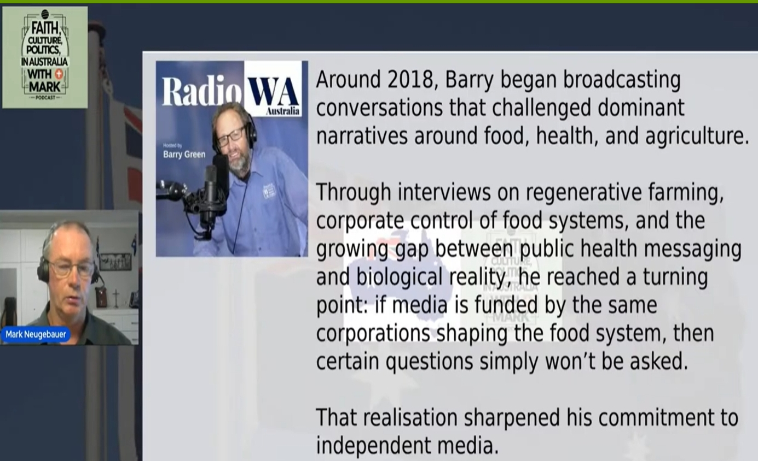
And a few weeks ago, I was interviewed by another independent, podcaster by the name of Mark Neugebauer. There's so many people of European backgrounds that are questioning things more than Australians are. But he did me the honour of having a look at some of the stuff I've got online and with a pretty good summary said. “Around 2018, Barry began broadcasting conversations that challenge the dominant narratives around food, health, and agriculture through interviews on regenerative farming, corporate control of food systems, and the growing gap between public health messaging and the biological reality. He reached a turning point if media is funded by the same corporation shaping the food system, then certain questions simply won't be answered. And that realization sharpened his commitment to independent media”. Which is pretty right. So I took that audio, used AI to generate a transcript because video stuff can be taken down. If there's a transcript and it saves the word document, it's there for the record. Within, uh, within that word document, there's direct links to various things we talked about. So I'll talk about transcripts. I think they're really important because they can be on hard copy.
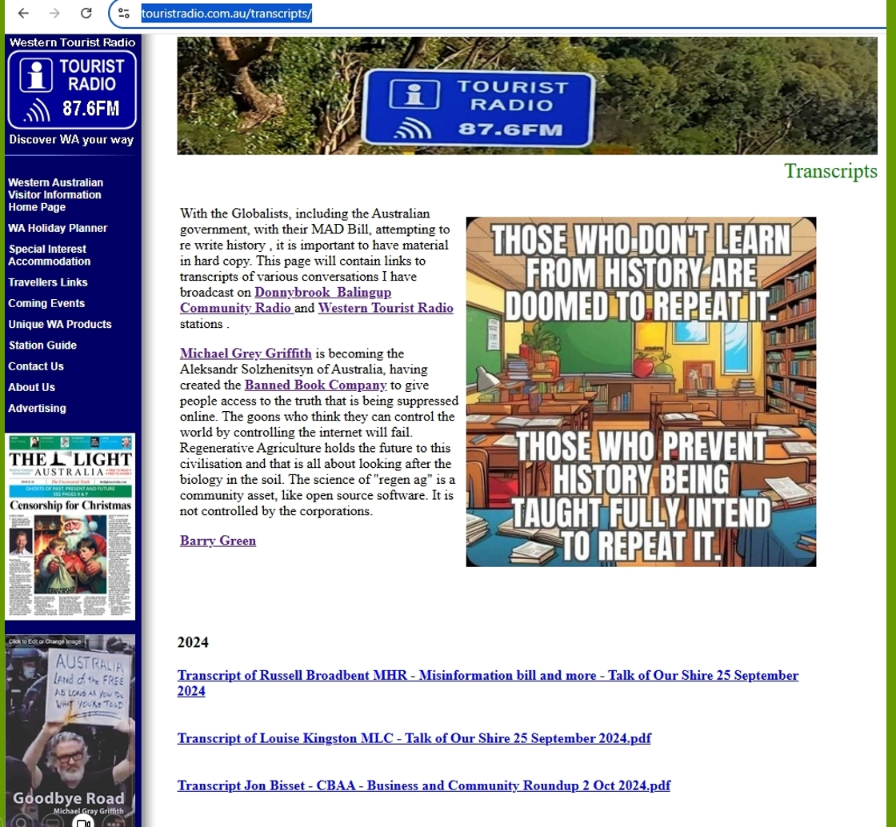
You know, there's lots of attempts to control the internet. I think they've missed the point because AI and all these data centres are a huge energy consumers. So how are they going to power them all on windmills? I'm not quite sure. But there is an upside, I don't much like Facebook, but it does set up some good stuff. “Those who don't learn from history are doomed to repeat it, and those who prevent history being taught fully intend to” . And so within that page of the website, I link to The Australian newspaper. There's a link to Michael Gray Griffith's book. Michael was one of the people who was shot by Dan Andrew thugs at the at the Shrine of Remembrance, who shot with rubber bullets at people protesting. He's a playwright, and since then he's travelled all around Australia recording interviews with people about the effect of Covid management on their lives. And they're all on the record. And he's now written a book. Now jumping around a bit here.
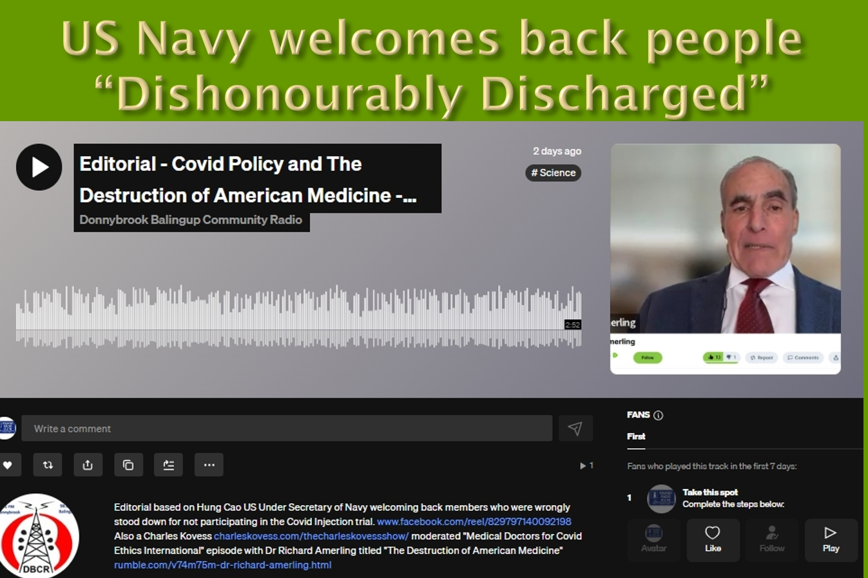
On the positive side, the US Navy has just started welcoming back into the Navy people who were dishonourably discharged for not getting the Covid injection. This is huge because once one government's done it, others have got to. The fact that and the US Navy undersecretary is welcoming people back and saying, made a mistake. We've done the wrong thing. We need you back in.
I think, you know, in many respects, the vaccine mandate had resulted in a lot of the critical thinkers being kicked out of government, and that's fairly dangerous situation. Charles Kovess is a podcaster and other things, who I now know quite well. He's also the Chair of the Aligned Council of Australia, which is a bringing together of lots of people who've been questioning the narrative. Charles has this episode with Doctor Richard Amerling did this interview called The Destruction of American Medicine, and he explains what's happened and how the pharmaceutical industry have really taken over medicine.
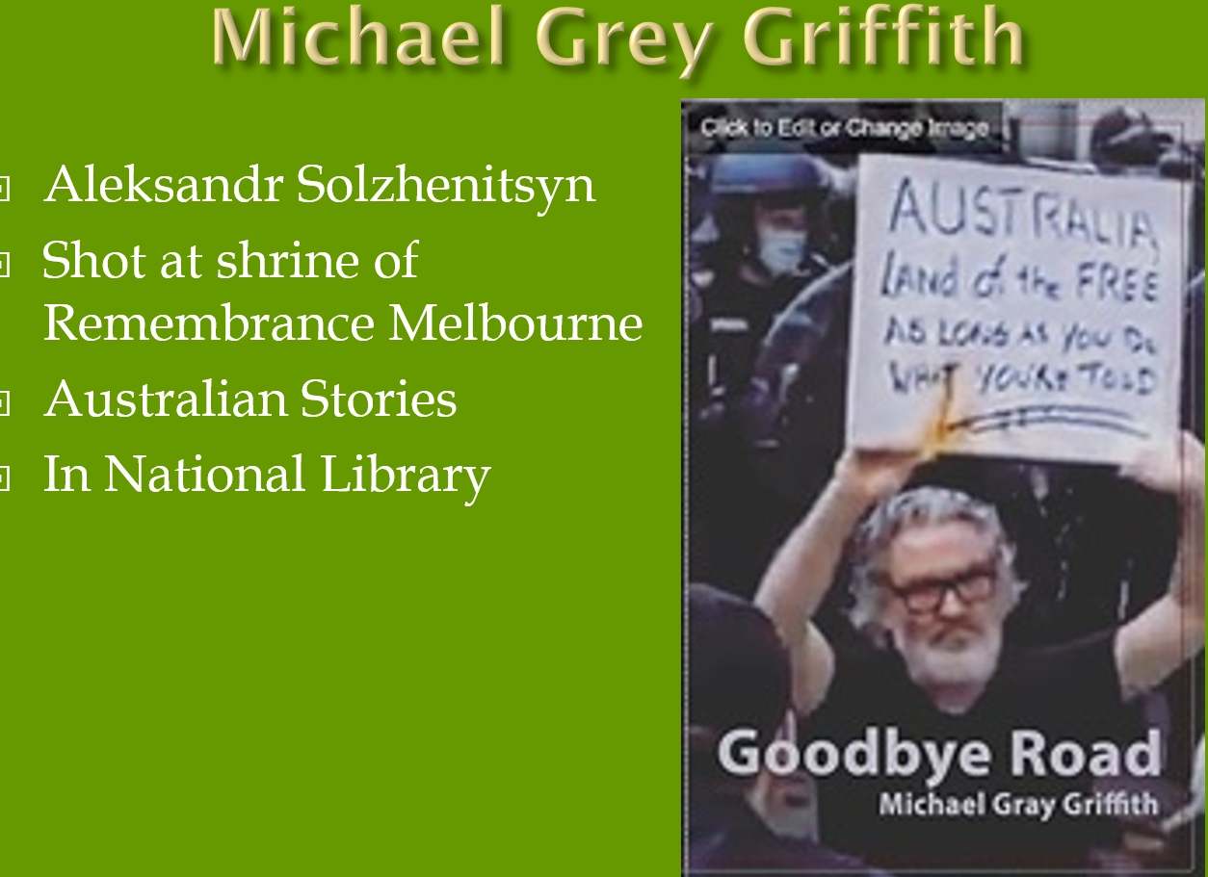
So there's Michael's book. I've read it. It brought me to tears. I think his book will go down in history as he'll go down as the Alexander Solzhenitsyn of Australia. We had to read Alexander Solzhenitsyn at school to, understand the things that went on in Russia. There's so much has happened in Australia that we haven't heard about because of the compliant media. ABC does “Australian stories” , but that isn't the pure domain of ABC anymore. There's lots of podcasters putting out Australian stories. I've interviewed Michael on my program. I've been interviewed on his and his book is in the National Library. It's official record now.
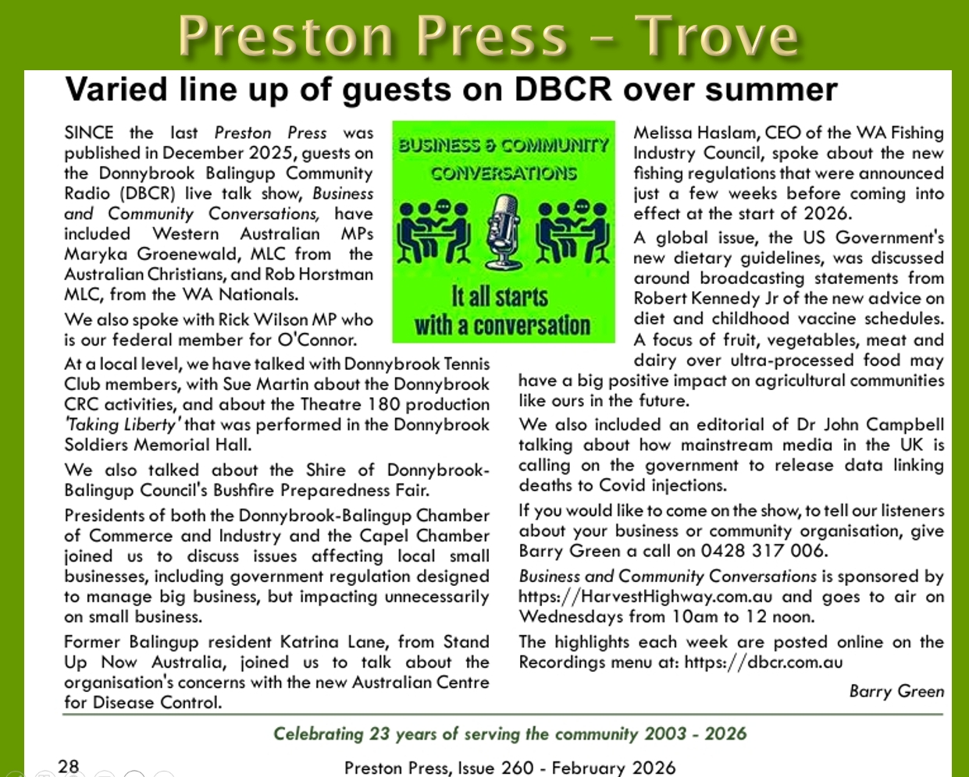
My program on Donnybrook Balingup Community Radio called Business and Community Conversations. Each month I write a bit of a review of people I've interviewed on the program. This is the one that's just come out in February where I talk to MPs. So it's hyperlocal, but it's also national from a local perspective. The Preston Press, our local papers also stored on Trove. So all this stuff is in the government record. And so, in conclusion, I hate to say it, but, Robert Kennedy saying it, we've been lied to by the government in relation to our food. And I think to the in the whole Covid management, the challenge I've faced is how do you build a communication business based on truth and not marketing spin. On the positive side, there's more and more information coming to light. With the new science of regenerative agriculture and the study of the human biome. I think we could be on the verge of a new renaissance as we get to understand the human condition better. And, as I say, the, science of biological, the human biome of the biological farming is a community asset akin to open source software.
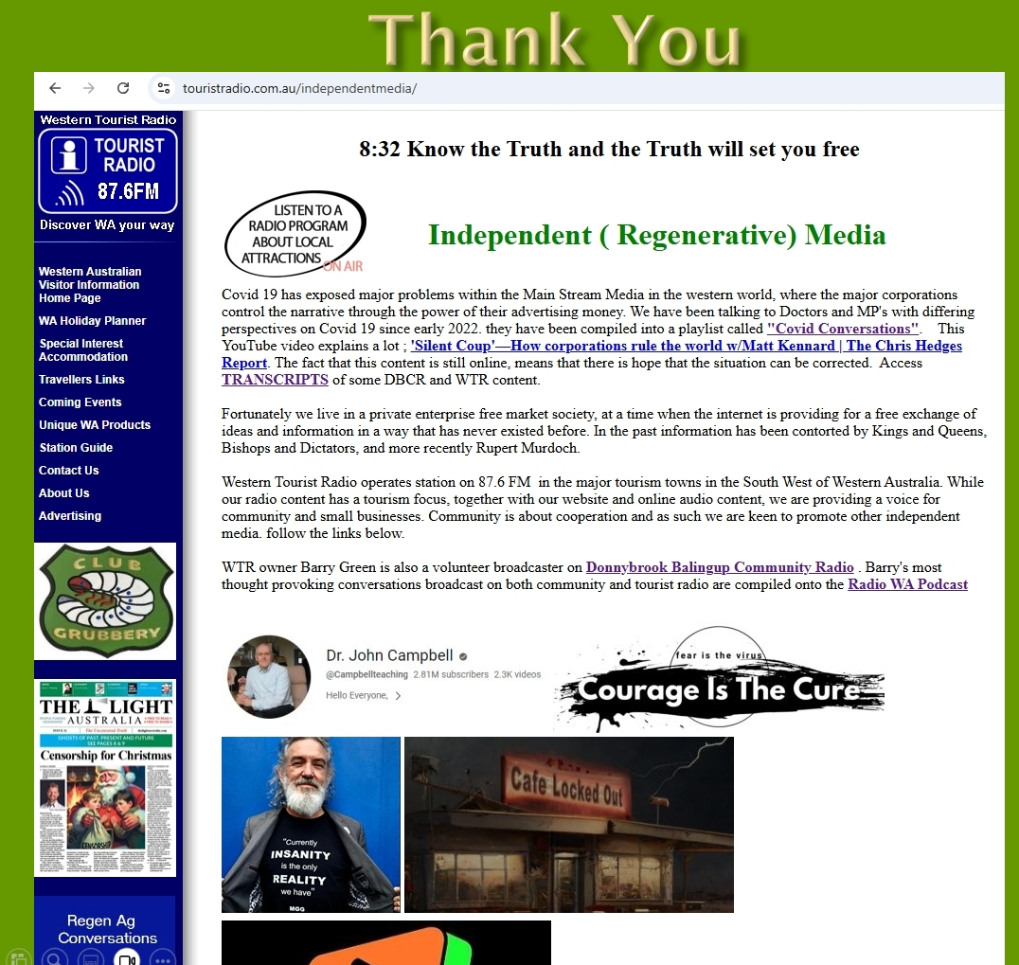
So that's the independent media page of the tourist radio website. I'm linking to all sorts of independent media. Graham Hood with the Qantas pilot who does Club Grubbery, Doctor John Campbell, who I allude to before. Robin, from Courage is the Cure in Perth. And there's other links down there so that that's about it. a bit heavy, but I remain, as I said, I've had black dog disease, you know, and I'm increasingly optimistic that we've been through a dark age and we really could be on the verge of a new renaissance. So thank you. Any questions?
Speaker2: Could you, having had Black Dog, did you find that your, issues were helped or depressions helped by what you ate and ingested?
Barry Green: I'm sure in many cases that would have a huge influence. We're pretty lucky in that, you know, we live on the farm, we've got our own veggies. So that wasn't the issue in my case, my issue, because my depression was, I'd convinced my wife to buy a business, borrow money and buy a business, that was sending us broke and she'd gone back to work full time. I did go to a Beyond Blue doctor. It was a complete and utter waste of time for me. And he said we could give you pills. I said, well, pills am not going to change it. I'm depressed because of the situation I'm in. He said we could do cognitive behaviour therapy. So I'll give that a try. So I had to write down the things that upset me and my reaction to it. Anyway, in the days I used to listen to the ABC. Sadly, I no longer trust the ABC. But the rural report in the morning they were talking about some new disease in agriculture, to which my reaction was, this is in 2006, when the government signing up to free trade agreements, which meant poxy apples could come from overseas. Western Australian apples, the most wholesome on the planet because we didn't have apple codling moth, the Fireblight. But we're signing up to this free trade agreement, which means all this crap could be brought into Australia. So I said, well, you know, my reaction to this new disease was, so here we go again Global Free Trade, spreading pests and diseases all around the world. And then the ag department was saying, spray this, with to which my reaction was here we go again. The government's become the advertising arm, the chemical companies. And the good doctor said to me, oh no, you organic farmers have got it all wrong. We need all this poison to feed the world. And that's when the penny dropped. You know, they're all part of the same problem. And so I actually went away from that and started writing my thoughts on a page of the tourist radio website, which I called Global Free Trade and Opinion. And that was my therapy. I could write things down, get them out of my head, and that's how I got through it. The really funny thing was from 2006 to 2017, if you searched Google for global free trade, my opinion was number one on Google, and that helped keep me going and didn't make any money. But it's what kept me going. The page is still there. I use a quote on the top of that page. it's a J.R.R. Tolkien quote or one of his characters. If we valued food, cheer, and song above hoarded gold, it would be a merrier world” . And the word food is linked to the farmer's Markets page. The word cheer is linked to the wine regions of Western Australia. The song is a link to the local Talent Time page, and hoarded gold is a link to my global free trade page. And you know, money is important. You know I have no delusion about it. It's bloody important. I've tried to run a business without it for 25 years. It's difficult. But at the end of the day, we must have been put on this planet for a reason other than to make a profit for shareholders. We've got to make a profit for shareholders. But that's not the only reason we've been put here. And you know, that's why I see community radio is so important. It's a local voice. We've lost our local voice. You look what's happened, especially in the regions. The media has been bought. Radio, print and TV has been bought by the corporations. Essentially shut down. I was the tech at GWN TV for 14 years. Community radio is so important, it provides a local voice.
John Hamblin : Barry one thing I have not noticed anywhere, and all of these people that are talking about good vegetables and good food, etc., the fertilisers we use are basically dug up, guano etc. no one ever talks about Terra Preta. Have any of your departments you've been to? Come up with stuff and discuss the Terra Preta, the Aztecs and Mayans produced a method of actually making their own fertilizer. Terra Preta means black people are going out through the Amazon, the old villages and stuff and actually using it. It's better than any fertiliser anywhere, yet no one will actually get in and use it.
Barry Green: That's the future. I do know that word now you mention it, I did an interview with a bloke who's talking about carbon and biochar. They call it biochar and get that in soil. So, you know, there's all this talk about CO2 and climate change, but regenerative agriculture is about using big ruminant animals because the big room and, and animals created the deep soils of the plains of Africa and America and the mechanism is you had these grasslands and the big herds would come through, graze it hard, piss and poop on it and move on. And then it grows. And that the best way to get carbon into the soil is dead roots of plants. And our industrial agriculture is taking soil organic carbon from sort of 5% down to 1%. So that's all carbon that should be in the soil is up in the atmosphere. Regenerative agriculture is about putting that carbon back into soil. And if you increase the soil organic content matter by 1%, that's 150,000l per hectare of water storage. So if you can lift it 2 or 3%, that's increasing your water storage. So part of the flooding we're getting in extreme events you're always going to get floods. But part of the worst flooding is because we've destroyed the organic matter in the soil. So it's lost its water holding capacity. And regenerative agriculture is about turning that back the other way. But the corporations aren't interested in that because, you know, they're all about controlling things. It is an exciting period to be living in. One of the websites I've got is that agritourism.WA.com.au and I've been talking about in 2012, I was invited to go to the New Industries Australia conference in Ballarat, and I was invited to go there to speak on agri tourism. My radio tech training taught me to fix a problem. You got to identify and address the cause. It also taught me a stable system needs a feedback loop. The feedback loop between farmers and eaters has been destroyed by the supermarket. So we've got an incredibly unstable system. We've got all these people in the city. No idea where their food comes from. I think it comes from Coles, but it won't be in Coles if you destroy your agricultural system, which is what's happening now. I grew up in Donnybrook in the 60s, and the talk then was all get big or get out, and it sort of made sense. I now see it differently. I now see it. This is part of the World Economic Forum's agenda. They want everybody living in cities where they can be controlled.

I think we've got so much to learn from Aboriginal people. I think, you know, I think they should have a voice to Parliament, but I don't think we should change the constitution to do it. Aboriginal people manage the Australian landscape for tens of thousands of years. We've been here 200 years and we've just about stuffed it. And I did an interview with Gina Williams, Aboriginal girl I used to work with at GWN TV she released the first normal language CD, and in that interview I came to realize just how their cultural, corporate and ecological knowledge was passed down through storytelling and in our culture. The storytelling has been taken over by the advertising executives of the major corporations. Herein lies the problem. The change has got to come from the bottom up. What Charles Massy talks about in region Ag. He said the change has got to come from the bottom up. It simply can't come from the top because the people at the top are fought to get there and like it the way it is. So, you know, we the people have got to drive the change and will drive that by where we choose to spend our money fairly deep and philosophical.
Speaker2: Thank you Barry.
Barry Green: It's a pleasure. Very therapeutic to get these ideas out of my head. Much better than going to Beyond Blue doctor.

