Professor Robert Clancy - The Long Enlightenment
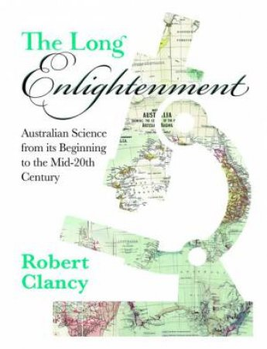
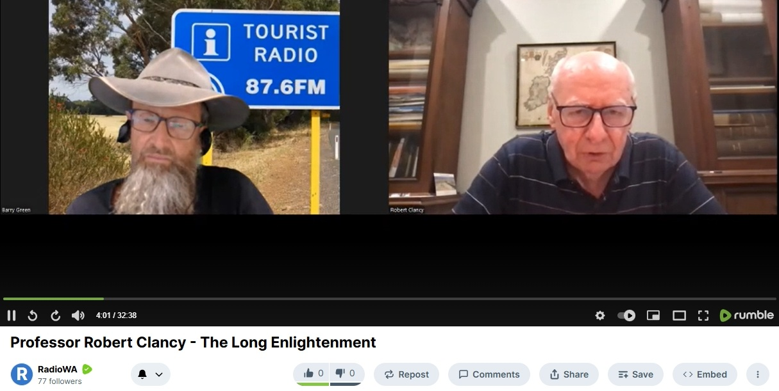

Spotify: (20 Min) https://creators.spotify.com/pod/profile/radio-wa/episodes/Professor-Robert-Clancy---The-Long-Enlightenment-e3eecud
Rumbel: (30 Min) https://rumble.com/v753mm0-professor-robert-clancy-the-long-enlightenment.html?e9s=src_v1_upp_a
Unedited version (30min) : https://soundcloud.com/westerntouristradio/professor-robert-clancy-the-long-enlightenment-unedited

[00:00:00] Barry Green: G'day I'm Barry Greene. Thanks for joining me on Conversations on Western Tourist Radio, 87.6 FM in the coastal southwest towns of Western Australia, and the Radio WA Podcast. This program's been created to tell the stories of people and places in Western Australia, and tourism is a great way for people around the world to learn about the cultures and the and the stories of other places in the world. In the last few years many things have been turned upside down, and it's a bit hard to know what to believe sometimes, but we can have conversations. And my next guest is Professor Robert Clancy. Professor Clancy is a clinical immunologist and a gastroenterologist with a PhD for studies in autoimmune diseases. He's foundation professor of pathology at the Newcastle University Medical School, where he established the Newcastle Mucosal Immunology Group. Discoveries include the role of T cells in controlling mucosal microbiome. He practices in Sydney. In addition, he has many publications on medical research. He's the author of Maps that Shaped Australia, Mapping Terra Australis and the book “The Long Enlightenment Australian Science from its beginning to mid 20th century” . G'day Professor Robert Clancy.
[00:01:33] Professor Robert Clancy: Hello, Barry.
[00:01:34] Barry Green: So tell us, with all your experience, what prompted you to write “The Long Enlightenment”?
[00:01:41] Professor Robert Clancy: Well, Barry, I've been asked that question, and I suspect I give a different answer each time, but, there is a call. I have always been interested in asking Why? The question of why? Why something happening? How does it work? What's it about? And so I've been interested in history. I like to know where we've come from on the basis that if we know where we've come from, where we are, you draw a straight line, you've got some idea of where you're going. I'm not sure that's worked in my life, but it sounded like a pretty good idea at the time. And I've always been interested. You know, I'm a physician, as you mentioned. I'm interested very much in medicine. I still practice, mainly in relation to damage from Covid vaccines, immunology these days. What I found when I finished the more formal aspect of my profession, as a professor of medicine in the university medical school at Newcastle. I look back over, my, time as I think everyone does. You look back and you say, you know, I've done my best, but has it been worthwhile? You get a little introspective about these things as you start planning what else you want to do? Although it's turned out not to be a major problem thanks to Covid, but I look very carefully at university granting systems.
[00:03:07] Professor Robert Clancy: And, to be frank, I'm disappointed by the quality of the research overall that comes out, you know, and again, given, that we have some outstanding people. And so I started looking backwards and I looked back to the beginnings of colonization, European colonization in Australia. And I was blown away by what was happening. And, when I looked at the first hundred years, f Europeans in Australia, we went from essentially a jail with a thousand people in it, in 1788 to by 1900, just 100 years or more to a country with the highest standard of living in the world. Not just in in one parameter, but in the half dozen or so parameters they use. We were top, and I said to myself, first of all, I said, it can't be right. But in fact, it is right. and we're talking about 1900, early 1900s now. And I thought, well, how on earth could that have come about? The more I thought about it, the more I realized that, Australia began as a group of people coming to a country which was very different to what they knew in, Europe or England, in the United Kingdom, everything was different. And so you had a number of people coming here that, had to cope, had to survive.
[00:04:38] Professor Robert Clancy: And what I found was that some amazing, remarkable people came to all our colonies from east to west. They came here, they faced problems. They analysed them, they experimented, And they got answers. So I suddenly found that we had conquered so many things, and we use science to do that. Now, a lot of these people you may not think of as scientists, but they in fact use scientific method. And then I looked at the people and I looked at the people who did these things. I'd never heard of most of them, and yet they did absolutely remarkable things. You know, people who discovered the cause of infections in sheep and cattle that no one else in the world was able to do. People who identified deficiencies in soil. Now they had to do this to survive. Someone had to find the cause of black disease, which my modern veterinary friends have never heard of, but it was costing millions and millions of dollars because it was killing sheep. But it was the Australians who actually discovered the answer. And then I looked at the people who were doing it, and they were just ordinary people. They were second or third sons. They were very poor farmers, they were convicts, ex-convicts. People came to Australia because they had tuberculosis. You would not believe the number of major discoveries that were made by people who came here for the weather, for the for the sun, because they had tuberculosis.
[00:06:16] Professor Robert Clancy: Remembering that it killed 40% of people back in the 19th century. And so we got remarkable geologists, parasitologists, all types of people came out here. And then it came to me that this was essentially a delayed enlightenment, because if you look at the enlightenment in Europe, particularly England and France, and you look at pictures of people sitting around, with their cups of tea, you look at these people looking very affluent and very wealthy and pontificating and coming out with great things, people like Newton, very amazingly bright people, but they were wealthy, gentry, they were people who had privilege. The average person in the street just had to survive. Now, these same average people, the ones that came to Australia, my forefathers and perhaps yours, because, the crops had filed in Ireland or something like that. And they had to do remarkable things. So to me, this was this amazing change that occurred over 100 years and continued in the first half of the 20th century. That, to me, was like a delayed and long enlightenment because they used they the principles of the enlightenment, which was far more 17th and 18th century back in Europe. That's the not so brief reason why I, wrote this, because I felt someone had to.
[00:07:44] Barry Green: The science you're talking about was largely driven by individuals, not necessarily with a lot of commercial or academic backing. So it was it was fundamental science and science that isn't purely the domain of universities, I guess
[00:08:02] Professor Robert Clancy: always individuals. but it's quite interesting and maybe we can get on to that. There was a cycle between Cambridge and Australia. So the early period it was individuals, you know, it was people like the Reverend William Clark defined the basic geology of New South Wales. Farrer came out here because he had tuberculosis to get away from his cousin, who happened to be Darwin and he'd been a classics scholar. But he married into a wheat growing family. And, they were running into problems so he said, well, let's sort it out. And he actually, did more work on genetics than Mendel. Remember, Mendel had made his discoveries earlier, but didn't publish them until many years later. So independently, Farrer did what Mendel did. And we all know what Mendel did in genetics. But things changed, in the last 20, 30 years of the 19th century.
[00:08:58] Barry Green: I'm very involved in regenerative agriculture. And in that space, there's a new understanding that's spreading, because the internet has provided a mechanism for innovative farmers to work with independent scientists. And within that movement, there's a realization that after the Second World War, the research was done by corporations to sell stuff to farmers, and it was that sort of economic model that's driven research. Whereas, what Regen Ag is doing, it's finding we can get better outcomes without all these inputs. So I guess there is an element of, follow the money in relation to science. Is, that your observation?
[00:09:41] Professor Robert Clancy: Well, actually that interesting, I didn't know that, Barry. I think that's extremely important. That is one of the things that is certainly destroying medical science in Australia is big industry. People now there's so much money available. I mean, look, I mean, I don't want to get on my hobby horse of Covid, but look at the disgraceful situation where universities have been bought by Moderna and Pfizer. They're pouring hundreds of millions of dollars into the universities. even my own university. Not Newcastle, of course, but some of the other ones that I have been associated with over the years. And this is defining the sort of work we're doing, and it's going along a path of destruction, and it's taking smart people away, because if you want to get money for research, then you hop onto where the money comes from. And of course, most of the money is coming from, commercial companies.
[00:10:36] Barry Green: But this is what's so interesting. I think 2026 is turning out to be an interesting year with, the Health Secretory in America calling on the pharmaceutical industry to actually demonstrate the efficacy of some of their processes. I've been saying for a while, you know, all through Covid, people were saying, big Pharma is too big to fail. But of course, they said the Titanic was too big to sink. But it sank. So, as there's more accountability coming in, you know, of course, pharmaceutical industry produces some handy products, but, it's become a bit of a case of the tail wagging the dog, hasn't it? And, you know, within the regen ag movement and the natural health movement, there's this notion that, there's been a whole body of human knowledge gained over generations that has been dismissed by the, the so-called science because, to profit from something, you've got to patent it. So it means that something like, say, wormwood, which is supposed to be good for, worms, you know, nobody can own that. So, it's this sort of, the patent and copyright system has allowed corporations to deny a whole body of human knowledge gained over generations.
[00:11:50] Professor Robert Clancy: Well, look, I think I think that is absolutely so. And certainly, there are many examples and a number of examples in the book that we're talking about. Now, with some trepidation, I'll move out of my area of, my comfort zone, which is biomedical science. I was intrigued to look at the chemistry industry in Australia, which was very linked to agriculture and mining. of course. Yeah. And that's the great thing about all this research that was done. It's pragmatic research. It's about real things. It's about, survival, uh, productivity and wealth generation. For those, people who thought about it first, we weren't some I mean, patents were around, but, u it wasn't. And patents were important even early on for some things, but not everything. Now, I think the chemistry industry is very important,
[00:12:43] Barry Green: Very interesting. You talk about chemistry, and chemistry is important. But I think within regenerative agriculture, the growing understanding of the biology in the soil, and there's this growing understanding of the biology of the human gut. And I attended a soil seminar years ago, and they were talking about the soil being made, the chemical or physical and biological properties. We got pretty good at understanding the chemical and the physical. The biological was too bloody hard, so we ignored it. I think the biology is, really the new frontier of in science in terms of human health and the soil. And it's very complex and it's a wicked system and we've been driven by a reductionist science where you try to take out one thing at a time until it stops working. But biological systems are incredibly more complex. And I guess that's what the space that you are working in, the microbiology of the of the airways.
[00:13:39] Professor Robert Clancy: That's true. Now we're jumping outside of the book, of course, but, the book tails off in the mid 1900s, when we started having, universities who felt they could and should do everything rather than focusing as they used to on single entity research areas. Yeah I mean, the big, the exciting thing to me in medicine going forwards is, the microbiomes of the airways and the gut. And again, Australians have been incredibly important in developing that. My own group, I think, can take responsibility for the airways. We've defined what it is, how it works, and how you can exploit that commercially. Once someone gives us a bit of money to, get through the TGA. But the, in the gut, we've got some amazing veterinary workers in, Sydney University, with the CSIRO when CSIRO was a great company. It no longer is. When universities were doing some great research, ANU, did terrific work on gut immunology. And of course, it culminated with Tom Borody. He's the guy who didn't get a Nobel Prize that should have one of your guys from Perth. Barry. Same name as you.
[00:14:59] Barry Green: Barry Marshall. I know that name.
[00:15:01] Professor Robert Clancy: Yeah. Barry Marshall and, his, pathology colleague Robin, got the Nobel Prize for, identifying an association between a particular bacteria and peptic ulcer.
[00:15:14] Barry Green: We are talking about the long enlightenment. But your other book, which we'll mention with, Dr Mel McCann “Covid Through Our Eyes”, that's, also very important. And, now there's all this stuff online. But at the end of the day, books are really important, aren't they?
[00:15:34] Professor Robert Clancy: They are. Barry. Mel and I, when I say we did it, we got together. Our friends who wrote important chapters. So there's about 15 of us. But, what we tried to do is capture the way we had seen the Covid pandemic. there's another book that quadrant, many of your viewers will know. Quadrant. It's, an outstanding, magazine. It's outstanding because it's kind enough to publish my articles and they probably have something like 14 or 15 articles on Covid, and they're bringing it out as a book, with an introduction and a follow up at the end. So it's really, contemporary because each of those articles were written about something that was of concern, at least to me at that time. So that should be coming out in the next few weeks or months.
[00:16:25] Barry Green: We are living in such an interesting period in history, Professor Clancy, but, I guess, and there's, you know, some things aren't that flash, but I guess we've always got to look at every cloud has a silver lining. And, you know, maybe, maybe we've been through a bit of a dark age. Maybe we're on the edge of a new renaissance because of all this new science. Maybe if we get back to first principles of science and science not driven purely by commercial interests. Do you share that optimism?
[00:16:59] Professor Robert Clancy: Well, I wish, I wish Barry. I think what you're right about, there is the importance to get back to what it's all about. I see the great tragedy of science is the drain that external money can put on good ideas. And the other thing is that, ideas are being now polarized between the sandstone universities and pretty much anybody else. And the sandstone universities are failing miserably across the board in coming up with new ideas. And what has happened in funded science, funded, means I'll probably never get a grant. Not that I ever want to write another one. The difference is that in funded science these days, it's ideas aren't funded, process is funded. To me, the difference between what I wrote about in this book, which goes basically well, around the 1950s, once we had big universities, as I said, doing everything. And now is that, we've replaced, prior to 1950, it was always an idea that had to be explored, developed, tested and proved and exploited in some way. Now I find that it’s about is survival in your position, in a competitive circumstance to get funding money and you get funding money not by having a great idea and saying, I'd like to test this idea. It's the process you use in putting that forward. And look, it'd be very really interested to see feedback from your listeners.
[00:18:45] Barry Green: Lets put it out there and see.
[00:18:46] Professor Robert Clancy: Because I'd like to know what other people who are involved in asking questions think. But I think that that's, to me, the critical thing. We've gone from ideas to process.
[00:18:56] Barry Green: We've gone from science to marketing, perhaps?
[00:18:59] Professor Robert Clancy: And that's another way of looking at it, another way of looking at it.
[00:19:04] Barry Green: Anyway, we're going to have to wrap it up now. Professor Clancy, anybody who wants to get hold of “The Long Enlightenment Australian science from the beginning to the mid 20th century” . How should they do that?
[00:19:16] Professor Robert Clancy: it's published by Halstead Press. The best publishers in the country, mainly because they publish my stuff. They're very good guys. Every good bookshop, they won't have it because for reasons I. But they they will get it in.
[00:19:32] Barry Green: And when we post this online, we'll include a link in the associated text so people can buy your book. We'll also include a link to “Covid Through Our Eyes” . So Professor Clancy, thanks so much for taking the time to talk to us today and your leadership in in all of this.
[00:19:50] Professor Robert Clancy: It's a great pleasure. Barry. Thank you for having me.
[00:19:53] Barry Green: That is just part of a conversation I recorded with Professor Robert Clancy on the 29th of January in 2026. The full interview is on both the Radio WA Rumble channel and the Radio WA podcast. The transcript can be downloaded from TouristRadio.com.au/Transcripts.
You've been listening to Conversations on Western Tourist Radio 87.6 FM in the South West, Coastal Tourism towns in Western Australia, and on the Radio WA podcast as we tell the stories of people and places in Western Australia.

