Tammi Jonas - Eat like the JONAI - Business & Community Conversations -21 Jan 2026
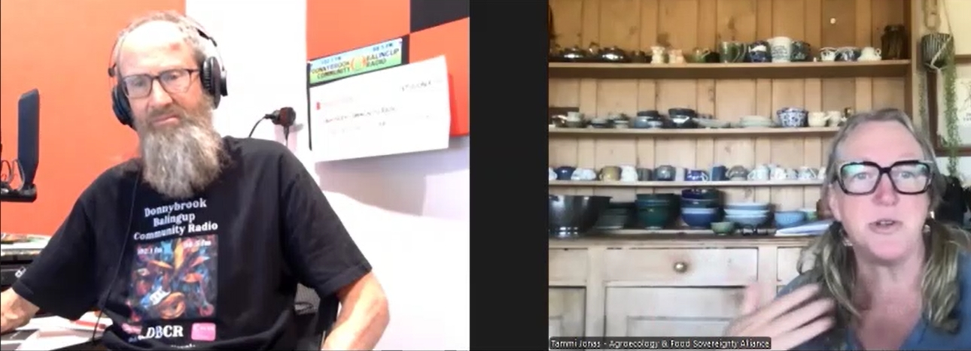
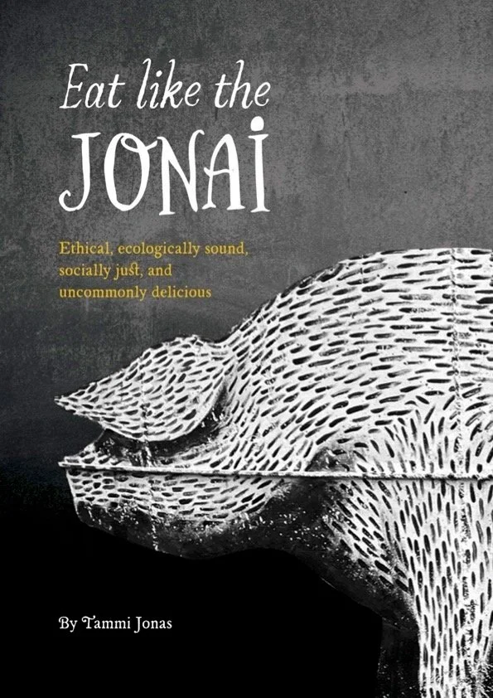

Listen Online
Sound Cloud: https://soundcloud.com/dbcommunityradio/tammi-jonas-eat-like-the-jonai
Spotify: https://creators.spotify.com/pod/profile/radio-wa/episodes/Tammi-Jonas---Eat-like-the-JONAI---Business--Community-Conversations--21-Jan-2026-e3dvede
Rumble: https://rumble.com/v74mqt0-tammi-jonas-eat-like-the-jonai-business-and-community-conversations-21-jan-.html
[00:00:00] Barry Green: And it's now what is it? 10:05 on Donnybrook-Balingup Community Radio. I'm Barry Green. This is Business and Community Conversations for the 21st of January in 2026. Business and Community Conversations is sponsored by HarvestHighway.com.au , and this is a live show. And the views of participants may not necessarily be the views of DBCR or Harvest Highway. And you've got a couple of interviews lined up today. But it's all about quality, not quantity. I'm going to be talking to Anne Mitchell, former councillor Anne Mitchell, who's, um, organising a class reunion for the class of 1971 at Donnybrook Junior High School about, um, about reunions generally. But first up, I'm talking to Tammi Jonas, who's written the book “Eat like a Jonai” and who's who I became aware of through the Tim Thompson, uh, farming Videos. She's, uh, was, uh, is, was an American who was a vegan. No, not correction vegetarian and, uh, married an Australian and is involved in farming in, in Victoria and uh, and has created a community driven, uh, abattoir. So that's quite a journey there. Tammy. Uh, welcome to the program.

[00:01:23] Tammi Jonas: Thanks. It's good to be here, Barry.

[00:01:25] Barry Green: So tell us about your journey from being a vegetarian to operating a community abattoir.

[00:01:33] Tammi Jonas: Yeah. I mean, it sounds like more of a stretch when you when you put it like that. But if you know that my motivations for being vegetarian for most of a decade were because I don't think animals should be treated the way they are in the industrial system, I don't think we should have pigs and poultry in sheds in particular. And so the vegetarian was my, I guess, the only kind of DIY thing I could do to not engage with that kind of meat, animals being raised in that way. And then I sort of thought that was a bit of a it was a little bit of a cop out to just to exit the system rather than try to be stay engaged with fixing the system. And so although it was a bout of anaemia in my third pregnancy that sent me back to red meat, uh, it was that pathway back into eating meat, which eventually got us onto a farm to raise livestock and show that you can you can raise animals on pasture and in, in a really good environment, um, and not treat them poorly in any way and still make an honest living. So why aren't we growing all our food that way? That was the sort of motivation. And then and then I became the butcher on the farm because smallholders, uh, really struggled to gain access to butchers and abattoirs, to be able to sell our meat directly. And so I became the butcher. And then as we've been losing access to abattoirs here and across in WA, of course, it's very bad as well. Um, we thought, well, we better build our own abattoir and as intensely curious people, that means that we got to learn another skill in terms of slaughter. And I'm now also a meat inspector. Um, so it's it's kind of a perfect full circle back to why I stopped eating meat. And so now when people say to me, and for years when people say to me, how can you eat an animal you knew, I always say, how can you eat one? You didn't.

[00:03:11] Barry Green: Very good point. Um, and, uh, you've written a book and it's called Eat Like a Jonai. Can you explain the title?

[00:03:20] Tammi Jonas: Yeah. So eat like, the Jonai is, um. I guess I wanted a book. That kind of is fun. It's fun and delicious. It's a cookbook, but it's a cookbook that's disguising a food sovereignty Warriors handbook, you know, like it's got the the politics of eggs, the politics of dairy, the politics of pork. Um, vegetables have politics too. So, um, in trying to engage people through cooking and eating delicious food that they either grow themselves or their friends grow or a farmer near them grows, um, and then preparing it together in meals and eating together in meals. Um, that's how we'll fix the food system, I think, is if we keep doing those activities. But while learning the politics that are stopping those things happening and what can we do about it? So each each as you know, each section also has like a what you can do, um, as well as what you can read or listen to podcasts, um, trying to help people become more educated about what they, what they could be empowered to actually do about the system, besides just going to the farmers market. That's a great thing to do if you can, but there's a lot more that can be done.

[00:04:24] Barry Green: Yeah, but we're in such an interesting time in history, and I'm inspired by the fact that the American government's turned the food pyramid upside down, which I think has huge implications, because when the the health secretary in the United States stands up and says he's authorized by the president of the leading capitalist country in the world to say that, you know, you've been lied to by the government and the corporations about the food pyramid. You should be eating more meat, uh, meat, vegetables, fruit, dairy and whole grains. And when you understand, as I have, because my background is in electronics and, and, uh, commercial media, commercial television and now community radio, um, the, the old media has all been driven by advertising from companies selling big food, big ag, big everything. Um, and I'm also involved in organic or regenerative agriculture. And I've coined the term regenerative media because we can have these conversations, um, because we're not unduly influenced by those corporations. That gives me great hope for the future, because there's a lot of doom and gloom around which which becomes self perpetuating. But if we can turn that narrative around and create positivity, and especially for places like Donnybrook, where I grew up in the 60s and we had lots of small farms and, you know, there was all this get big or get out thing and, and there was lots of something like 30 or 40 family abattoirs around the southwest. They weren't making people sick, but they've gone out of business because of government regulations. And in your book you talk about how, you know, we've got this corporate takeover of of our abattoirs by multinational corporations. And yet the ACCC, which is, you know, the Consumer and Competition Commission has allowed this and it's it's taken control of that food out of Australia and largely isn't in the interest of the people of Australia. Do you want to talk a bit about that?

[00:06:24] Tammi Jonas: Yeah, absolutely. Thanks, Barry. I think, um, you're you're dead right about the role of regulations in making it harder for small scale infrastructure like processing facilities, whether it's abattoirs or dairy processing. It's been harder and harder for them to exist in that system. But a big other part of that push is the, um, the government's fascination with and enthusiasm for productivity and exports. And so that that push to export more food, produce more food, and export more food has a number of devastating effects on our food economies, of course, and the most obvious one. I always say it's weird how the ideology of productivism is so inherently reductive. You know, it has literally reduced the number of species of animals we grow the, um, the species of plants that we're growing. You know, there's like nine crops in across America, sorry, across the world that are the majority, 66% of people's diets around the world. It's crazy how much that productive mentality has reduced the diversity of what we eat. And then it has also reduced the diversity of the other parts of the ecosystem, if you like, in terms of the ecosystem of abattoirs and the ecosystem of dairy processing facilities. And so the um, the corporate capture of all of those spaces means that the smallholders like us have nowhere to go. Right? So and in the book, I talk about how, um, 25 years ago or 26 years ago now, they deregulated dairy right in 2000.

[00:07:54] Tammi Jonas: In that time, we have lost 67% of the dairy farmers in this country because they had they had no right to fair prices for their for their milk. And they increasingly have just lost and lost and lost access to the processing facilities, or a fair price, if they can even get them in there. So, um, with livestock farmers, small scale livestock farmers like us, I mean, I've been studying this stuff for 30 years, right? Like I'm obsessed with the food system, and hence the book is trying to, uh, distill 30 years of of my obsession to make it easier for others to understand and know what they can do. Um, but livestock is going to be the story of dairy if we don't do something different to what's been done before. And I think there's there's two parts to that. One is reform of particular bits of legislation, and the other bit is a revolution of taking over, of recreating local food economies. And that means building abattoirs, and it means building dairy processing facilities, taking things, the things that we can do as just regular citizens is we can build stuff and then we can run it for our communities rather than leaving it in others hands.

[00:09:01] Barry Green: You're right. And you talked about the dairy one and we've seen that here. You know, it was a there was lots of small dairies and you know, and we've lost them. Um, but, you know, the so-called dairy deregulation. But dairy is the most highly regulated industry. And, um, doctor Aseem Malhotra, who's a US, UK medical man, uh, looks after tickers. What do you call them? Heart Man. Um. Cardiologist. That's the one. And, um, you know, he talks about deregulation has just shifted regulation from government to the corporations. And there is a classic example of that. And that's where I get really inspired by Joel Salatin. And I've played a thing on this program last year, uh, there was Joel Salatin and doctor, uh, Doctor Robert, Doctor Robert Malone talking about the MAHA movement in America, make America Healthy again. And I think it can become Maker Australia healthy again. And Joel talks about how uh and I've met Joel. He's been in Western Australia in the past. He talks about he's a farmer and a very good communicator. And he talks about how, you know, we got a situation in America and similar here where the average age of farmers is about 60. Uh, so in the next, uh, next few years, there's going to be a massive change of ownership of agricultural infrastructure. And if that goes to the corporations, we're in trouble. But if if we can get young people back into agriculture in their own right, and then the innovation of the individual can, can drive the change. And I think that's really important because corporate farms really don't give a stuff about human health. And you talked about, uh, the, the export drive and, you know, so Australians is getting harder and harder for Australians to buy food. And we're exporting it all overseas. Um, you know, you've really got to wonder, You know where the ACCC allegiance lies.

[00:10:57] Tammi Jonas: Well, I mean, Australia has a terrible reputation, really, for having corporate capture of its boards, you know, of all of our governance model. And increasingly that's happening across the world. It's not only here, but but it's particularly bad here, like the APVMA, the Australian, um, pharmaceuticals and veterinary medicines, uh, whatever they're called. Authority. Um, you know, which, which regulates pesticides and veterinary medicines their board is stacked with, with like big, um, the big industry people. And now the country's just established a National Food Council. And the Food Sovereignty Alliance has been very critical of this, because they went through a process of putting in expressions of interest. Quite a lot of people from across the food sovereignty movement who are very expert in the field, put in expressions of interest to participate in the National Food Council so that the peoples and the smallholders interests would be represented. And instead they put in, um, the all the big guys. Right. So you've got the, um, one of the retail associations, you've got the, um, I mean, BEGA, you know, bigger cheese, which is a $3.5 billion, um, family company. Uh, Bega is on there as bigger, like, it's not even they're not even trying to hide that. They've put the big corporations onto the National Food Council to determine food security strategies in this country. And and that's the case here. That's the case in the US and the UK. Across the global north, um, corporations increasingly sit in the governance seat. The ACCC has some of those sort of nefarious, uh, histories as well. So these decisions are not being made, um, fairly and without bias. They're being made by those who stand to benefit from the decisions.

[00:12:38] Barry Green: Um, and of course, we're spending billions of dollars on submarines to defend us from some other countries. And, uh, but of course, our ability to feed ourselves is fundamental to our security. In 2018, I recorded an interview for Western Tourists Radio with former Governor General Michael Jeffery, who is the founder of the soils for life organisation. And he was saying, you know, if Australia can double its food production, we might help the world a bit. I don't think we will because, you know, generally it's going down. But but, he says if we can teach the world how to grow food better, we can have a global impact. And I think that, you know, it's hard to see at the moment, but I think it's starting to come around to that because the permaculture concept of stability through diversity is that's key. And we need economic and and environmental diversity, which regenerative agriculture is providing. And the poor old cows get a pretty bad rap. But and and if you if you're growing grains with NPK farming and trucking it to feedlots that's that is a problem. But if ruminant animals, cattle and sheep grown in in healthy pastoral situations are actually sequestering carbon by putting carbon in the soil. And this is there's lots of talk about that a thing recently and there's government people there. They've got no real understanding of what Regen AG is really about. And it is about using ruminant animals to build a soil carbon, which is about sequestering carbon in the soil and improving the water holding capacities.

[00:14:13] Tammi Jonas: So that's right in what's considered part of the carbon cycle, right, instead of the long fossil carbon cycle.

[00:14:19] Barry Green: Yeah. So we can have these conversations on community radio. Tammi. Because because we can. And going back to 2018, I did a documentary, a documentary called Healthy Soils, Healthy Communities. And, and that sort of started me on this journey. And it's what's giving me hope that that through community media, we can have conversations that aren't being had in the mainstream media. And you writing a book and you can, you know, you can get your book out there and you can get the hard copy because there's all these attempts to control the narrative online. But at the end of the day, people can still read a book. And when we're told one thing and we see the other, it is destroying confidence in a lot of those, uh, those institutions. So, you know, I think I think things are coming full circle there. What's your thoughts on that?

[00:15:09] Tammi Jonas: Yeah, look, I do I think people are I mean, you see the uprisings in the US right now against the extreme violence coming from ice and, uh, just what's happening over those horrendous. But the people are standing up for themselves at last. You see it in Venezuela, um, where the people are not only standing up for themselves that like 3 million of them since they started bombing their fishing boats, uh, signed up for the the people's militia, and they're armed and they're trained so that they can defend their homeland. So I take a lot of hope in the fact that people everywhere are starting to say enough is enough. Um, and actually, what I would say about your point about, um, Jeffrey's comment about if we could just teach people to grow food. But first of all, if we double production, we will not solve hunger. We've already done that, and we've not solved hunger because hunger is not a problem of production or productivity. It's a problem of distribution and governance. But the other thing that I that I just find really kind of arrogant about it is most of the world, the global South in particular, they have continued to grow food in, in ecologically sound ways in the face of losing land to big corporations and land grabs.

[00:16:13] Tammi Jonas: They still, you know, I spend a lot of time in the global movement with peasants all over the world, and the way they grow food is exactly what you and I would consider the best way to grow food. So to say that going from our big, broad ecosystems of monocultures, we should go teach people how to do that better. I don't think so. I think we need to go out and learn from the smallholders of the world how to grow food better, because they're committed to keeping the health of the land that they're never going to leave. They're not a corporation that comes, ruins a place and then goes to the next one. These are people like us who who come and stay for your whole life, and then hope that your children and their children and their children, and in our case, some other young market gardeners, come and farm here as well because they couldn't afford land. So we're all trying to keep this land so healthy that it will feed us for generations, not just something we can extract from and then disappear once we've ruined it. They're fundamentally different things, and I think people are starting to realise that more and more, and that they can play a part in that sort of regeneration and reparations.

[00:17:14] Barry Green: Very good. And this is community radio, we do have to pay our bills as well. So we'll run a few sponsor messages, Tammy, and come back and continue the conversation.

[00:17:21] Tammi Jonas: Great.

[00:17:22] Sponsor Message: You're listening to DB Community Radio. This station is made possible by our generous sponsors. Please support them. Bridgestone Tires, Donnybrook, Highland View Farm and Balingup progress Association. Stay listening. You'll enjoy it.

[00:17:37] Barry Green: The four Tops and I'll turn to stone. My guest this morning is Tammy Jonas, the author of Eat Like a Jonai. So tell me, why did you write the book?

[00:17:49] Tammi Jonas: Uh, so it actually, I mean, I've been. I love cooking, and I've been writing up recipes for my kids, you know, for years. They're all grown now. And then when I was talking about pulling it all together into a publishable thing, somebody who was living and working with us on the farm at the time, young Adam, who's actually now over in WA, uh, actually with his, with his partner. But he said, why don't you turn the cookbook into a fundraiser for the abattoir? And I was like, ding! So instead of going to a publisher and getting, you know, $0.02 per per book, uh, for my efforts, we decided that I would self publish it and we would keep all the profits, which is it's interesting because that's been our philosophy about everything on the farm. That's why I became the butcher. So we didn't have to pay a middle person to do the butchering. And now we're building the abattoir and we'll pay ourselves to do the slaughter. And so it makes perfect sense to me that I pay us to do all of the work to produce a book. We paid the printer, obviously. Um, and my friend who did the photography, Benj, I was paid as well. Um, but yeah, then the rest of it was money to raise money for the was to raise money for the abattoir. And I've raised about $70,000. I think it is with the with the cookbook so far. Um, and I mean, we now have nearly enough money to finish the abattoir. We're very close to completion. Uh, but it's it's an outreach book, right? To show people that food sovereignty is something you can live, breathe, eat and enjoy.

[00:19:10] Barry Green: Um, and be more healthy from.

[00:19:13] Tammi Jonas: And be more healthy from. Um, and and you can build major projects like the abattoir without going into debt. Because that's the other thing I find is always being very committed to is avoiding debt everywhere we can. Um, so we don't like to go out and take a loan for things if we can figure out another way to fund them. And so the abattoir has been funded through a really diverse range of funding. You can read about it on the farm's website, but the cookbook is about probably two or between a third and a half of the funding. It's about $200,000 project because we don't pay Stuart my husband. So if we paid him, it would be a lot more expensive. Um, and then the other things we did, like a raffle and we did a big dinner and, um, some young farmers raised some of our pigs to learn how to raise pigs and donated that actually, Adam and some of his friends to, to donate their labor from that to then produce the pigs and put another 10,000 in the pot. So we do all these really diverse ways to avoid debt because debt is in our country. It's very normalized. Everybody thinks it's normal to carry a bunch of debt, but actually it's a lie. There's nothing normal about being in enormous amounts of debt. And it's one of the things that really restricts farmers and and everyday people from living their fullest lives, you know, from choosing how they spend their days because they spend so much of their day just servicing the interest on a debt, not only the debt. And I was very inspired on a trip to Sri Lanka, Um, two years ago, where I was, I was with, um, the Vimukti women's collective, uh, of farmers in the center.

[00:20:52] Tammi Jonas: They had over 200 women had committed suicide in the last five years because of predatory micro-financing within their communities. And and they charge like extortionate interest on those little hundred dollar loans and things. And so nobody should die for a debt. And we know many people do. And these were tiny debts by our consideration. But they were shamed. They were ashamed of it. And so they they carried the notion of debt alone instead of seeing that this is a collective problem, that we're all being collectively oppressed by debt. And so they started a movement called Yavana Bay, which means cannot pay, will not pay. And together they refused to pay so that they couldn't all be, you know, sort of get in trouble or actually be beaten is one of the things that was happening. Um, and then because the Vimukti Women's Collective was part of Mongla, which is Sri Lanka's uh, National Peasant Organization, I spread it to all of Sri Lanka. So all of the women joined the movement and stopped paying their debts. And because they're part of La Via Campesina, which is the national. Oh, sorry. International movement for peasants. La Via Campesina took it to Karnataka in India. And now there are women's collectives there, refusing to pay those predatory microfinance debts. So the global food sovereignty movement is really interested in like a global debt resistance campaign to say these debts are not normal and they're not fair, and we're not going. And imagine if you just stopped giving all the capitalist money. That would be amazing, right? Think of what we could do if we all did that together.

[00:22:18] Barry Green: So the thing about capitalism and communism, you know, I think a lot of people confuse capitalism and private enterprise. You know, we used to be a private enterprise, free market economy. And to that, for that to work, you need multiple players at all levels. Uh, and we are losing that. But, uh, so we could wax lyrical about this for ages, but we better not. So anybody who wants to get your book. Uh, Tammy, how'd they do that?

[00:22:42] Tammi Jonas: Uh, they just, um, buy it off the website, and then I ship it out.

[00:22:45] Barry Green: And the website is.

[00:22:47] Tammi Jonas: Uh, Jonai farms. Jonaifarms.com.au.

[00:22:51] Barry Green: Very good. We got a very good bookshop in Donnybrook. Uh, donnyBOOKS. So I'll. I'll take your book down there. They might even get some in, because I think if, uh, local people who've, uh, you know, look at what's happening here. I think if you read this book, it'll give you a different perspective of food and, uh, and, uh, you know, we're fortunate to live in an agricultural town that has been sort of severely impacted by the effects of the supermarkets. But these things go in cycles. And, uh, I'm optimistic that, uh, the, the tide's going to turn and we'll get back to eating healthy food grown off of healthy soils with lots of small to medium farmers. So on that.

[00:23:31] Tammi Jonas: Note, that's the dream.

[00:23:32] Barry Green: That's the dream. And we all need a dream. Uh. Thanks, Tammi.

[00:23:37] Tammi Jonas: Thanks, Barry.

[00:23:39] Barry Green: I've been talking to Tammi Jonas from Eat Like a Jonai and we'll. When we post this online later today, I'll include a link to where you can buy her book.

[00:23:51] Sponsor Message: DBCR would like to thank the following sponsors for their generous support the Veteran Car Club of Donnybrook, Trevor's Carpets in Bunbury, Donnybrook Glass and Redtail Plumbing DBCR your community station.

[00:24:12] Barry Green: The Brookhampton Bellringers have been ringing bells at Brookhampton since 1904. They play at the Brookhampton Hall at 7.30 Most Thursdays. You don't need to be able to read music to learn to play the bells. If you would like to know more about this unique local institution and possibly join, give Alan Coxall a call on 0428 396 018 or visit the Brookhampton Bellringers on Facebook.

